**Movie Review System(testing)**

1. Users
2. Create user



1. Get users



1. Get user by id



1. Update user



1. Delete user

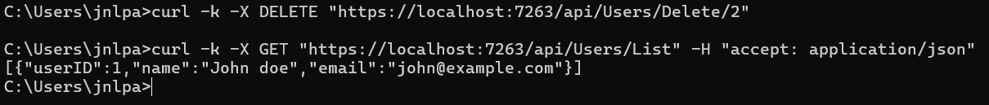

1. Genre
2. Genre add



1. Get genre list



1. Get genre by id



1. Update genre



1. Delete genre

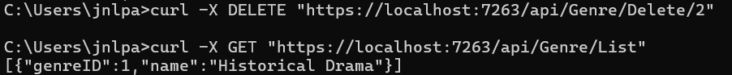

1. Movies
   1. Movie add



* 1. Movie list and delete

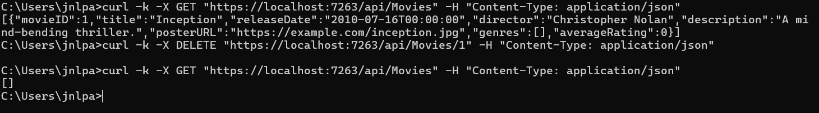

* 1. Update movie

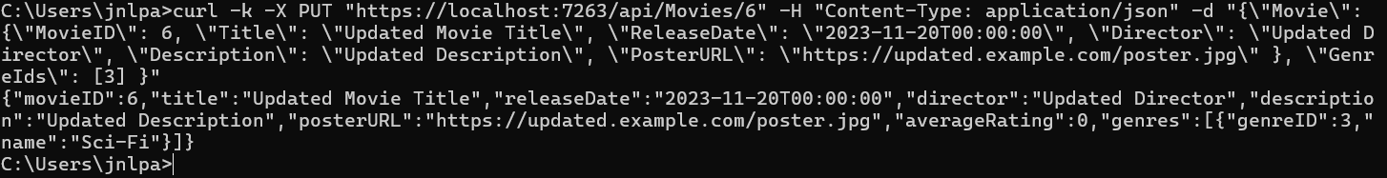

* 1. Add review by movie id

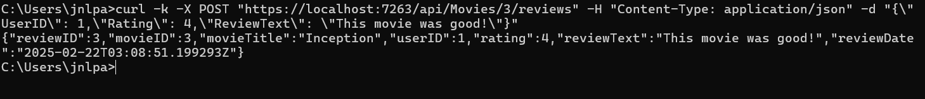

* 1. Get review by movie id



1. Reviews
   1. Get reviews

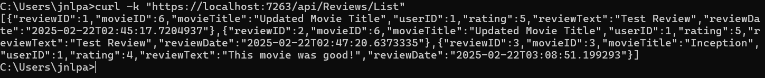

* 1. Get review by id   
     
  2. Get review for specific movie id

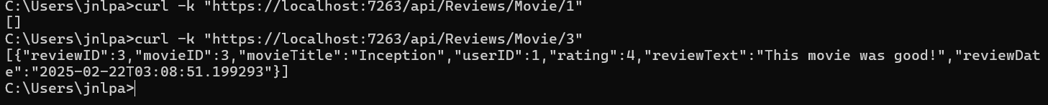

* 1. Get review for specific user

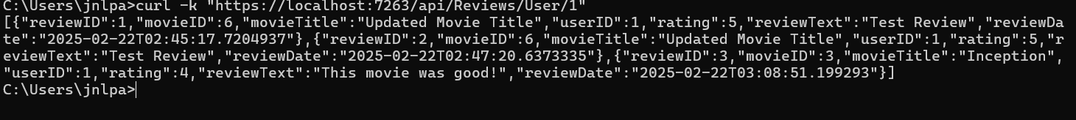

* 1. Add review



* 1. Update review

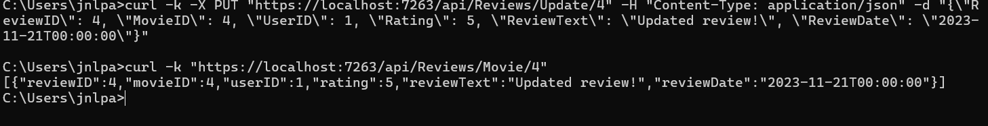

* 1. Delete review

