

Department of Communication

and Humanities

Name: Joeven R. Luison Jr.

Course and Section: Bsit-3 / EEP 3 XQ1

# ACTIVITY: ONLINE QUIZ FOR SOFT SKILLS

Directions: Take an online quiz using this link: [https://www.quizony.com/what-are-myskills/index.html](https://www.quizony.com/what-are-my-skills/index.html) *(Note: since this quiz is adopted, some questions cannot be found in our context. However, your answer in those is still needed)* After finishing the quiz, attach your result to this activity sheet and answer the following questions:

Result:

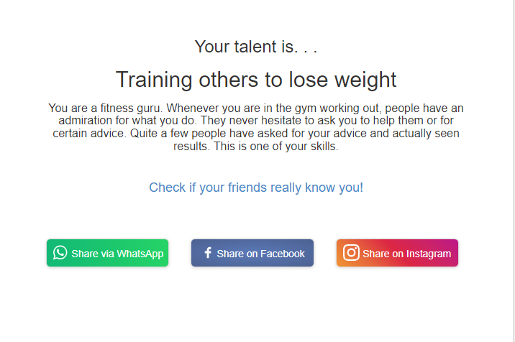

1. Do you agree/disagree with your result? Why?

I'm primarily interested in athletics and am not now training to reduce weight, thus I disagree with the result. Although the indicated proficiency in losing weight training is praiseworthy, my own fitness goals are more focused on improving general endurance, agility, and sports performance. Playing sports demands a specific training regimen that puts an emphasis on injury avoidance, game-specific conditioning, and skill development.

1. How can you relate your result to the Soft Skill discussion done in class and to the activity that came with it?

The discussion was on the value of having effective communication skills and being able to adjust to the requirements of others. Despite the discussion supposing my experience in aiding with weight reduction, I noticed a difference because my interest is more in sports than in weight loss. This demonstrates how important it is to be able to comprehend others and modify communication in situations outside than work, such as helping someone get in shape. It is important to be adaptable and vigilant in a variety of circumstances.