Autonomous Driving Technology,
Cloud Computing, and Scalability Benchmark
Power BI Dashboard Build Guide
Four report pages, star schema, measures, filters, layouts, and QA
Historical cutoff: June 30, 2025
Independent public-data reconstruction
Jannatul Nayeem | July 2026

1. Purpose and Scope
This guide explains how to build the four requested Power BI report pages from the delivered workbook and CSV tables. The dashboard must preserve role, unit, automation level, exposure, and source limitations. It should not imply that all four companies are identical competitors.
Do not combine vehicle deliveries, rider only miles, systems shipped, trips per week, test miles, or platform partnerships into one scale metric. Use the original unit and an interpretation label.

2. Files to Import
File | Purpose
powerbi/powerbi_ready_data.xlsx | Primary multi sheet import option with a scenario calculator and executive summary
powerbi/csv/*.csv | Preferred option for a transparent one table per file model
powerbi/dax_measures.txt | Measure definitions and warning measures
powerbi/data_model_specification.md | Relationship details, grain, and filter direction
powerbi/mockups/*.png | Visual layout references for the four pages

3. Recommended Import Sequence
- Import dimensions first: dim_company, dim_date, dim_geography, dim_source, and dim_technology.
- Import bridge_company_technology.
- Import facts: capability, deployment, disengagement, incident, partnership, GPU pricing, training cost scenario, and scalability score.
- Import reporting tables only when they simplify a visual; do not create ambiguous duplicate relationships.
- Set data types and hide technical keys from the report view.
- Create relationships exactly as specified before adding measures.
- Create the shared measures and warning labels.
- Build report pages in the order shown in this guide.

4. Star Schema and Relationships
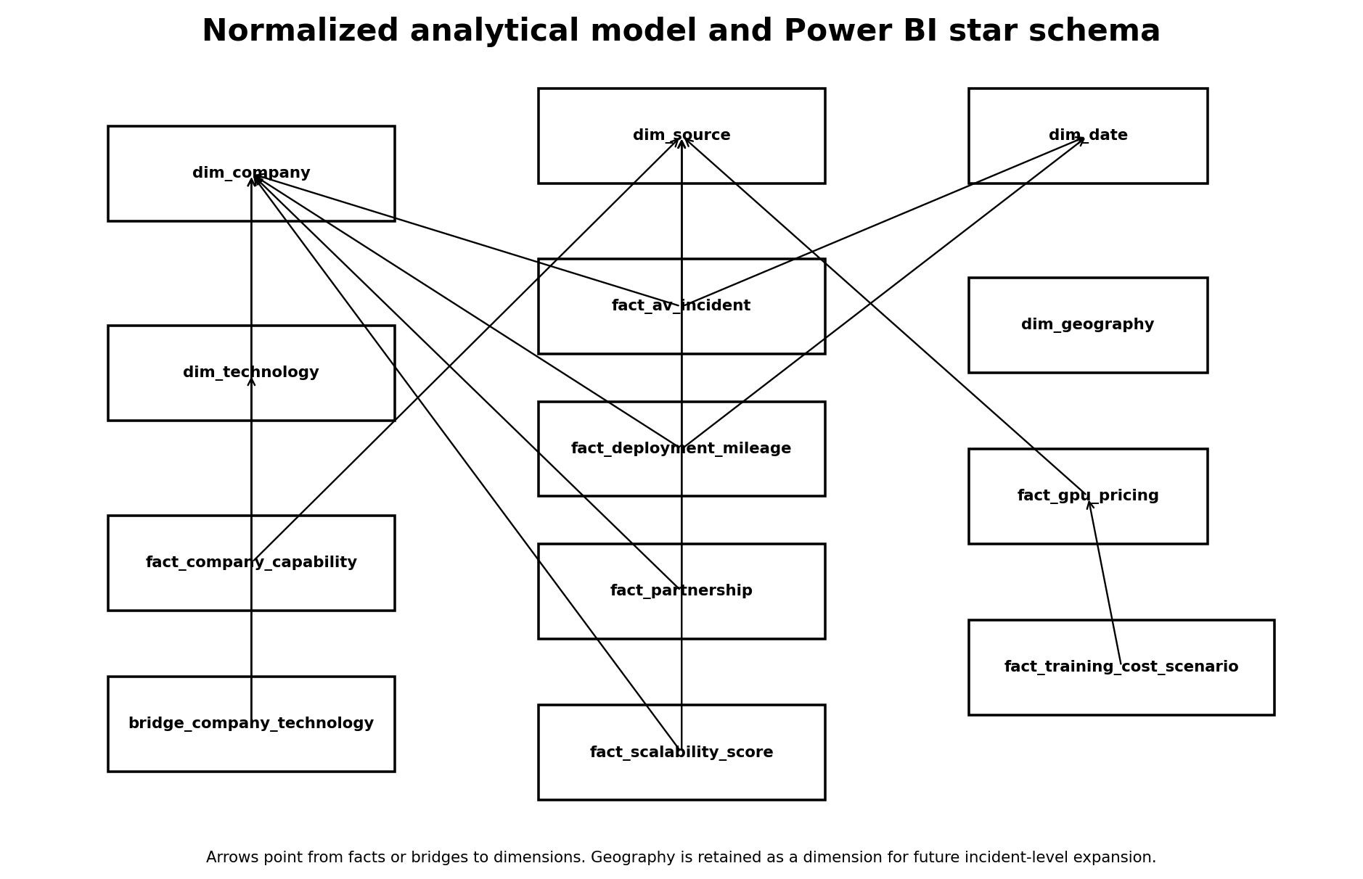
Figure 1. Executed relational model and Power BI star schema reference.
From | To | Cardinality | Filter direction
dim_company[company_id] | fact_company_capability[company_id] | 1 to many | Single
dim_company[company_id] | fact_deployment_mileage[company_id] | 1 to many | Single
dim_company[company_id] | fact_disengagement[company_id] | 1 to many | Single
dim_company[company_id] | fact_av_incident[company_id] | 1 to many | Single
dim_company[company_id] | fact_partnership[company_id] | 1 to many | Single
dim_company[company_id] | fact_scalability_score[company_id] | 1 to many | Single
dim_company[company_id] | bridge_company_technology[company_id] | 1 to many | Single
dim_technology[technology_id] | bridge_company_technology[technology_id] | 1 to many | Single
dim_source[source_id] | Evidence fact source_id fields | 1 to many | Single
dim_date[date] | Dated fact fields where used | 1 to many | Single
dim_geography[geography_id] | Geographic fact fields where available | 1 to many | Single

Program totals such as California statewide miles may have no company key. Keep those rows visible in program level visuals and exclude them from company rankings.

5. Data Type and Formatting Rules
Field type | Rule
Dates | Date type; display YYYY-MM-DD or Year Month
Counts | Whole number with thousands separator
Miles | Decimal or whole number with unit in title
Currency | USD with zero decimals in executive visuals and full precision in detail tables
Rates | Decimal with explicit denominator in the measure name
Scores | One or two decimals on a 1 to 5 scale
Source IDs | Text; use for tooltip and drill through
Warnings | Text measure displayed in cards or tooltip pages

6. Shared KPI Definitions
KPI | Definition | Interpretation
Logged Sources | COUNTROWS(dim_source) | Number of source register entries
Primary or Authoritative Sources | Count source_class = Primary or reliability begins with A | Source quality context
Validation Checks Passed | Count qa_validation_result where status = PASS | Pipeline quality status
Deployment Metric Value | SUM(fact_deployment_mileage[metric_value]) | Use only with one metric and unit selected
Scenario Cost | SUM(fact_training_cost_scenario[total_cost_usd]) | Cost under selected workload, provider, instance, and price model
Weighted Scalability Score | Weighted average of score by selected weighting scheme | Decision aid, not a universal winner
Incident Report Count | COUNTROWS(fact_av_incident) | Descriptive only unless a matching exposure denominator is selected

Mandatory Warning Measures
- Incident totals are not exposure normalized unless a matching denominator is selected.
- Supplier adoption measures are not autonomous driving exposure.
- Scenario costs are standardized model outputs, not company expenditures.
- Scalability scores are ordinal and sensitive to weighting choices.
- Historical evidence is frozen at June 30, 2025.
Source control: Copy the exact DAX expressions from powerbi/dax_measures.txt. Measure names in this guide describe the expected behavior.

7. Report 1: Executive Benchmark
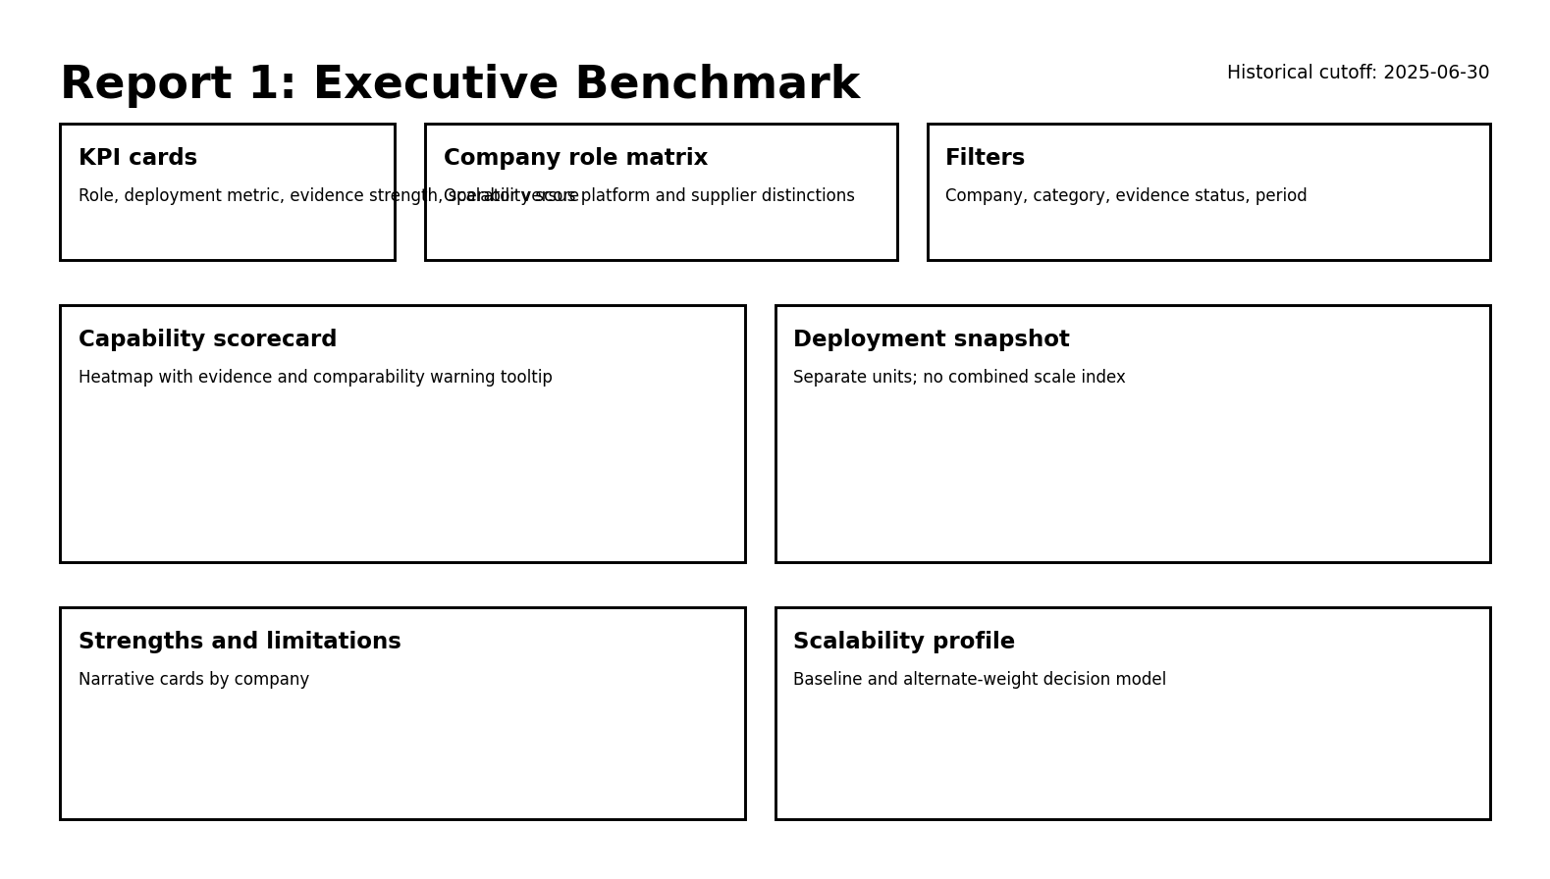
Figure 2. Executive Benchmark mockup.

Page Objective
Give a decision maker a fast view of role, evidence, deployment indicators, capability profiles, and strategic tradeoffs without forcing one winner.
Area | Visual specification
Top band | Historical cutoff card, source count, validation status, selected company, and selected weighting scheme
Upper left | Role classification matrix with primary role, automation exposure, and business model
Upper center | Capability evidence scorecard by data, training, simulation, compute, sensors, and deployment
Upper right | Deployment snapshot with metric and unit preserved
Lower left | Technology comparison table
Lower center | Weighted score visual with weighting scheme slicer and limitation subtitle
Lower right | Strategic strengths, limitations, and evidence confidence

Recommended Visuals
- Cards for cutoff, sources, checks passed, and selected metric.
- Matrix for role and business model classification.
- Heatmap or matrix for capability evidence.
- Clustered bar for weighted score by selected lens.
- Table for strengths, limitations, and source IDs.

Slicers
- Company
- Capability category
- Metric name
- Weighting scheme
- Evidence status
- Source reliability

8. Report 2: ADAS Workflow and Technology
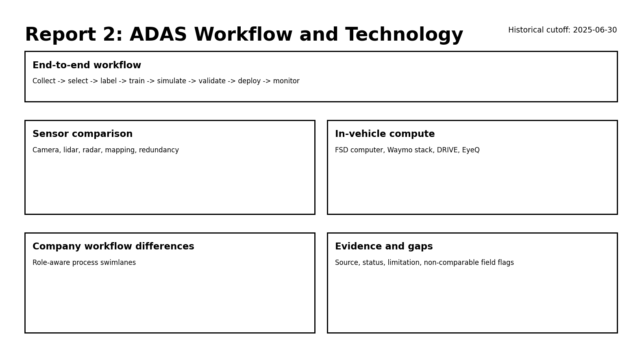
Figure 3. ADAS Workflow and Technology mockup.

Page Objective
Show how data collection, labeling, training, simulation, validation, in vehicle compute, sensors, and deployment differ across the four ecosystem roles.
Workflow stage | Content
Data collection | Fleet or partner data channels, public dataset evidence, and role specific limitations
Data preparation | Labeling, filtering, scenario mining, mapping, or data curation evidence
Model development | Training stack, accelerators, workflow, and available public evidence
Simulation | Closed loop simulation, synthetic data, validation, and disclosed constraints
Vehicle integration | Sensor suite, compute platform, software stack, and OEM integration
Validation and deployment | Testing, safety process, operating domain, production integration, and feedback loop

Recommended Visuals
- Horizontal process diagram for the end to end workflow.
- Company by workflow stage matrix with evidence status.
- Sensor comparison table that separates simplicity from redundancy.
- Compute platform table with product, workload, integration model, and limitations.
- Technology association matrix from bridge_company_technology.

Slicers and Tooltips
- Company, workflow stage, technology category, evidence status, and source.
- Tooltip fields: source ID, publication date, evidence summary, limitation, and reliability classification.

9. Report 3: Safety, Incidents, and Deployment
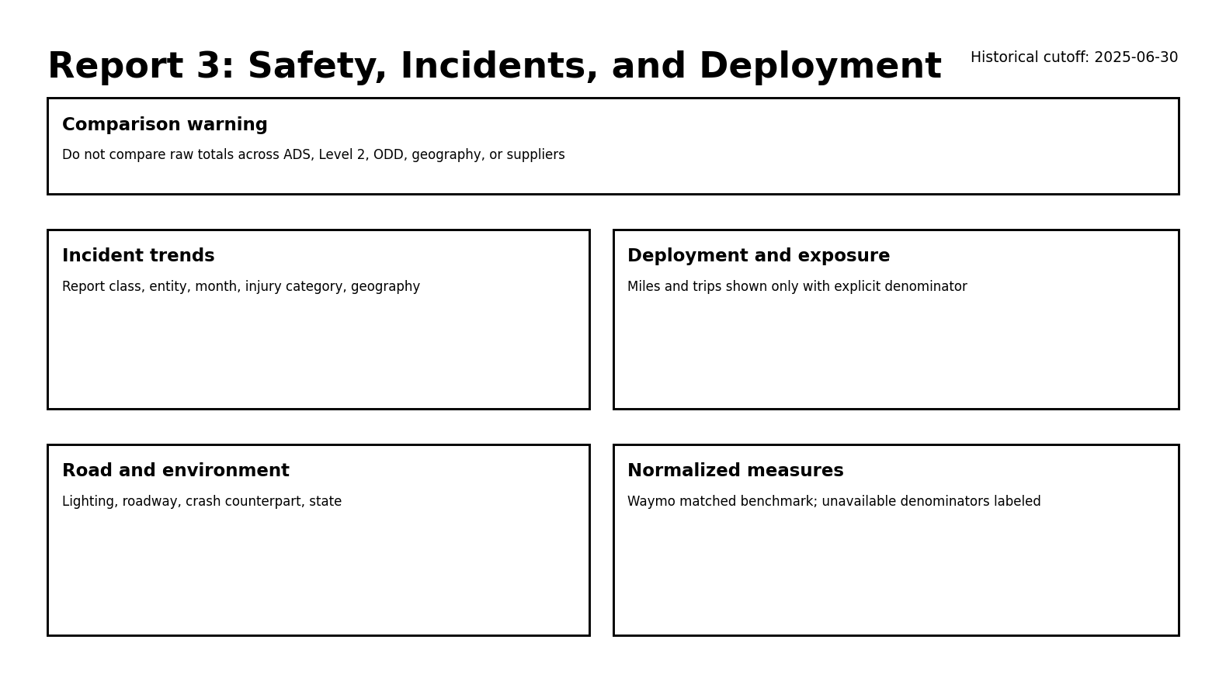
Figure 4. Safety, Incidents, and Deployment mockup.

Page Objective
Present available safety and deployment evidence while making comparison limitations impossible to miss.
Area | Specification
Header warning | Dynamic text explaining whether selected metrics have an aligned denominator
KPI cards | Report count, selected severity, selected exposure metric, geography count, and latest period
Trend | Incident reports by month and reporting entity, clearly labeled descriptive
Geography | State or city distribution where the field is available
Conditions | Roadway, lighting, weather, crash counterpart, and injury severity
Deployment | Miles, trips, vehicles, systems, or deliveries in separate visuals by unit
Normalized panel | Only precomputed matched rates or defensible report per exposure metrics
Limitations | Reporting threshold, telemetry, ODD, software, geography, and exposure notes

Comparison Guardrails
- Do not divide NHTSA incident reports by Tesla deliveries or Mobileye shipments.
- Do not compare ADS and Level 2 incident totals without explaining threshold differences.
- Do not use California disengagements as a universal autonomy quality score.
- Use Waymo matched benchmark outputs only with the study locations, exposure window, and event definitions.
- Hide or disable a rate visual when the denominator is absent or mismatched.

Slicers
- Reporting entity
- System type
- Period
- State
- City
- Roadway type
- Lighting
- Severity
- Crash counterpart

10. Report 4: GPU Cost and Scalability
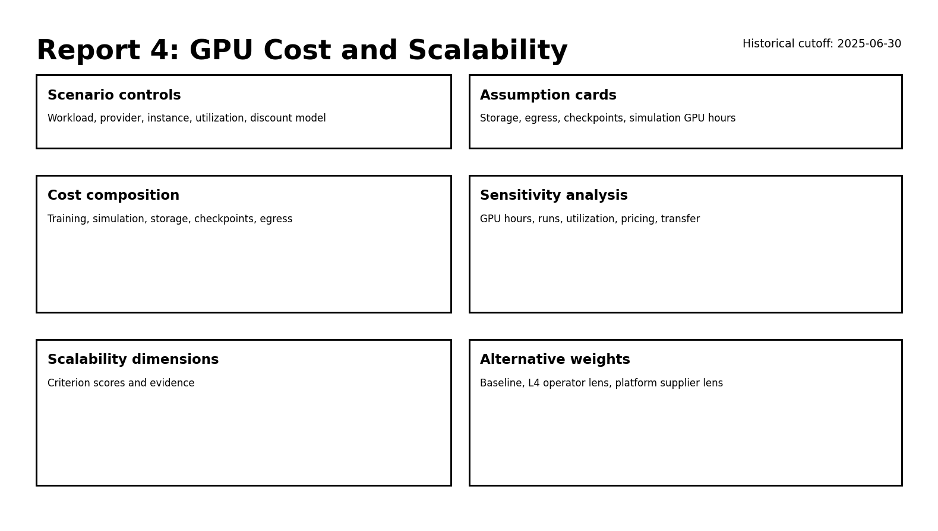
Figure 5. GPU Cost and Scalability mockup.

Page Objective
Compare standardized cloud workloads, expose cost composition and sensitivity, and show scalability tradeoffs under alternative decision lenses.
Area | Specification
Scenario controls | Scenario, provider, GPU model, instance type, pricing model, and utilization
Cost cards | Training compute, simulation compute, storage, checkpoint, egress, and total
Provider comparison | Total cost by provider and instance for the selected scenario
Composition | Stacked column or waterfall for cost components
Sensitivity | Tornado or indexed line chart for GPU hours, runs, utilization, storage, transfer, and price factor
Scalability | Company profile by twelve criteria
Weight sensitivity | Weighted score by baseline, Level 4 operator, and platform supplier lens
Assumptions | Editable or visible model inputs and scenario disclaimer

Interpretation Rules
- Scenario cost is an analytical workload comparison, not confidential company expenditure.
- The committed and interruptible factors are assumptions, not quoted discounts.
- A lower cloud scenario cost does not prove a lower total autonomous driving development cost.
- A weighted scalability score depends on the selected decision lens and evidence quality.

Slicers
- Scenario
- Cloud provider
- GPU model
- Instance type
- Pricing model
- Weighting scheme
- Company
- Criterion

11. DAX Implementation Notes
- Create a disconnected Weighting Scheme table with Baseline, L4 operator lens, and Platform supplier lens.
- Use SWITCH to select the appropriate criterion weight.
- Use DIVIDE for all rates and return BLANK when a denominator is absent.
- Use SELECTEDVALUE for metric and unit titles.
- Use CONCATENATEX to show selected limitation text and source IDs in tooltips.
- Use RANKX only within the selected weighting scheme and display a subtitle that the score is ordinal.
- Use conditional formatting to highlight evidence status, not to imply factual certainty where evidence is missing.
Every rate measure should have a corresponding validity measure. The visual should display a warning or blank result when the event and exposure definitions are not aligned.

12. Power Query Guidance
Step | Guidance
Headers | Promote the first row and preserve source field names in raw queries
Types | Assign text to IDs, date to dates, decimal to costs and miles, whole number to counts
Company names | Use canonical names from dim_company; do not fuzzy merge companies
Dates | Create or relate to dim_date; preserve original period fields when the source is month only
Units | Do not pivot different units into one numeric field without a unit dimension or filter
Source fields | Retain source_id and limitation columns for tooltips and audit
Null company keys | Preserve program totals and prevent accidental company assignment
Load settings | Disable load for helper queries and avoid importing duplicate reporting and fact tables unless required

13. Visual and Accessibility Standards
- Use descriptive titles that include unit and period.
- Use a consistent company ordering across visuals.
- Use patterns, labels, and text in addition to color.
- Provide alt text for charts and mockups.
- Avoid dense maps when geography is incomplete.
- Show source IDs and limitations in tooltips.
- Keep warning text visible on safety and scenario pages.
- Use at least 11 point report text and readable contrast.

14. Build and Publish QA Checklist
QA area | Check
Model | No ambiguous relationships; dimensions filter facts in one direction
Keys | No orphan company, source, technology, date, or geography keys
Cutoff | No source or metric evidence after June 30, 2025
Units | Every numeric visual has a visible unit
Safety | No rate is shown without an aligned denominator
Scenarios | Total cost equals component sum
Scores | Weights total 100 for each scheme; scores stay within 1 to 5
Filters | Slicers do not create misleading cross fact combinations
Warnings | Safety, supplier attribution, and scenario disclaimers are visible
Performance | Remove unused columns, disable unnecessary auto date tables, and limit high cardinality text
Refresh | Refresh succeeds from relative project files or a documented folder parameter
Publish | Confirm tooltips, mobile layout, accessibility, and export behavior

A PBIX file is not included because Power BI Desktop was not available in the execution environment. The delivered data model, DAX, build guide, and mockups are the reproducible substitute.

