Autonomous Driving Technology,
Cloud Computing, and Scalability Benchmark
Tesla, Waymo, NVIDIA, and Mobileye
Portfolio Grade Comparative Analytics Report
Historical cutoff: June 30, 2025
Prepared as an independent portfolio reconstruction
Jannatul Nayeem | July 2026

Document Control and Scope
This project is an independent, publicly reproducible reconstruction and extension of an earlier Microsoft client based global internship facilitated through the Russell Palmer Career Management Center at Michigan State University. Jannatul Nayeem was not employed by Microsoft. The reconstructed outputs are not represented as the exact historical deliverables submitted to Microsoft.
Item | Definition
Historical cutoff | June 30, 2025
Evidence policy | Primary government, regulatory, filing, technical, and dated company sources are prioritized.
Project status | Executed analytical reconstruction using public information. Not the exact historical Microsoft client deliverable.
Database | SQLite normalized model with tested foreign keys, views, validation queries, and example outputs.
Power BI | Power BI ready data, DAX, model specification, build guide, and mockups. No PBIX is claimed.
Raw incident data | Official URLs and acquisition code are included. A verified excerpt executes the pipeline because the runtime could not transfer the large archives.

How to Read This Report
Findings are labeled as verified, scenario based, inferred, or unsupported. A verified fact is directly supported by a logged source. A scenario result follows transparent assumptions. An inference combines verified facts but is not itself a disclosed company metric. Unsupported questions are left unanswered rather than estimated.
The central analytical rule is simple: compare shared concepts, preserve original units, and do not convert different ecosystem roles into a false four company leaderboard.

Executive Summary
Autonomous driving benchmarks often fail because they compare companies as though they sell the same product, operate at the same automation level, collect exposure in the same geography, and report safety under the same rules. This project reconstructs the comparison around ecosystem role, evidence quality, and unit compatibility.
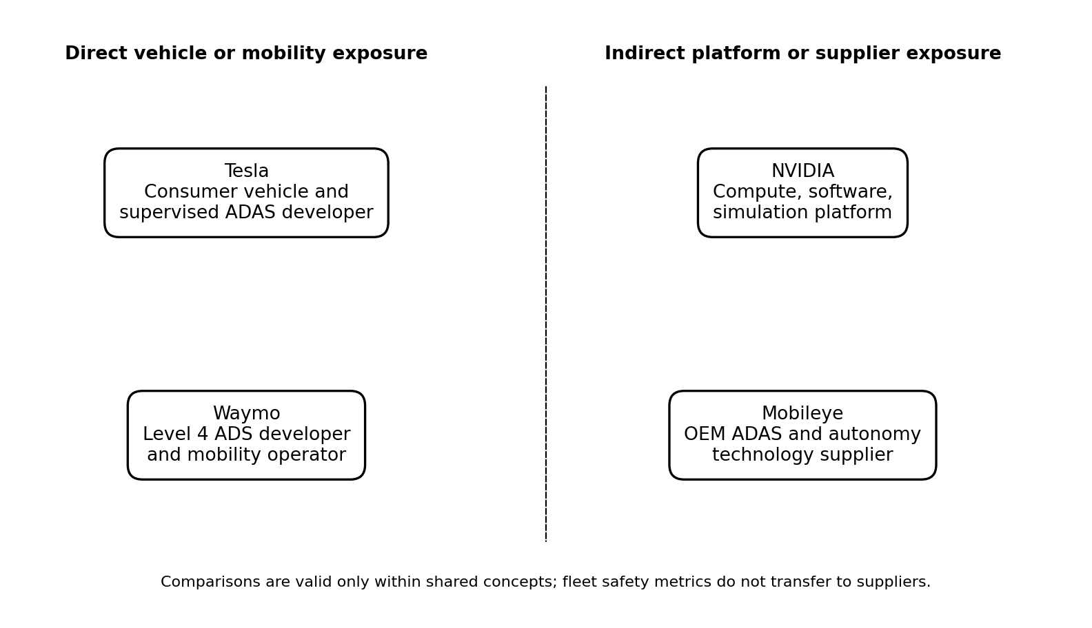
Figure 1. Role aware comparison framework
Sources and interpretation: Company roles are supported by Tesla 2024 Form 10-K, Waymo Safety Impact and deployment releases, NVIDIA FY2025 Form 10-K, and Mobileye 2024 Form 10-K. Source IDs SRC009, SRC010, SRC015, SRC018, and SRC023.

Most Supported Conclusions
- Tesla is best interpreted as a vertically integrated vehicle manufacturer and consumer supervised ADAS developer. Its broad vehicle distribution and vision focused hardware strategy create a distinct scaling path, but public system level exposure denominators are insufficient for matched incident rate analysis.
- Waymo is best interpreted as a Level 4 mobility operator and ADS developer. It had the strongest public exposure aligned safety evidence in this group by the cutoff, including matched benchmark analysis over 56.7 million rider only miles.
- NVIDIA is a compute, operating software, simulation, and reference platform provider. Its scale is visible through customer programs and platform breadth, not through one directly attributable fleet mileage or crash rate.
- Mobileye is an OEM technology supplier spanning base ADAS through higher autonomy tiers. Its installed base and 2024 shipments demonstrate integration scale, but those units represent mixed generations and capabilities.
- Raw NHTSA reports and California disengagement totals cannot establish a universal safety ranking. Reporting thresholds, exposure, geography, telemetry, vehicle type, system version, and human intervention practices differ.
- Standardized cloud scenarios show that GPU hours, number of runs, utilization, and pricing treatment dominate cost. Storage, checkpoints, and transfer become material at large data volumes but generally remain secondary to compute.

Selected Evidence Snapshot
Company or program | Public indicator by cutoff | Interpretation | Source
Waymo | 56.7 million rider only miles analyzed through January 2025 | Exposure aligned research basis, limited to Waymo ODDs | SRC009
Waymo | >250,000 paid trips per week and >1,500 vehicles in May 2025 | Point in time company reported operating scale | SRC010
Tesla | 1,789,226 consumer vehicle deliveries in 2024 | Distribution scale, not autonomous mileage | SRC015
Mobileye | 29.0 million systems shipped in 2024; >200 million cumulative vehicles | Mixed ADAS and autonomy tiers | SRC023
California program | 4,498,066 public road test miles in 2024 reporting period | All permit holders combined; not company specific | SRC006

1. Business Problem and Comparison Framework

1.1 Why a Conventional Ranking Is Misleading
A company can scale through millions of consumer vehicles, thousands of robotaxis, a reference computing platform adopted by automakers, or tens of millions of purpose built chips. Those outcomes are commercially important but not interchangeable. A vehicle delivery is not an autonomous mile. A system shipment is not a driverless deployment. A partner announcement is not an exposed fleet. A safety report is not comparable unless the event definition and denominator align.

1.2 Four Comparison Lenses
Lens | Relevant companies | Valid questions | Invalid shortcut
Vehicle or mobility operator | Waymo; Tesla for supervised consumer exposure | Where and at what automation level is the system deployed? What exposure denominators exist? | Treating vehicle deliveries as driverless miles
Consumer ADAS developer | Tesla; selected Mobileye tiers | How are data, perception, compute, validation, and driver responsibility structured? | Comparing Level 2 incident thresholds with ADS thresholds
Compute and software platform provider | NVIDIA; Mobileye; internal stacks at Tesla and Waymo | What training, simulation, inference, and integration capabilities are public? | Attributing customer fleet crashes directly to the supplier
OEM technology supplier | Mobileye; NVIDIA | How broad is the integration ecosystem and product range? | Treating all systems shipped as equivalent autonomy capability

1.3 Comparability Decision Rule
- Confirm the ecosystem role and automation level.
- Confirm that the metric unit and period are the same.
- Confirm the reporting threshold and event definition.
- Confirm a defensible exposure denominator.
- Confirm similar geography and operational design domain.
- Preserve limitations in the output and tooltip.
- Do not rank when one or more conditions fail.

2. Research Architecture and Source Control
The project uses a normalized source controlled architecture. Important claims link to `dim_source` through source IDs. This avoids untraceable narrative claims and lets Power BI tooltips expose publication date, organization, reliability, URL, and limitation.
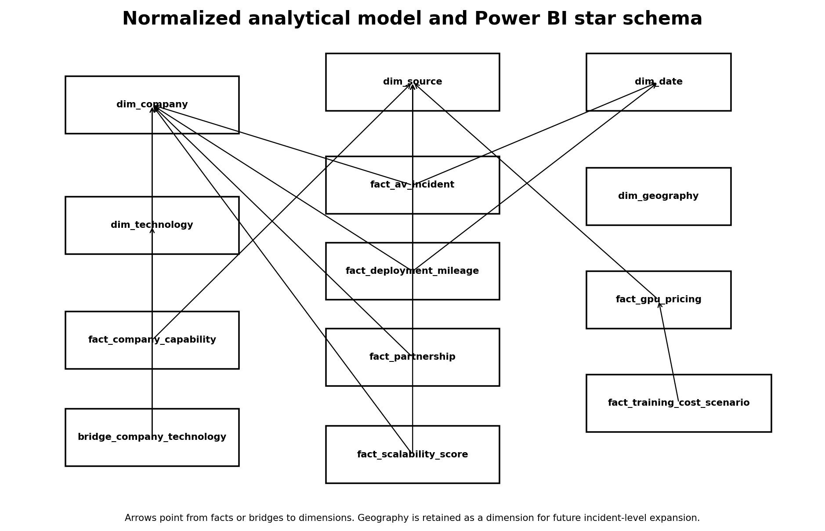
Figure 2. Executed relational model
Sources and interpretation: The database contains 15 populated tables, primary and foreign keys, indexes, reporting views, and quality results.

2.1 Source Register
The source register contains 35 rows. 33 are classified as primary. All source publication dates pass the June 30, 2025 cutoff check.
Reliability class | Definition | Use
A | Government, regulatory filing, official technical documentation, or dated primary research | Primary support for material claims
B | Company primary or academic evidence with mutable page or methodological limitation | Use with explicit caveat
C | Dated secondary corroboration | Only for context or model input corroboration

2.2 Historical Cutoff Control
Each source stores a publication date and cutoff flag. The validation layer fails when any publication date exceeds the cutoff. For mutable pages, only dated releases or information independently established by a pre cutoff filing is used.

2.3 Raw Data Redistribution Constraint
The official NHTSA archive URLs are included. The project runtime could not reliably transfer the large CSV archives into the deliverable. A verified three row ADS excerpt preserves original field names and executes ingestion, date parsing, company standardization, state validation, row hashing, and deduplication. The excerpt is excluded from substantive rates and distributions.
No missing raw archive was replaced with synthetic incident records. The package provides the official URLs, acquisition script, processing code, and a precise explanation of the runtime constraint.

3. Data Pipeline, Database, and Quality

3.1 Pipeline Layers
Layer | Purpose | Examples
Raw | Preserve source fields and acquisition logs | NHTSA schema excerpt, acquisition log
Manually compiled | Store sourced facts and assumptions | Source log, GPU prices, criteria, assumptions
Staging | Standardize names, dates, geography, and hashes | NHTSA standardized excerpt
Cleaned | Create relational dimensions and facts | Company, source, deployment, cost, score facts
Reporting | Create role aware analysis tables | Company benchmark, sensitivity, findings
Data quality | Store tests and reconciliation | Validation results, missingness, record counts

3.2 Database Design
The executed SQLite database enforces keys and checks. Program level California totals use a null company key rather than a fabricated company. Source IDs resolve to `dim_source`. Scores are constrained to 1 through 5. Utilization is constrained to greater than zero and at most one. Prices and deployment values must be nonnegative.

3.3 Quality Results
Severity | Status | Checks
Critical | PASS | 13
High | PASS | 5
Medium | PASS | 2

All 20 project checks passed, including cutoff validation, source uniqueness, company standardization, incident date parsing, duplicate detection, range checks, cost reconciliation, weight totals, score constraints, source integrity, and foreign key validation.
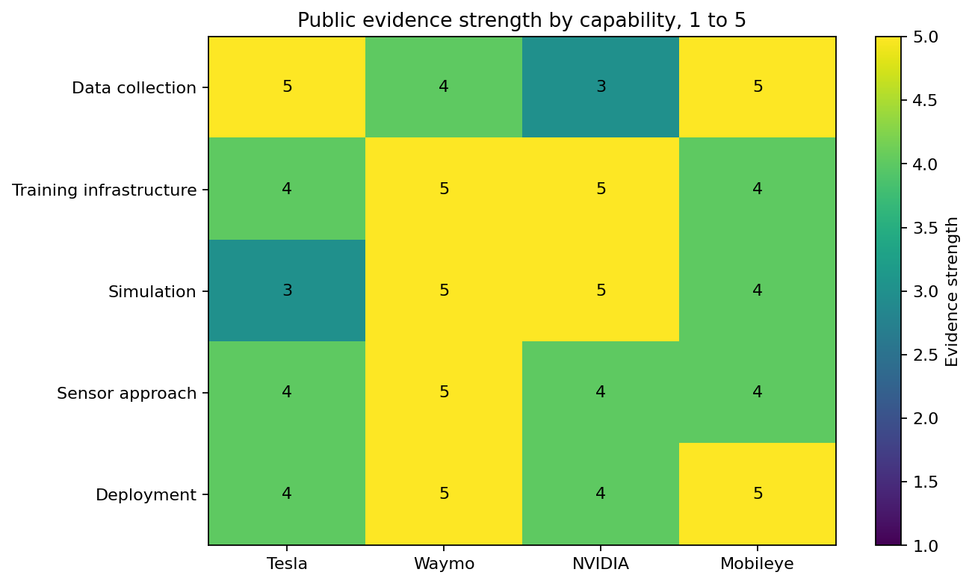
Figure 3. Public evidence strength by capability
Sources and interpretation: Scores indicate public evidence strength, not technical superiority. Sources are stored on each capability row.

4. Company Roles and Technical Strategies

4.1 Tesla
Tesla combines vehicle manufacturing, customer distribution, custom in vehicle compute, fleet learning, and supervised driver assistance. Its 2024 filing describes a primarily vision based approach and continued AI infrastructure development including Cortex.
The strategic advantage is a large direct consumer distribution channel and relatively simple external sensing hardware. The main public evidence limitation is the absence of matched system level exposure by software version, geography, road type, and driver monitoring state.

4.2 Waymo
Waymo develops and operates a geofenced Level 4 ADS. Its public architecture emphasizes multimodal redundancy, mapping, simulation, and structured release validation. The sixth generation public design described 13 cameras, four lidar units, six radar units, and external audio receivers.
The strategic advantage is direct rider only operating experience and a public safety research program with an exposure denominator. The scaling constraint is the combined burden of sensor hardware, fleet operations, mapping or ODD expansion, maintenance, and local regulatory coordination.

4.3 NVIDIA
NVIDIA supplies data center computing, DRIVE software, simulation, operating software, reference sensor architecture, and in vehicle compute. The platform connects model development and simulation to deployment but does not define a single customer vehicle or operating domain.
The strategic advantage is ecosystem flexibility and hardware software breadth. The analytical limitation is attribution: partner announcements, design wins, and platform revenue cannot be converted into NVIDIA autonomous miles or a direct crash rate.

4.4 Mobileye
Mobileye supplies a camera first stack, purpose built EyeQ processors, REM road experience mapping, and product tiers from base ADAS to SuperVision, Chauffeur, and Drive. Higher tiers can add radar and lidar redundancy.
The strategic advantage is broad OEM integration and workload specific hardware efficiency. The limitation is heterogeneity: cumulative equipped vehicles and annual shipments span generations, automakers, features, and automation levels.

4.5 Sensor and Compute Comparison
Company | Sensor approach | In vehicle compute | Primary scalability tradeoff
Tesla | Primarily camera based vision | Custom FSD computer | Lower sensor complexity versus dependence on vision software and supervised operation
Waymo | Camera, lidar, radar, audio redundancy | Custom Waymo Driver stack | Robust multimodal perception versus hardware and fleet operations burden
NVIDIA | Configurable reference architecture | DRIVE AGX, Orin, Thor roadmap | Flexible platform versus customer integration and hardware dependence
Mobileye | Camera first; radar and lidar at higher tiers | EyeQ family | Purpose built efficiency and OEM scale versus product tier heterogeneity

5. ADAS and ADS Model Development Workflow
A common analytical workflow contains collection, event selection, labeling, training, simulation, validation, deployment, and monitoring. The companies differ in where they control each step and which evidence is public.
Stage | Tesla | Waymo | NVIDIA | Mobileye
Collection | Customer fleet data and selected edge cases | Test and rider only fleet data within service ODDs | Customer and partner data pipelines | OEM fleet and REM mapping channels
Training | Internal AI infrastructure and Cortex | Internal training stack and public dataset research | DGX and accelerated computing platform | Centralized development with EyeQ optimized deployment
Simulation | Public detail is less quantitative | Strong public simulation and scenario evidence | DRIVE Sim and Omniverse platform | Public evidence supports validation but fewer comparable quantities
Validation | Supervised release and vehicle monitoring | Structured safety case, simulation, track, and road validation | Safety assessed reference platform and customer validation | Product tier and OEM validation processes
Deployment | Direct software and vehicle channel | Managed Level 4 mobility fleet | OEM and developer integration | OEM production integration

Public descriptions do not reveal the full internal training corpus, labeling workforce, model architecture, experiment count, cluster utilization, or release thresholds. These are preserved as unknowns.

6. Safety, Incidents, and Deployment

6.1 Why Raw Incident Totals Are Insufficient
- NHTSA ADS and Level 2 ADAS reporting thresholds are different.
- Reporting entities have different telemetry and ability to detect qualifying events.
- Fleet mileage and system engagement exposure are not consistently public.
- Operational domains differ by city, speed, road type, weather, and service boundaries.
- Initial reports can be incomplete and later corrected or updated.
- Vehicle types and system versions change over time.
- A supplier does not control all customer sensors, software, drivers, or fleet operations.
Sources and interpretation: NHTSA SGO data and limitations, SRC001 through SRC004. California DMV comparison warning and reporting scope, SRC005 through SRC007.

6.2 Metrics That Can Be Normalized
Metric | Normalization status | Conditions
Waymo rider only crash rates | Defensible within published matched study | Same ODD exposure, benchmark construction, crash group, and period
California program miles | Program trend only | Same reporting scope and period; not a company capability ranking
Company disengagement rate | Cautious within entity trend | Stable testing goals, definitions, geography, and intervention policy
Tesla SGO incidents | Not defensibly normalized in this project | Public system version and engaged mile denominator unavailable
NVIDIA or Mobileye incidents | Not attributable as a fleet rate | Supplier products span many customers and configurations

6.3 Waymo Matched Benchmark Evidence
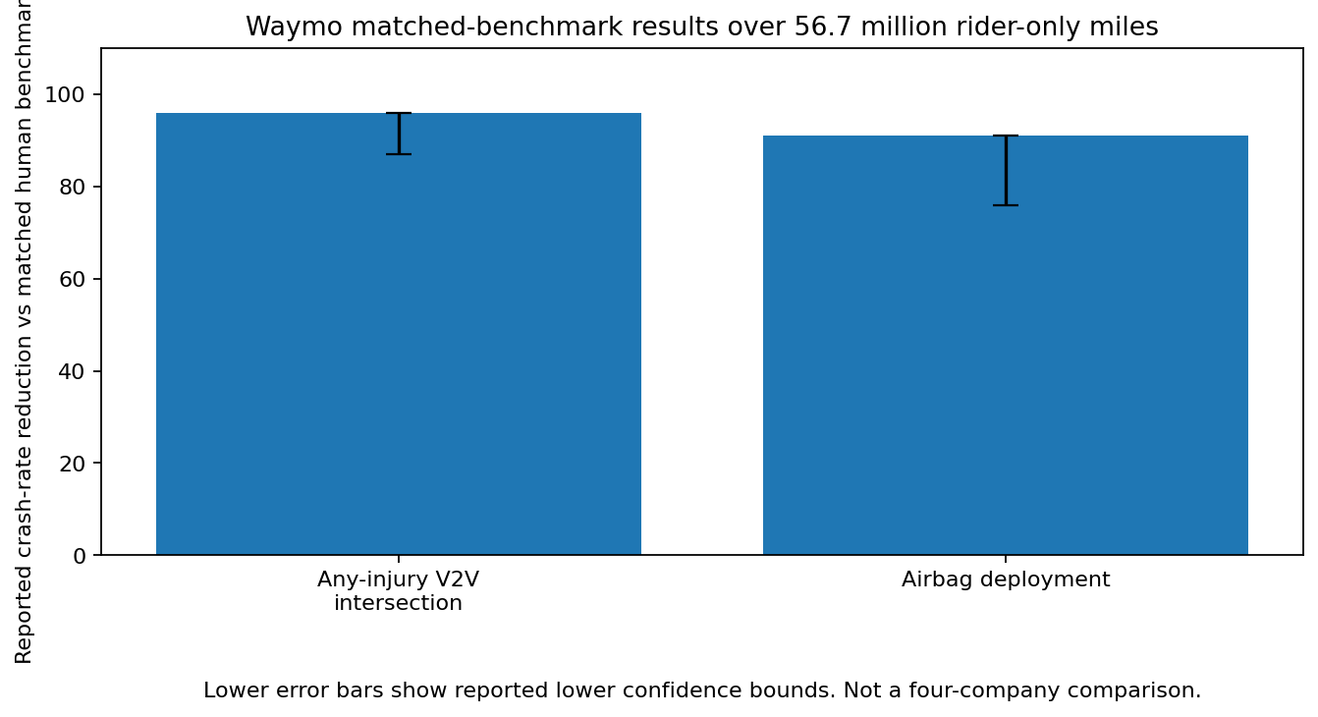
Figure 4. Selected Waymo matched benchmark results
Sources and interpretation: Waymo reported 96 percent lower any injury vehicle to vehicle intersection crash rate with an 87 percent lower confidence bound, and 91 percent lower airbag deployment crash rate with a 76 percent lower confidence bound. SRC009. These are not four company rates.

6.4 California Testing Program
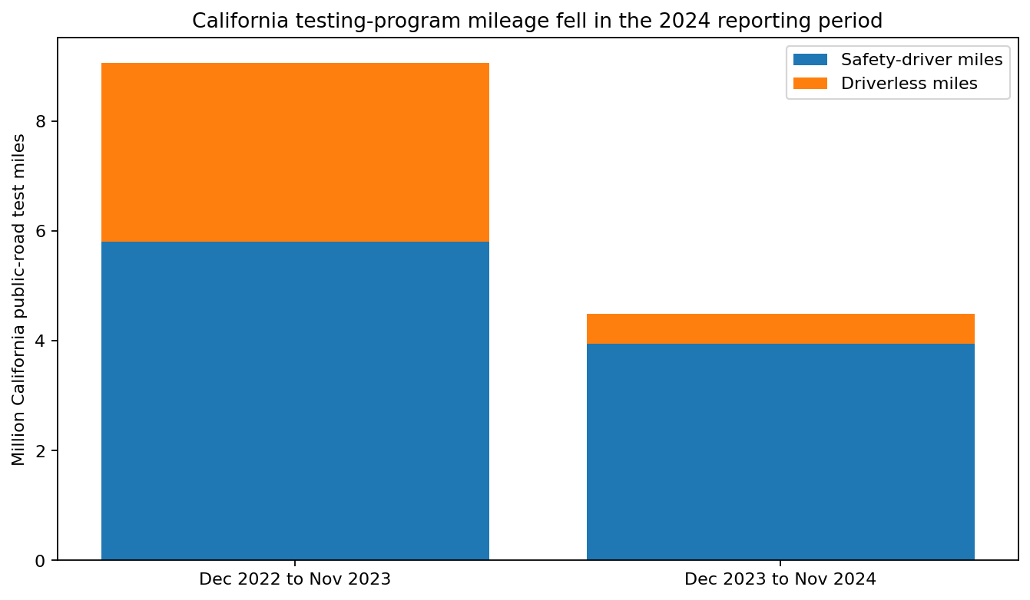
Figure 5. California testing program mileage
Sources and interpretation: Program totals from California DMV, SRC006 and SRC007. DMV states that these reports are not designed for cross company comparisons and exclude private roads, out of state testing, below Level 3 testing, and simulation.

6.5 Deployment Indicators
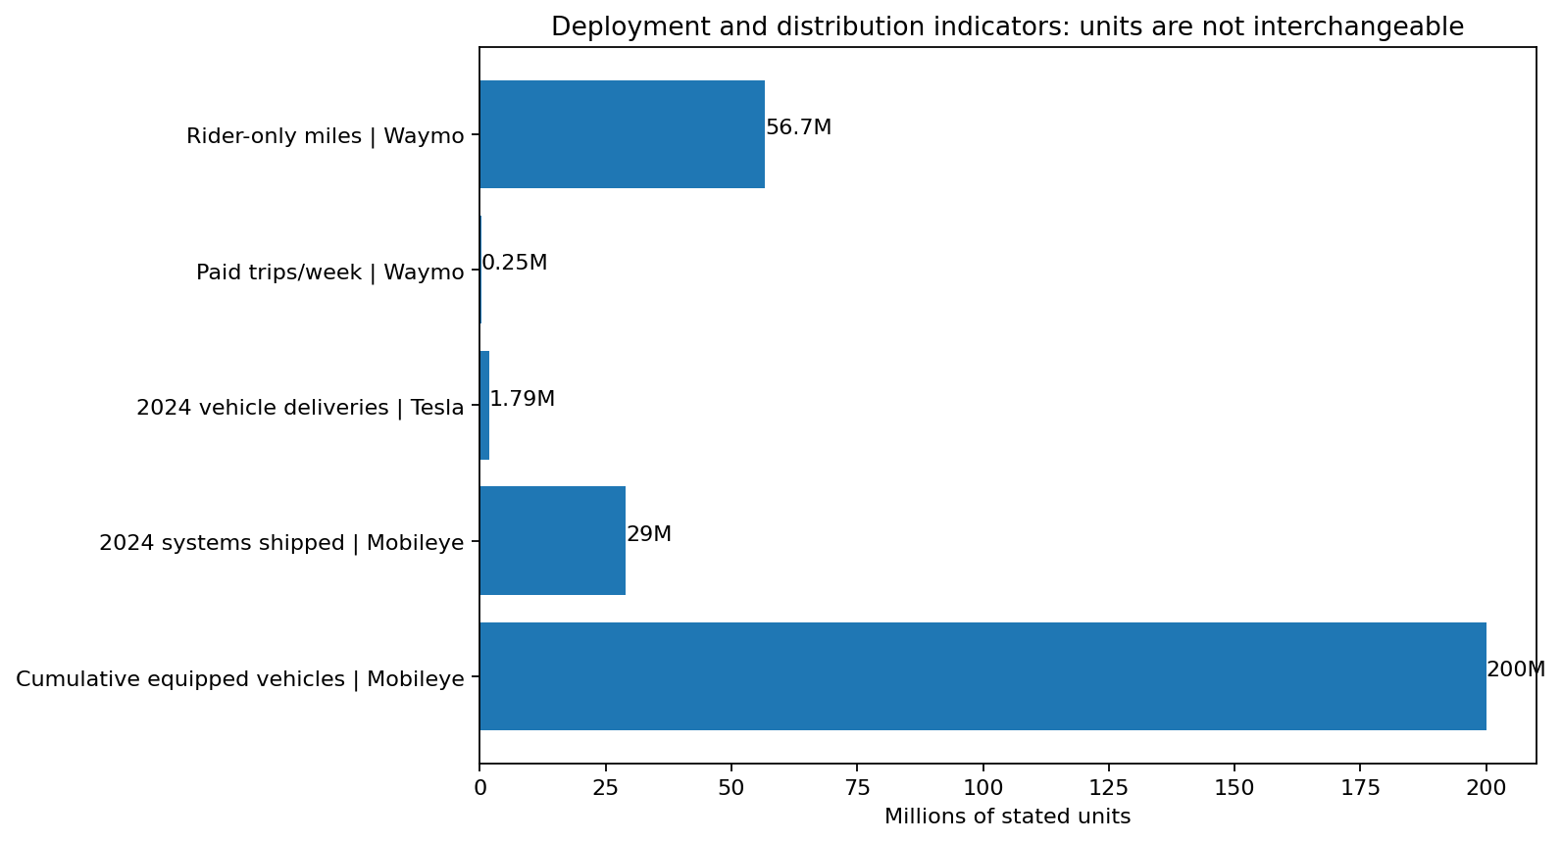
Figure 6. Distribution and deployment indicators with separate units
Sources and interpretation: Waymo, Tesla, and Mobileye metrics are deliberately not summed or transformed into one scale index. SRC009, SRC010, SRC015, and SRC023.

7. GPU and Cloud Cost Scenarios

7.1 Purpose and Boundaries
The model compares cloud configurations under identical standardized workloads. It does not estimate Tesla, Waymo, NVIDIA, or Mobileye spending. Internal workloads, contracts, on premises capacity, discounts, networking, CPU use, and data engineering differ.
Scenario | GPUs | Hours per run | Runs | Storage TB | Simulation GPU hours | Utilization
Small experimentation | 1 | 24 | 5 | 1 | 100 | 70%
Medium development | 8 | 168 | 10 | 20 | 10000 | 80%
Large AV training | 64 | 720 | 12 | 200 | 100000 | 85%

7.2 Calculation Logic
The model calculates required instances with a ceiling function, then divides training and simulation work by utilization. Storage includes training data and checkpoints. Egress is charged separately. Price factors represent on demand, committed, and interruptible scenarios.
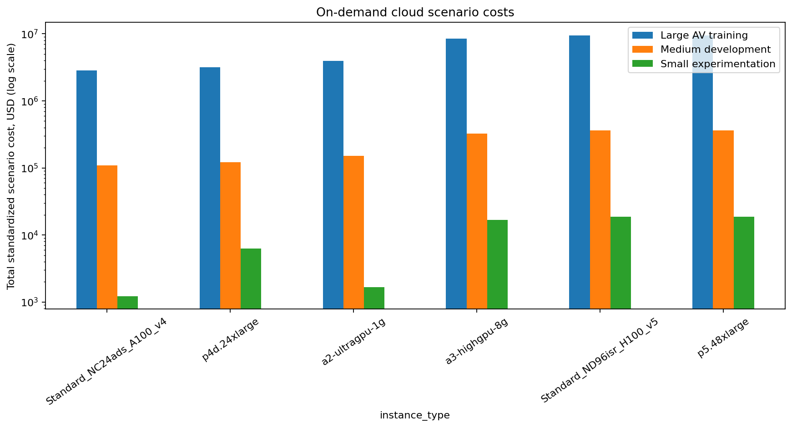
Figure 7. On demand scenario cost by cloud configuration
Sources and interpretation: Historical reference snapshots and dated corroboration. SRC026 through SRC030. Log scale is used because workloads span several orders of magnitude.
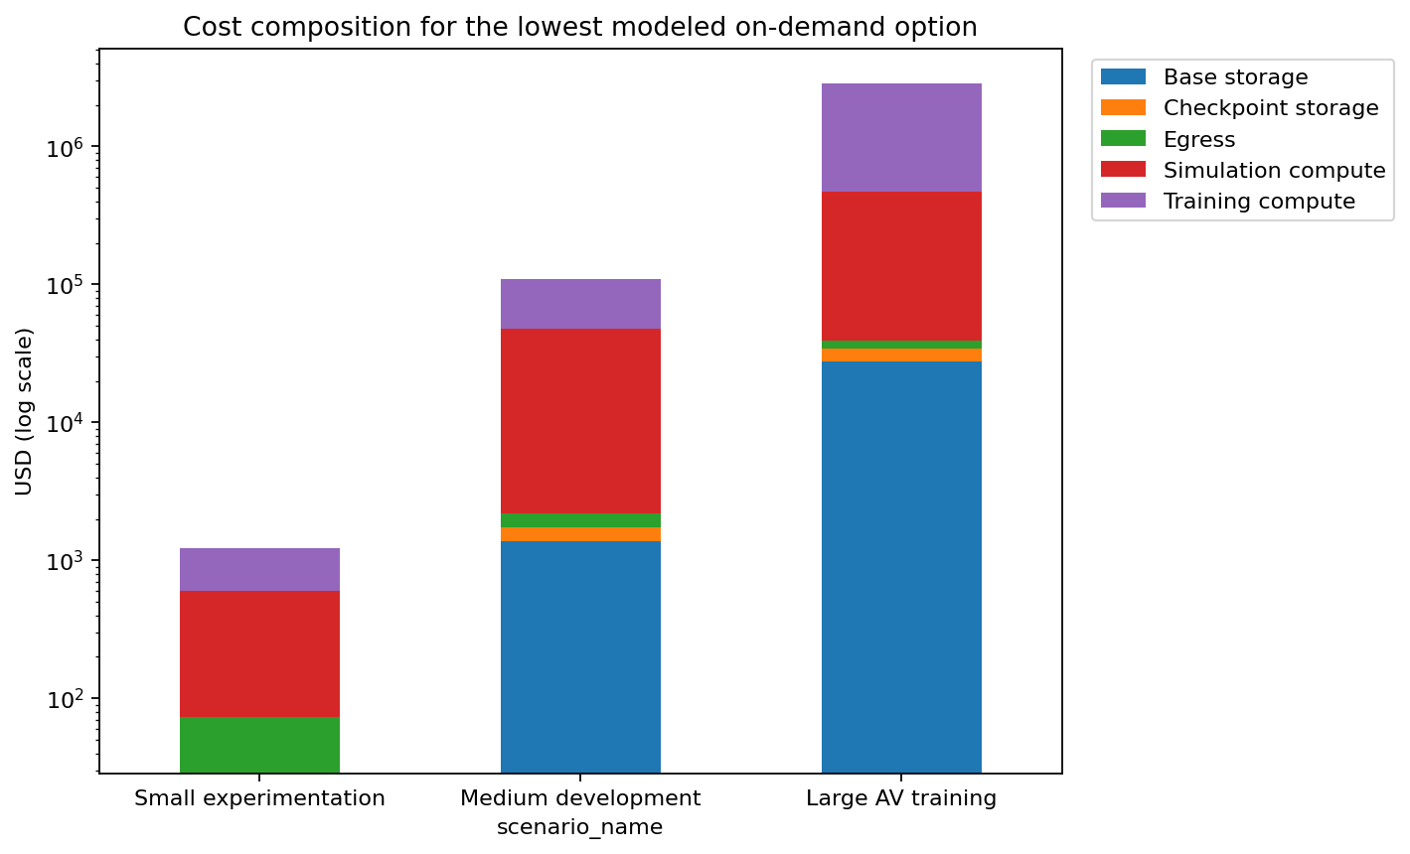
Figure 8. Cost composition for the lowest modeled on demand configuration
Sources and interpretation: Model output. Compute dominates the standardized scenarios. Storage and transfer assumptions remain explicit.

7.3 Scenario Results
Scenario | Lowest modeled on demand provider | Instance | Total
Small experimentation | Microsoft Azure | Standard_NC24ads_A100_v4 | $1,227.18
Medium development | Microsoft Azure | Standard_NC24ads_A100_v4 | $109,706.00
Large AV training | Microsoft Azure | Standard_NC24ads_A100_v4 | $2,858,250.82

The lowest modeled option in these inputs is the single GPU Azure A100 configuration because the model permits many instances and the dated price snapshot is low. This does not imply that it is operationally optimal for large distributed training. Communication overhead, networking topology, memory, availability, quotas, and enterprise contracts are outside the public scenario.

7.4 Sensitivity
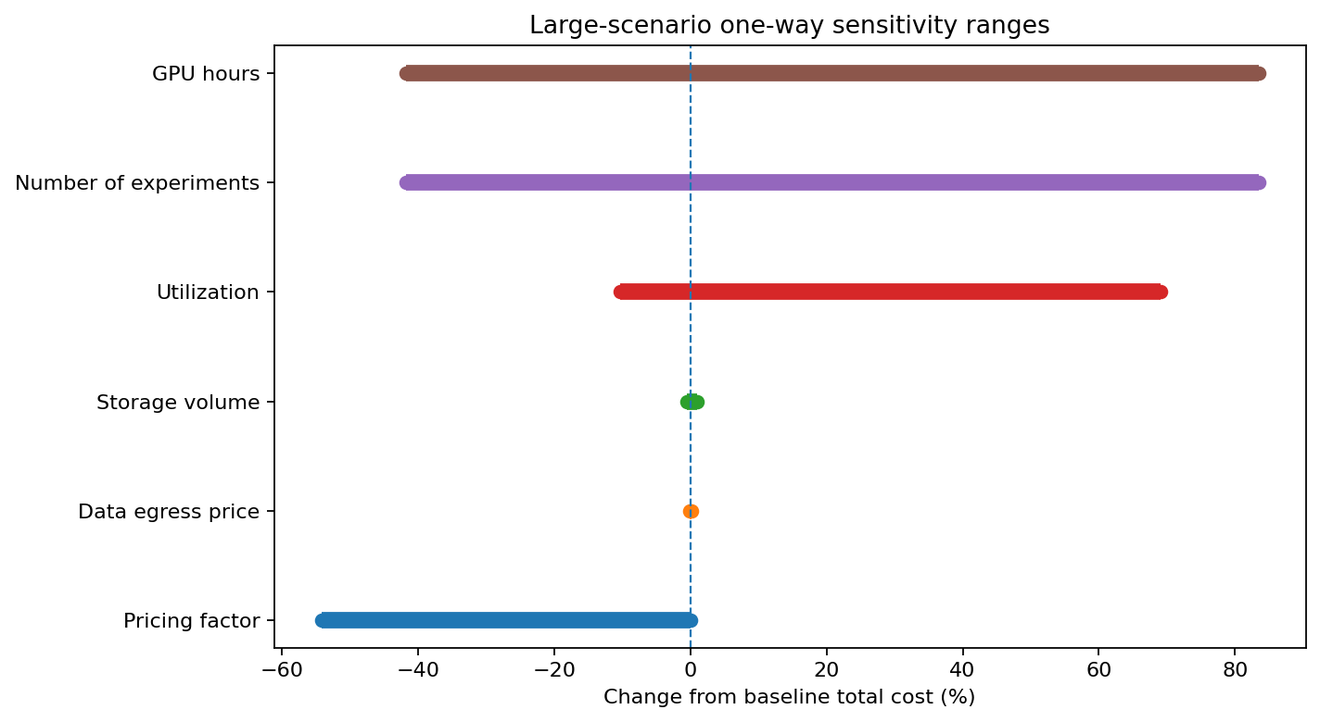
Figure 9. Large workload one way sensitivity
Sources and interpretation: GPU hours, experiment count, utilization, and price factor generate the largest cost ranges. The sensitivity changes one variable at a time.

8. Scalability Framework
Scalability is multidimensional. The framework separates data, infrastructure, vehicle architecture, integration, deployment, regulatory exposure, commercial flexibility, and cost. Scores are ordinal judgments from public evidence, not measured physical quantities.
Criterion | Baseline | L4 lens | Supplier lens | Measurement
Data scale | 10 | 5 | 8 | Evidence of deployed/test data channels; not raw vehicle count alone
Training infrastructure | 10 | 10 | 12 | Public stack, accelerators, and workflow evidence
Simulation capabilities | 8 | 12 | 10 | Closed-loop and scenario coverage evidence
In-vehicle compute | 8 | 8 | 12 | Production platform and workload fit
Sensor complexity | 8 | 4 | 5 | Higher score means simpler scalable hardware, not necessarily higher perception redundancy
Geographic scalability | 10 | 8 | 8 | Current reach plus adaptation burden
Hardware dependence | 7 | 5 | 6 | Higher score means lower dependency/constraint
OEM or fleet integration | 10 | 8 | 14 | Production integration, reference platforms, fleet processes
Deployment maturity | 10 | 14 | 10 | Role-specific deployment evidence
Regulatory exposure | 7 | 10 | 5 | Higher score means more manageable exposure
Commercial flexibility | 7 | 8 | 7 | Direct, platform, supplier, and partnership options
Cost scalability | 5 | 8 | 3 | Relative architecture burden; no confidential unit economics

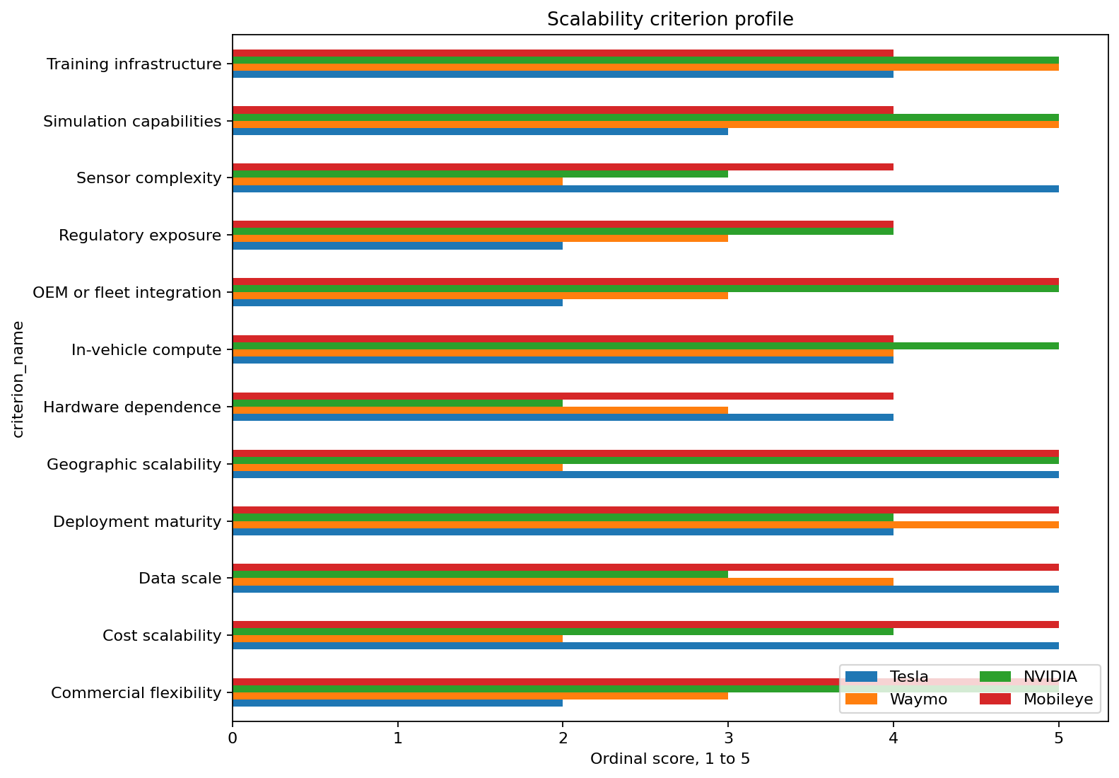
Figure 10. Criterion score profile
Sources and interpretation: Each score retains an evidence source and missing data treatment. Sensor complexity rewards lower integration burden, not higher redundancy.
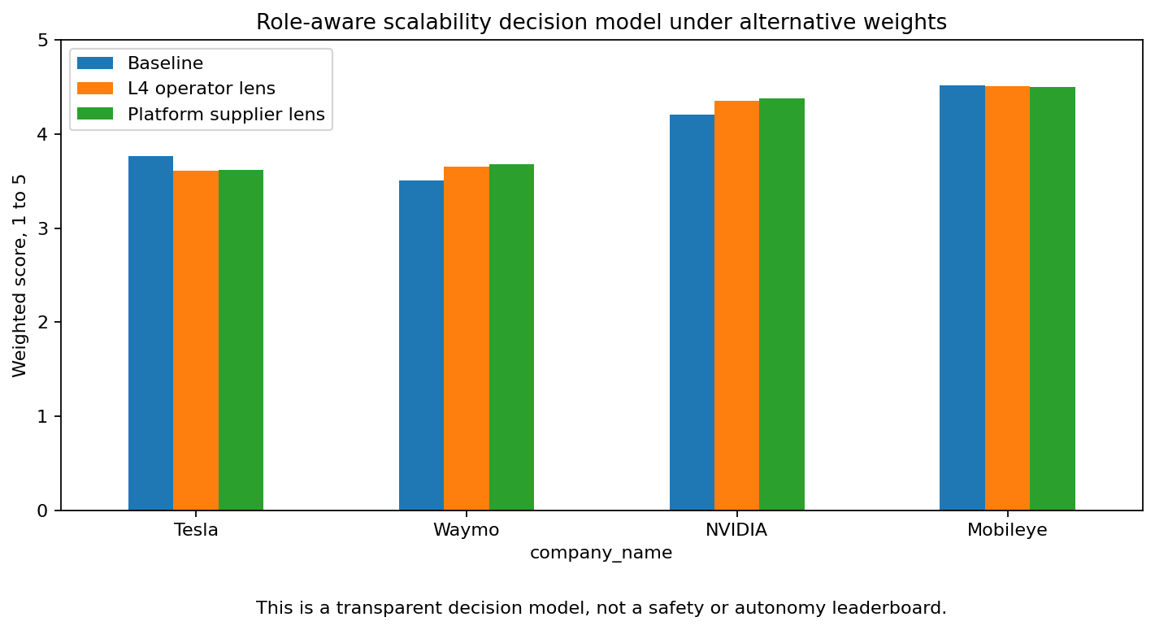
Figure 11. Weight sensitivity
Sources and interpretation: The model is a diagnostic. A weighted total should not be presented as a safety or autonomy winner.

8.1 Methodological Limitations
- Ordinal scoring compresses nuanced evidence into a small scale.
- Public disclosure quality can influence score confidence.
- Private cost, reliability, software quality, and organizational execution are missing.
- One company can score well for a role specific reason that is irrelevant to another role.
- Alternative weights do not solve incompatible business objectives.

9. Strategic Advantages, Constraints, and Risks
Company | Strategic advantages | Constraints and risks
Tesla | Direct consumer distribution, vertical integration, fleet learning channel, simpler external sensing hardware | Supervised status by cutoff, denominator gaps, regulatory scrutiny, dependence on vision software and driver behavior
Waymo | Rider only operating experience, matched safety research, multimodal redundancy, strong simulation evidence | Geofenced expansion burden, hardware and fleet operations complexity, local regulatory and operational dependencies
NVIDIA | End to end compute and software platform, simulation, broad ecosystem, configurable reference architecture | Customer execution determines outcomes, hardware cycle dependence, indirect deployment attribution
Mobileye | Large OEM installed base, purpose built EyeQ efficiency, product tier breadth, REM mapping | Mixed product tiers, OEM program timing, heterogeneous exposure, limited public training infrastructure quantities

10. Confidence Classification and Unsupported Questions

10.1 Strongly Supported
- Ecosystem role classification.
- Waymo reported deployment and safety study exposure.
- Tesla 2024 deliveries and public architecture description.
- NVIDIA platform role and FY2025 business disclosure.
- Mobileye 2024 shipments, installed base, and product tiers.
- California program mileage and reporting limitations.

10.2 Moderately Supported or Inferred
- Relative scaling burden of sensor architectures.
- Breadth of internal simulation and training systems when only high level descriptions are public.
- Commercial flexibility and integration burden.
- Role aware scalability scores.

10.3 Scenario Based
- Small, medium, and large cloud workload costs.
- Committed and interruptible price factors.
- Storage, checkpoint, egress, and utilization sensitivity.
- Weighted scalability totals.

10.4 Unsupported by Public Data
- Exact company training expenditure.
- Complete internal dataset size and labeling cost.
- Sensor bill of materials and per vehicle hardware margin.
- Matched Tesla engaged miles by software version and ODD.
- A universal four company crash rate.
- A universal winner across safety, autonomy, scale, and commercial value.

11. Reproducibility and Portfolio Use
The full pipeline executes with relative paths. The source log, assumptions, data dictionary, database, SQL, notebooks, Power BI tables, DAX, mockups, charts, and quality reports are included. The master `run_pipeline.py` completed successfully in the delivery environment.
Asset | Purpose
README.md | Business problem, architecture, findings, reproduction, ethics, and project context
source_log.xlsx | Traceable dated evidence register
autonomous_driving.db | Executed normalized SQLite database
python/run_pipeline.py | Master reproducible pipeline
notebooks/ | Executed analytical notebooks
powerbi/powerbi_ready_data.xlsx | Star schema tables and formula driven cost calculator
outputs/quality_report.xlsx | Automated validation and reconciliation
project_report.docx and PDF | Portfolio report
interview_guide.docx | Interview explanations and questions

Appendix A. Data Quality Check Register
Check | Table | Severity | Status | Expected | Actual
Historical cutoff validation | dim_source | Critical | PASS | All publication dates <= 2025-06-30 | 35/35 valid
Source ID uniqueness | dim_source | Critical | PASS | 35 unique source IDs | 35
Source URL completeness | dim_source | High | PASS | 0 missing URLs | 0
Company key uniqueness | dim_company | Critical | PASS | 4 unique companies | 4
Company standardization | dim_company | High | PASS | Tesla, Waymo, NVIDIA, Mobileye | ['Mobileye', 'NVIDIA', 'Tesla', 'Waymo']
Incident duplicate detection | fact_av_incident | High | PASS | 0 duplicate report IDs | 0
Incident date validation | fact_av_incident | High | PASS | All incident months parse | 3
Incident cutoff validation | fact_av_incident | Critical | PASS | All dates <= cutoff | 2025-06-01
US state validation | fact_av_incident | Medium | PASS | All state codes valid | ['AZ', 'CA', 'TX']
Mileage reasonableness | fact_av_incident | Medium | PASS | 0 to 1,000,000 | 45257 to 164698
Deployment nonnegative | fact_deployment_mileage | Critical | PASS | All values >= 0 | 1500.0
Deployment cutoff | fact_deployment_mileage | Critical | PASS | All dates <= cutoff | 2025-05-05
GPU pricing nonnegative | fact_gpu_pricing | Critical | PASS | All hourly rates > 0 | 3.67
Scenario utilization range | gpu_scenarios | Critical | PASS | 0 < utilization <= 1 | [0.7, 0.8, 0.85]
Scenario cost reconciliation | fact_training_cost_scenario | Critical | PASS | Total equals component sum | 0.0
Scalability weight totals | scalability_criteria | Critical | PASS | Each scheme sums to 100 | {'baseline_weight': 100, 'l4_operator_weight': 100, 'platform_supplier_weight': 100}
Scalability score range | fact_scalability_score | Critical | PASS | All scores 1 to 5 | 2 to 5
Score referential integrity | fact_scalability_score | Critical | PASS | All company and criterion keys resolve | All resolved
Capability source integrity | fact_company_capability | Critical | PASS | All source IDs resolve | 20
Record-count reconciliation | NHTSA excerpt | High | PASS | Raw = staging = clean for no-duplicate excerpt | 3 = 3 = 3

Appendix B. Selected Source Register
ID | Organization | Title | Date | Reliability | Key limitation
SRC001 | NHTSA | Standing General Order on Crash Reporting | 2025-04-24 | A: authoritative primary | Reports are not exposure-normalized; reports may be incomplete, corrected, or unverified
SRC002 | NHTSA | SGO 2021-01 Incident Reports - ADS archive through June 15, 2025 | 2025-06-15 | A: authoritative primary | Incident reporting threshold differs from Level 2; mileage exposure is not supplied
SRC003 | NHTSA | SGO 2021-01 Incident Reports - Level 2 ADAS archive through June 15, 2025 | 2025-06-15 | A: authoritative primary | No system-level mileage denominator; threshold differs from ADS
SRC006 | California DMV | Over 4 Million Test Miles Logged by Autonomous Vehicle Permit Holders in California | 2025-01-31 | A: authoritative primary | Not designed for cross-company comparison; excludes simulation, private roads, out-of-state, and below L3
SRC009 | Waymo | Comparison of Waymo Rider-Only Crash Rates by Crash Type to Human Benchmarks at 56.7 Million Miles | 2025-05-01 | A: company primary with research methods | Company-authored; limited to Waymo ODDs and benchmark construction
SRC010 | Waymo | Scaling our fleet through U.S. manufacturing | 2025-05-05 | A: company primary | Operational metrics are company reported and point-in-time
SRC012 | Waymo | Meet the 6th-generation Waymo Driver | 2024-08-19 | A: company primary | Planned generation; not all fleet vehicles used this configuration by cutoff
SRC015 | Tesla | Tesla 2024 Form 10-K | 2025-01-29 | A: audited/regulated primary | Corporate disclosure; does not provide FSD miles or training spend
SRC018 | NVIDIA | NVIDIA FY2025 Form 10-K | 2025-02-26 | A: audited/regulated primary | Automotive reporting aggregates multiple products and customers
SRC019 | NVIDIA | DRIVE Hyperion achieves safety and cybersecurity milestones | 2025-01-06 | A: company primary | Certification and assessment do not establish deployed vehicle safety rate
SRC023 | Mobileye | Mobileye 2024 Form 10-K | 2025-02-27 | A: audited/regulated primary | Installed-base figures span product generations and automation levels
SRC026 | Google Cloud | Accelerator-optimized VM pricing | 2025-06-30 | B: official but mutable | Current page is mutable; snapshot values are retained as historical model inputs
SRC027 | Microsoft Azure | Azure Retail Prices REST API overview | 2024-08-07 | A: official primary | Historical SKU availability varies by region; API output can change
SRC028 | AWS | New GPU-equipped EC2 P4 instances | 2020-11-02 | A: official primary | Release is not a complete historical price archive

