STM32 CAN Telemetry Node
Rev A — Design Report

Author | Joshua Nwaneli
Date | June 2026
Design Tool | Altium Designer
PCB Size | 90 mm × 67 mm
MCU | STM32F103C8T6, LQFP-48
CAN Bitrate (planned) | 500 kbps
DRC Status | 0 warnings · 0 rule violations · 0 unrouted nets
Design Status | Schematic complete · PCB routed · DRC clean · Bring-up planned

Completed in Altium Designer. Physical assembly and firmware bring-up planned as next steps.

1. Project Overview
The STM32 CAN Telemetry Node is a purpose-built PCB designed to collect vehicle sensor data and transmit it over a CAN bus. The board accepts a 12 V vehicle input, regulates it through a two-stage power chain to +5 V and +3.3 V, and uses an STM32F103C8T6 microcontroller to sample analog, digital, and frequency signals before encoding them into CAN frames. This design was created as a portfolio project and embedded hardware design demonstration, completed in Altium Designer.
Rev A covers full schematic capture across six sheets, a routed and DRC-clean PCB layout, a Bill of Materials, and a complete manufacturing output package. Physical assembly and firmware bring-up are planned as the next phase. The intended application is an automotive or motorsport environment where a CAN network aggregates data from distributed sensor nodes.

2. Design Goals
- Accept a 12 V vehicle input with fuse and transient protection.
- Generate regulated +5 V and +3.3 V rails from the 12 V input.
- Interface an STM32F103C8T6 with a CAN transceiver for 500 kbps CAN communication.
- Condition four analog voltage inputs, two digital inputs, and one frequency/wheel-speed input.
- Transmit CAN message ID 0x100 at a 100 ms interval, encoding four 16-bit raw ADC values.
- Include debug infrastructure: SWD programming header, status LEDs, user button, and labeled test points.
- Pass Altium DRC with 0 warnings and 0 rule violations before releasing manufacturing outputs.

3. System Block Diagram
Figure 1 shows the top-level block diagram, drawn as schematic sheet 00 in Altium. It traces the power path from the 12 V input through fuse and protection circuitry, 5 V regulation, and 3.3 V regulation down to the STM32 MCU. From the MCU, the diagram shows the signal paths to each subsystem: ADC inputs from analog sensors, GPIO connections for digital inputs and status LEDs, a timer input for the wheel-speed/frequency signal, the SWD debug interface, and the CAN_TX/CAN_RX path through the transceiver to the CAN connector.

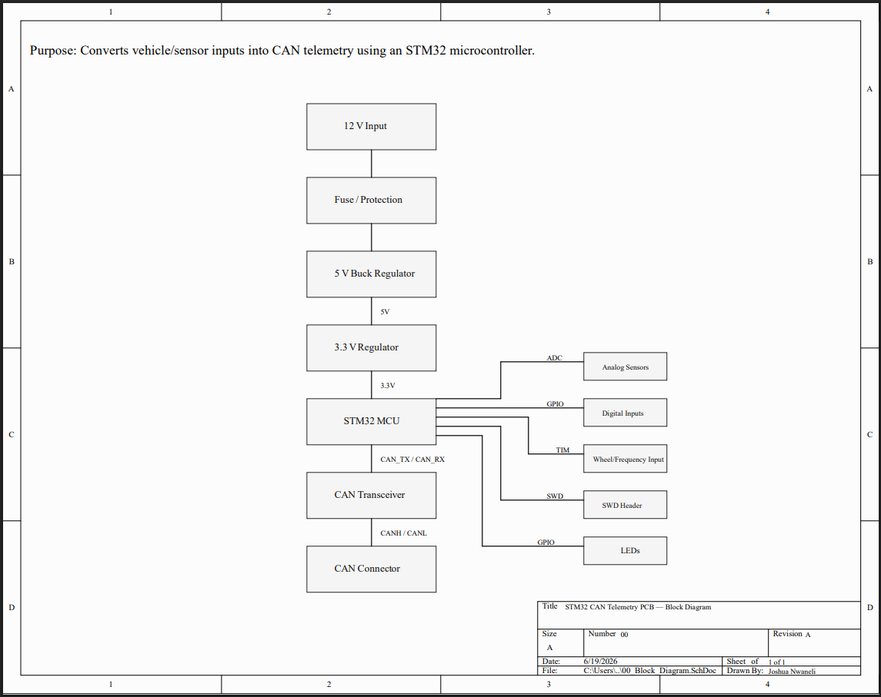
Figure 1: System Block Diagram

4. Power Architecture
The power supply chain, shown in Figure 2, starts at J1, a 2-pin power input connector that accepts the raw 12 V vehicle supply. The input path includes a resettable fuse (F1) and a reverse-polarity protection diode (D1), followed by an input TVS diode (D2) across the rail for transient suppression. This combination is intended to protect the board against overcurrent events, reverse connection, and voltage transients common in automotive environments.
From the protected 12 V rail (VIN_12V), a 5 V switching regulator (U1) steps the voltage down to +5 V. The +5 V rail then feeds a 3.3 V LDO regulator (U2) that produces the supply used by the STM32 and CAN transceiver. A design note on the schematic explicitly states that the STM32 VDD must not be driven directly from +5 V. Bulk and bypass capacitors are placed at each stage to stabilize the rails under load. A power-indicator LED (D3) with a series current-limiting resistor confirms +3.3 V rail presence. Test points TP1 through TP4 provide probe access to VIN_12V, +5 V, +3.3 V, and GND during bring-up.

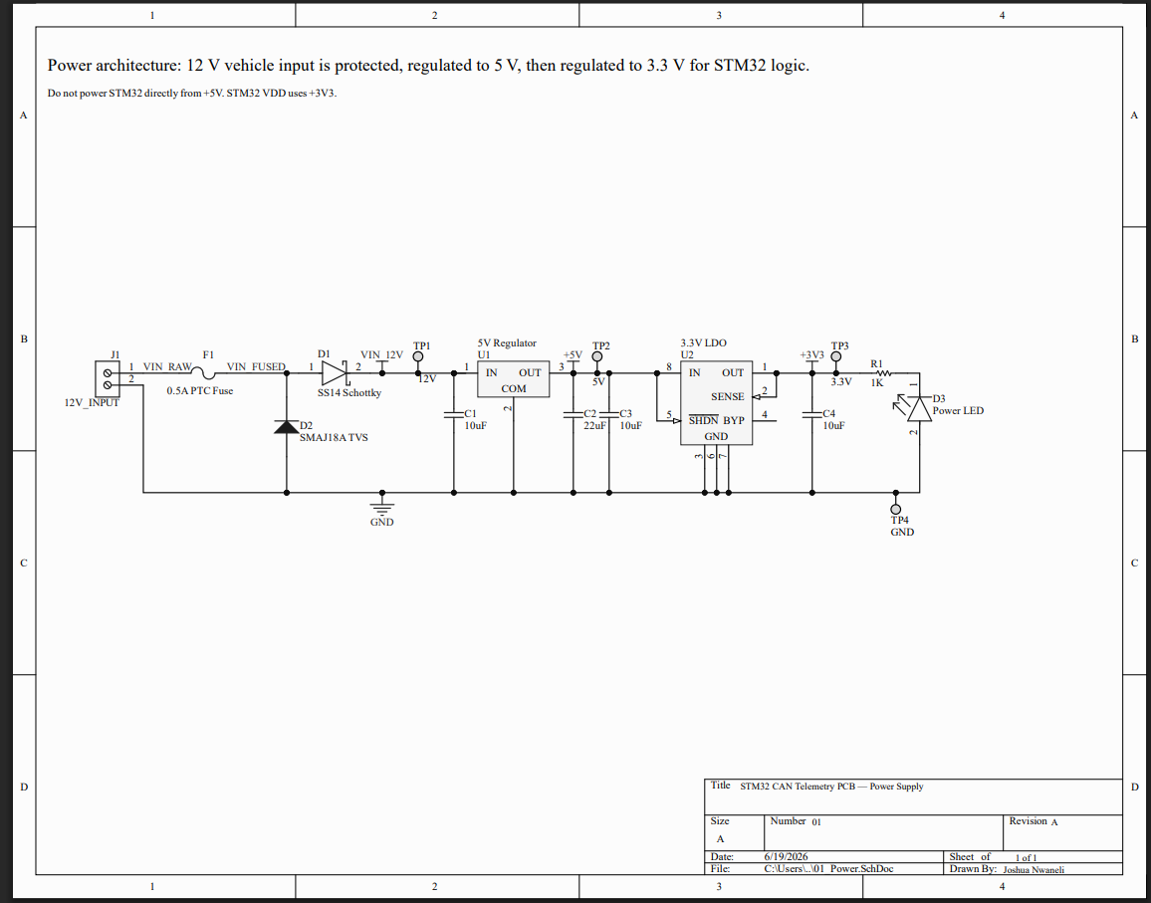
Figure 2: Power Architecture Schematic

5. STM32 Microcontroller Section
The central controller is the STM32F103C8T6, an ARM Cortex-M3 device in a 48-pin LQFP package with 64 KB Flash and 20 KB SRAM. The STM32 symbol is divided into U3A and U3B sections, with U3A showing the I/O pins and U3B showing the power pins. The MCU is powered entirely from the +3.3 V rail.
Multiple 0.1 µF ceramic decoupling capacitors (C5–C8) are placed directly at each VDD pin, and a 10 µF bulk capacitor (C9) supports the local power area. An external 8 MHz crystal oscillator (Y1) with 27 pF load capacitors (C11, C12) provides the clock source, improving frequency accuracy and CAN bit-timing stability over the internal RC oscillator.
The reset circuit uses a pull-up resistor on NRST, a decoupling capacitor, and a normally-open pushbutton (SW1) that pulls NRST low when pressed. BOOT0 is pulled down through a resistor for normal flash boot operation, with a 2-pin header (JP1) that allows BOOT0 to be pulled high to enter the STM32 system bootloader. Net labels on the MCU schematic connect each peripheral signal to its respective sub-schematic: CAN_TX and CAN_RX to the CAN sheet, ADC_IN0–ADC_IN3 and FREQ_TIMER_IN to the sensor sheet, and LED_STATUS, LED_CAN, LED_ERROR, USER_BUTTON, SWDIO, SWCLK, and NRST to the debug/SWD sheet.

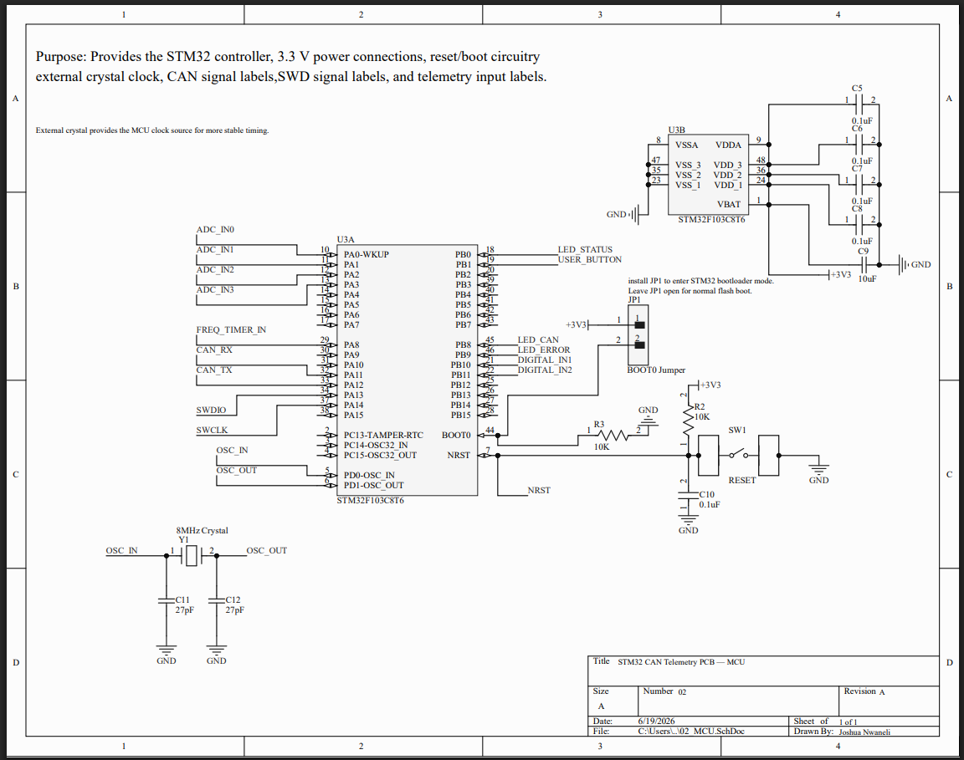
Figure 3: STM32 MCU Schematic

6. CAN Interface
The CAN interface schematic (Figure 4) converts STM32 logic-level CAN_TX/CAN_RX signals into differential CANH/CANL bus signals as required by ISO 11898. A 3.3 V CAN transceiver (U4) interfaces the STM32 to the differential bus. CANH and CANL connect externally through J2, a 4-pin CAN bus connector that also carries GND and VIN_12V. A CAN TVS diode (D4) is placed across CANH and CANL near the connector to clamp transient events before they reach the transceiver. Test points TP5–TP7 provide probe access to CANH, CANL, and GND during bus bring-up.
An optional 120 Ω termination resistor (R4) can be enabled by installing jumper JP2. A schematic note specifies that R4 should only be installed when the board is at the physical end of the CAN bus. The planned bitrate is 500 kbps with a 100 ms transmit interval.

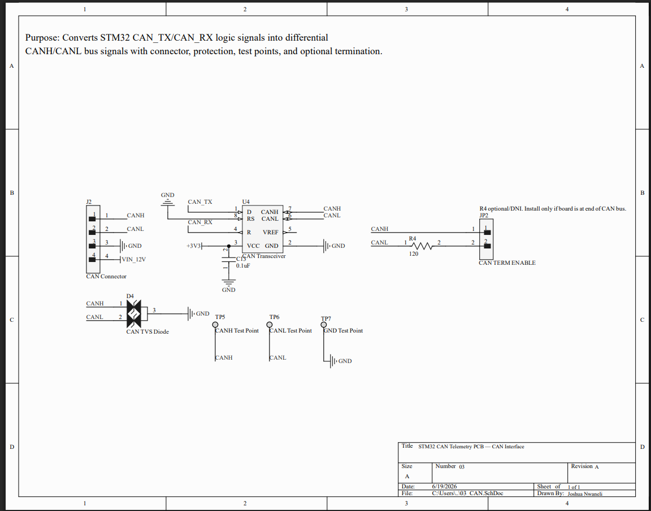
Figure 4: CAN Interface Schematic

Table 1: CAN Message Map (ID 0x100 · 500 kbps · 100 ms period)
CAN ID | DLC | Bytes | Signal | Description
0x100 | 8 | Byte 0–1 | AIN1_RAW | Raw ADC value from AIN1
0x100 | 8 | Byte 2–3 | AIN2_RAW | Raw ADC value from AIN2
0x100 | 8 | Byte 4–5 | AIN3_RAW | Raw ADC value from AIN3
0x100 | 8 | Byte 6–7 | AIN4_RAW | Raw ADC value from AIN4

7. Sensor Input Circuits
The sensor input schematic (Figure 5) covers all signal conditioning between the external sensor connector J3 and the STM32 ADC and GPIO pins. J3 is a multi-pin sensor header carrying +5 V, +3.3 V, GND, four analog inputs, two digital inputs, and one frequency/wheel-speed input.
Each of the four analog inputs (AIN1–AIN4) uses a 10 kΩ/20 kΩ resistor divider designed to scale a 0–5 V sensor range down to 0–3.3 V for the STM32 12-bit ADC, with a 100 nF filter capacitor at the ADC input. The two digital inputs (DIN1, DIN2) each use a 1 kΩ series resistor and a 10 kΩ pull-down. The frequency input (FREQ_IN) uses the same 1 kΩ/10 kΩ network with an additional 1 nF capacitor to filter noise while preserving the pulse edge for timer capture. Table 2 summarizes signal routing and circuit configuration for all seven inputs.

Table 2: Sensor Input Signal Map
Signal | Connector Net | MCU Net | Circuit | Notes
AIN1 | AIN1 | ADC_IN0 | 10 kΩ/20 kΩ divider + 100 nF | Scales 0–5 V to 0–3.3 V
AIN2 | AIN2 | ADC_IN1 | 10 kΩ/20 kΩ divider + 100 nF | Scales 0–5 V to 0–3.3 V
AIN3 | AIN3 | ADC_IN2 | 10 kΩ/20 kΩ divider + 100 nF | Scales 0–5 V to 0–3.3 V
AIN4 | AIN4 | ADC_IN3 | 10 kΩ/20 kΩ divider + 100 nF | Scales 0–5 V to 0–3.3 V
DIN1 | DIN1 | DIGITAL_IN1 | 1 kΩ series + 10 kΩ pull-down | Logic level input
DIN2 | DIN2 | DIGITAL_IN2 | 1 kΩ series + 10 kΩ pull-down | Logic level input
FREQ | FREQ_IN | FREQ_TIMER_IN | 1 kΩ + 10 kΩ pull-down + 1 nF | Timer capture, wheel speed

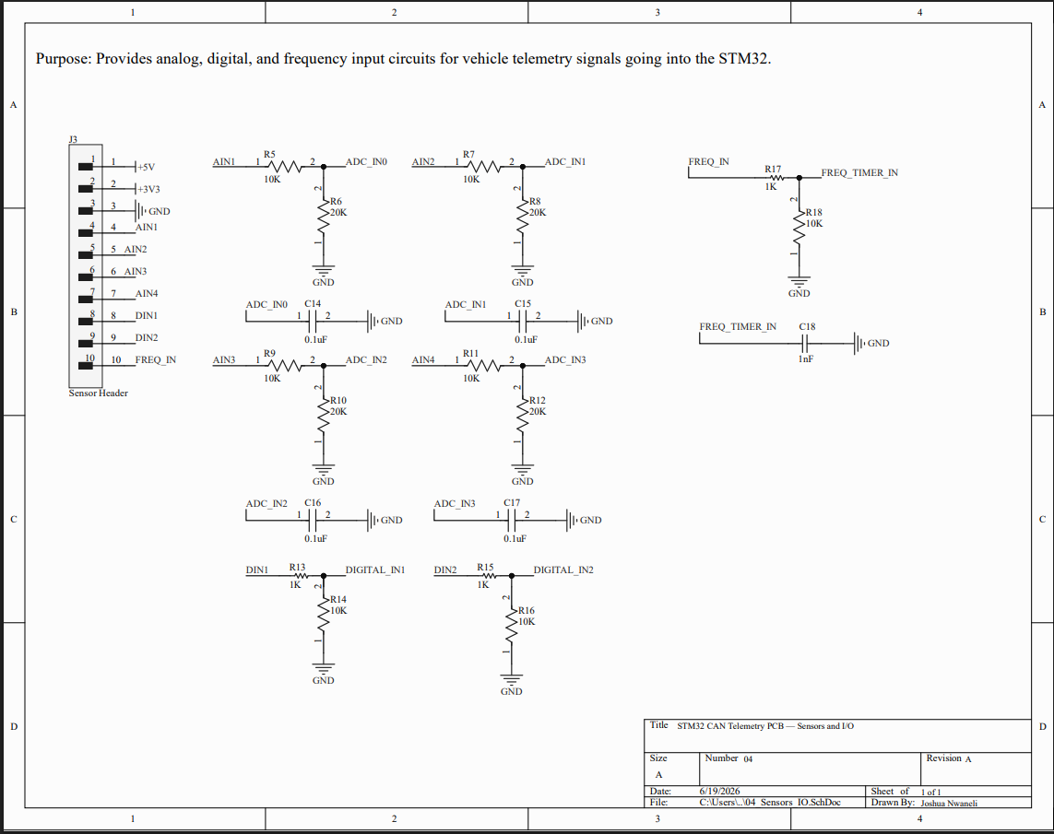
Figure 5: Sensor/Input Schematic

8. Debug and Programming Interface
The debug schematic (Figure 6) consolidates board bring-up features onto a single sheet. J4 is a 5-pin SWD programming header that exposes +3.3 V, SWDIO, SWCLK, NRST, and GND, allowing a standard ST-Link programmer to be connected for firmware flashing and debugging. Test points TP8–TP11 provide probe access to SWDIO, SWCLK, NRST, and USER_BUTTON without needing to probe the connector pins directly.
Three status LEDs indicate runtime state: D5 (LED_STATUS) reflects general firmware activity, D6 (LED_CAN) indicates CAN bus transmission, and D7 (LED_ERROR) signals fault conditions. Each LED is driven through a 1 kΩ current-limiting resistor from an STM32 GPIO pin. A user pushbutton (SW2) connected to USER_BUTTON with a pull-down resistor provides firmware-controlled input for testing.

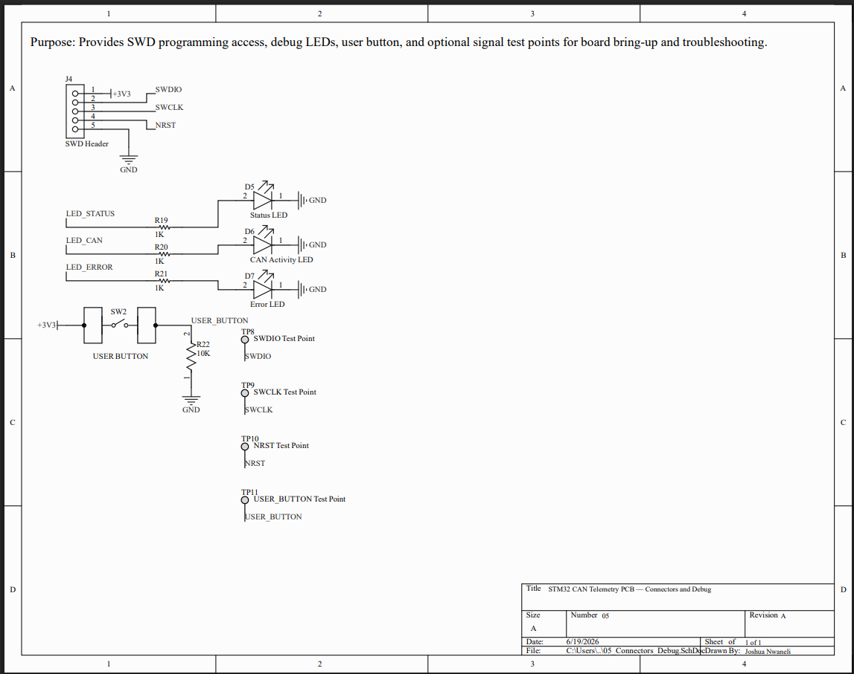
Figure 6: Debug and SWD Schematic

9. PCB Layout Decisions
The final PCB measures 90 mm × 67 mm, routed entirely in Altium Designer. Mounting holes near the four corners allow the board to be secured in an enclosure or chassis bracket. Ground pours on both copper layers reduce return path impedance and simplify GND connectivity across the board.
An early placement iteration positioned the STM32 near the left edge, close to the CAN connector. Pin escape routing from the LQFP-48 package proved difficult given the simultaneous demands of CAN, ADC, crystal, SWD, and power traces. Moving the MCU to the board center resulted in cleaner routing to each subsystem. The final zone arrangement is:
- Power (J1, F1, D1, D2, U1, U2, D3) — lower-left, keeping the switching regulator away from ADC traces.
- STM32 (U3, Y1, reset and boot circuitry, decoupling) — board center.
- CAN interface (U4, J2, D4, JP2, CAN test points) — left side, adjacent to the CAN connector.
- Sensor inputs (J3, divider and filter networks R5–R18, C14–C18) — right side.
- SWD and debug (J4, LEDs, SW2, debug test points) — top edge, accessible from the board perimeter.

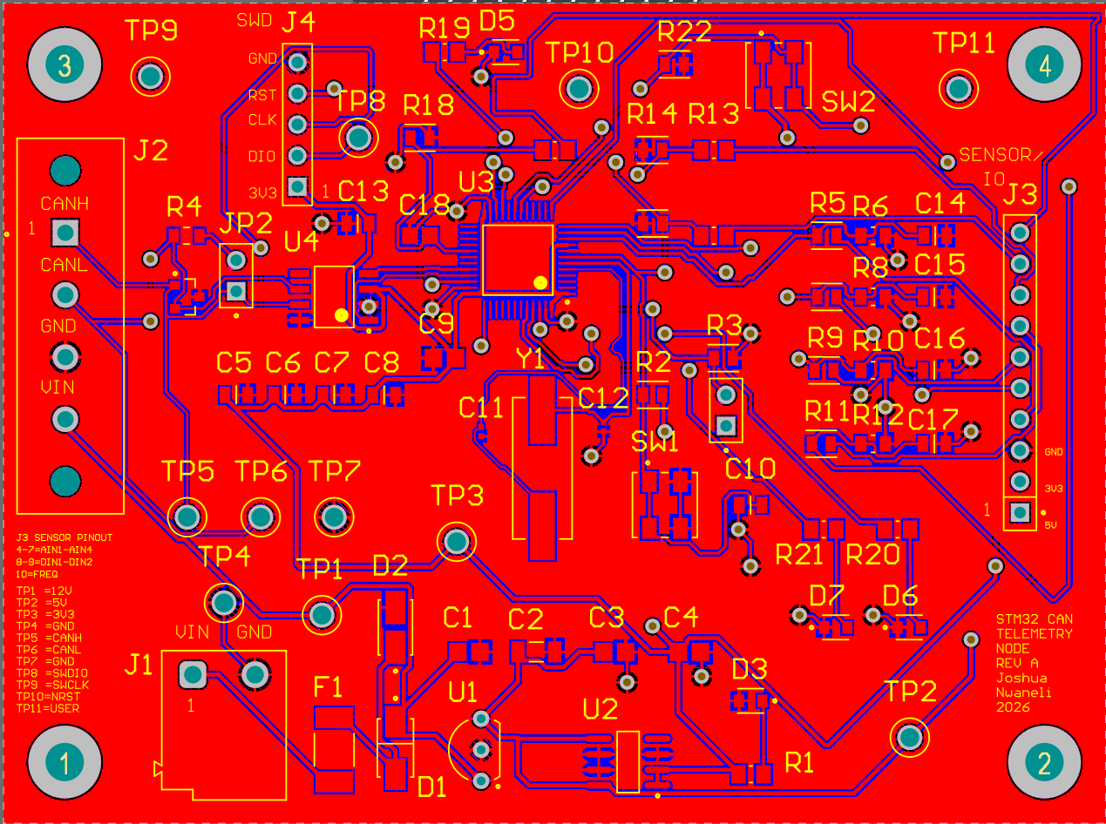
Figure 7: Final PCB Top View

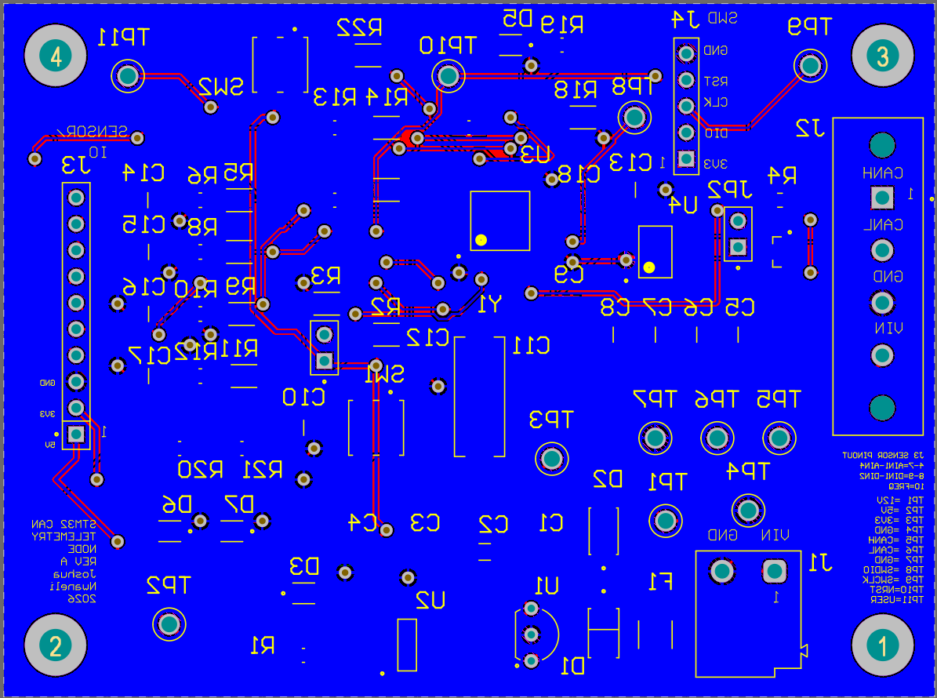
Figure 8: Final PCB Bottom View

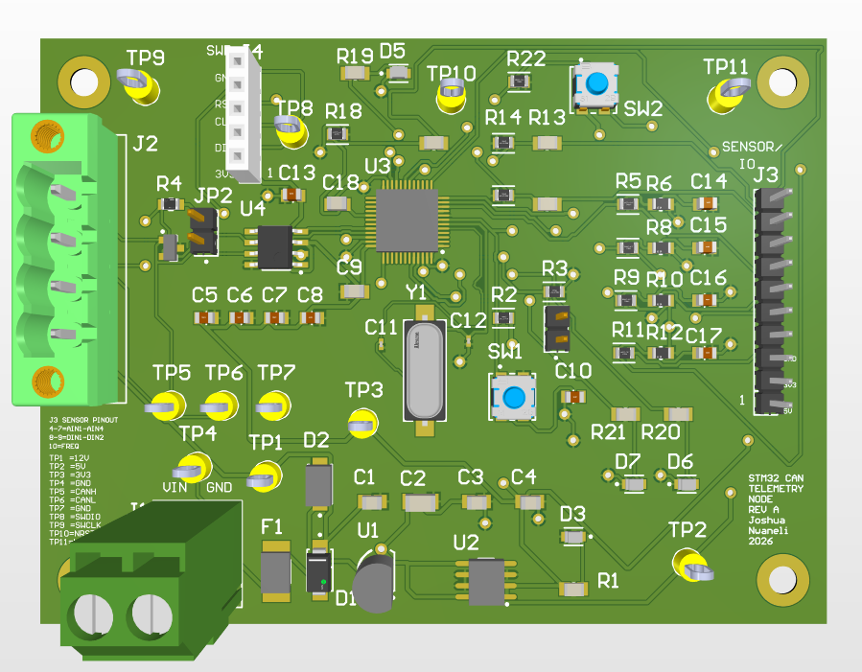
Figure 9: 3D Top Render

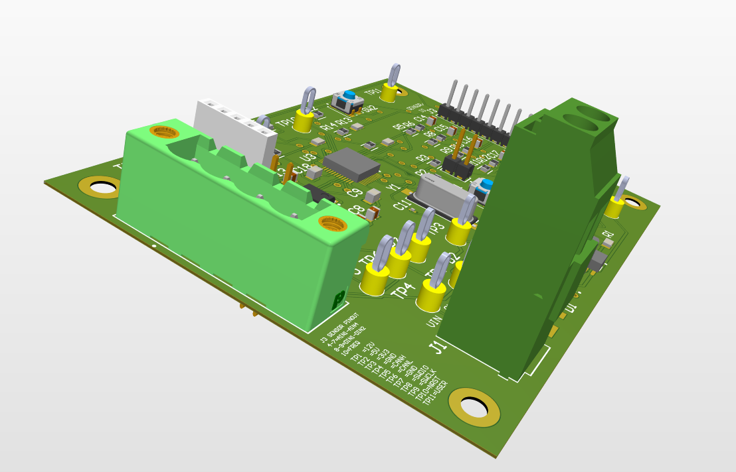
Figure 10: 3D Angled Render

10. Design Rule Check
Before generating manufacturing outputs, the design was run through the Altium DRC engine. The rule set covers clearance constraints, short-circuit detection, unrouted net detection, trace width rules, hole size and hole-to-hole clearance, solder mask sliver checks, net antenna checks, and height constraints. The PCB passed with 0 warnings, 0 rule violations, and 0 unrouted nets across all checked categories. Figure 11 shows the full DRC report.

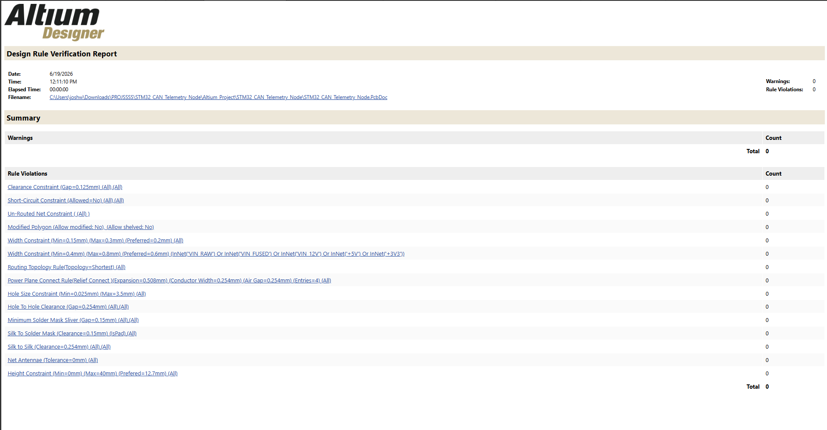
Figure 11: DRC Report Showing 0 Rule Violations

11. Manufacturing Outputs
After the DRC passed, the following output files were generated and organized in the project output folder (Figure 12):
- Schematic PDF — complete multi-sheet schematic export (STM32_CAN_Telemetry_Node_Schematic.PDF).
- Gerber files — copper layers, silkscreen, solder mask, and board outline.
- NC Drill files — drill data for all through-hole and via passes.
- Bill of Materials — component list with designators, values, and footprints (STM32_CAN_Telemetry_Node_BOM.xlsx). Some manufacturer part numbers may be refined before fabrication.
- Pick-and-place file — centroid data for all SMD components.
- PCB 2D images — top and bottom layer exports for visual reference and fabrication verification.
- 3D renders — Altium model screenshots showing component placement and board form factor.
- DRC report — saved as a reference confirming the design passed all rule checks before output generation.

This package is intended to be sufficient for PCB fabrication, pending final part number verification on any components with placeholder references.

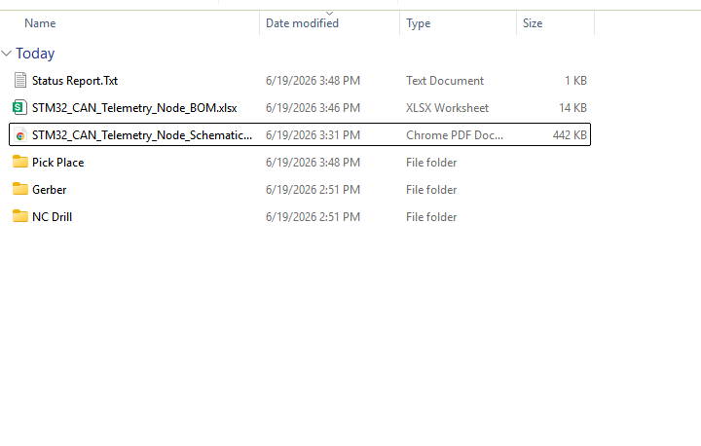
Figure 12: Manufacturing Outputs Folder

12. Bring-Up Test Plan Summary
The following bring-up sequence is planned for when the Rev A board is assembled. Steps are ordered to isolate issues at each power and logic stage before proceeding.
- Visual inspection — check for solder bridges, missing components, and correct part orientation before applying power.
- Continuity check — verify that the VIN, +5 V, and +3.3 V rails are not shorted to GND.
- Current-limited power-up — apply 12 V from a bench supply with a current limit; confirm stable draw and no overheating.
- Test point measurements — probe TP1–TP4 to confirm VIN_12V, +5 V, and +3.3 V are within expected ranges.
- Power LED check — confirm the power indicator LED illuminates when the +3.3 V rail is active.
- ST-Link connection — connect an ST-Link programmer to J4 and verify the STM32 is detectable in STM32CubeProgrammer.
- LED blink firmware — flash a GPIO toggle program to blink LED_STATUS, confirming crystal oscillation, SWD, and flash programming.
- ADC input test — apply known voltages to AIN1–AIN4 and read back ADC counts via SWD to verify resistor divider scaling.
- CAN transmission test — connect a CAN analyzer to J2 and run firmware that transmits ID 0x100 at 500 kbps; verify the frame and payload.
- LED activity check — confirm LED_CAN toggles on each CAN transmission and LED_ERROR remains off under normal operation.

13. Future Rev B Improvements
Rev A is intended as a layout validation and design proof. The following improvements are planned for Rev B based on design review and anticipated bring-up findings:
- Complete physical assembly and full validation of all Rev A circuits.
- Firmware development: ADC sampling, CAN frame encoding at ID 0x100, and 100 ms transmit scheduling.
- CAN analyzer testing to verify bit timing, frame structure, and message content.
- More compact PCB layout after Rev A component placement is validated.
- Improved automotive-grade protection on the analog and digital input lines.
- USB-C connector for firmware programming and debug as an alternative to the SWD header.
- Optional SD card for local data logging during vehicle testing.
- Enclosure or mounting bracket design for in-vehicle installation.
- Optional second CAN channel for expanded network connectivity.
- Final manufacturer part number selection and footprint verification for any components with placeholder references.

14. Conclusion
The STM32 CAN Telemetry Node Rev A is a complete hardware design covering schematic capture, power architecture, STM32 support circuitry, CAN interface design, sensor input conditioning, PCB routing, DRC verification, and manufacturing output preparation. The design was developed end-to-end in Altium Designer, from a system block diagram through to a manufacturing output package ready for review before fabrication.
The schematic is organized across six sheets, each handling a distinct subsystem. The power section uses a two-stage regulation chain with input protection for a 12 V vehicle environment. The STM32 section includes all required support components: decoupling capacitors, external crystal oscillator, and reset and boot circuitry. The CAN interface uses a 3.3 V transceiver with bus protection and optional end-of-line termination. The sensor front-end conditions seven input signals for the STM32 ADC, GPIO, and timer peripherals. Debug infrastructure — status LEDs, test points, SWD header, and user button — was included to support bring-up without requiring additional external hardware.
The PCB passed Altium DRC with 0 warnings, 0 rule violations, and 0 unrouted nets, and the full manufacturing output package has been generated. Physical assembly and firmware bring-up are planned as the next steps. This project demonstrates proficiency in schematic design, PCB layout, power architecture, embedded microcontroller support circuitry, CAN interface design, sensor signal conditioning, routing, DRC cleanup, and manufacturing output preparation.

Appendix A: PCB Section Close-Ups
The following close-up views show individual functional zones of the PCB top copper layer for reference during bring-up and assembly review.

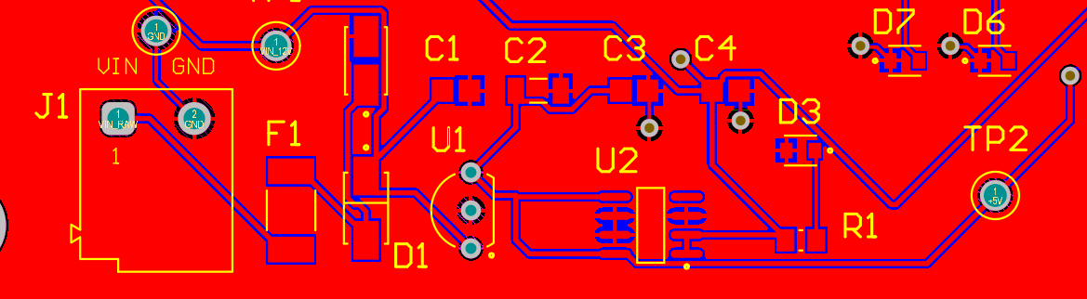
Figure 13: Power Section PCB Close-Up

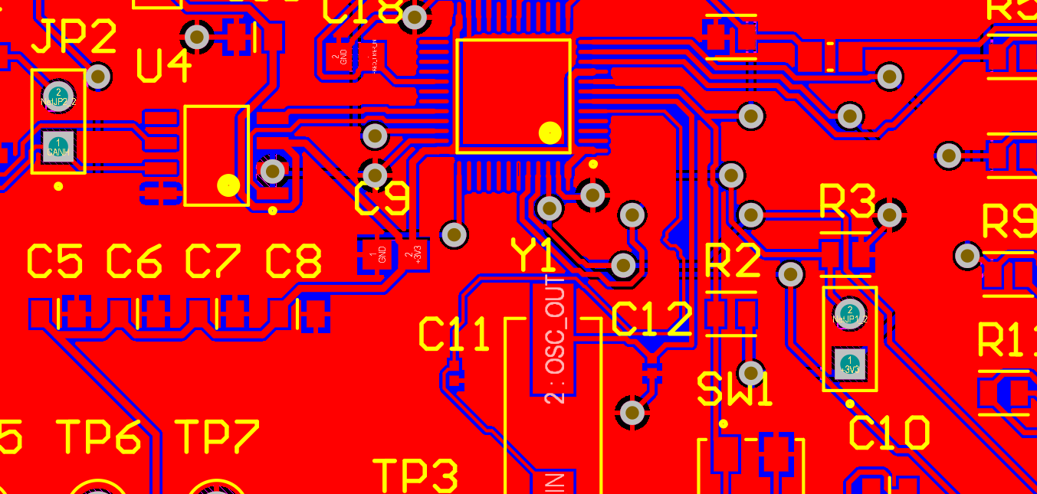
Figure 14: STM32 MCU Section PCB Close-Up

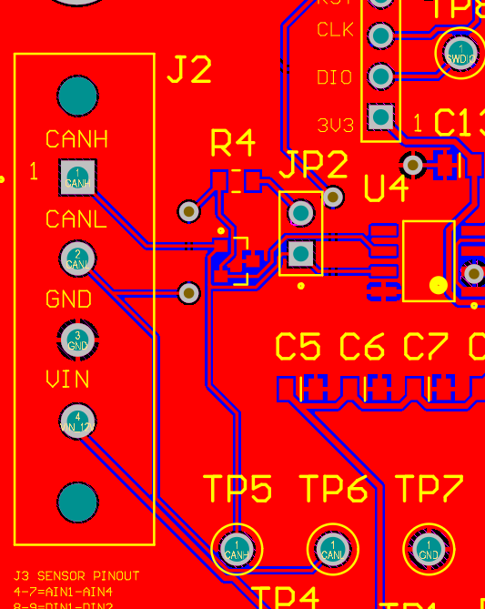
Figure 15: CAN Section PCB Close-Up

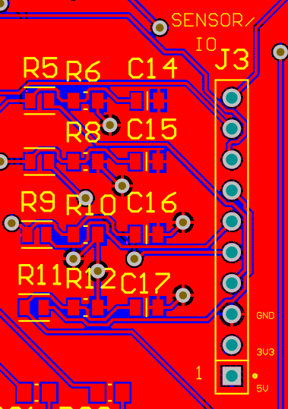
Figure 16: Sensor Input Section PCB Close-Up

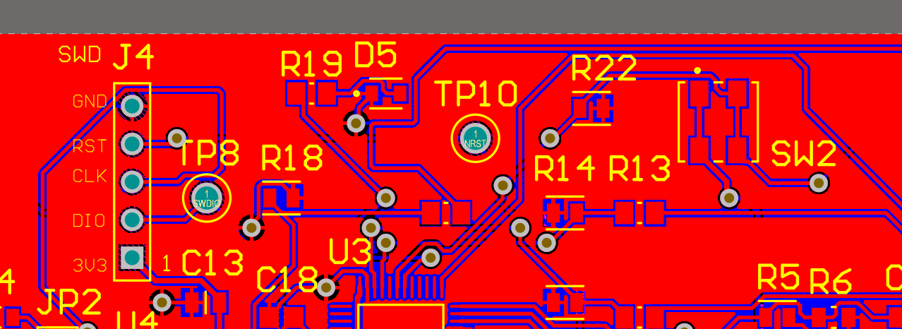
Figure 17: Debug and SWD Section PCB Close-Up

