Bilkent University

Department of Computer Engineering

**CS353 Term Project**

*Student Registration System*

Project Proposal – Group 29

Doğukan KÖSE, 21602375

Musab OKŞAŞ, 21602984

Serkan DELİL, 21501289

Mustafa Çağrı GÜNGÖR 21602251

**Contents**

1. Introduction 3

2. Description 3

3. Why and How Database Is Going to Be Used 4

4. Functional Requirements 4

4.1. Students 4

4.2. Instructors 5

4.3. Teaching Assistants 5

5. Non-Functional Requirements 5

5.1 Authentication & Security 5

5.2 Usability 6

5.3 Scalability 6

5.4 Response Time 6

5.5 Availability 6

5.6 Accessibility 6

5.7 Capacity 6

5.8 Data Integrity 6

5.9 Extensibility 6

5.10 Maintainability 7

5.11 Portability 7

6. Limitations 7

7. E/R Diagram 8

8. Link 9

References 9

## 1. Introduction

This report is a proposal of our project for a Student Academic Information Registration System similar to the STARS system utilized by Bilkent University. In this report, the purpose, basic functionality and scale of the project will be discussed in the description part. It continues with the questions of why we need a database and how we can use a database as part of the Student Academic Information Registration System. Requirements part includes functional and nonfunctional requirements. Functional requirements are important in order to define the functionalities, scope and characteristics of the project. The functional requirements are explained by analyzing user ends, their permissions and the capabilities of the system. In non-requirements, we have provided the system with authentication and security, usability, scalability, response time, etc. In the pseudo-portion, we listed the technologies that we would be using as part of the project. In the limitations part, the boundaries and constraints of the system are provided. At the end of the report, the E/R diagram that shows the basis of our database design is provided.

## 2. Description

The proposed program is a Student Academic Information Registration System that allows instructors, teaching assistants (TA) and students to access course-related queries. The system will provide instructors with a platform for offering courses, defining requirements for courses and grading for assessments. TA's will grade labs, projects, and homework assignments. Students will be able to track the performance and attendance of their course, enroll and withdraw courses and submit their assignments.

Users will initially sign up to register themselves for an account. The system users will have three separate accounts i.e. instructors, TAs and students. User-made accounts will be registered using email addresses and passwords, each giving a unique identification.

In a single semester, instructors will select a list of courses they will be offering and will choose the sections of these courses to allocate the schedule of lectures. They will then create syllabuses for each course and publish in this system. Throughout the semester, instructors will update the exam grades, attendances for each student, enter assignments and announcements to the system for each course, give tasks for TA’s and prepare their personal information.

The teaching assistants would be assigned the job of grading a project, lab work and homework assignments for students. They will join these grades in the program during the semester. The TA's will also show their weekly office hours for students to visit them, and ask questions in person, or students may also ask questions via the given email address.

Finally, the students will use this system to show their course performance which includes the grades they receive for each component of the course grading and will also report their attendance results. Before the start of the semester, students will be eligible to enroll for courses and to withdraw from a specific course until the deadline to be determined later by instructors. Students may also submit their assignments to the TA for evaluation. Students may apply to another university for a student exchange program.

While our system does not accurately represent the university structures, it will essentially reminisce how it looks like a university database system.

## 3. Why and How Database Is Going to Be Used

The Student Academic Data Registration System must contain huge amounts of data, as it includes all data about classes, students, teachers and teaching assistants. In addition, the system must keep the grading of exams, quizzes, assignments and homeworks etc. Students will be able to learn their results in each semester; thus, the data must be properly modified. Our database will also support us to reduce redundancy with data by deleting duplicate data. Database is also a more secure means of storing data. Data can be lost because of system failure or crash. That is why, a database management system provides a backup and recovery mechanism for saving data until the user removes it from the system himself. So, handling all of the above issues without an integrated database system could be quite problematic. Therefore, in our project, we use databases to acquire a faster and more easily controlled program.

We will use the database to manage all data in the Student Academic Information Registration System. Then we will display the information according to user action by means of queries. When a new course is added and deleted, new students are registered, transcripts are ordered etc., our system will be updated by generating new data entries or updating the existing ones.

## 4. Functional Requirements

### 4.1. Students

* Students can use the service via registered student-id and password.
* Students can see the list of currently offered courses.
* Students can see the syllabuses of courses.
* Students can see the offered sections of courses.
* Students can register for course sections.
* Students can see other students registered to the courses they are registered for.
* Students can see their grades for current and earlier semesters.
* Students can see their attendance for current and earlier semesters.
* Students can see their own personal information.
* Students can request change for their personal information.
* Students can see their up-to-date transcript.
* Students can see their current schedule.
* Students can see their curriculum.
* Students can apply for an exchange program.
* Students can see their CGPA and GPAs for earlier semesters.
* Students can use GPA calculator for the end of the current semester.
* Students can apply to get a sticker. If they pass the driving test, they can sign up their cars under the sticker they get.

### 4.2. Instructors

* Instructors can use the service via registered instructor-id and password.
* Instructors can see the sections of courses they are assigned to teach.
* Instructors can update the syllabuses of courses.
* Instructors can see the registered students of the sections of courses they teach.
* Instructors can see the registered teaching assistants of the sections of courses they teach.
* Instructors can give grades to the students.
* Instructors can update the attendance of the students.
* Instructors can give tasks to teaching assistants.
* Instructors can request change for their personal information.
* Instructors can select sections.
* Instructors can apply to get a sticker. If they pass the driving test, they can sign up their cars under the sticker they get.

### 4.3. Teaching Assistants

* Teaching assistants can use the service via registered ta-id and password.
* Teaching assistants can see the sections of courses they are assigned to assists.
* Teaching assistants can see the registered students of the sections of courses they teach.
* Teaching assistants can give grades to the students.
* Teaching assistants can update the attendance of the students.
* Teaching assistants can request change for their personal information.
* Teaching assistants can apply to get a sticker. If they pass the driving test, they can sign up their cars under the sticker they get.

## 5. Non-Functional Requirements

### 5.1 Authentication & Security

In the system, each user such as instructor, student or teaching assistant must have unique Ids and passwords to register to the system. In order to make the system more secure, there will be some security restrictions such as passwords must have both upper and lowercase letters and passwords must be at least 8 characters, etc. Moreover, the system will send an authentication code to the user’s phone, so that the user can register to the system by using the code. Also, according to registered user type, users can access different services in the system.

Our application will be private for users so that one user cannot see other user’s information such as private information, schedule, gpa, etc. This information can only be seen by themselves.

### 5.2 Usability

Users of the system may not be good at using computers; therefore, we are aiming to make a simple user interface so that every user can understand the system and use it easily.

### 5.3 Scalability

The system will be scalable because universities that use our system can decide to increase their number of students or the number of instructors for next year. To handle an increasing number of users of the system, it must be scalable.

### 5.4 Response Time

Response time is an important issue for web-based applications because users can be annoyed with the slow response time. The system’s response time will be less than 1.0 seconds with a normal internet connection (at least 8mbps). We try to make it less than 1.0 second because 1.0 second is about the limit for the user's flow of thought to stay uninterrupted. [1]

### 5.5 Availability

We are aiming to make the system available 7/24 so that users can use the system whenever they want.

### 5.6 Accessibility

The system will be accessible by only members of the university such as students, instructors, and teaching assistants.

### 5.7 Capacity

Since we are trying to make a database system, it should have enough capacity to store information about students, teaching assistants, instructors, etc. For the beginning capacity we aim to have one thousand user capacity. However, it can be expanded in the future.

### 5.8 Data Integrity

Since the project includes a database, it should be consistent and accurate for retrieving and saving data. By maintaining data integrity, we try to prevent the corruption of data. For example, we will not allow you to save phone numbers to the database in the wrong format. Also, we try to back-up data every month so that if there is a data loss, we can fix it.

### 5.9 Extensibility

We want our system should be extensible so that the system can be expanded with new features easily without changing the original source code of the project.

### 5.10 Maintainability

Further implementations should be added considering the current environment of the system.

### 5.11 Portability

Users can use the system with web browsers on their phones, computers, tablets, etc.

## 6. Limitations

* Students can only see the up-to-date syllabuses of courses.
* Students can only register for courses offered to them.
* Students can only register to courses that pre requirement conditions are satisfied.
* Students can only register for courses with available quota.
* Students can only register for courses that don't overlap with other courses they already registered.
* Students must register to a minimum 5 maximum 6 courses unless they are senior students.
* Students can only send 3 personal information requests per semester.
* Only students with more than 2.5 CGPA can apply for exchange programs.
* Only students who are in the 4th or 6th semester can apply for exchange programs.
* Students can only apply up to 3 different schools for exchange programs in one application.
* Students can have a maximum of 2 exchange applications in different semesters.
* Students who are already participating in exchange programs cannot apply for the second time.
* Instructors can only update the syllabuses of courses they are assigned as course coordinator.
* Instructors can only give grades to students in the sections they teach.
* Instructors can only update the attendance of the students in the sections they teach.
* Instructors can only give tasks to teaching assistants under their superiority.
* Teaching assistants can only give grades to students in the sections they assist.
* Teaching assistants can only give grades to students with the authorization of their supervisor instructors.
* Teaching assistants can only update the attendance of the students in the sections they assist.
* Teaching assistants can only update the attendances of the student with the authorization of their supervisor instructors.
* Teaching assistants can only send 3 personal information requests per semester.
* In order to get sticker application of students, instructors, and teaching assistants needs to get confirmed by the university management.
* At most 3 cars can get signed up under one sticker.
* A sticker is valid only one-year period and as long as the driver’s penalty point is under 100 points.

## 7. E/R Diagram

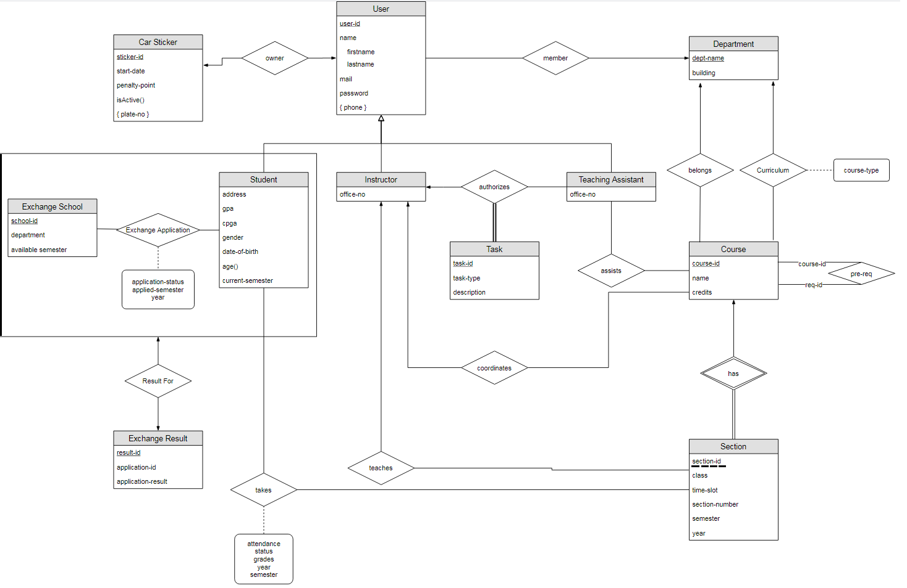

## 8. Link

<https://github.com/mmoksas68/CS-353-Student-Registration-System>

## References

1- <https://www.nngroup.com/articles/response-times-3-important-limits/>