Jo-Ann Beaubrun

CS 499 Computer Science Capstone

Milestone Four – Databases

For this part of the capstone, I will be looking at past work from the databases categories. In computer science, a database is a collection of information that is organized in a way that it can easily and quickly retrieved by a computer. Database is important because it is at the core of virtually every software in use today. Being able to build an effective database also show understanding of hardware, OS, programming language design, data structures and algorithms, and network programming.

The work that I am about to show is from DAD 220- Intro to SQL. The first week of this course the instructor made an announcement saying that this class and SQL will be the “MOST IMPORTANT PROGRAMMING LANGUAGE OF YOUR CAREER”, and as the weeks went by, as I was learning more, I could not have agreed more. Using Codio,I was able to create, update and deleted information from a database. Some concepts were challenging but I did end up loving the course a lot, and of course, I learned a lot.

The first artifacts are from Milestone two where I was instructed to populate a database, and alter a table by adding columns, adding new records, and insert new information on those records.

* Alter the customer table

The first task was to customer table, and added a custom column. I decided to add the DOB column.

I used the ALTER TABLE, and ADD in other to add the colum.

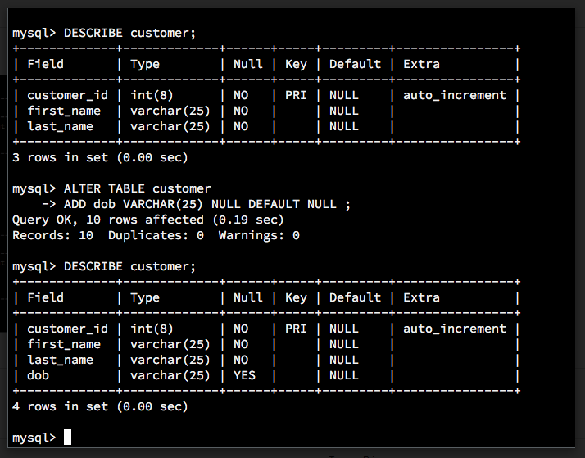

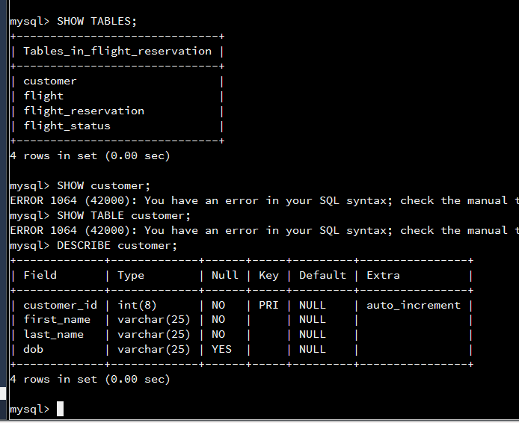

* Update first five record

Update the customer database using the SET and WHERE conditions. I used limit 5 in order to update the first 5 records.

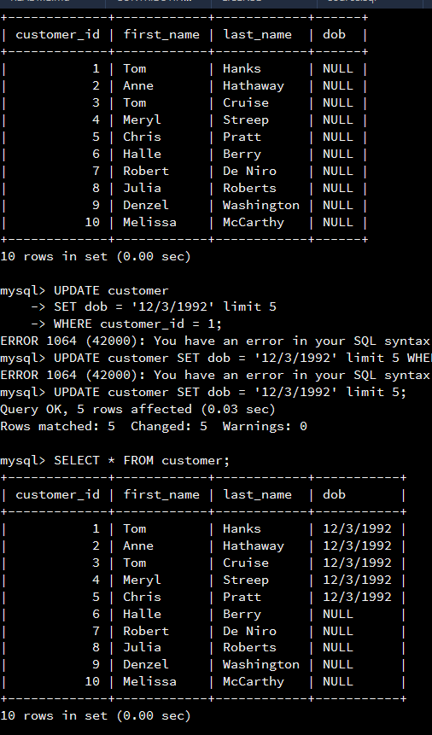

These next artifacts from milestone three from the same class. Here I was instructed to find specific information from an existing database. I needed to find the number of meeting Tom Hanks was attending, where these meeting will take place and how many people meeting in the same building. These skills and concepts are crucial, because any programmer need to be able to look through a large amount of data and retrieve exactly what they are looking for. As a security analyst, I would at some point perform forensic analysis, where I would need to look through all the information from a computer to find the cause of an attack, the point of entry, and how to fix the issue. I could use the skills learned to performed these tasks.

Meeting that Tom Hanks need to attend:

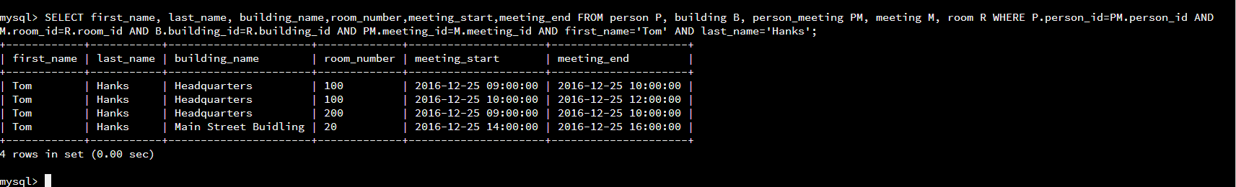

People attending the same meeting

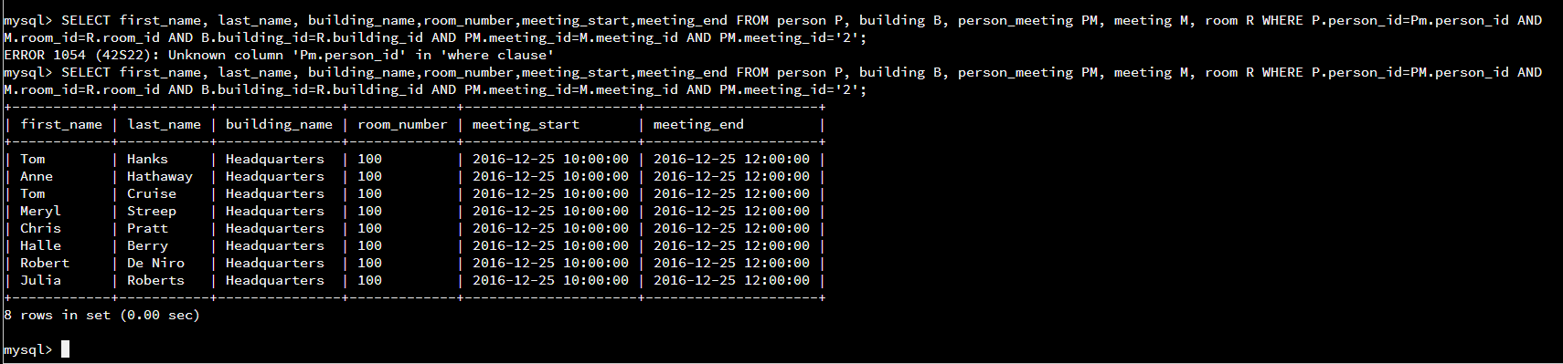

Number of attendee for each meeting :

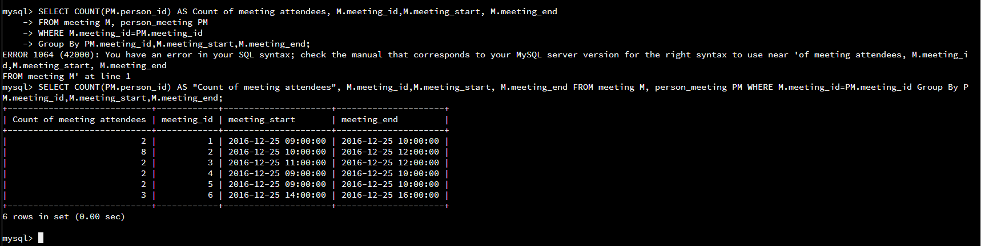

Here, I was getting an empty set when I was trying to find out the number of people who have attended a meeting on a main street building. I was able to learn from my mistake, and improve on the final project. ( Which I am also including in this paper).

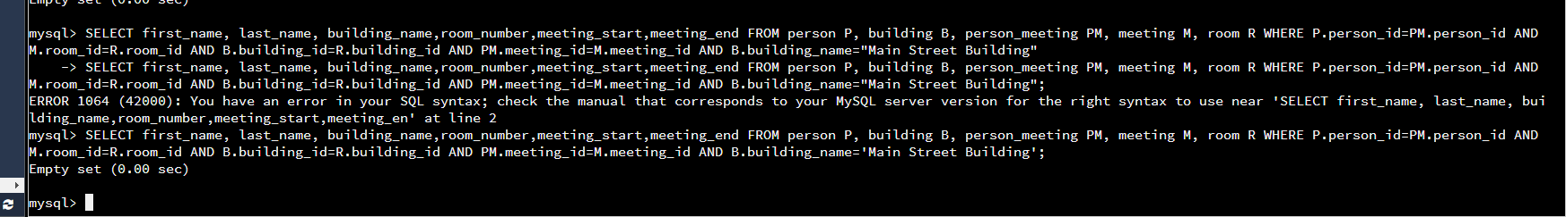

For the final project, I had to put all the different skills into practice. I was given a database that I needed to retrieve information, update, and delete from. First I was able to list all the different databases, use the one I needed and delete date from the record.

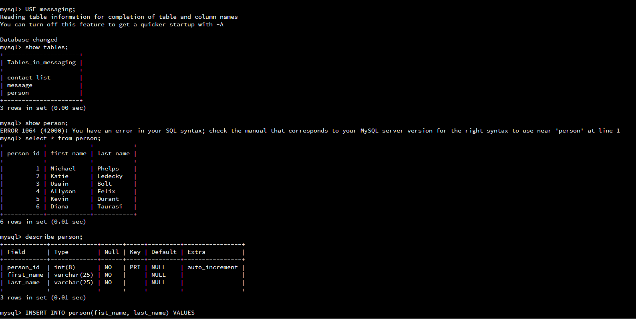

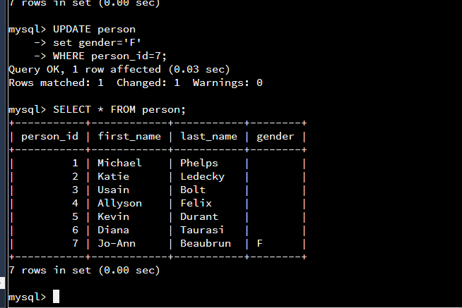

Diana’s record was removed from the record.

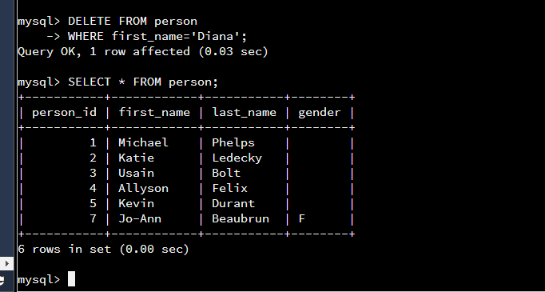

I was also able to insert information to the messaging table

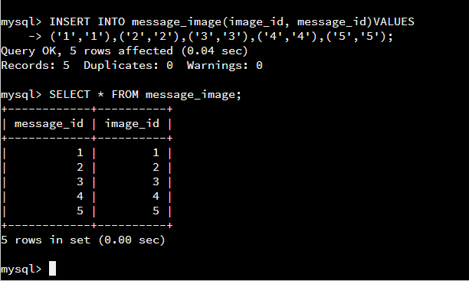

And find all the email sent by a user.

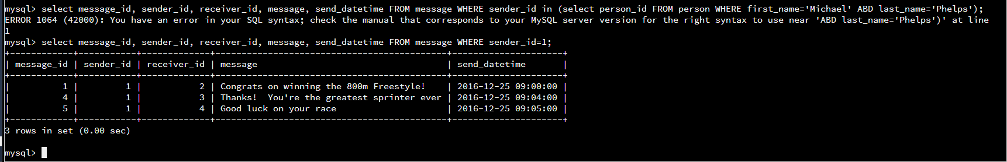

I enjoyed all the lesson learned from this class. I was able to help my department by helping them create and organized their database better. I was also able to have a better understating of other interdisciplinary of computer Science.