Jo-Ann Beaubrun

CS 499- Computer Science Capstone

Milestone Three – Algorithms and Data Structure

Data structure and algorithms refer to a programmatic way of sorting, and manipulating data in a way that can be used efficiently. Big tech companies such as Amazon, Microsoft, Apple etc. expect graduate to have a deep understanding of data structure because it is essential in developing great and functional application. With that being said, there are different components of data structure that I learned during my time here at SNHU. The class that I can look back to bring out some artifacts is: Operating environment.

The operating environment is the area where users run application software. The environment consists of user interface and an application programming interface or API. It is important to understand the role of operating environment in your organization In order to set it up for success. Understanding each OS would help you choose the best applications, the memory that need to be allocated, how each space is used, and what is needed to keep everything secure while running smoothly.

For this part of the capstone, I will include three projects, along with the instructor’s feedbacks on two of them. The last one will be the final project that I submitted for this class that shows my growth, and the implementation of those earlier feedbacks.

The first project was written last year, when I was tasked to choose an OS that I would like to study more. I needed to dive in and do research about it system components, its file system, how it would interact over a network, and how it would support application development. The first screen shot below was just an announcement that I decided to research Mac OS X along with some background history.

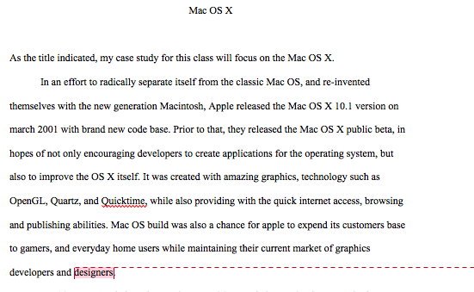

Jumping into Milestone three of the Operating environment class, I submitted another project focusing on distributed system with this first paragraph:

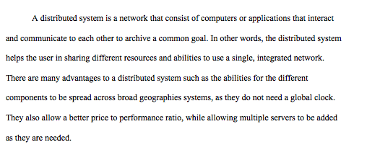

These two were extracted from two different projects that I will include in full as a zip file along with this document. The last piece is from the final project where I included all the details of what make a Mac Operating system from how it allocates its memory in the background, to its user friendliness.

The reason why I chose to focus on this artifacts is to show my understanding of how different operating environment organized and stored their data for better usage. As a Mac user, it made me appreciate the OS a bit more, while also learning of the many thing that I can do with my computer to improve my skills. I thought understanding how OS efficiently managed their data would help me create applications that are effective as well.

I was lucky to find two project that have my instructor’s feedback, along with the final project. That way, you can see where I started, and how my understanding has changed at the end of the course.