Jo-Ann Beaubrun

CS 499 – Computer Science Capstone

3-2 Milestone – Software Design and Engineering

I have worked through and with different projects in different coding languages. The project that I decided to perform a code review on are from a previous class that I have taken a year ago. The first one was part of a collaboration and team project class where we were learning to collectively adding new information to an existing project. The artifact that I chose to include is just a small portion of the project, where we needed to add the songs in a larger playlist. In addition of building my java skills, this project taught me how to work within a group, the best practices of submitting changes to a code, commenting and more. I chose this artifact because I was mostly comfortable writing code in Java at that time, and the project needed improvement. There are too many comments that are not adding value to the project, and I used repetitive code, which can cause a security issue. On the other hand, I learned how to properly set up variables, how to import information from an already existing library, and used the correct naming convention. My improvements would include: removing some comments, re-write comments so that they can explain the line of code, instead of stating the obvious. Looking at past work help me look at my progress objectively, and apply knowledge that I have gained throughout my college career.

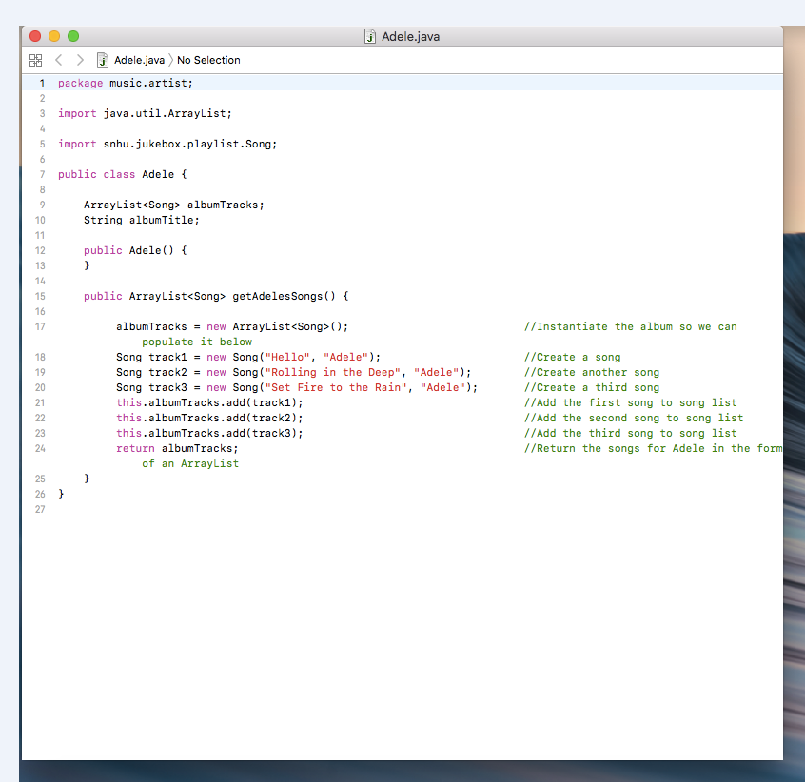

This second artifact is from a different project that I worked on where I was building a simple calculator. Part of the code was provided, and imported, hence the heading. And I had to add component to the code in order to make it properly. This code is visually better than the first one. The comments are adding an explanation to the code, and make it easier to follow the logic. It is also indented properly, and has the correct amount of white space. This code is an improvement of the last artifact in general. It is also written in java because that is my most comfortable language.

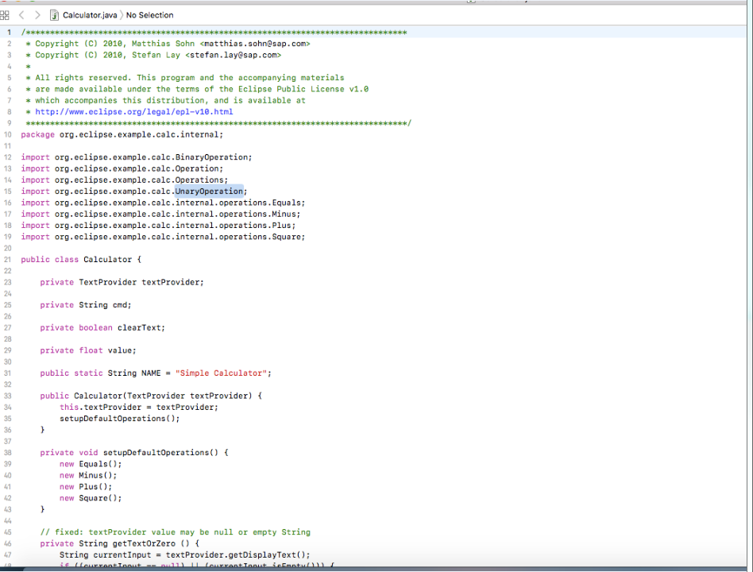

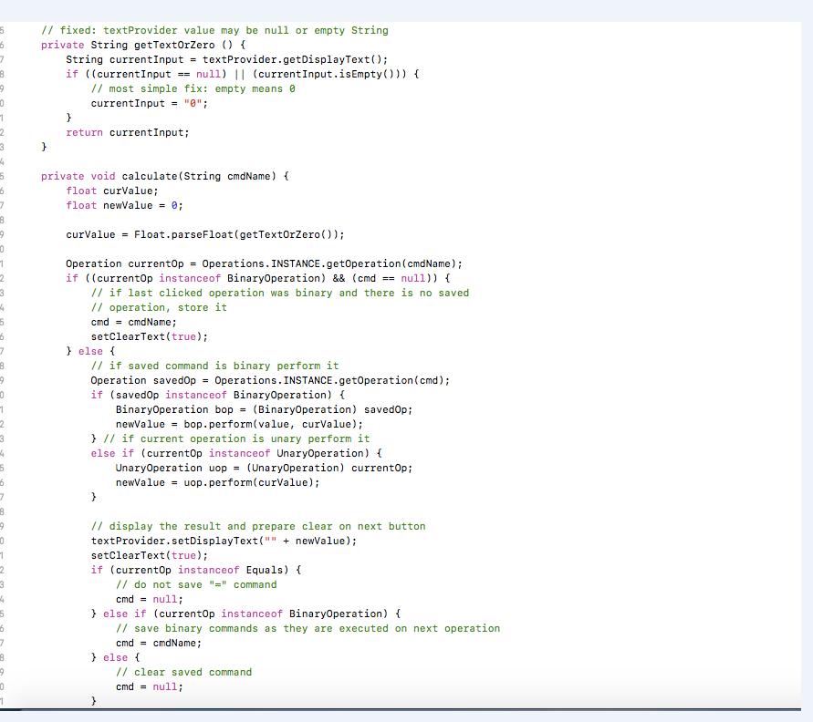

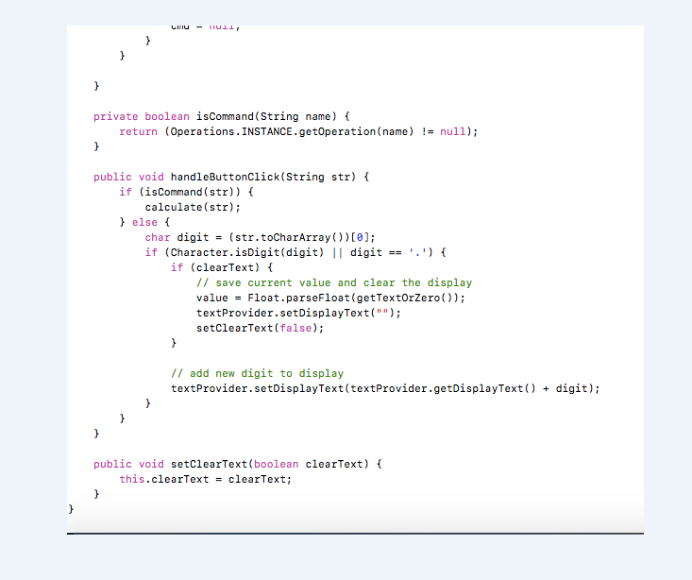

Both of the artifacts submitted were chosen because I believe that it shows growth. I have taken both classes within a few terms of each other. I was able to make the code re-usable without making it repetitive. I got better with the java naming convention, and better with setting up conditions. When writing any programs, I always have trouble figuring out where I made certain errors, and how to fix them Eclipse does a great job at debugging, however it is best to know what is wrong with an issue within tour own program. Learning how to spot errors has been a great challenge for me, but the more I work with the code, getting feedback from my teacher, the better I was able to quickly improve on my short comings.