8xGPU Gen4 7v13 server assembly & first checks
  - Technician guide | Ubuntu 24.04 Server on USB | 10 September 2026
Fit the RAM, connect the front GPU risers, install eight GPUs and verify detection before handing the server on for further testing.
Hardware | Required configuration
Motherboard and CPUs | ASRock ROME2D32GM-2T with two AMD EPYC 7V13 CPUs
GPUs | 8 x RTX 5090, one in every physical GPU position
RAM | 512GB using one homogeneous configuration on page 3
First check pass | BIOS detects 512GB in the correct slots; Ubuntu detects 8 RTX 5090s with all current PCIe widths x16

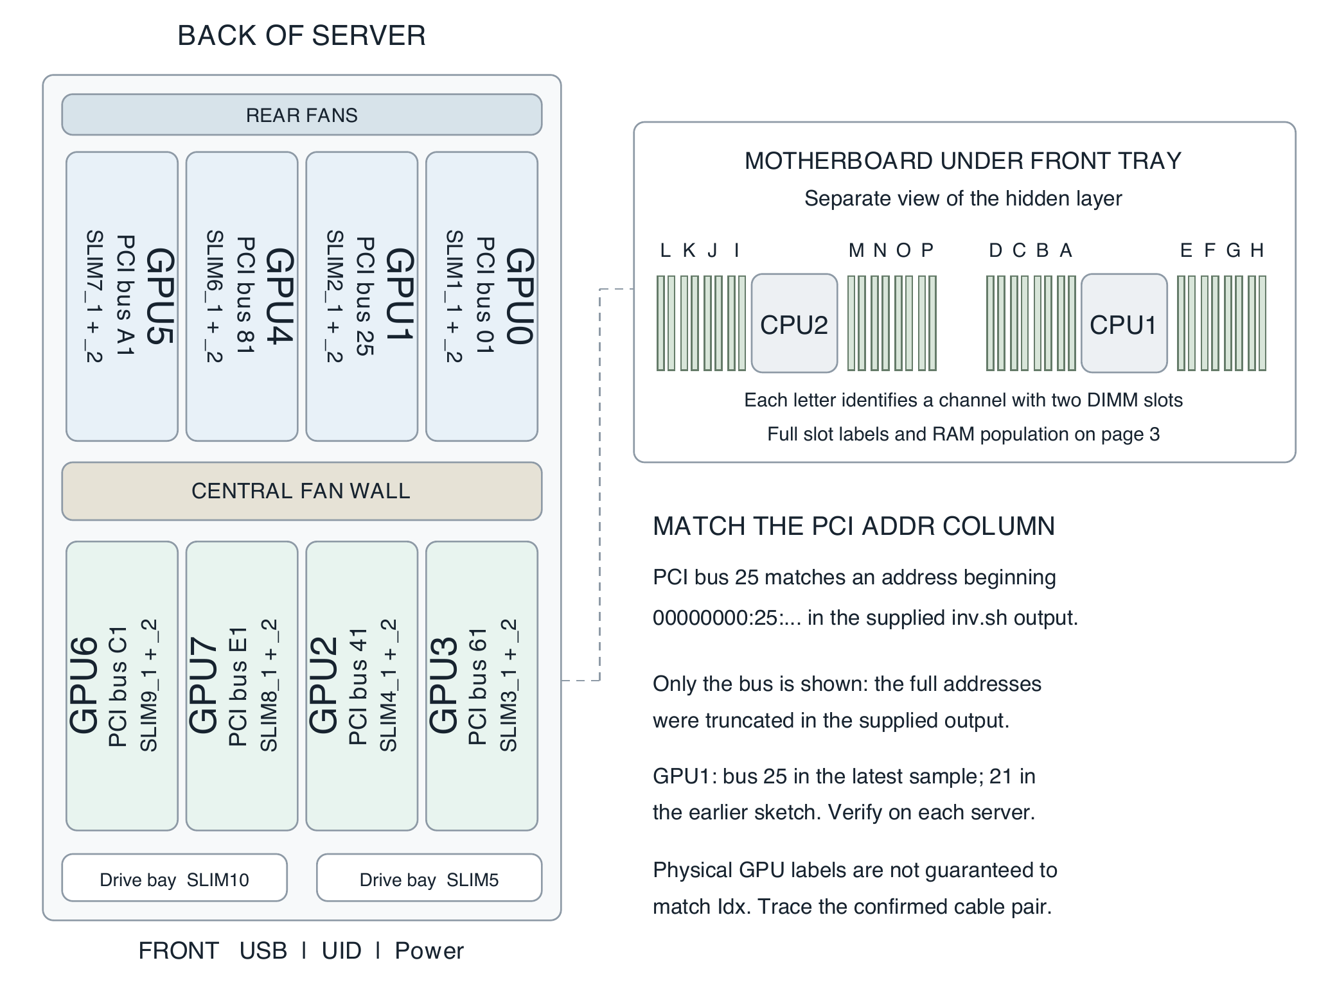
Figure 1 Top view with the front at the bottom. Chassis and card proportions follow the server photo approximately; GPU labels are rotated 90 degrees. PCI buses are reference observations from inv.sh.
Use the guide in order. Assembly: pages 2–6. BIOS and USB checks: pages 7–8. Fault isolation: pages 9–10. Record: page 11. USB preparation: page 12.
These checks establish detection and link width. They do not certify sustained load stability, performance or complete memory integrity.

1 Open the front riser tray
Before touching hardware Shut down the server and disconnect every AC power feed. Wait for fans and standby indicators to stop. Use ESD protection and handle boards and DIMMs by their edges.
Start with CPUs and cooling installed. Riser power and all eight GPU power leads are pre-routed. The four front GPUs are GPU6, GPU7, GPU2 and GPU3. Their data cables must be connected during this assembly.
1. Keep the front tray empty of GPUs. Locate the five marked tray screws on each side of the chassis.
2. Remove five screws from each side, ten in total. Keep them together for refitting. Remove only the marked tray fixings.
3. Support the tray, slide it forward, then lift it upward to expose the RAM. No cable disconnection is required for this movement on this server. Support the tray nearby without pulling, trapping or loading the attached cables.
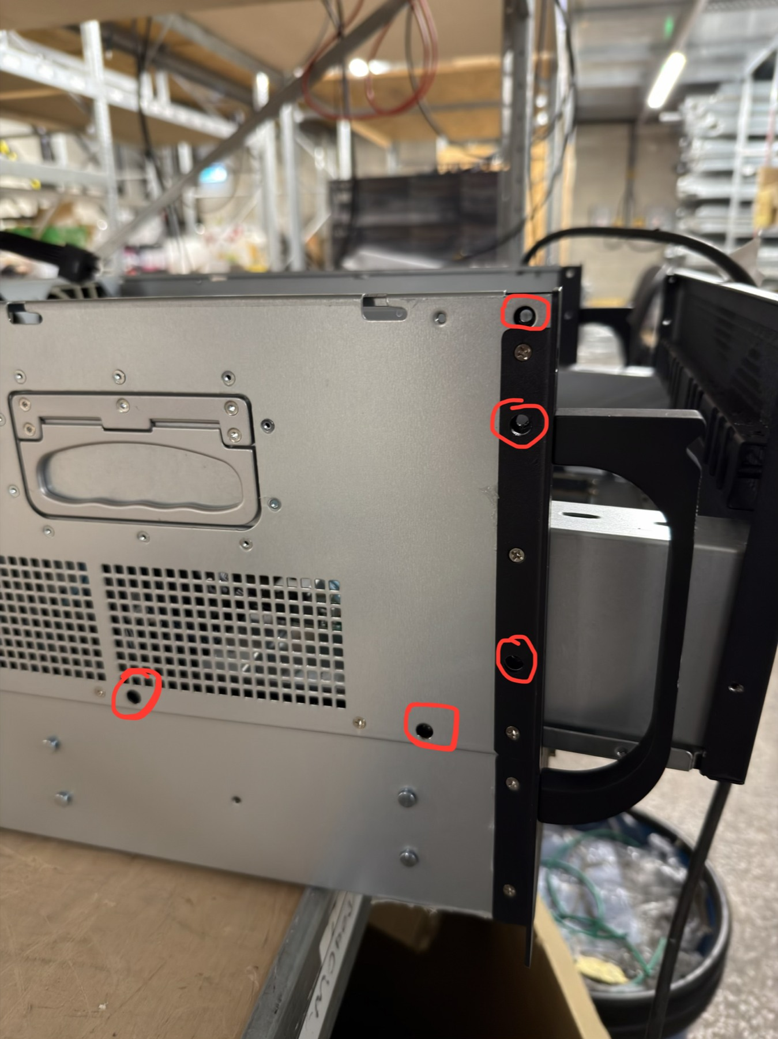
Figure 2 Five tray fixing locations on one side. Remove the matching five on the opposite side as well.
Before fitting RAM Choose one of the three configurations on page 3. Check every module label for capacity and RDIMM or LRDIMM type.

2 Fit the selected RAM configuration
Use one configuration per server. Do not mix capacities or RDIMM and LRDIMM types. Distribute 256GB to each CPU. Read the full motherboard label, including the final 2.
512GB configuration | CPU1 slots | CPU2 slots
16 x 32GB RDIMM | A2 B2 C2 D2  E2 F2 G2 H2 | I2 J2 K2 L2  M2 N2 O2 P2
16 x 32GB LRDIMM | A2 B2 C2 D2  E2 F2 G2 H2 | I2 J2 K2 L2  M2 N2 O2 P2
8 x 64GB LRDIMM | A2 B2 C2 D2 | I2 J2 K2 L2

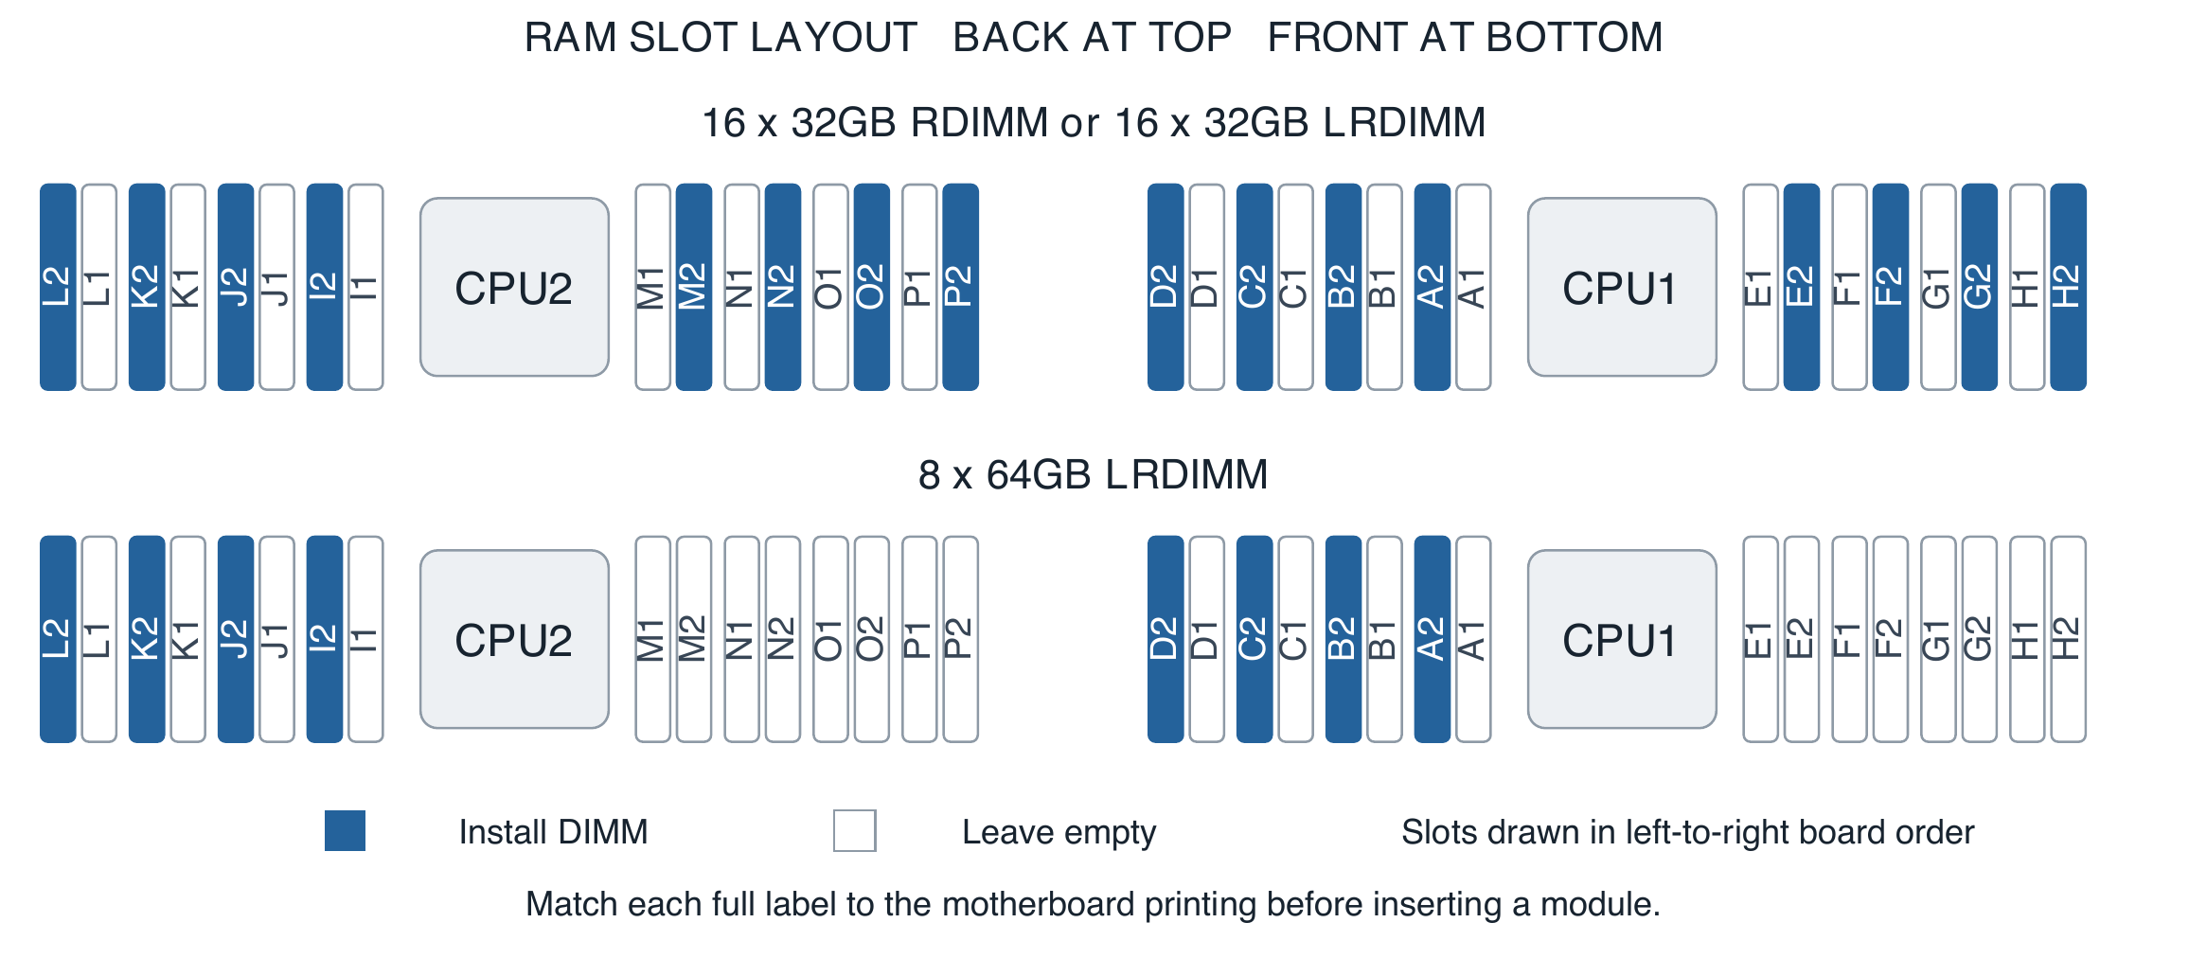
Figure 3 DIMM sockets flank each CPU in physical left-to-right order. Blue slots are populated; white slots remain empty. The upper pattern covers both 32GB kits and the lower pattern covers the 64GB kit.
1. Open the retaining latch or latches on the selected empty slot. Line up the DIMM notch with the key in the socket.
2. Press the module straight down, evenly at both ends, until it is fully seated and the retaining latches engage. Stop and check the orientation if it does not fit; do not force it.
3. Check both ends of each DIMM: the module should sit level, with no end raised and the latches engaged.
4. Count the fitted modules and confirm their labels. Leave all other slots empty: 16 populated slots for either 32GB kit, or 8 populated slots for the 64GB kit.
Population rule These configurations use the slots ending in 2 first. The 64GB option uses four channels per CPU; either 32GB option uses eight channels per CPU.
Slot selection: ASRock ROME2D32GM-2T manual, section 2.4, printed page 24, two CPU population table.

3 Connect the four front GPU cable pairs
Each front GPU requires two data cables from the same motherboard SLIM group. The sketch used only the _1 name as shorthand. Use the full pair below.
Physical GPU | Motherboard to riser connector 1 | Motherboard to riser connector 2
GPU6 | SLIM9_1 | SLIM9_2
GPU7 | SLIM8_1 | SLIM8_2
GPU2 | SLIM4_1 | SLIM4_2
GPU3 | SLIM3_1 | SLIM3_2

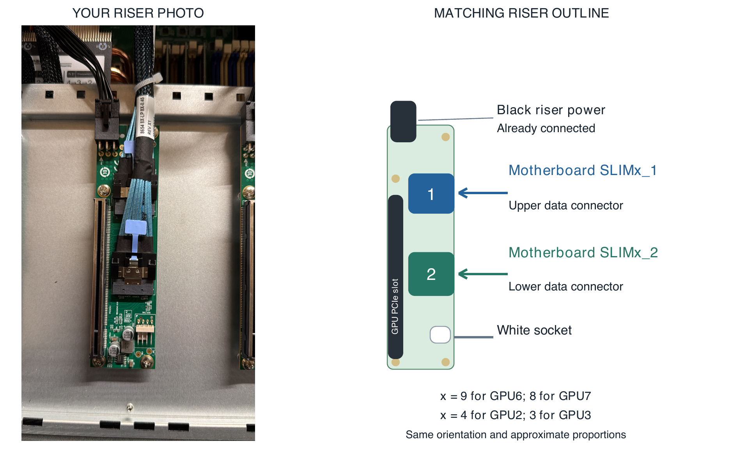
Figure 4 Photo and matching outline show the same orientation and approximate PCB proportions. Upper connector 1 takes SLIMx_1; lower connector 2 takes SLIMx_2. Not a dimensioned drawing.
1. Trace and label one complete pair at a time, at both ends. For example, label the two GPU6 leads SLIM9_1 and SLIM9_2.
2. Read the printed motherboard connector names. Route _1 to riser connector 1 and _2 to riser connector 2. Do not cross groups or exchange _1 and _2.
3. Align each keyed plug squarely with its socket. Insert it fully until its latch engages; check the housing is even and there is no visible partial insertion. Check both motherboard ends and both riser ends.
4. Route the pair clear of DIMM latches, fan blades, tray edges and screw holes. Leave enough slack for refitting the tray without tension.
Connector names The motherboard manual calls these SlimSAS connectors. In this guide, the MCIO or SLIM cables mentioned at the bench are these paired GPU data leads. Match the actual supplied connector and labels.

4 Recognise the riser cable endpoints
Use physical landmarks rather than left and right: a rotated riser or photograph can reverse those directions.
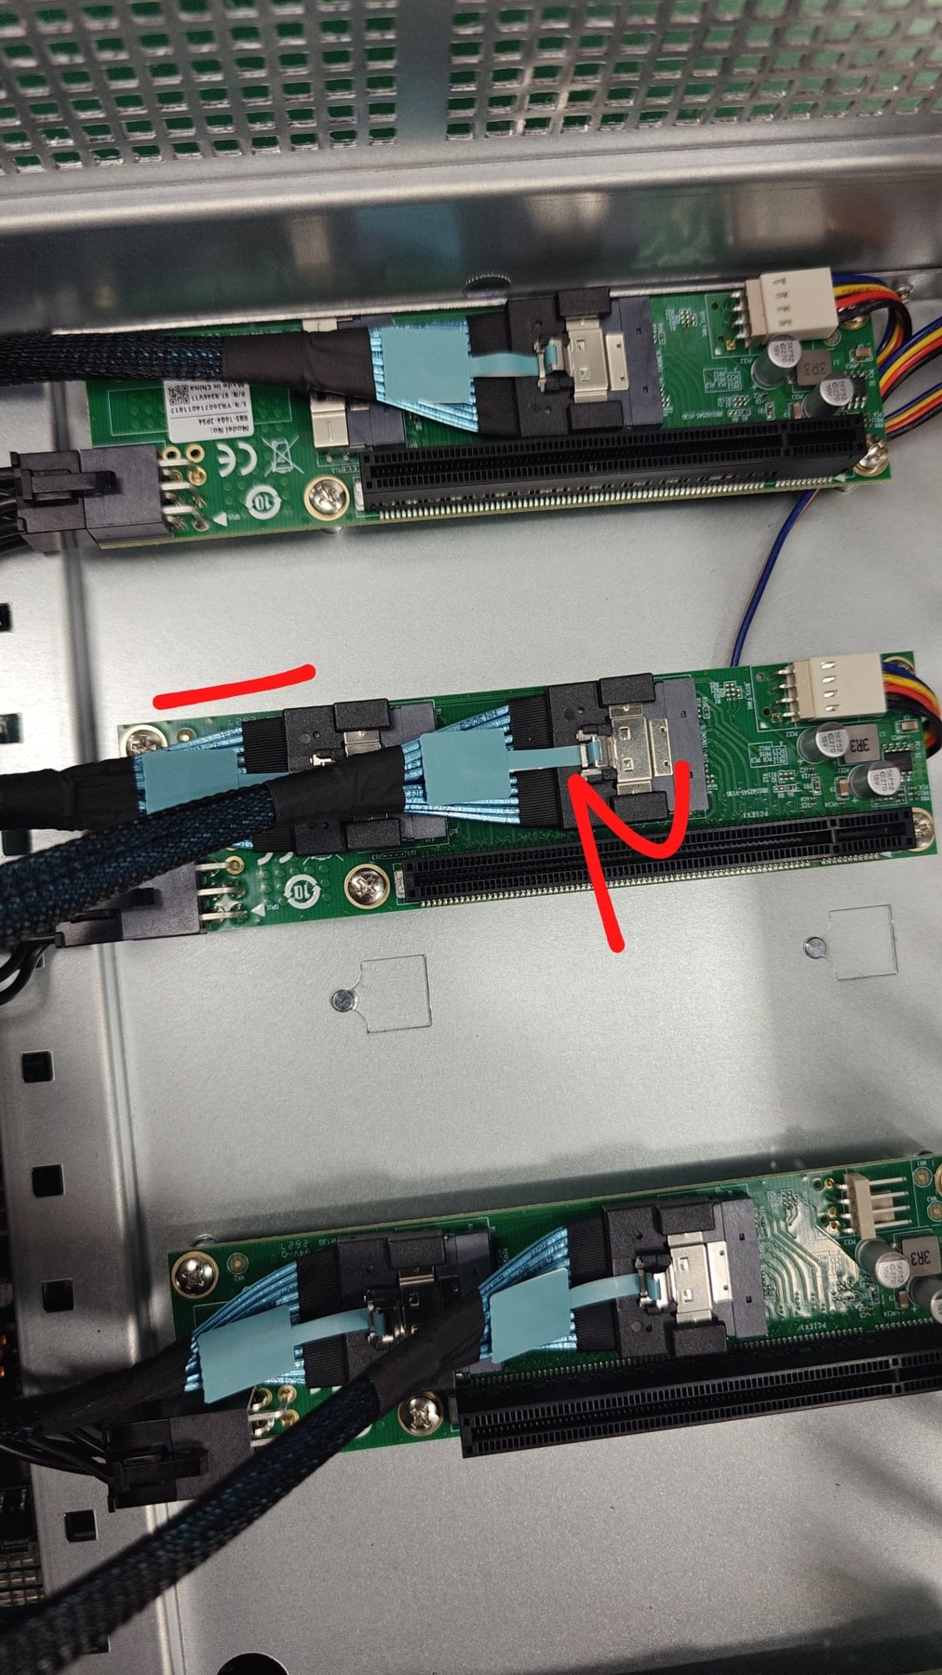
Figure 5 The marked riser photo identifies connector 1 at the black power end and connector 2 at the white socket end.
Riser landmark | Connection to check
Connector 1 | Data cable from motherboard SLIMx_1; nearest black riser power.
Connector 2 | Data cable from motherboard SLIMx_2; nearest the white four-pin socket.
Black power connector | Riser power; already connected before assembly. Check it has not been disturbed.

The white socket is an orientation landmark here. Riser power wiring is supplied pre-assembled; this step adds no wiring to that socket.
Pair check For each front GPU, trace two cables and inspect four fully seated data connectors before the GPU obstructs access.

5 Refit the tray and install the GPUs
1. Inspect the DIMMs and cable routes while they are visible. Lower the tray back into position and slide it rearward to its seated position. Check underneath for trapped cables, then reinstall the ten tray screws.
2. Confirm each riser is secure and its black power connector is seated. Rear GPU data cables are already connected; inspect them for disturbance.
3. Install one RTX 5090 in each physical position. Align the card with the riser PCIe slot and chassis supports. Seat it straight and fully, engage the slot retention mechanism where fitted, and secure it with the chassis GPU brackets and supplied fixings.
4. Connect the pre-routed GPU power lead at that position. Seat the plug fully and engage its latch. Check the connection from more than one angle, without a visible gap or sideways pull on the plug. Keep cables clear of fans and the lid.
5. Repeat until all eight positions contain a secured GPU with its power lead connected. Support the cards by their chassis mounts; do not leave their weight on loose risers.
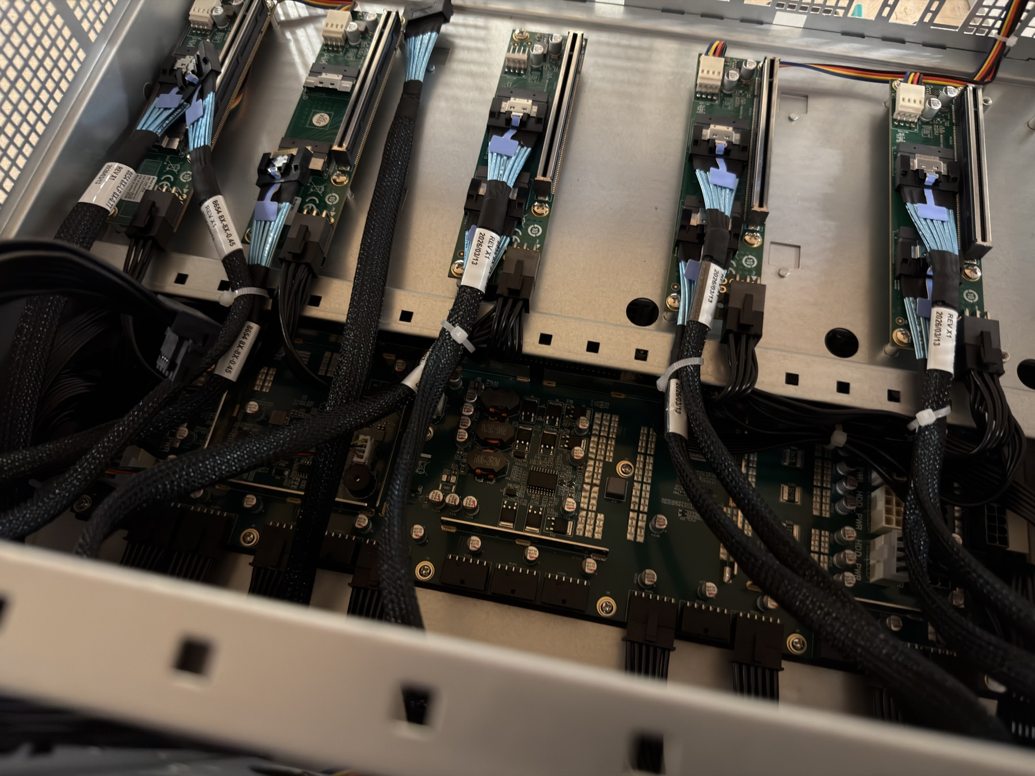
Figure 6 The pre-assembled power module beneath the rear risers supplies all eight GPU leads: four routed to the back and four to the front.
Before power on Count eight GPUs and eight connected GPU power leads. Confirm all front data pairs, riser power plugs, RAM latches and ten tray screws. Remove tools and loose screws. Refit the chassis covers and check that airflow paths are clear.

6 Check RAM in BIOS and boot Ubuntu
1. Connect the monitor to the server motherboard display output and connect a USB keyboard. Insert the prepared Ubuntu 24.04 Server USB drive, then reconnect the server power feeds.
2. Power on and press F2 or Delete during POST to enter BIOS. Allow memory training to finish. If Ubuntu has already started, log in, run sudo reboot and press F2 or Delete during the next POST.
3. On the Main tab, find Total Memory and the DDR4 slot list below it. Scroll down to inspect all slots for both CPUs. The ASRock manual shows names such as DDR4_A1 and DDR4_A2 that match the board printing.
Required total 512GB, or 524288MB if this BIOS displays MB. Record the BIOS version and total on page 11.
Selected configuration | Expected slot readings in BIOS
16 x 32GB RDIMM | A2–H2 and I2–P2: 32GB in every listed slot. All slots ending in 1: None or empty.
16 x 32GB LRDIMM | A2–H2 and I2–P2: 32GB in every listed slot. All slots ending in 1: None or empty.
8 x 64GB LRDIMM | A2 B2 C2 D2 and I2 J2 K2 L2: 64GB each. Every other slot: None or empty.

These are expected readings, not a captured BIOS screen. Compare the full names with page 3; DDR4_A2 means the printed A2 socket. Menu appearance can vary with the installed BIOS version.
4. Count the detected modules: 16 for either 32GB kit or 8 for the 64GB kit. Every intended populated slot must show the correct size. Record any unexpected None, empty or incorrect-capacity entry by its full BIOS label.
If RAM does not match Use page 10 before marking the RAM check as passed. If this BIOS does not expose matching slot labels, record what it shows and ask the lead technician to establish the mapping; do not guess a physical slot.
5. Exit BIOS without changing settings. Use the boot menu to select the Ubuntu USB drive and log in at the text console. The repository is ~/infra in the login account home directory. Continue with the single GPU check command on page 8.

Why BIOS is used for RAM location
dimm-inv.sh reports SMBIOS names such as DIMM 1 with P0 CHANNEL A, and repeats DIMM 1 for other channels. These are not the printed A2–P2 socket names. Do not select a DIMM for replacement from the SLOT column alone. Use the BIOS labels and physical board printing.
Reference: ASRock manual section 3.2, Main screen, printed page 47. No Linux DIMM inventory or JSON processing is required for this first check.

7 Check eight GPUs and their link widths
At the Ubuntu command prompt, type this command and press Enter. Enter the login password if sudo asks; no characters appear while typing the password.
sudo bash ~/infra/gpucheck/inv.sh
This works from any directory. If the USB already provides the inv shortcut, that shortcut may also be used.

Example of a passing detection and width check
Selected columns from the supplied server output are shown below. GPU names are shortened to fit; the full output says NVIDIA GeForce RTX 5090. Row order is preserved.
Idx | GPU Name | Gen(C/M) | Wdth(C/M) | Lnk(Sp/W) | Status
0 | RTX 5090 | 4/5 | 16/16 | 16/x16 | BelowMax
1 | RTX 5090 | 4/5 | 16/16 | 16/x16 | BelowMax
3 | RTX 5090 | 1/5 | 16/16 | 2.5/x16 | BelowMax
2 | RTX 5090 | 4/5 | 16/16 | 16/x16 | BelowMax
4 | RTX 5090 | 4/5 | 16/16 | 16/x16 | BelowMax
5 | RTX 5090 | 4/5 | 16/16 | 16/x16 | BelowMax
7 | RTX 5090 | 4/5 | 16/16 | 16/x16 | BelowMax
6 | RTX 5090 | 4/5 | 16/16 | 16/x16 | BelowMax

1. Count exactly eight GPU data rows, with eight distinct indices and an RTX 5090 name on every row. Do not count the heading or Slot Mapping Notes. Rows need not be in numerical order.
2. Check Wdth(C/M) on all eight rows: it must be 16/16. The first number is the current width. A value such as 8/16, 4/16, a blank or N/A requires investigation. Lnk(Sp/W) should also end in /x16.
BelowMax alone is not a width failure The example passes the requested width check even though all rows say BelowMax. The board is Gen4 while the GPU maximum is Gen5. The 1/5 and 2.5/x16 row still reports x16 width. This example does not establish temperatures or power readings as acceptance limits.
Slot names can be ambiguous In the supplied output, index 1 lists SLIM2 and SLIM5 candidates; index 6 lists SLIM10 variants and SLIM9. Idx is not a guaranteed physical GPU position label, and these bridge mappings do not prove a cable endpoint. Use the confirmed map on pages 4–5 and trace the pair before reseating. Do not move physical GPU6 to SLIM10 based on the displayed name.
Finish Record the eight results on page 11. If output wraps or is incomplete, use the optional checks on page 12. After repair, repeat the BIOS RAM check and this GPU check.

8 Resolve a missing GPU or narrow link
1. Record the observed count and PCI address. Use the confirmed physical cable map below to identify the affected GPU. Bus values are observations from the supplied output and may differ between servers or after firmware changes.
Physical GPU | Position from above | SLIM group | Reference PCI bus
GPU5 | Back row, far left | 7 | A1
GPU4 | Back row, inner left | 6 | 81
GPU1 | Back row, inner right | 2 | 25
GPU0 | Back row, far right | 1 | 01
GPU6 | Front row, far left | 9 | C1
GPU7 | Front row, inner left | 8 | E1
GPU2 | Front row, inner right | 4 | 41
GPU3 | Front row, far right | 3 | 61

Left and right refer to Figure 1. GPU1 used bus 21 in the original sketch and bus 25 in the supplied output: do not hard-code the address. Indices may also shift when a GPU is missing. Slot Mapping Notes can list several candidate SLIM pairs. Confirm by tracing the labelled pair with power removed; ask the lead technician if the endpoint remains uncertain.
2. Shut Ubuntu down with sudo poweroff. Disconnect every AC feed and wait for fans and standby indicators to stop before reseating hardware.
3. Check both data cables for the affected GPU. Confirm the same SLIM group and correct _1/_2 order. Release the cable latch before removal; hold the connector housing rather than pulling the wires.
4. Reseat both cables at both ends, squarely and fully. Inspect for damaged plugs or sockets. Check that a plug is not partly inserted or held at an angle by a tight bend or trapped cable.
5. Check the GPU is fully seated in its riser. For a missing GPU, also check its GPU power lead and the black riser power connector.
6. Restore supports and covers, reconnect power and repeat the USB checks. Before each further cable substitution, shut down, disconnect every AC feed and wait for standby indicators to stop. Try a known-good identical cable, one change at a time, preserving the pair order. Escalate persistent faults for riser or GPU substitution.
Do not assume a failed GPU A low width is a reason to check the entire data path. A loose connector, damaged cable, riser, GPU seating or configuration issue can produce a similar symptom.

9 Resolve a RAM mismatch
1. Enter BIOS with F2 or Delete during POST. On Main, compare Total Memory and the complete DDR4 slot list with page 3. Record each unexpectedly empty, unknown or incorrectly sized slot using its full BIOS label before switching off.
Selected kit | Expected populated count | Examples requiring investigation
16 x 32GB | 16 DIMMs, total 512GiB | 15 detected = 480GiB; 14 detected = 448GiB
8 x 64GB | 8 DIMMs, total 512GiB | 7 detected = 448GiB; 6 detected = 384GiB

2. Shut down, remove every AC power feed and wait for the server to de-energise. Remove any front GPUs that obstruct tray movement, recording their positions and cables first. Remove the ten tray screws, slide forward and lift to access RAM without straining cables.
3. Check the printed label of the suspect slot. Confirm the module is in an intended slot ending in 2, the capacity and RDIMM/LRDIMM type match the chosen kit, and both retaining latches are engaged.
4. Remove and reseat the suspect DIMM with ESD precautions. Align the notch and press evenly until both ends are fully seated. Reassemble, enter BIOS and check Total Memory and the affected slot again.
5. If the fault remains, shut down, disconnect every AC feed and wait for the server to de-energise again. Exchange the suspect DIMM with a known-good, matching DIMM from another intended populated slot. Record both slot labels and module part or serial numbers. Keep the correct population pattern.
Result after controlled exchange | Action
Fault follows the DIMM | Replace that DIMM with a known-good module of the same type and capacity, preferably matching the kit part number.
Fault stays at the same slot | Check seating and the population pattern again. Escalate the slot, memory channel or CPU path to the lead technician.
Several slots disappear together | Recheck the pattern and compare the affected channels or CPU group. Escalate if correct reseating does not restore them.

6. Restore the complete 512GB configuration and refit the tray and GPUs. Check RAM total and slot detection in BIOS, then boot Ubuntu and repeat inv.sh for GPU count and all link widths. Mark pass only after the complete set is correct.
If the server does not POST Confirm all feeds, power plugs and RAM seating with power removed. Compare slots against page 3 and record any displayed POST code. Escalate a persistent no-POST condition; CPU socket work is outside this procedure.

10 Record the first check result
Server ID ____________________ Technician ____________________
Date and time _________________ Ubuntu USB ID _________________
Selected RAM kit: 16 x 32GB RDIMM / 16 x 32GB LRDIMM / 8 x 64GB LRDIMM
BIOS version __________ Detected DIMMs __________
BIOS Total Memory __________ GB / MB Slot list checked: Yes / No
Ubuntu version __________ NVIDIA driver version __________________
Optional output file _____________________________________________
Physical GPU | Actual PCI address | RTX 5090 detected | Current width
GPU0 | ________________ | Yes / No | _______
GPU1 | ________________ | Yes / No | _______
GPU2 | ________________ | Yes / No | _______
GPU3 | ________________ | Yes / No | _______
GPU4 | ________________ | Yes / No | _______
GPU5 | ________________ | Yes / No | _______
GPU6 | ________________ | Yes / No | _______
GPU7 | ________________ | Yes / No | _______

Before marking pass
[ ] All eight physical GPU positions are fitted and secured.
[ ] All eight RTX 5090s are detected by the NVIDIA driver.
[ ] Every current PCIe width is x16.
[ ] BIOS shows 512GB total and correct detection in every intended populated slot.
[ ] Cables are seated and clear of fans; tray screws and covers are restored.
[ ] BIOS and GPU results are recorded; any repairs have been retested.
Overall result: PASS / FAIL / CHECK INCOMPLETE
Faults and actions ______________________________________________
______________________________________________________________
Replacement part and slot _______________________________________
Retest result __________________ Sign off _______________________

11 Diagnostic USB preparation and references
For the USB maintainer: prepare and verify these items before sending the drive to the assembly bench. The drive runs a full Ubuntu 24.04 Server installation with a text console only. The technician procedure does not install drivers, run provisioning or start stress tests.
Item | Required readiness
Login and repository | Working text-console login with sudo; repository at ~/infra in the login account home directory, with gpucheck scripts present.
GPU tools | Working NVIDIA driver for RTX 5090 and nvidia-smi. Test inv.sh on a known-good server.
System tools | Bash, dmidecode, pciutils (lspci), jq, column (bsdextrautils) and GNU awk selected as awk.
Storage | Writable Ubuntu home directory for dated result folders; sufficient free space.

Check the script prerequisite
awk --version
Expect GNU Awk. The reviewed inventory scripts use GNU awk syntax; Ubuntu's default mawk can produce a syntax error. A missing tool, parser error or unavailable value means the check is incomplete, not that the hardware has failed. Have the USB maintainer correct the prepared image before relying on the result.

Optional output capture
sudo bash ~/infra/gpucheck/inv.sh \
--csv "$HOME/gpu-check-$(date +%Y%m%d-%H%M%S).csv"
Use this when a full PCI address or slot field is clipped on screen, or when an output file is required. The timestamp gives each run a separate file in your home directory.

If the inventory is incomplete or difficult to read
nvidia-smi \
--query-gpu=index,name,pci.bus_id,pcie.link.width.current \
--format=csv
This narrower output must show eight RTX 5090 data rows and current width 16 on every row. A driver error or unavailable value is not a pass.
sudo bash ~/infra/gpucheck/bare-inv.sh
sudo lspci -s 0000:41:00.0 -vv
The bare inventory can find PCI devices when the NVIDIA driver fails; its IDX is not a physical GPU label. For lspci, substitute the actual affected GPU address and read LnkSta Width x16. PCI enumeration alone does not establish successful driver detection.

References
ASRock motherboard manual Memory population in section 2.4 and BIOS Main in section 3.2
NVIDIA SMI documentation GPU enumeration and current PCIe link information
Repository sources: gpucheck/dimm-inv.sh, gpucheck/inv.sh and gpucheck/bare-inv.sh; reviewed at commit a96066f. Use the prepared, validated USB version at the bench.
Physical GPU positions, front cable endpoint order, tray movement and pre-installed power routing follow the server photographs and assembly configuration supplied for this guide.

