**Faculdade de Engenharia da Universidade do Porto**



**CityFix - Product Backlog**

Laboratório de Desenvolvimento de Software

Cristóvão Silva

Georgina Esteves

Márcio Fontes

Ricardo Castro

Tiago Miranda

October, 2015

**1. Introduction**

In the simplest definition the Scrum Product Backlog is simply a list of all things that needs to be done within the project. It replaces the traditional requirements specification artifacts. These items can have a technical nature or can be user-centric e.g. in the form of user stories.

The owner of the Scrum Product Backlog is the Scrum Product Owner. The Scrum Master, the Scrum Team and other Stakeholders contribute it to have a broad and complete To-Do list.

This artifact contains the specification of all actors that interact with the system and their respective *user* *stories* as an agile documentation of the project requirements. This section pretends to illustrate the communication between actors (with *case diagrams*) and describe the potential interactions from users with the system – *user stories*.

**2. Actors**

An actor is a person, organization, or external system that plays a role in one or more interactions with a system. Actors may inherit from another actors and are never part of the system that is being modeled (Ambler, 2004). An action performed by an actor implies a response from the system. For **CityFix** system let’s consider the following actors represented in Figure 1 (Annex 1) and described in Table 1.

|  |  |  |  |
| --- | --- | --- | --- |
| **ID** | **Identifier** | **Description** | **Example** |
| 0 | Visitor | Unauthenticated user; may register or log into the system and access to public information (homepage, list of tickets) | n/a |
| 1 | Authenticated | Authenticated user; may logout from the system, edit his profile or recover his password | tlucio |
| 2 | User | Can upload and vote on a ticket | joesteves |
| 3 | Moderator | Responsible for ticketing management (validate its content, assign extra points to users based on the points system, etc.) | cris92 |
| 4 | Entity | Responsible for retrieving information from the applied tickets and updating the current tickets’ state. | cmp |
| 5 | Administrator | Responsible for users management, system security and data integrity. | admin |
| 6 | Google API | External API which will be used to detect the user’s geographical localization. | gmaps |

**3. Product Backlog Items**

An user story is a high-level definition of a requirement, containing all the enough information to make it possible to produce a reasonable estimate of the effort to implement it (Ambler, 2004). The description of a potential interaction from an user with the system focuses the behaviour requirements, rather than design aspects. Usually, an user story is described by the following template (Cohn, 2004):



For **CityFix** system, let’s consider the following *user* *stories* described on the tables below, based on the above template.

**3.1 Visitor**

|  |  |  |  |  |
| --- | --- | --- | --- | --- |
| **Identifier** | **Name** | **Priority** | **Description** | **Cost** |
| US001 | Login | High | As a Visitor I want to login into the system so that I can have access to restricted information. | 3 |
| US002 | Register | High | As a Visitor I want to register myself so that I can upload new tickets. | 5 |
| US003 | Password Recovery | Medium | As a Visitor I want to recover my authentication credentials so that I can access the platform if I forget my password or username. | 3 |
| US004 | List Tickets | Medium | As a Visitor, I want to see a list with a simple view of recent tickets so that I know the most recent activity. | 2 |
| US005 | Facebook Register | Low | As a Visitor, I want to register myself with my Facebook account so that my basic information is already filled automatically . | 8 |

**3.2 Authenticated**

|  |  |  |  |  |
| --- | --- | --- | --- | --- |
| **Identifier** | **Name** | **Priority** | **Description** | **Cost** |
| US101 | Search | Medium | As an Authenticated I want to search all public information (entity profiles, etc.) so that I can know who I should contact if there is a problem near my location. | 5 |
| US102 | View Ticket | High | As an Authenticated I want to view a ticket’s content so that I can know if there is a problem near my location and what actually happened. | 3 |
| US103 | Logout | High | As an Authenticated I want to be able to logout from the system so that I can terminate my session correctly. | 1 |
| US104 | Profile | Medium | As an Authenticated I want to see and edit my profile so that I can change my basic information and authentication credentials. | 3 |

**3.3 User**

|  |  |  |  |  |
| --- | --- | --- | --- | --- |
| **Identifier** | **Name** | **Priority** | **Description** | **Cost** |
| US201 | Add Ticket | High | As an User I want to submit a ticket to the system so that I can show that there’s a problem near my location. | 3 |
| US202 | Edit Ticket | High | As an User I want to edit a ticket i own in the system so that I can update its information. | 5 |
| US203 | Remove Ticket | High | As an User I want to remove a ticket I own so that I can hide its content from the public. | 2 |
| US204 | Associate Category | High | As an User I want to associate a ticket to a category so that it helps to solve a problem. | 1 |
| US205 | Manual Location | Medium | As an User I want to manually add a location so that I can add a ticket after a situation when I didn’t have internet connection. | 8 |
| US206 | Automatic Location | High | As an User I want the system to automatically detect my location so that I don’t have to add it manually. | 8 |
| US207 | Vote | High | As an User I want to vote on a ticket so that I can contribute to the truthfulness of that ticket and its respective user. | 3 |
| US208 | List My Tickets | Medium | As an User I want to have access to a list of my submitted tickets so that I can keep track of their status. | 3 |
| US209 | Associate Image to Ticket | High | As an User I want to associate an image to a ticket so that an user or entity can easily detect what’s happening on that location. | 5 |
| US210 | Ticket Suggestion | Medium | As an User I want to suggest changes to a ticket so that whenever I think an update must be, it shall be considered. | 5 |
| US211 | Ticket Search | High | As an User I want to search all public tickets so that I can see information on tickets others submitted | 3 |

**3.4 Moderator**

|  |  |  |  |  |
| --- | --- | --- | --- | --- |
| **Identifier** | **Name** | **Priority** | **Description** | **Cost** |
| US301 | Validate Tickets | High | As a Moderator I want to validate tickets so that an entity can solve the problem. | 1 |
| US302 | Change Ticket Information | Medium | As a Moderator I want to change information of a ticket so that I can update the current status, etc. | 5 |

**3.5 Entity**

|  |  |  |  |  |
| --- | --- | --- | --- | --- |
| **Identifier** | **Name** | **Priority** | **Description** | **Cost** |
| US401 | Entity tickets | High | As an Entity I want to access the tickets associated with me so that I can take action on solving those problems. | 3 |
| US402 | Change Ticket State | High | As an Entity I want to change a ticket’s state so that an active user may know the current state of that specific problem. | 1 |
| US403 | Filter Tickets | Low | As an Entity i want to filter tickets so that I can optimize my schedule. | 8 |

**3.6 Administrator**

|  |  |  |  |  |
| --- | --- | --- | --- | --- |
| **Identifier** | **Name** | **Priority** | **Description** | **Cost** |
| US501 | Manage Users | High | As an Administrator I want to manage users so that I can delete or mute an user if necessary. | 3 |
| US502 | Manage Content | High | As an Administrator I want to manage the system’s content so that whenever a change is necessary, there is permission to do so. | 5 |
| US503 | Statistics | Low | As an Administrator I want to get statistics so that I can know information about my system. | 8 |

**3.7 Technical Items**

|  |  |  |  |
| --- | --- | --- | --- |
| **Identifier** | **Priority** | **Description** | **Cost** |
| TI01 | Low | Check for advantages of using NodeJS | 3 |
| TI02 | High | Design database | 8 |
| TI03 | High | Implement database | 3 |
| TI04 | High | Populate database | 2 |
| TI05 | High | Integration of Google Maps API | 8 |
| TI06 | High | Test authentication | 2 |
| TI07 | High | Test tickets system | 5 |
| TI08 | High | Test administrator system | 3 |
| TI09 | High | Test notification system | 2 |

**3.8 Business Rules**

|  |  |  |
| --- | --- | --- |
| **Identifier** | **Name** | **Description** |
| BR01 | Password | On the registration, password must be at least 6 characters and contain numbers and letters |
| BR02 | Email | An email must be associated with only one account |
| BR03 | Ban | An user is banned whenever he uses the system improperly |
| BR04 | Aprove | Only a moderator or an  administrator can aprove a ticket |
| BR05 | Change Information | After being aproved, a ticket can not be changed |
| BR06 | Access | After authentication, the user must terminate the session before he can login with another account |
| BR07 | Ticket Text | A ticket must have between 1 and 5000 characters |
| BR08 | Ticket Creation | After creating a ticket a user has 30 minutes to change any information on it |
| BR09 | Facebook Restrition | An entity or Admin cannot have a facebook account associated |
| BR10 | Service Association | An entity can only take action on tickets whose category the service serves |

**3.9 Functional Requirements**

|  |  |  |
| --- | --- | --- |
| **Identifier** | **Name** | **Description** |
| FR01 | Usability | The system must be simple and easy to use. |
| FR02 | Accessibility | The system must be available to all web browsers. |
| FR03 | Portability | The system must work on different operative systems. |
| FR04 | Performance | The system must have response time of at most 5 seconds. |
| FR05 | Security | The system must protect information from unauthorized access through a system of authentication and privilege checking. |
| FR06 | Fault tolerance | The system must be prepared to treat and keep working with runtime errors. |
| FR07 | Traceability | The system must store action history of its users, such as ticket uploads. |
| FR08 | Ethics | The system must respect the ethical principles by encrypting passwords. |
| FR09 | Scalability | The system must have the capacity to maintain the same performance when there is an increase in the number of users and / or simultaneous requests. |
| FR10 | Availability | The system must be avilable 99% of the time for each 24 hours period. |

**4. Acceptance Tests**

**4.1 Visitor**

**4.1.1 User Login**

**ID**: 1

**Requirement ID**: US001

**Description**: This test should verify that a user is able to authenticate himself in the system and take full use of its API according to his privileges.

**Actors**: Visitor

**Pre-conditions**:

* User device has active internet connection
* No account in local device authenticated in the system
* Record of account with email user@test.com with password User123 must be registered in the database.
* Record of account with email phony@test.com must not be registered in the database.
* Record of account with email moderator@test.com with password Moderator123 must be registered in the database.
* Record of account with email entity@test.com with password Entity123 must be registered in the database.
* Record of account with email admin@test.com with password Admin123 must be registered in the database.
* Record of account with account registered with facebook must be registered in the database
* No facebook session should be live
* 3.0.2 Visitor Register
* 3.0.5 Facebook Register

|  |  |  |
| --- | --- | --- |
| Step | Description | Result |
| 1 | Access City Fix welcome page and press register login | A register form appears |
| 2 - User authentication scenario | | |
| 2.1 | Wrong email and password scenario.  Fill email login input with [phony@test.com](mailto:phony@test.com) and Password input with a password that validates system requirements (e.g.: Phony12345).  Click Login. | A message with text “wrong email/password combination” and a link with text “Recover Password” are displayed. |
| 2.2 | Wrong password scenario. Fill email login input with [user@test.com](mailto:user@test.com) and Password input with User12345. Click Login. | A message with text “wrong email/password combination” and a link with text “Recover Password” are displayed. |
| 2.3 | Valid login scenario  Fill email login input with [user@test.com](mailto:user@test.com) and Password input with User123 Click Login. | User’s homepage is loaded. User’s first name and last name are displayed on top bar. |
| 3 – Moderator authentication scenario | | |
| 3.1 | Fill email login input with [user@test.com](mailto:user@test.com) and Password input with User123 Click Login. | Login succeeds.  Moderator’s homepage is loaded. User’s first name and last name are displayed on top bar. Dropdown list on top right corner has a “moderator” item. |
| 4 – Administrator authentication scenario | | |
| 4.1 | Fill email login input with [admin@test.com](mailto:admin@test.com) and Password input with Admin123 Click Login. | Login succeeds.  Administrator’s homepage is loaded. Admin panel loads on page. |
| 5 – Entity authentication scenario | | |
| 5.1 | Fill email login input with [entity@test.com](mailto:entity@test.com) and Password input with Entity123 Click Login. | Login succeeds.  Entity’s homepage is loaded. Entity’s panel loads on page.  Displays ticket’s to be served by the entity |
| 6 – Facebook User authentication with no facebook session live scenario | | |
| 6.1 | Press login with facebook | A popup asking to provide facebook login information (if a facebook session is live) shows up. |
| 6.2 | Fill facebook form with valid facebook account also registered in CityFix. Press login. | User’s homepage is loaded. User’s first name and last name are displayed on top bar. |
| 7 – Facebook User authentication with live facebook session scenario | | |
| 7.1 | Login to facebook | Facebook interface will appear |
| 7.2 | Open CityFix welcome page again | CityFix page will appear |
| 7.3 | Press login with facebook | User’s homepage is loaded. User’s first nameand last name are displayed on top bar. |

**4.1.2 Visitor Register**

**ID**: 2

**Requirement ID**: US002, BR01, BR02

**Description**: This test should verify that a visitor is able to register an account in the system and take full use of its API according to his privileges.

**Actors**: Visitor

**Pre-conditions**:

* User device has active internet connection
* No account in local device authenticated in the system
* Record of account with email [user@test.com](mailto:user@test.com) in the database

**Post-conditions**:

* Repeat test 3.0.1 – User Login through step 2.3 with email account used in registration step 5.

|  |  |  |
| --- | --- | --- |
| Step | Description | Result |
| 1 | Access City Fix welcome page and press register | A register form will appear |
| 2 | Mandatory fields missing scenario.Leave all fields blank and select register | An alert message with text “Some fields are missing” is displayed. Missing fields are also highlighted. |
| 3 | Unique email violation scenario.  Fill all fields with correct criteria except email. Insert [user@test.com](mailto:user@test.com) on email input and Click Register | An alert message with text “Email account already registered” is displayed. Missing fields are also highlighted. |
| 4 | Password requirements violation scenario. Fill all fields with correct criteria except password. Insert “111” in password field and press register | Message saying “Password must be |
| 5 | Correct registration scenario. Fill all fields with correct criteria (email cannot be [user@test.com](mailto:user@test.com)). An email account to which you have access must be provided. Press register | A message displaying “Welcome to City fix. An email was sent to you. Please confirm your registration”. |
| 6 | Repeat test 3.0.1 - User Login through step 2.3 with email account used in registration step 5. | Login fails due to wrong email and password.  A message with text “wrong email/password combination” and a link with text “Recover Password” are displayed. |
| 7 | Go to email account used in registration in step 5, open confirmation email and click the provided link. | Page with message “Registration confirmed” will load. |

**4.1.3 Visitor Password Recovery**

**ID**: 3

**Requirement ID**: US003, BR01

**Description**: This test should verify that a visitor is able to recover his password.

**Actors**: Visitor

**Pre-conditions**:

* User device has active internet connection
* No account logged in on device
* Record of account with email [phony@test.com](mailto:phony@test.com)  cannot be in the database.
* Test 3.0.2 Visitor Register until step 7

**Post-conditions**:

* Repeat test 3.0.1 – User Login through step 2.3 with email account used in password recovery step 7.

|  |  |  |
| --- | --- | --- |
| Step | Description | Result |
| 1 | Access City Fix welcome page |  |
| 2 | Click recover password | A form will appear with a password input |
| 3 | Non-registered account scenario.  Fill data with [phony@test.com](mailto:phony@test.com) and press recover | A message with text “the email account provided is not registered” will be displayed |
| 4 | Valid account scenario.  Fill data with valid email (email registered in and press recover | Message saying to check email will appear |
| 5 | Go to email account and click recover password | A page will load with input for new password |
| 6 | Password requirements violation scenario.  Insert password “123”. | A message will load saying password does not meet criteria |
| 7 | Fill password input with a password that validates system requirements (e.g.: Phony12345). | Messsage with text “A new password has been set please login” will be displayed. |

**4.1.4 List Tickets**

**ID**: 4

**Requirement** **ID**: US004

**Description**: This test should verify that a list of recent tickets is shown on the welcome page

**Actors**: Visitor

**Pre-conditions**:

* User device has active internet connection
* Record of at least one ticket in database

|  |  |  |
| --- | --- | --- |
| Step | Description | Result |
| 1 | Access City Fix welcome page | Information about CityFix |
| 2 | Scroll down until a list with label “Recent tickets” show up | A list with one or more recent tickets will appear |

**4.1.5 Facebook Register**

**ID**: 5

**Requirement ID**: US005

**Description**: This test should verify that a visitor is able to register himself in the system using facebook authentication.

**Actors**: Visitor

**Pre-conditions**:

* User device has active internet connection
* User must have facebook account.

|  |  |  |
| --- | --- | --- |
| Step | Description | Result |
| 1 | Access City Fix welcome page |  |
| 2 | Press register with facebook | A popup asking to provide facebook login information or to confirm facebook account details (if a facebook session is live) shows up. |
| 3 | Click accept | A message with text “Welcome to City fix.” appears |

**4.2 Authenticated**

**4.2.1 Search**

**ID**: 6

**Requirement ID**: US101

**Description**: This test should show to an authenticated user the result of his/her search.

**Actors**: Authenticated

**Pre-conditions**:

* User device has active internet connection;
* The user must be logged in;

|  |  |  |
| --- | --- | --- |
| Step | Description | Result |
| 1. | Locate the search bar |  |
| 2. | The authenticated user should write what he/she wants to search |  |
| 3. | The authenticated user should click on the “Ok” button | A page with his/her search results will appear |

**4.2.2 View Ticket**

**ID**: 7

**Requirement ID**: US102

**Description**: This test should show to an authenticated user the details of a specific ticket.

**Actors**: Authenticated

**Pre-conditions**:

* User device has active internet connection;
* The user must be logged in;

|  |  |  |
| --- | --- | --- |
| Step | Description | Results |
| 1. | Click on “Tickets” button | A list of tickets appears |
| 2. | Select one of the tickets | The detailed information of that ticket is presented. |

**4.2.3 Logout**

**ID**: 8

**Requirement ID**: US103

**Description**: This test should make an authenticated user go unauthenticated.

**Actors**: Authenticated

**Pre-conditions**:

* User device has active internet connection;
* The user must be logged in;

|  |  |  |
| --- | --- | --- |
| Step | Description | Results |
| 1. | Click on “Logout” button | The authenticated user is logged out. |

**4.2.4 Profile**

**ID**: 9

**Requirement ID**: US104

**Description**: This test should show to an authenticated user his/her own profile page where he/she can see and edit his/her own information

**Actors**: Authenticated

**Pre-conditions**:

* User device has active internet connection;
* The user must be logged in;

|  |  |  |
| --- | --- | --- |
| Step | Description | Results |
| 1. | Click on “My Profile” button | The profile page is displayed |
| 2. | Click on “Edit Profile” button | The user can now edit his/her basic information |

**4.3 User**

**4.3.1 Add Ticket**

**ID**: 10

**Requirement ID**: US201

**Description**: This test should show to an user a submitted ticket by him/her

**Actors**: User

**Pre-conditions:**

* User device has active internet connection;
* The user must be logged in;

|  |  |  |
| --- | --- | --- |
| Step | Description | Results |
| 1. | Click on “Add Ticket” button | A page to submit a ticket is displayed |
| 2.1 | All informations about the ticket are valid | Ticket is submitted |
| 2.2 | Informations about the ticket are not valid | Ticket not submitted |
| 3 | User saves the changes | Data verification is made |
| 4.1 | The changes are successful | The data is updated |
| 4.2 | A problem occured while changing the data | The data remains the same and the user returns to the previous page |

**4.2.2 Edit Ticket**

**ID**: 11

**Requirement ID**: US202

**Description**: This test should verify if a user can ticket edit its, i.e, change its current status, respective description, etc.

**Actors:** User

**Pre-conditions**:

* User device has active internet connection;
* The user must be logged in;
* The ticket must belong to the respective user;
* The ticket must not be blocked by the moderator (concerning the status) in order to edit it;

**Post-conditions**:

* The ticket’s respective status must not change if it is already blocked by a moderator;
* If no problem occurs, then the changes must be saved and the data consistent;
* Otherwise, the data must remain unchanged;
* The user redirected to his Tickets page;

|  |  |  |
| --- | --- | --- |
| Step | Description | Result |
| 1 | Click on “My Tickets” button | A list of own tickets appears |
| 2.1 | Select one of the tickets | The detailed information of that ticket is displayed |
| 2.2 | There are no tickets to be displayed | The user can’t edit any tickets |
| 3 | A list of fields is displayed and the user must edit the respective data |  |
| 4 | User saves the changes | Data verification is made |
| 5.1 | The changes are successful | The data is updated |
| 5.2 | A problem occured while changing the data | The data remains the same and the user returns to the Tickets page |

**4.3.3 Remove Ticket**

**ID**: 12

**Requirement ID**: US203

**Description**: This test should remove a ticket from an user (if is not blocked or undergoing).

**Actors:** User

**Pre-conditions**:

* User device has active internet connection;
* The user must be logged in;
* The ticket must belong to the respective user;
* The ticket must not be blocked by the moderator (concerning the status) in order to edit it;

**Post-conditions**:

* If no problem occurs, then the ticket is removed;
* Otherwise, the ticket must remain unchanged;
* The user is redirected to his Tickets page;

|  |  |  |
| --- | --- | --- |
| Step | Description | Result |
| 1 | Click on “My Tickets” button | A list of own tickets appears |
| 2.1 | Select one of the tickets | The detailed information of that ticket is displayed |
| 2.2 | There are no tickets to be displayed | The user can’t edit any tickets |
| 3.1 | Click on the delete button |  |
| 3.2 | The delete button is blocked due to ticket’s undergoing status | The user can’t remove the ticket |
| 4 | An input box appears and asks the user if he really wants to remove the ticket | The user must choose yes or no |
| 5.1 | The changes are successful | The ticket is removed |
| 5.2 | A problem occured while removing the ticket | The ticket remains in the database |

**4.3.4 Associate Category**

**ID**: 13

**Requirement ID**: US204

**Description**: This test should test if it allows an user to associate a category to a ticket.

**Actors:** User

**Pre-conditions**:

* User device has active internet connection;
* The user must be logged in;
* The ticket must belong to the respective user (if the user wants to associate a category after creating it);
* The ticket must not be blocked by the moderator (concerning the status) in order to edit the category;

**Post-conditions**:

* If no problem occurs, then the category is associated;
* Otherwise, the ticket must remain unchanged or not created;
* The user is redirected to his Tickets page;

|  |  |  |
| --- | --- | --- |
| Step | Description | Result |
| 1 | Click on “My Tickets” button | A list of own tickets appears |
| 2.1 | Click on “Create a Ticket” button | A creation form appears |
| 2.2 | Select one of the tickets | The detailed information of that ticket is displayed |
| 3.1 | User fills the form and then selects a category |  |
| 3.2 | A list of fields is displayed and the user must edit the category |  |
| 4 | User clicks on the “Save” button | Data verification is made |
| 5.1 | The changes are successful | The ticket is created or edited and a category is associated |
| 5.2 | A problem occured while creating or editing the ticket and associating a category | The category is not associated |

**4.3.5 Manual Location**

**ID**: 14

**Requirement ID**: US205

**Description**: This test should test if it allows an user to type a location during a ticket creation.

**Actors:** User

**Pre-conditions**:

* User device has active internet connection;
* The user must be logged in;

**Post-conditions**:

* If no problem occurs, then the ticket is created with the specified location;
* Otherwise, the ticket is not created and the user must specify the location again;
* The user redirected to his Tickets page;

|  |  |  |
| --- | --- | --- |
| Step | Description | Result |
| 1 | Click on “My Tickets” button | A list of own tickets appears |
| 2 | Click on “Create a Ticket” button | A creation form appears |
| 3 | User fills the form and then types the location | The system tries to establish connection to Google Maps API to recognize the typed location for a more efficient use. |
| 4.1 | The typed location is not recognized by Google Maps | The location is still saved but not directly connected to Google Maps |
| 4.2 | The typed location is recognized by Google Maps | The location stays associated to Google Maps |
| 5 | User clicks on the “Save” button | Data verification is made |
| 6.1 | The changes are successful | The ticket is created and the location is associated |
| 6.2 | A problem occured while creating the ticket or associating a location | The ticket is not created and the user must rewrite or try again to recognize the location |

**4.3.6 Automatic Location**

**ID**: 15

**Requirement ID**: US206

**Description**: This test should test if it allows an user recognize its current location.

**Actors:** User

**Pre-conditions**:

* User device has active internet connection;
* The user must be logged in;
* The device must be capable to recognize the user’s geographical location.

**Post-conditions**:

* If no problem occurs, then the user’s location is recognized;
* Otherwise, the user must specify a manual location;

|  |  |  |
| --- | --- | --- |
| Step | Description | Result |
| 1 | Click on “My Tickets” button | A list of own tickets appears |
| 2 | Click on “Create a Ticket” button | A creation form appears |
| 3 | User fills the form and then selects the automatic location | The system tries to establish connection to Google Maps API to recognize the user’s location. |
| 4.1 | The location is recognized | The user may save the ticket and its respective location is associated |
| 4.2 | The user attempts to recognize the location again | The system tries again to establish a connection to Google Maps API |
| 4.3 | The location is not recognized and the user must type the location by himself (4.2.5) |  |
| 5 | User clicks on the “Save” button | Data verification is made |
| 6.1 | The changes are successful | The ticket is created and the location is associated |
| 6.2 | A problem occured while creating the ticket or associating a location | The ticket is not created and the user must rewrite or try again to recognize the location |

**4.3.7 Vote**

**ID**: 16

**Requirement ID**: US207

**Description**: This test should test if it allows an user to vote on a ticket.

**Actors:** User

**Pre-conditions**:

* User device has active internet connection;
* The user must be logged in;

**Post-conditions**:

* If no problem occurs, then the vote is accepted;
* Otherwise, the user must retry to vote;

|  |  |  |
| --- | --- | --- |
| Step | Description | Result |
| 1 | Click on “Tickets” button | A list of tickets appears |
| 2 | Select a ticket | The detailed information of that ticket is displayed |
| 3 | The user clicks on the “Vote” button (Up or Down) |  |
| 4.1 | The vote is successful | The vote is counted and is saved on the database |
| 4.2 | A problem occured while voting (try to vote twice or lost internet connection, etc.) | The vote is saved on the database |

**4.3.8 List My Tickets**

**ID**: 17

**Requirement ID**: US208

**Description**: This test checks if the user is able to correctly list the tickets he created

**Actors**: User

**Pre-conditions**:

* The user must be logged in;
* User device has active internet connection;

|  |  |  |
| --- | --- | --- |
| Step | Description | Result |
| 1 | Access the User profile |  |
| 2 | Click on the symbol that opens the menu | The menu with multiple options will show |
| 3 | Click on “My tickets” | The list of tickets submitted by the user will show |

**4.3.9 Associate Image to Ticket**

**ID**: 18

**Requirement ID**: US209

**Description**: This test checks if the user is able to attach an image to the ticket he is creating, either by using the phone’s camera or by searching in its gallery

**Actors**: User

**Pre-conditions**:

* The user must be authenticated with an User account
* Access to the phone’s camera
* Access to the phone’s gallery
* A ticket creation process must have been initiated previously:

|  |  |  |
| --- | --- | --- |
| Step | Description | Result |
| 1 | Click on “Attach a photo” | A popup asking if the user wants to take a photo or search in the phone’s gallery appears |
| 2 | Click on “Take a Photo” | A new window will open with the image from the phone’s camera |
| 2.1 | Take the photo | The photo taken will automatically appear in the ticket creation screen. The camera will close. |
| 2 | Click on “Upload from Gallery” | A new window will appear listing all the photos the user has in its phone’s gallery |
| 2.1 | Click on a photo | The photo will become selected and a button will appear in the top right corner saying “Upload” |
| 2.2 | Click on “Upload” | The selection screen will close and the photo will appear in the ticket creation screen |

**4.3.10 Ticket Suggestion**

**ID**: 19

**Requirement ID**: US210

**Description**: This test checks if the user is able to submit for approval suggestions to change some information in the ticket details

**Actors**: User

**Pre-conditions**:

* The user must be authenticated with an User account
* Internet connection

:

|  |  |  |
| --- | --- | --- |
| Step | Description | Result |
| 1 | Click on “Search tickets” | A new screen appears |
| 2 | Click on “Take a Photo” | A new window will open with the image from the phone’s camera |
| 2.1 | Take the photo | The photo taken will automatically appear in the ticket creation screen. The camera will close. |
| 2 | Click on “Upload from Gallery” | A new window will appear listing all the photos the user has in its phone’s gallery |
| 2.1 | Click on a photo | The photo will become selected and a button will appear in the top right corner saying “Upload” |

**4.3.11 Ticket Search**

**ID**: 20

**Requirement ID**: US211

**Description**: This test checks if the user is able to search the ticket directory, either by date, or location, or by entity

**Actors**: User

**Pre-conditions**:

* The user must be authenticated with an User account
* Internet connection

|  |  |  |
| --- | --- | --- |
| Step | Description | Result |
| 1 | Access the User profile |  |
| 2 | Click on the symbol that opens the menu | The menu with multiple options will show |
| 3 | Click on “Search Tickets” | A new screen will appear with text fields to fill |
| 4 | Fill the fields with required information |  |
| 5 | Click on “Search” | In the screen will appear a list of tickets corresponding to the information requested |

**4.4 Moderator**

**4.4.1 Validate Tickets**

**ID**: 21

**Requirement ID**: US301

**Description**: This test checks if the moderator is able to approve a ticket previously submitted

**Actors**: Moderator

**Pre-conditions**:

* The user must be authenticated with a Moderator account
* Access to the internet

|  |  |  |
| --- | --- | --- |
| Step | Description | Result |
| 1 | Access the user account |  |
| 2 | Search a ticket | A list of tickets corresponding to the search will appear in a new screen |
| 3 | Click on an unapproved ticket | A new window will appear will all the ticket information, as well as a button in the bottom saying “Approve ticket” |
| 4 | Click on “Approve Ticket” | The where the Moderator clicked will become green saying “Ticket Approved” |

**3.3.2 Change Ticket Information**

**ID**: 22

**Requirement ID**: US302

**Description**: This test checks if the moderator is able to change some information on the ticket’s details

**Actors**: Moderator

**Pre-conditions**:

* The user must be authenticated with a Moderator account
* Access to the internet

|  |  |  |
| --- | --- | --- |
| Step | Description | Result |
| 1 | Access the user account |  |
| 2 | Search a ticket | A list of tickets corresponding to the search will appear in a new screen |
| 3 | Click on a ticket | A new window will appear will all the ticket information, as well as “Edit” buttons on each of the ticket’s fields |
| 4 | Click on “Edit” on any field | The field will become editable and the Moderator can now change the information. A green tick mark will appear next to the field being edited. |
| 5 | Click on the green tick mark | The field will be locked and the information in the ticket is updated. The screen keeps showing ticket details |

**4.5 Entity**

**4.5.1 Entity tickets**

**ID**: 23

**Requirement ID**: US401

**Description**: This test will check that the tickets are being redirected to the right Entity, and that the Entity is able to access the tickets in order to solve the situation.

**Actors**: Entity

**Pre-conditions**:

* The user must be authenticated with an Entity account
* Internet connection

**Post-conditions**:

* The user accesses a list of active tickets associated with the Entity. Then, he can access the tickets and change the state of them, if needed.

|  |  |  |
| --- | --- | --- |
| Step | Description | Result |
| 1 | Access the Entity profile |  |
| 2 | Click on the “My Tickets” button |  |
| 3.1 | A list of active tickets is displayed, and the user can access the tickets listed by clicking it | A list of multiple active tickets is displayed, and the user can access the tickets |
| 3.2 | There are no available tickets to be displayed | A warning informing that there are not active tickets at the moment appears on the screen |

**4.5.2 Change Ticket State**

**ID**: 24

**Requirement ID**: US402

**Description**: This test will confirm that when a ticket is validated and associated with an Entity, the Entity responsible can update the current state of a situation, and even close it.

**Actors**: Entity

**Pre-conditions**:

* The user must be authenticated with an Entity account
* Internet connection
* At least one active ticket related to that Entity must be available

**Post-conditions**:

* The current state of the ticket changes

|  |  |  |
| --- | --- | --- |
| Step | Description | Result |
| 1 | Access the Entity profile |  |
| 2 | Click on the “My Tickets” button | A list of multiple active tickets is displayed |
| 3 | Select one of the tickets | The detailed information of that ticket is displayed |
| 4 | Click the dropdown menu, and choose a new state to the ticket |  |
| 5.1 | The alteration is successfully made | The state of ticket is updated |
| 5.2 | A problem occured with the selection | The state of the ticket remains the same |

**4.4.3 Filter Tickets**

**ID**:25

**Requirement ID**: 403

**Description**: This test will confirm that an Entity can successfully filter tickets by geographical distance, and with this organize an optimized route to attend and solve the active problems

**Actors**: Entity

**Pre-conditions**:

* The user must be authenticated with an Entity account
* Internet connection

**Post-conditions**:

|  |  |  |
| --- | --- | --- |
| Step | Description | Result |
| 1 | Access the Entity profile |  |
| 2 | Click on the “My Tickets” button | A list of multiple active tickets is displayed |
| 3 | Select “My route” button | A map using Google Maps is displayed, with marks representig the active problems in the area |
| 4 | Select one of the active marks | The mark is highlighted, and some information about the problem is displayed |
| 5.1 | Click the “plus” sign next to the mark icon | The mark is added to the current route |
| 5.2 | A problem occured while adding the mark | A popup appears indicating the error and the route remains the same |

**4.5 Administrator**

**4.5.1 Manage Users**

**ID**: 26

**Requirement ID**: 501

**Description**: This test will verify the user’s management system. All the activities related with change of permissions or accounts will be tested.

**Actors**: Administrator and User

**Pre-conditions**:

* The user must be authenticated with an Administrator account
* Internet connection

|  |  |  |
| --- | --- | --- |
| Step | Description | Result |
| 1 | Access the Administrator profile |  |
| 2 | Click on the “Manage Users” button | A list of the system’s users is displayed |
| 3 | Click on the name of an User, Moderator or Entity | The detailed information of that User is displayed |
| 4.1 | Click the dropdown menu, and promote an User to Moderator | The User is now seen by the system as a Moderator, and gains the permission associated with it |
| 4.2 | Click the dropdown menu, and depromote a Moderator to User | The Moderator is now seen by the system as an User, and loses his previous permissions |
| 4.3 | Click the dropdown menu, and delete an User, Moderator or Entity | The User’s account no longer exists in the system |

**4.5.2 Manage Content**

**ID**: 27

**Requirement ID**: 502

**Description:** This test is meant to test if the administrator can manage content from the website.

**Actors**: Administrator

**Pre-conditions**:

* The user must be authenticated with an Administrator account
* Internet connection

|  |  |  |
| --- | --- | --- |
| Step | Description | Result |
| 1 | Access the Administrator profile |  |
| 2 | Click on the “Manage Content” button | A list of most active tickets will be displayed |
| 3 | Click on a ticket | The detailed information of that ticket is displayed |
| 4.1 | Click the dropdown menu, and select “Edit Ticket” button | The ticket information is immediately updated |
| 4.2 | Click the dropdown menu, and select “Delete Ticket” button | The ticket is removed from the system |

**4.5.3 Statistics**

**ID**: 28

**Requirement ID**: 503

**Description**: This test is meant to verify if the administrator can observe users and tickets statistics.

**Actors**: Administrator

**Pre-conditions**:

* The user must be authenticated with an Administrator account
* Internet connection

|  |  |  |
| --- | --- | --- |
| Step | Description | Result |
| 1 | Access the Administrator profile |  |
| 2 | Click on the “Manage Content” button | A view with multiple graphs and statistics is displayed |
| 3 | Click on the radio button corresponding to the desired information | The graph will change, displaying the information accordingly |

# **Bibliography**

Ambler, S. (2004). *The Object Primer* (3ª ed.). Cambridge: Cambridge University Press.

Cohn, M. (2004). *User Stories Applied: For Agile Software Development* (3ª ed.). Chicago: Addison-Wesley Professional.

*Does every item in the product backlog require a User Story?* (October de 2015). Fonte: Agile @ Adobe: http://blogs.adobe.com/agile/2012/06/20/does-every-item-in-the-product-backlog-require-a-user-story/

Raymond, E. S., & Landley, R. W. (2004). *The Art of Unix Usability.* Pearson Education, Inc.

*The Scrum Product Log*. (October de 2015). Fonte: International Scrum Institute: http://www.scrum-institute.org/The_Scrum_Product_Backlog.php

**Annexes**

**Annex A**

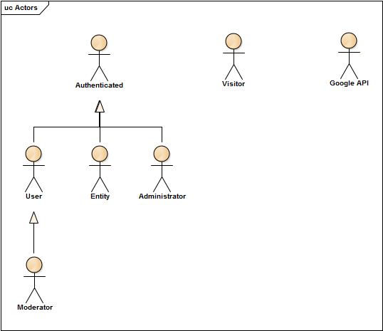

Figure - Actors

**Annex B**

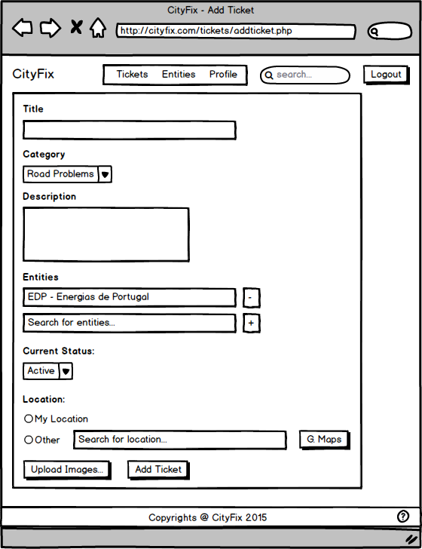

Figure - Add Ticket UI

**Annex C**

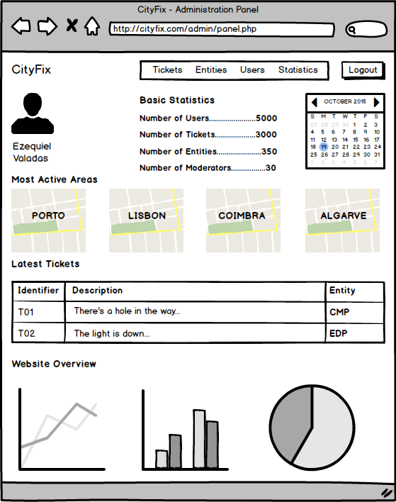

Figure - Administrator Panel UI

**Annex D**

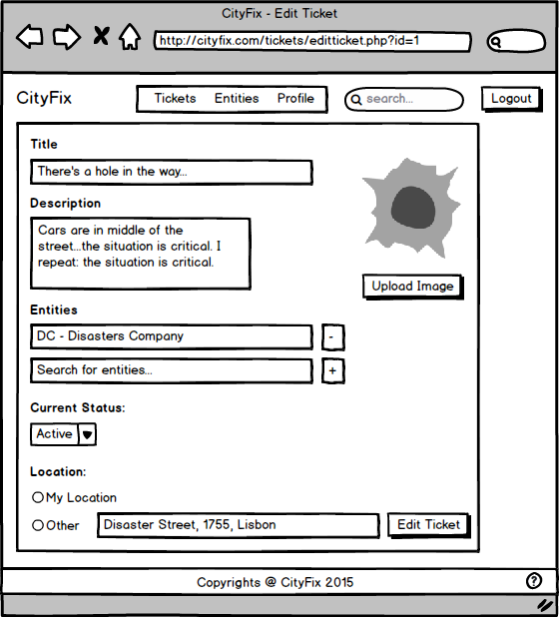

Figure - Edit Ticket UI

**Annex E**

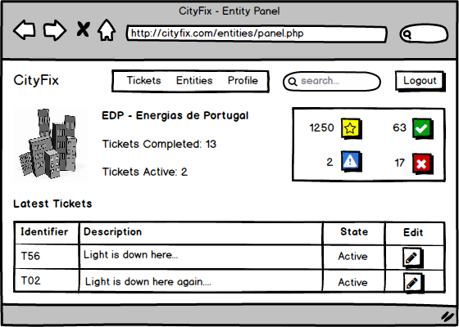

Figure - Entity Panel UI

**Annex F**

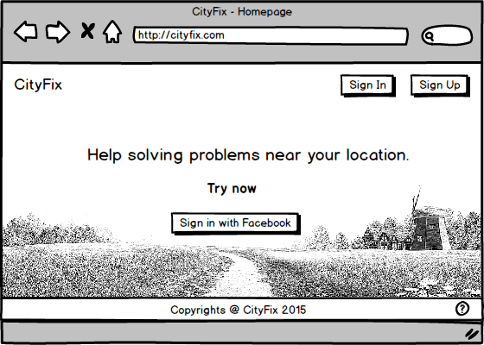

Figure - Homepage UI

**Annex G**

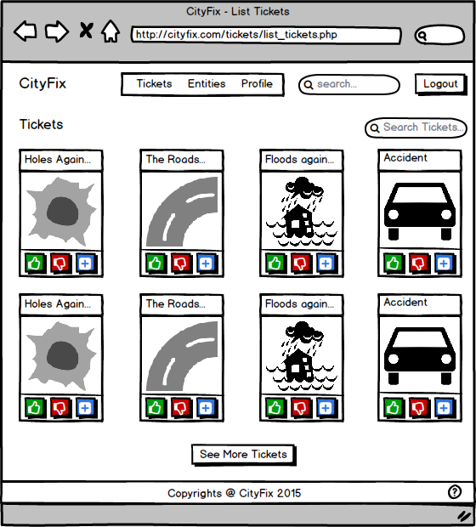

Figure - List Tickets UI

**Annex H**

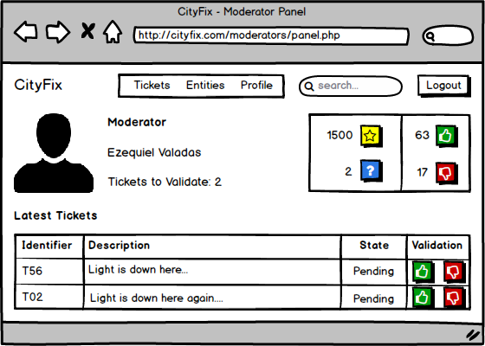

Figure - Moderator Panel UI

**Annex I**

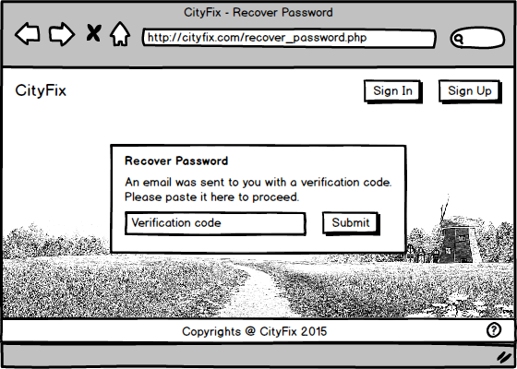

Figure - Recover Password UI

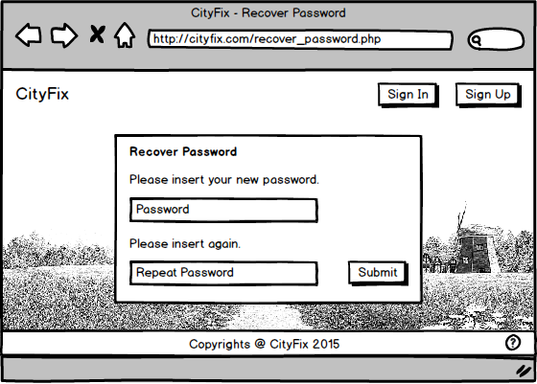**Annex J**

Figure - Recover Password 2 UI

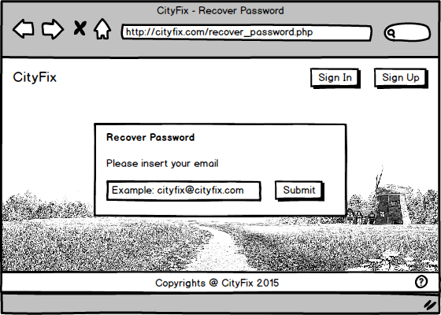**Annex K**

Figure - Recover Password 3 UI

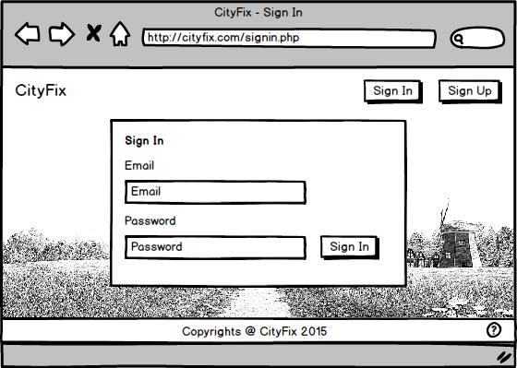**Annex L**

Figure - Sign In UI

**Annex M**

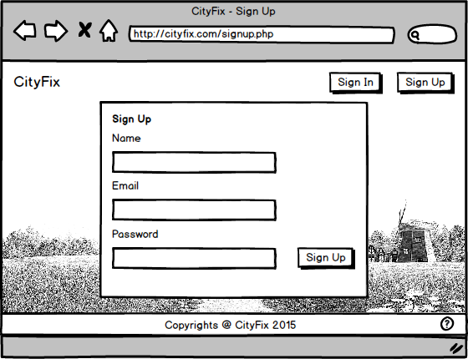

Figure - Sign Up UI

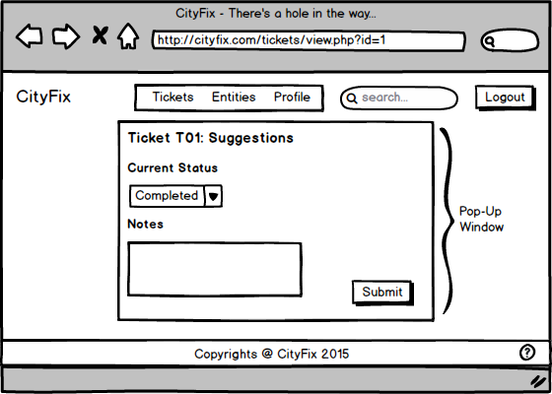**Annex N**

Figure - Suggestions to Ticket UI

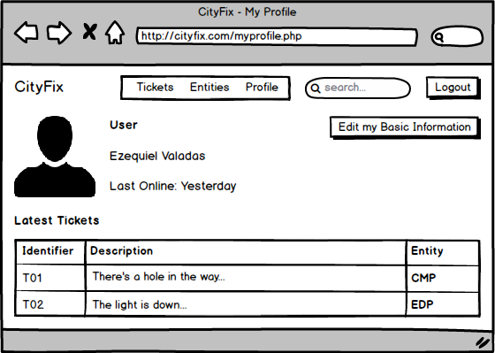**Annex O**

Figure - User Profile UI

**Annex P**

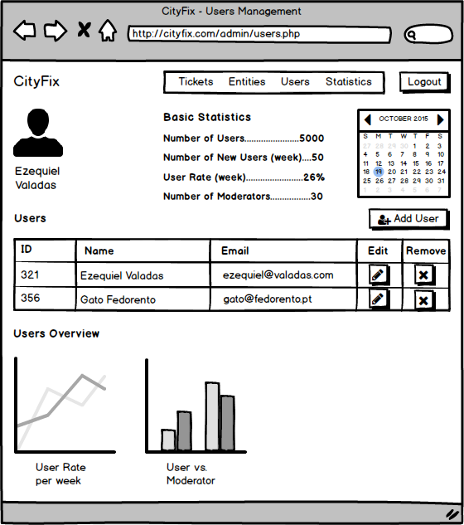

Figure - Users Management UI

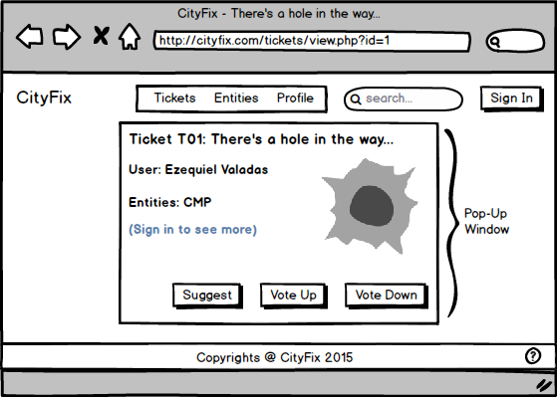**Annex Q**

Figure - View Ticket (online) UI

**Annex R**

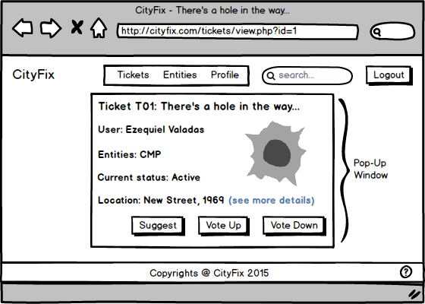

Figure - View Ticket (offline) UI