**JAVA PROGRAMMING**

**LAB CYCLE**

**Note: Strictly follow OOPS concepts & naming conventions**

**Cycle 2**

1. Write a program to implement the **Tower of Hanoi** problem using recursion
2. Write a program to create a class **DynamicArray** to implement a dynamic array. Provide
   1. Constructor to initialize the array
   2. Function to print array
   3. Function to add elements to a position (if position not specified, add to end)
   4. Function to remove elements
   5. Function to search an element
3. Write a program to **Pascal triangle.**
4. Write a program to create a class employee having members Employee id, Employee name, date of birth, date of joining, and salary. Read the details of n employees, sort the employee list in the descending order of salary, and print it. (Note use nested class for date of birth and date of joining)
5. Create a swing program to implement a simple calculator (without drag and drop).
6. Write a program to illustrate exception handling in Java for the following exception.
   1. Number format exception
   2. Null point exception
7. 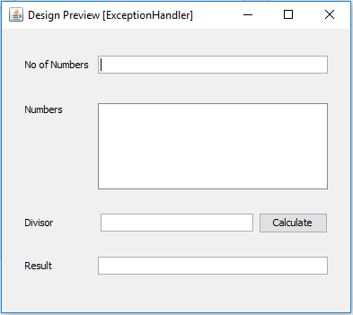Write a program to create the following GUI

To read element s to an array, divide the sum of element s with the given divisor and print the result. Handle all exceptions and alert the user using dialogue.

1. Write a program to illustrate user-defined exceptions.
2. Write a program to create a 2-player tic-tac-toe game (using a grid layout)
3. Write a program to remove duplicate elements from a string array using tree set collection.