Section 2: The Implementability Imbalance
Motivation Section — Draft for Dissertation
Standard machine learning models for stock return prediction optimise a loss function that weights all stocks equally. This section documents three empirical facts that reveal a fundamental misalignment between this training objective and the implementable investment universe. We show that (i) the training sample overrepresents untradeable stocks, (ii) the model predicts best where it matters least, and (iii) the resulting gross alpha is entirely destroyed by transaction costs. These findings motivate the implementability-weighted training framework developed in Section 3.
All results in this section use an ElasticNet model (Zou and Hastie, 2005) as the linear benchmark. The out-of-sample (OOS) period spans January 2000 through December 2024 (299 monthly cross-sections). Liquidity quintiles are formed monthly on 21-day trailing average daily dollar volume.

2.1 The Distribution Mismatch
Under standard training, each liquidity quintile contributes 20% of training observations by construction. However, the fraction of stocks that an investor can profitably trade depends on fund size. We define a stock as implementable at a given AUM if its estimated one-way transaction cost, computed using the Frazzini, Israel, and Moskowitz (2018) model, is below 1%.
Table 1: Training Sample vs. Implementable Universe
Quintile | Training | $100M | $500M | $1B | $5B
Q1 (Illiquid) | 20.0% | 11.1% | 8.3% | 7.0% | 4.4%
Q2 | 20.0% | 18.7% | 17.6% | 16.8% | 13.8%
Q3 | 20.0% | 21.5% | 21.9% | 21.8% | 20.7%
Q4 | 20.0% | 23.6% | 25.1% | 25.8% | 27.8%
Q5 (Liquid) | 20.0% | 25.0% | 27.1% | 28.5% | 33.3%
Notes: Each implementable column sums to 100%. Implementable defined as one-way TC < 1% using Frazzini et al. (2018). Trade size assumes equal-weight positions across 20% of the monthly cross-section.
Table 1 reveals that the training distribution overrepresents illiquid stocks relative to the implementable universe. At our primary AUM of $500M, the two most liquid quintiles (Q4–Q5) account for 52.2% of implementable stocks but receive only 40% of the training gradient. This mismatch intensifies with fund size: at $5B, Q5 alone accounts for 33.3% of implementable stocks while receiving only 20% of training attention. The market impact component of transaction costs scales with √(Q/ADV), disproportionately penalising illiquid stocks as trade sizes grow.

2.2 Prediction Accuracy by Liquidity
We evaluate the standard model’s out-of-sample prediction accuracy within each liquidity quintile using the zero-benchmark R² of Gu, Kelly, and Xiu (2020). Table 2 reports the results.
Table 2: Out-of-Sample R² by Liquidity Quintile
Liquidity Quintile | OOS R² (%)
Q1 (Most Illiquid) | +0.40
Q2 | +0.19
Q3 | +0.10
Q4 | −0.14
Q5 (Most Liquid) | −0.23
Pooled | +0.15
Notes: Monthly OOS R² (%) using zero benchmark. Positive values indicate the model outperforms a naive zero-return forecast. Model trained on the full universe with standard (unweighted) loss.
The results demonstrate a monotonic decline in prediction quality from the most illiquid to the most liquid quintile. For the two most implementable quintiles (Q4–Q5), the R² is negative: the model performs worse than predicting zero. The pooled R² of 0.15% is comparable to the pooled results reported by Gu, Kelly, and Xiu (2020) for ElasticNet, yet it masks the failure in liquid stocks entirely, as it is dominated by illiquid stocks that constitute a diminishing share of the implementable universe.

2.3 The Implementability Gap
We form within-quintile decile long-short portfolios using the standard model’s predictions and compute both gross and net Sharpe ratios across multiple AUM scenarios. Table 3 reports the results.
Table 3: Gross vs. Net Sharpe Ratio by Liquidity Quintile
Quintile | Gross SR | Net $100M | Net $500M | Net $1B | Net $5B | Ret (%) | TC $500M (%)
Q1 | 2.13 | −0.04 | −1.68 | −2.47 | −3.57 | 3.86 | 7.03
Q2 | 1.51 | 0.57 | 0.10 | −0.26 | −1.66 | 2.78 | 2.61
Q3 | 1.15 | 0.46 | 0.25 | 0.09 | −0.59 | 1.94 | 1.53
Q4 | 0.71 | 0.16 | 0.07 | 0.00 | −0.31 | 1.05 | 0.95
Q5 | 0.52 | 0.17 | 0.15 | 0.13 | 0.05 | 0.80 | 0.58
Notes: Within-quintile decile long-short portfolios, equal-weighted. Net SR at each AUM using Frazzini et al. (2018) TC model. Ret and TC are monthly percentages.
The gross and net Sharpe ratios form a “scissors” pattern (Figure 1). Gross SR declines monotonically from 2.13 (Q1) to 0.52 (Q5), confirming that the model’s predictive signal is strongest among illiquid stocks. However, after transaction costs, the picture inverts. At $500M, Q1’s monthly gross return of 3.86% is overwhelmed by 7.03% monthly transaction costs, producing a net SR of −1.68. The optimal quintile shifts rightward with fund size: Q2 at $100M, Q3 at $500M, and only Q5 at $5B. At $5B, Q5 is the sole quintile with positive net performance (SR = 0.05)—yet it receives only 20% of the training gradient.
Figure 1: Gross vs. Net Sharpe Ratio by Liquidity Quintile (Standard Training)
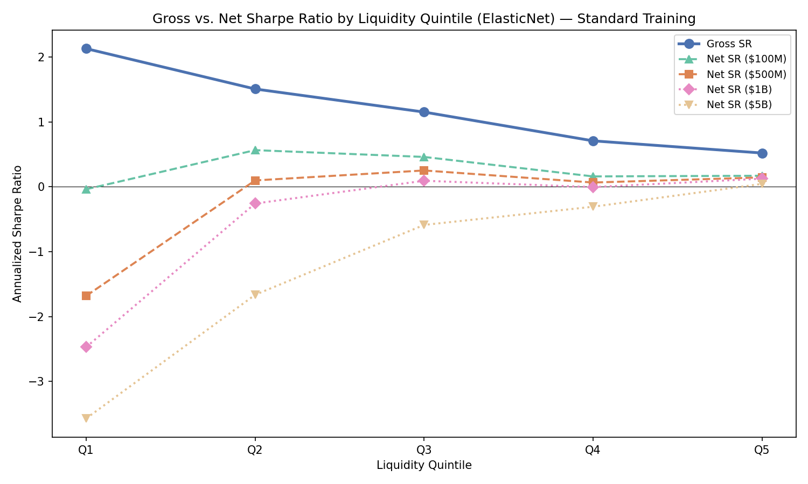
Notes: Solid line shows gross SR (AUM-independent). Dashed lines show net SR at four AUM levels. Within-quintile decile long-short portfolios, ElasticNet, OOS 2000–2024.

2.4 Connecting the Evidence
The three pieces of evidence form a logical chain. Table 1 establishes that 40% of the training gradient is directed at Q1–Q2 stocks, which contribute only 26% of the implementable universe at $500M. Table 2 shows that this misallocated capacity produces the model’s best predictions in precisely the quintiles that cannot be traded: R² is positive only for Q1–Q3. Table 3 completes the argument by demonstrating that even Q1’s impressive gross alpha of 3.86% per month is entirely consumed by transaction costs.
Pooled OOS R² and gross Sharpe ratios are the headline metrics frequently reported in the academic literature. Our quintile decomposition reveals that both are misleading: pooled R² is driven by illiquid stocks that no institutional investor can profitably trade, and gross Sharpe ratios ignore the transaction costs that destroy alpha in precisely those quintiles where the model predicts best. The standard ML training pipeline optimises for the wrong objective.

2.5 Preview: Implementability-Weighted Training
The preceding evidence motivates a natural remedy: reweight the training loss to allocate more capacity to implementable stocks. We preview this approach using a softmax rank weighting scheme, which assigns weights proportional to exp(λ · percentile_i) where percentile_i is the stock’s dollar volume rank and λ = 2.0 controls the contrast. Higher-ranked (more liquid) stocks receive greater weight in the loss function, steering the model toward implementable stocks without discarding illiquid observations entirely.
Table 4: OOS R² Under Standard vs. Weighted Training (Softmax λ = 2.0)
Quintile | Standard | Weighted | Improvement
Q1 (Illiquid) | +0.40% | +0.28% | −0.122
Q2 | +0.19% | +0.16% | −0.027
Q3 | +0.10% | +0.13% | +0.029
Q4 | −0.14% | −0.05% | +0.091
Q5 (Liquid) | −0.23% | −0.20% | +0.034
Notes: R² improvement in percentage points. Weighted training uses softmax rank scheme (λ = 2.0). Both models are ElasticNet with identical features and rolling-window protocol.
Table 4 and Figure 2 demonstrate the capacity reallocation mechanism. Under weighted training, R² decreases by 0.12 percentage points for Q1 (the model devotes less attention to illiquid-stock patterns) and increases by 0.03–0.09 percentage points for Q3–Q5 (capacity is redirected toward implementable stocks). The largest improvement occurs in Q4 (+0.091 pp), which moves from −0.14% to −0.05%—still negative, but substantially less so. These improvements are achieved with a simple linear model; we expect larger effects for the nonlinear models deployed in the main experiment (Section 5).
Figure 2: OOS R² Under Standard vs. Weighted Training (Softmax λ = 2.0)
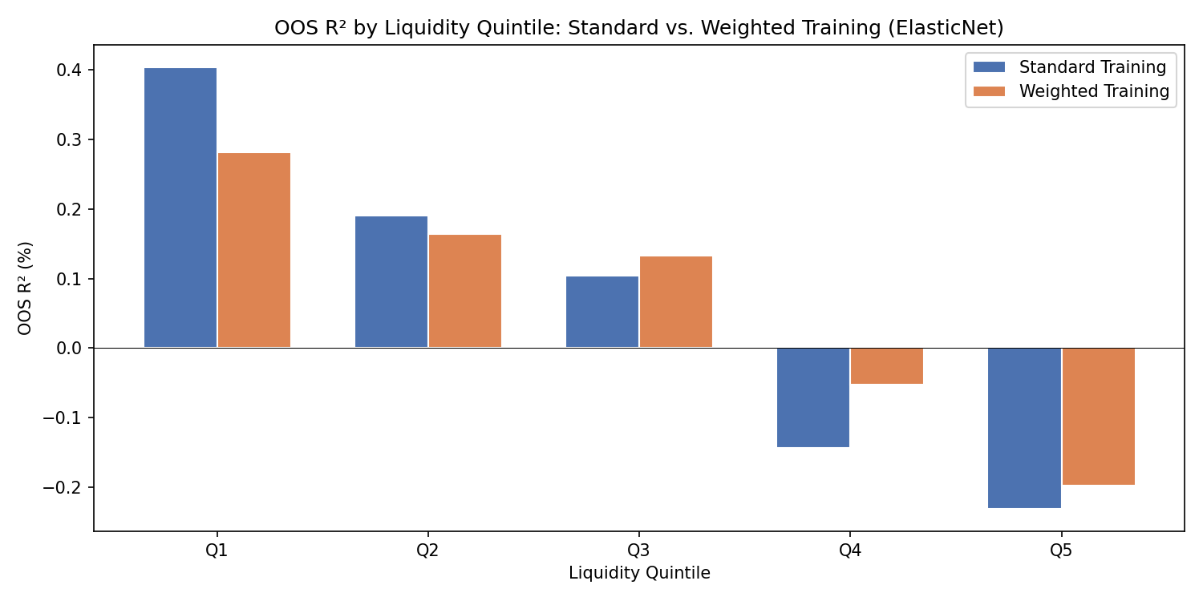
Notes: Blue bars show standard training R²; orange bars show weighted training R². The capacity reallocation is visible: Q1 decreases, Q3–Q5 increase.
Table 5: Net Sharpe Ratio Improvement from Weighted Training at $500M
Quintile | Std Net SR | Wt Net SR | Improvement
Q1 | −1.68 | −2.19 | −0.51
Q2 | 0.10 | −0.00 | −0.10
Q3 | 0.25 | 0.41 | +0.15
Q4 | 0.07 | 0.07 | +0.00
Q5 | 0.15 | 0.07 | −0.08
Notes: Net Sharpe ratio at $500M AUM. Softmax rank weighting (λ = 2.0). ElasticNet, within-quintile decile long-short portfolios.
The net Sharpe ratio improvements concentrate in Q3 (+0.15), the “sweet spot” quintile where stocks are liquid enough to trade but still predictable enough to generate alpha. The improvement is robust across AUM levels, ranging from +0.17 at $100M to +0.11 at $5B. However, the aggressive capacity reallocation of softmax weighting reduces performance in Q2 and Q5, illustrating the trade-off between concentration and breadth. Milder weighting schemes (e.g., spread-based) produce smaller but more uniform improvements across all implementable quintiles. The choice of weighting scheme is examined in full in the robustness analysis (Section 7).
Figure 3: Standard vs. Weighted Training — Gross and Net Sharpe Ratios
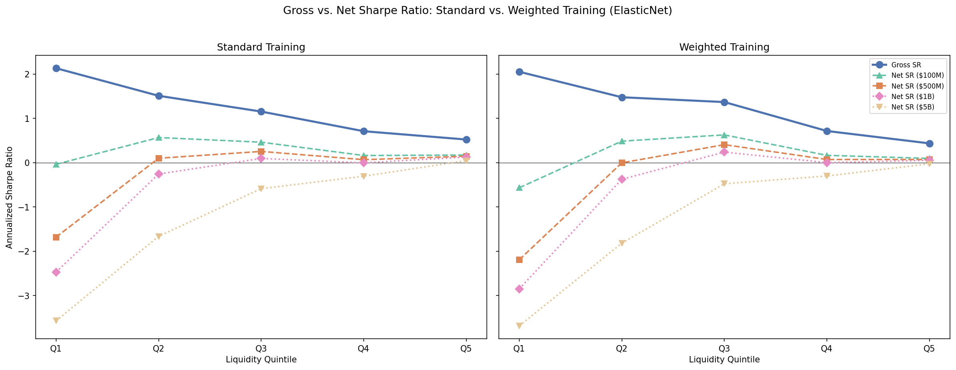
Notes: Left panel shows standard training; right panel shows softmax rank weighted training (λ = 2.0). The gross SR curve (solid) flattens under weighted training as capacity shifts from illiquid to liquid stocks. The net SR curves shift upward for Q3. Shared y-axis across panels.

2.6 Summary and Roadmap
The evidence in this section establishes three facts about standard ML return prediction:
First, the training distribution is misaligned with the implementable universe. At $500M, 40% of training observations come from stocks that contribute only 26% of implementable capacity, and the mismatch worsens with fund size.
Second, the model’s predictive power concentrates in the wrong place. OOS R² is positive only for the three least liquid quintiles and negative for the two most implementable quintiles. The pooled R² of 0.15% masks this failure.
Third, gross alpha is illusory. The most predictable quintile (Q1, gross SR = 2.13) produces deeply negative net returns at any institutional AUM. The “scissors” pattern shows that transaction costs destroy alpha precisely where the model predicts best.
A preview of implementability-weighted training demonstrates that even a simple linear model can partially correct this misallocation: R² shifts from illiquid to liquid quintiles, and net Sharpe ratios improve in the implementable region. These findings motivate the two-dimensional framework developed in Section 3, which combines weighted training (the row dimension) with TC-adjusted portfolio ranking (the column dimension) and tests their individual and joint contributions across three ML architectures.

