Original research papers

Evolution of the bark beetle crisis in the spruce forest: a remote sensing analysis in Belgium and North east France.

Gilles Arthur1, Lisein Jonathan1, Cansel Juliette2, Latte Nicolas1, Piedallu Christian3, Claessens Hugues1

**Abstract**

*Keywords:* Norway spuce, Species vulnerability, Bark beetle, forest management, forest site, topographic condition, time series, Sentinel-2

1 **1. Introduction**

2 Global changes are increasing the risk of disturbances in forest environment: frequency and

3 intensity of abiotic events (fire, storm, drought) and health problems (diseases and pest invasion) will

4 be more recurrent (Lindner et al., 2010). In Western Europe, we expect a decrease of precipitation

5 and an increase of drought events during the vegetation period, which will impact the actual

6 geographic distribution of tree species (Hanewinkel et al., 2013). In this context, Norway spruce

7 (*Picea abies L. Karst*) which is one of the most important economic forest species in Europe

8 (Nystedt et al., 2013) is also one of the most triggered species. Indeed, this species is very sensitive to water shortage (Modrzyn´ski, 2007) and lack of water induces stress that affect growth

10 and health of the tree. Moreover, its major pest, the bark beetle, causes important outbreaks

11 after storm, which provide breeding material e.g. windfalls, or after severe drought that weaken

12 trees. A recent bark beetle crisis, triggered by the exceptionally hot and dry weather of 2018,

13 occurred in Western Europe. It has highlighted the need of improving our

14 understanding of both Norway spruce and bark beetle autecology and synecology for minimizing

15 the impact of bark beetle on spruce stands with adapted management methods. It should concern

16 the monitoring of bark beetle population and early detection of attacks on trees as well as adapted

17 silvicultural methods and adequate species composition of future forest, especially in the thousands

18 of clear-cutted hectares decimated by bark beetle attacks. The Norway spruce is a native species

*Email address:* [arthur.gilles@uliege.be](mailto:arthur.gilles@uliege.be) (Gilles Arthur)

1Li`ege University - Faculty of Gembloux Agro-Bio Tech - unit of forest ressources managment

2Centre National de la propri´et´e foresti`ere

3 Université de Lorraine, AgroParisTech, INRAE, Silva, 54000 Nancy, France

19 of the boreal or mountainous climates of Europe including the Vosges mountains but it has been

20 also successfully planted out of its native range on warmer sites of low altitude, as in the Grand-Est

21 (France) and Wallonia (Belgium) during the 19*th* and 20*th* centuries (Noirfalise and Thill, 1975;

22 Guinier, 1959). The massive reforestations occurring at this time have led to the formation of

23 large pure even-aged stands. It usually develops a taproot system with fine roots in shallow depth,

24 although the roating can adapt its configuration constrained (Puhe, 2003; K¨ostler et al., 1968).

25 The most important pest for Norway spruce are bark beetles species, especially *Ips typographus*

26 that causes the most damages on spruce stands. Thus in this paper, bark beetle refers to this

27 species. Stressed Norway spruce produce volatile compounds which attract bark beetles, making

28 himself more susceptible to pest attack (Netherer et al., 2015, 2021). Bark beetle is ubiquitous in

29 the forest and their populations are usually low (endemic phasis) without producing damage on

30 healthy trees. However a large amount of stressed trees causes a shift to an epidemic phasis with a

31 explosion of bark beetle populations during which even healthy trees are massively attacked (Kautz

32 et al., 2014). The life cycle of bark beetle depends on temperature and photoperiod (Annila, 1969;

33 Baier et al., 2007). In Northern Europe, the bark beetle is univoltine (one single generation) but

34 it is multivoltine (breed two or even three generations) in Western and Central Europe (Annila,

35 1969). After spring swarming, the adult enter in the bark and burrow wood to make brood gallery

36 where they mate and lay the eggs that mature to larvae into the phloem (Hl´asny et al., 2021).

37 The bark beetle adult can re-emerge and swarm a second time to give birth to one sister brood

38 (Zolubas and Byers, 1995). After the larvae maturation that last about seven weeks (Baier et al.,

39 2007), the new generation of beetles emerges and attacks the direct surrounding trees (Zolubas and

40 Byers, 1995). Attacked trees defend themselves by pulsing resin to kill the bark beetle but this

41 defence failed to resist again numerous simultaneous attacks that induce their decline and rapid

42 death. The Norway spruce dieback goes through three physiological stages which are denominated

43 green, red and grey stage. During the green stage, the bark beetle has succeeded to penetrate the

44 phloem and the spruce retains its green needles. The tree is still alive but begins to suffer of water

45 shortage caused by sap conduction problem. After several weeks, the red stage is reached when

46 the needles turn brown-red. The tree is recently dead and the dry needles start to fall. When all

47 the needles of the spruce have fallen off and the grey bark of the trunk is visible, the grey stage is

48 reached (Abdullah et al., 2018). To control the infestation of bark beetle, the practical solutions are

49 limited. The use of phytosanitary product is forbidden in Belgian and French forest. Pheromone

50 trap systems are commercialized to fight bark beetle but they failed to limit the economic loss in

51 case of large outbreak (Kuhn et al., 2022). The only solution to limit the bark beetle population

52 and its associated damages is to fell and remove each attacked tree at the green stage, before the

53 swarming. It takes this ideal breeding material out of the forest.

54 The European Union’s earth observation program, with its satellite twin constellation Sentinel-

55 2A and Sentinel-2B, provides free earth imagery with a high revisit time, which have been inten-

56 sively used for forestry purpose. Time series of Sentinel-2 (S2) images enable to model the phenology

57 courses of vegetation indices in order to detect forest disturbances (L¨ow and Koukal, 2020), like

58 the one caused by bark beetle outbreaks. Infestation maps of the last sanitary crisis have been

59 generated for Germany (Ali et al., 2021; Thonfeld et al., 2022), Czech Republic (B´arta et al., 2021),

60 Italy (Dalponte et al., 2022) and France (Nardi et al., 2022). This paper aims to assess the evo-

61 lution of the bark beetle crisis during the 2017-2022 period in the Walloon and Grand-Est spruce

62 forest using remote sensing. To this end, we map Norway spruce dieback using S2 time series.

63 Then, we analyse the relationship between the level of bark beetle damages and some main

64 environmental parameters such as altitude and topography in order to determine the most sensitive

65 forest sites where Norway spruce forestry should no longer be considered.

66 **2. Material and methods**

67 *2.1. Study area*

68 The study area include Wallonia (south of Belgium) and the Grand-Est region (north-east of

69 France). The Walloon forest covers 554,600 ha and Norway spruce stands occupy quarter of this

70 area (Lejeune et al., 2022). The Norway spruce covers seven percent of the 1,939,000 ha of the

71 Grand-Est forest (Inventaire forestier national fran¸cais, 2022). Both neighbour countries share

72 some similar environmental conditions. They are included in the temperate oceanic bioclimatic

73 zone (Lindner et al., 2010). However at a finest scale, 24 ecoregions have been defined in Wallonia

74 and Grand-Est, mainly by climate and soil parameters and therefore influence the tree species distribution

75 (Walthert and Meier, 2017). To better analyse the dieback of Norway spruce, the French and

76 Walloon ecoregions have been grouped in three main regions according to average temperature and

77 precipitation during the growing season of the 1990-2020 period in three homogeneous bioclimatic

78 areas: Plains, Ardenne and Vosges (Figure 1). Plains are characterized by the lowest rainfall during

79 the growing season( *<* 400 mm) and among the highest mean temperature during the growing season ( *>* 15

C); ecoregions with rainfall between 400 mm and 450 mm and temperature lower than15,5 °C correspond to

80

81 bioclimatic area of the lower Ardenne. Vosges are ecoregions with the highest rainfall (*>* 400 mm)

82 and temperature between 15.5 C and 17 C. The climate variables for Wallonia have been provided

83 by the Institut Royal M´et´eorologique and come from the climate map Digitalis for the Grand-Est (Piedallu et al.,

84 2014) . These three regions differ in their altitude which can be considered as

85 an imperfect proxy for climate (Figure 2). The

86 majority of spruce in the Plains is located in low altitude under 300 m in contrast with the Ardenne

87 and the Vosges where the majority of Norway spruce stand grow above 400 m. The studied spruce

88 area covers 107,926 ha in Ardenne, 24,462 ha in the Vosges and 75.067 ha in the Plains in the

89 Grand-Est region.

90The regional climate is locally influenced by topography

91 (De Frenne et al., 2021). South-facing slopes are warmer and drier and their temperature differ-

92 ence between day and night are greater than the north-facing ones. Three topographic exposures

93 have been determined using the Delvaux and Galoux (1962) definition. Plateaus and plains are neutral topo-

94 graphic conditions that does not create a particular local climate. Comparatively to flat areas, north-facing orientations are

slopes greater than 20% facing north (285 to 125 ) with colder and more shades conditions. South-facing

95

orientations are slopes greater than 20% facing south (125 to 285 ) with a warmer micro-climate.

96

97 The digital elevation model (DEM) data from the Copernicus Land Monitoring Service (European

98 Union, 2022) at a resolution of 25 m have been used for altitude and topographic exposures maps.

99

100 *2.2. Mapping the spruce alive and dieback stands.*

101 The first prerequisite to assess spruce dieback is to map the species distribution at a fine scale,

102 especially in mixed stands where management maps consider mixed stands as undifferentiated

103 entities. For the south of Belgium, we used existing reliable composition maps from Bolyn et al.

104 (2022), computed from remote sensing data, in order to restrict our analysis to Norway spruces.

105 In the Grand-Est, the composition map came from the French national geographic agency (Institut National

106 de l’Information G´eographique et Foresti`ere, 2018). Composition of forest stand was determined

107 by photointerpretation and forest stands identifyed as ”spruce or fir” were selected to

108 restrict the dieback analysis.

Phenology courses are highly suitable for forest

110 tree species discrimination (Lisein et al., 2015; Grabska et al., 2019; Ma et al., 2021). We have used

111 S2 spectral bands courses along the vegetation season to refine the determination of species present

112 in the area interpreted as ”spruce or fir” in the Vosges. The objective was to identify and remove every

113 area that did not correspond to spruce stand All S2 spectral bands were first summarized

115 for each of the four trimesters of the year, by averaging all observations

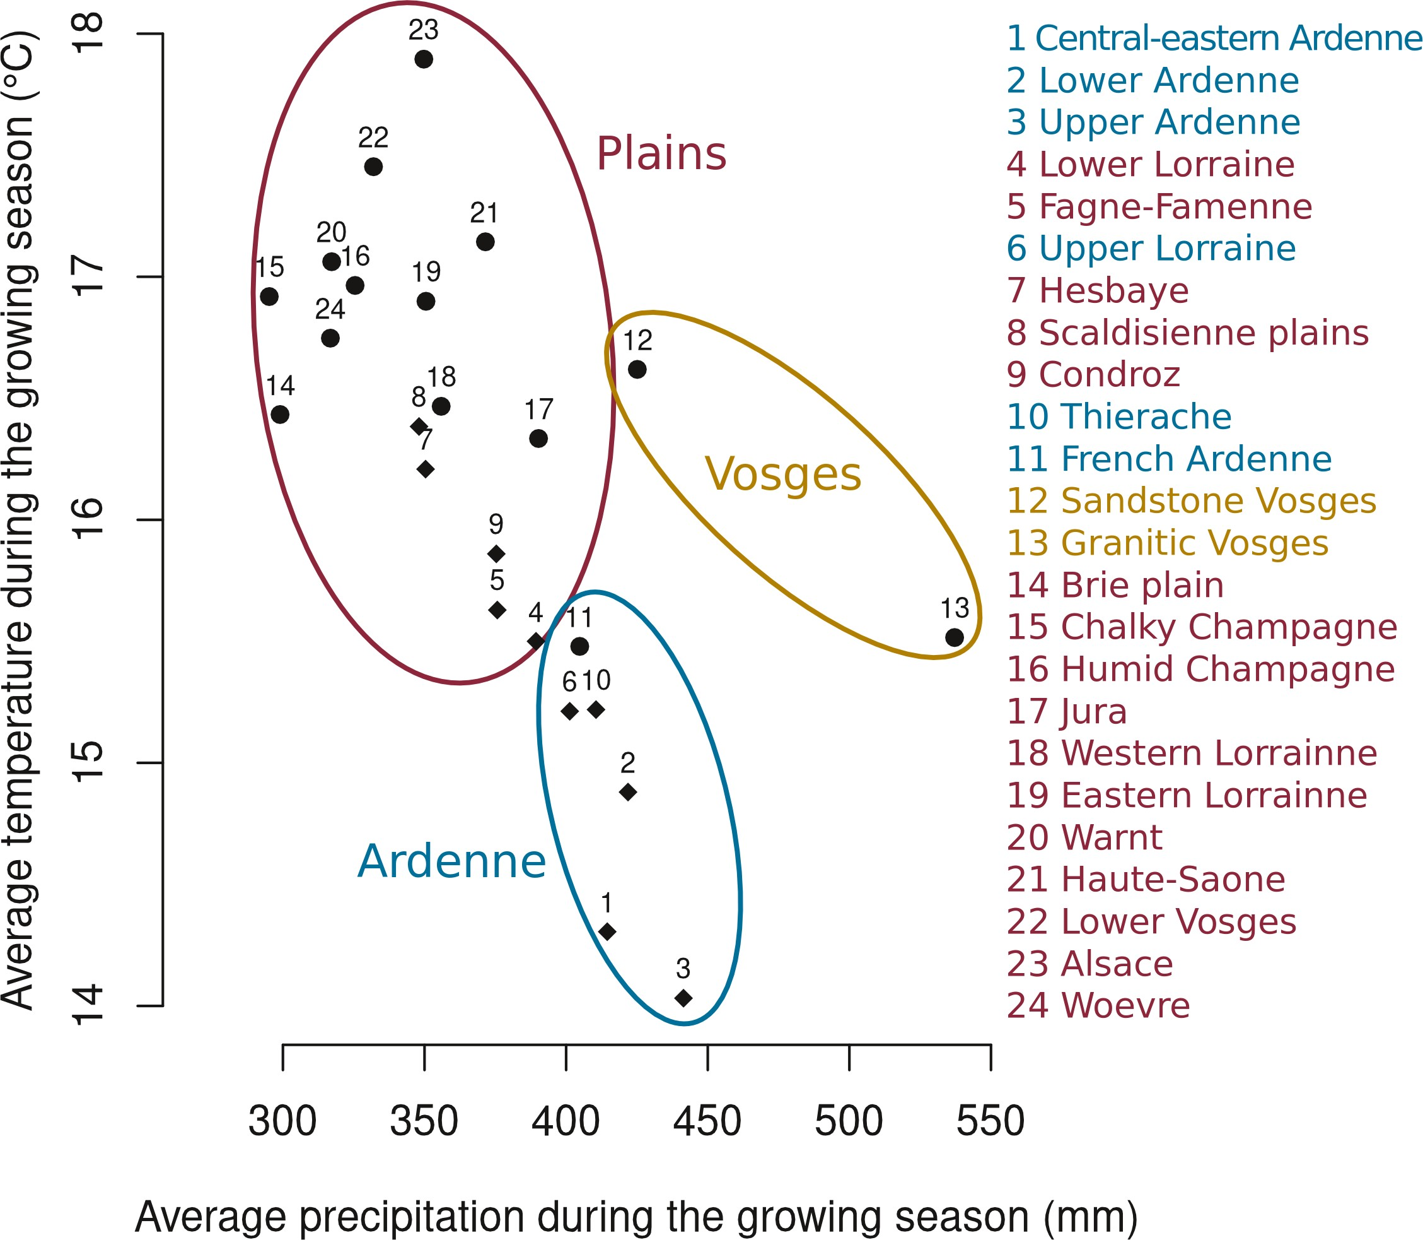

Fig. 1: Groupss of ecoregions according to the temperature and precipitation of the growing season during the 1990-2020 period : Ardenne (blue), Plains (red) and Vosges (orange). Walloon ecoregions are depicted with diamond-shaped points, and Grand-Est regions are illustrated by rounded points.

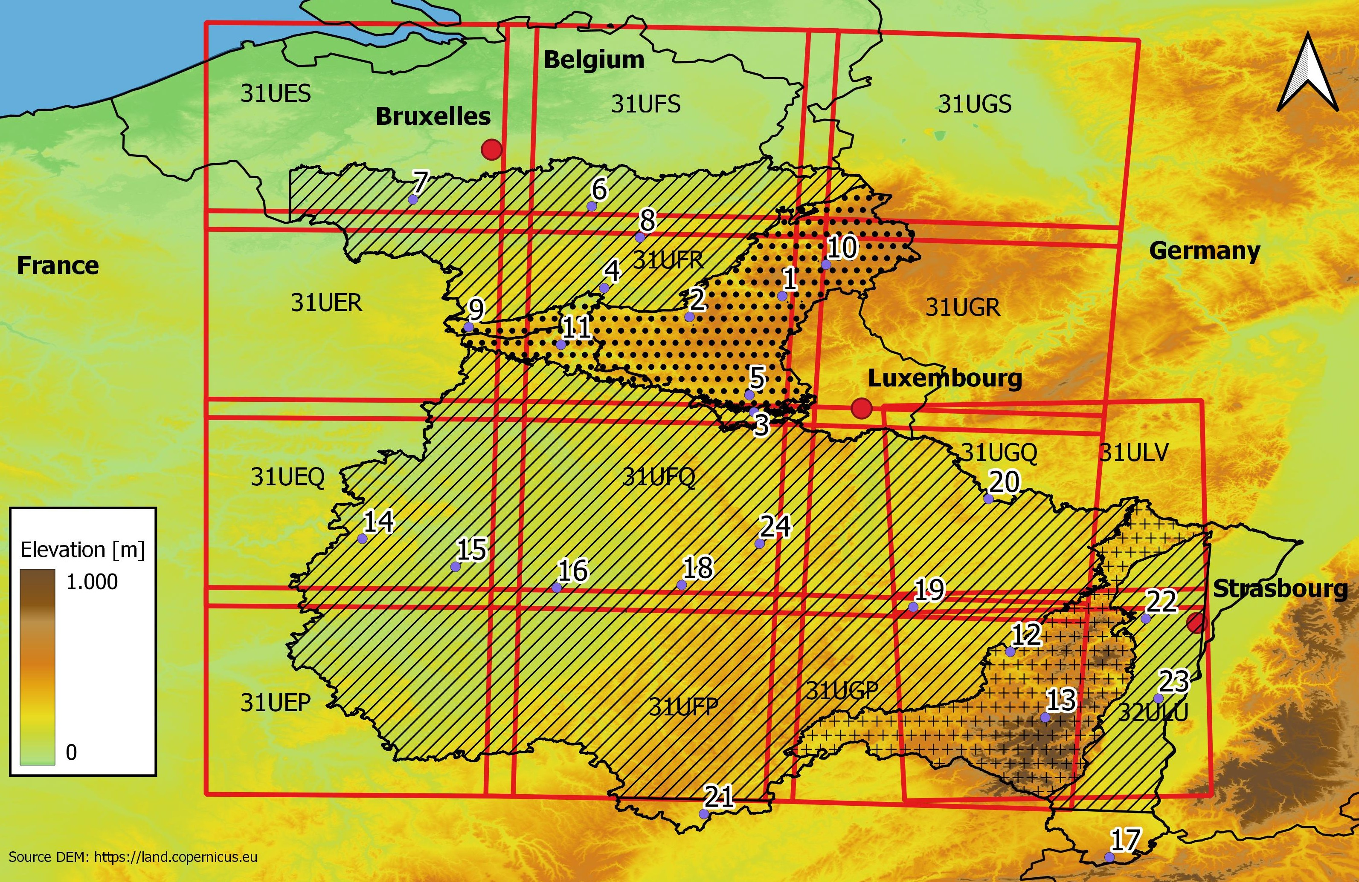

Fig. 2: Study area: Plains (hashed, altitude varying between 100 and 500 meters above see level), Ardenne (black dot, altitude between 200 and 700 m) and Vosges (cross, altitude ranging from 300 to 1500 m). Red squares illustrates the extend of Sentinel satellite 2 tiles which are used for the detection of bark beetle attack.

116 . Then, a Random Forest algorithm was trained on these synthetic intra-annual time

117 series to discriminate spruce from non-spruce pixels, based on a training set of observation from

118 Belgium (Bolyn et al., 2018). this Random Forest classifier was applied on ”spruce

119 and fir” area of Vosges and bark beetle detection was carried on only for pixels detected as spruce.

120 The detection of Norway spruce dieback was realized by using dense time series of S2 imagery

121 following the methodology developed by Dutrieux et al. (2021). Sentinel-2 (S2) satellites carry

122 multispectral sensor with a ground resolution up to 10 m. The study area is covered by 14 Sentinel-

123 2 tiles of 100km x 100km (Figure 2). Vegetation changes were tracked by means of a phenology

124 metric, the *SWIR Continuum Removal* vegetation index (*SWIRCR*). All S2 acquisitions were used

125 in the analyses, provided that the cloud cover does not exceed 35 percent. Bottom of Atmosphere

126 reflectance images (L2A product) were downloaded from the Theia data cluster (Theia Team,

127 2022) for all the 14 tiles. The *SWIRCR* is based on three spectral bands, the near-infrared, the

128 shortwave infrared 1 band and the shortwave infrared 2, and is sensitive to the foliage water content:

129 it is appropriated to detect spruce dieback during the green stage of bark beetle attack (Figure

130 3). Seasonal variation of *SWIRCR* for healthy stand was modelled and a bark beetle attack was

131 detected if the observations deviate from the healthy phenology trajectory. Figure 3 illustrates

132 a time-serie of *SWIRCR* observations (grey dots) for one pixel. When the observations went

133 beyond the threshold represented by the purple-dashed line (in 2018 in Figure 3), the spruce stand is

134 most likely suffering from a serious stress. As soon as *SWIRCR* vegetation index shows a stress

135 for at least three consecutive times Dutrieux et al. (2021). We assume that the stress i caused by a

136 bark beetle attack, in parallel to the detection of bark beetle stress, stand cutting and thinning were

137 subject of particular attention. Bare soil was detected by using a combination of thresholds for red,

138 green, blue and shortwave infrared reflectance values (Band 8A 12% reflectance and Band 2 6 %

*≥ ≤*

139 reflectance and Band 3 + Band 4 8 % reflectance). Cutting are thus taken into account and were

*≥*

140 classified either as normal harvest cutting or as sanitary thinning based on the health status prior to

141 the cutting. The analysis of image time-series was thus quite straightforward and has been performed

142 individually pixel per pixel starting from the 2016 year, which is the beginning of S2 acquisitions and

143 corresponds to the first reported increase of significant of bark beetles attacks in Belgium. Although

144 Dutrieux et al. (2021) have published their methodology as a open-source python package, named

145 *FORDEAD*, we have adapted the pipeline in C++ in order to comply with our specific requirements

146 (our code is online on github repository <https://github.com/JoLeBelge/s2-spruce-dieback/>).

147 We made use of OTB toolbox (Grizonnet et al., 2017) for image processing and the health status

148 was summarized by seasonnal annual health maps (in raster format). The annual health maps cover

149 the period starting from may and finishing in april of the next calendar year, because we made the

150 assumption that Norway spruce dieback detected in april are related to bark beetle attack from the

151 previous calendar year (Mu¨ller et al., 2022). For every year between 2018 and 2022, the health

152 status of every pixel located in a spruce stand is summarized in four

153 classes: healthy, bark beetle attacked, cutted or sanitary thinning. In view of the rapid death of

154 spruce trees, it is assumed that all trees detected as dead are due to bark beetle attack. The dense

155 time-serie covers the 2017-2022 period and count a minimum of 126 and maximum 260 acquisition

156 dates according to the location. The annual time-serie enumerate a minimum of 10 and maximum of 51 acquisition dates. Introduce here the term of “sanitary map” you use after …

157 The maps of spruce health status were validated by three different methods. Firstly,

158 a global validation with annual orthophotoplan on random spruce stand on the 2018-2021 period.

159 The sanitary level of the spruce stand in the sanitary map was compared with thehealth

160 status observed on the orthophotoplan. Secondly, a stratified random sampling based on the

161 size of the dieback area on the sanitary map was used for 2018. The dieback area is a combination

162 of bark beetle attacked area and sanitary cutting area. The selected stands were photo-interpreted

163 with the annual orthophotoplan of the Wallonia. A field validation on the Vosges massif have been

164 realized on 95 stands in winter 2020-2021. Each stand have been inspected for the presence of bark

165 beetles or dead trees. The result of this field inspection have been compared with the sanitary map.

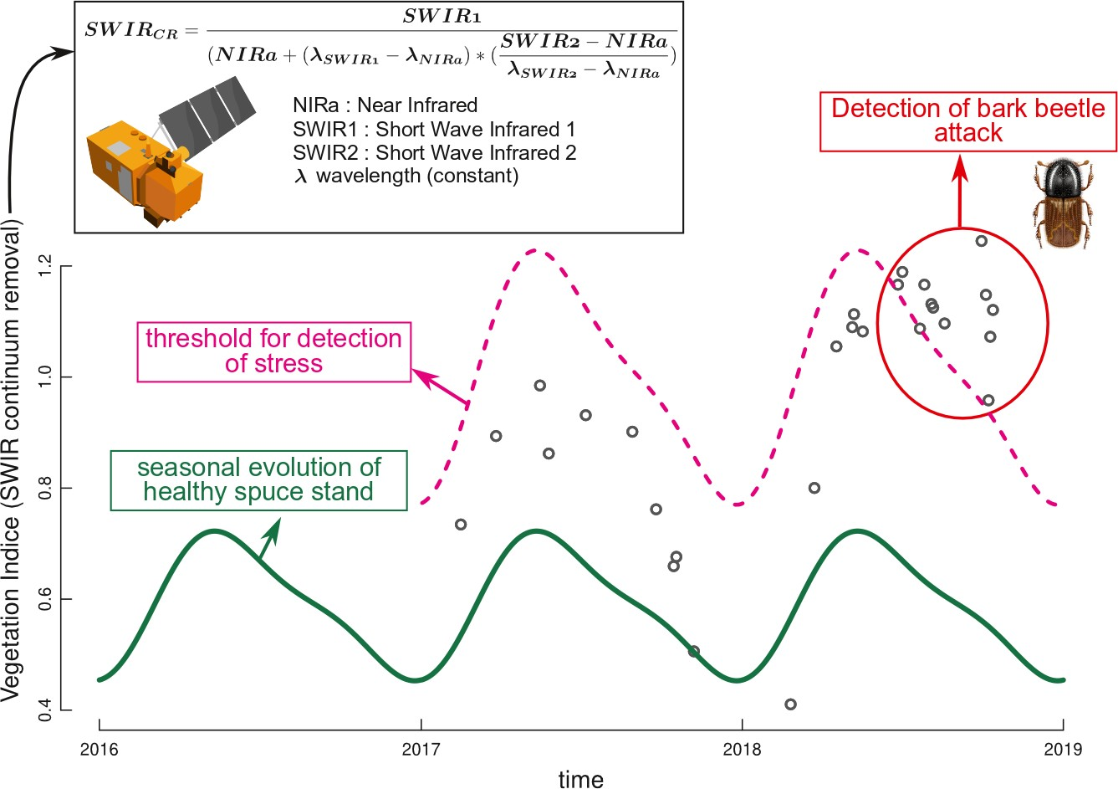

Fig. 3: Bark beetle infestation map are computed by detecting change in the *SWIRCR* phenology metric. The *SWIR Continuum Removal* is computed using three bands from Sentinel-2 imagery for every single acquisition date and its value is compared to a threshold (purple dashed line) in order to detect vegetation stress. If a stress is detected three consecutive times, we assume dieback occured.

166 *2.3. Relation between bark beetle attack and topographical conditions*

167 The forest practitioners of the two countries drew our attention to the variables that seemed

168 to influence spruce dieback. According to them, the south-facing slopes and low altitude favor

169 the spruce dieback. This hypothesis match with autecology of spruce, that is known to suffer

170 from heatwaves and low water availability. Indeed, in the study area, precipitation increase with

171 altitude, temperatures decrease the higher the altitude at least within the tree main ecoregions.

172 In addition, the warmer climate of south-facing slopes favours the development of bark beetle

173 population (Annila, 1969; Baier et al., 2007; J¨onsson et al., 2009; Marini et al., 2012) and increase

174 the susceptibility of Norway spruce to the attack of bark beetle (Wermelinger, 2004; Netherer et al.,

175 2015). Following this theory, there should be more attacked Norway spruce in low altitude and in

176 south-facing slopes in the three climatic areas. Sanitary map has been used to study the relation

177 between the dieback and these two topographic variables. The altitude has been broken down by

178 100 m classes and kept the three topographic exposures classes. To determine which class of the

179 two topographic variables was most affected, we estimated the dieback areas for each class of each

180 factors based on the health status maps for each year of the period 2017-2021. The annual ? dieback

181 rate is the dieback area of a class during one year divided by the total area of Norway spruce of

182 this class at the beginning of the same year. Dieback area is the surface of Norway spruce attacked

183 by bark beetle and the area of sanitary cutting during the year. The total area of spruce at the

184 beginning of the years is composed of the area of healthy spruce area at the beginning of the year.

185 **3. Results**

186 *3.1. Sanitary map validation*

187 The photo-interpretation of spruce stand crossed with the sanitary mapshows when the sanitary map predicts a decline, the dieback is confirmed by the orthophotoplan

189 in 86.1 % of the verified spots (Table 1). In 13.9 % this is a false positive because the trees are still healthy.

Table 1: Sanitary map validation using aerial photographs for 274 spruce stands.

|  |  |  |
| --- | --- | --- |
| Orthophotoplan  Sanitary map | Dead trees | Healthy trees |
| Attacked trees | 86.1 % | 13.9 % |

190

191

206

207

208

209

210

211

212

The field validation in the Vosges confirms the result of the photo-interpretation method. Dead stands are identified correctly in 84.7 %. The healthy stands on the sanitary map are validated in 100 % of the stand in the field (Table 2).

Table 2: Sanitary map validation for 95 spruce stands using field survey in the Vosges mountains.

|  |  |  |
| --- | --- | --- |
| Field  Sanitary map | Dead trees | Healthy trees |
| Dieback trees (=39) | 84.7 % | 15.3% |
| Healthy trees (n=56) | 0 % | 100 % |
|  |  |  |

|  |  |  |  |
| --- | --- | --- | --- |
| Region | Total spruce dieback  area during the crisis (ha) | Total spruce area  before crisis (ha) | Percentage of area  with dieback |
| Plains | 11,298 | 21,720 | 52,0 |
| Ardenne | 13,397 | 107,926 | 12,2 |
| Vosges | 4,305 | 75,067 | 5,7 |
| Total | 29,000 | 204,763 | 14,2 |

Replace commas by dots

*3.3. Influence of altitude on the Norway spruce mortality*

. Because spruce was planted outside its distribution range in low altitude and according to studies showing a shift of species distribution along the altitudinal gradient (add references like lenoir (Lenoir et al. 2008 A Significant Upward Shift in Plant Species Optimum Elevation During the 20th Century), more mortality was expected at lower altitude. The variation of the dieback rate during the 2017-2021 for the three biocli- matic regions. The shows an important effect of altitude, but with some differences according to the region. More dieback was observed at low altitude : at the height of the crisis, the probability of new dieback exceeded 20% each year in the altitude class under 300 m. In Ardenne, since the beginning of the crisis, the dieback rate is gradually decreasing when altitude

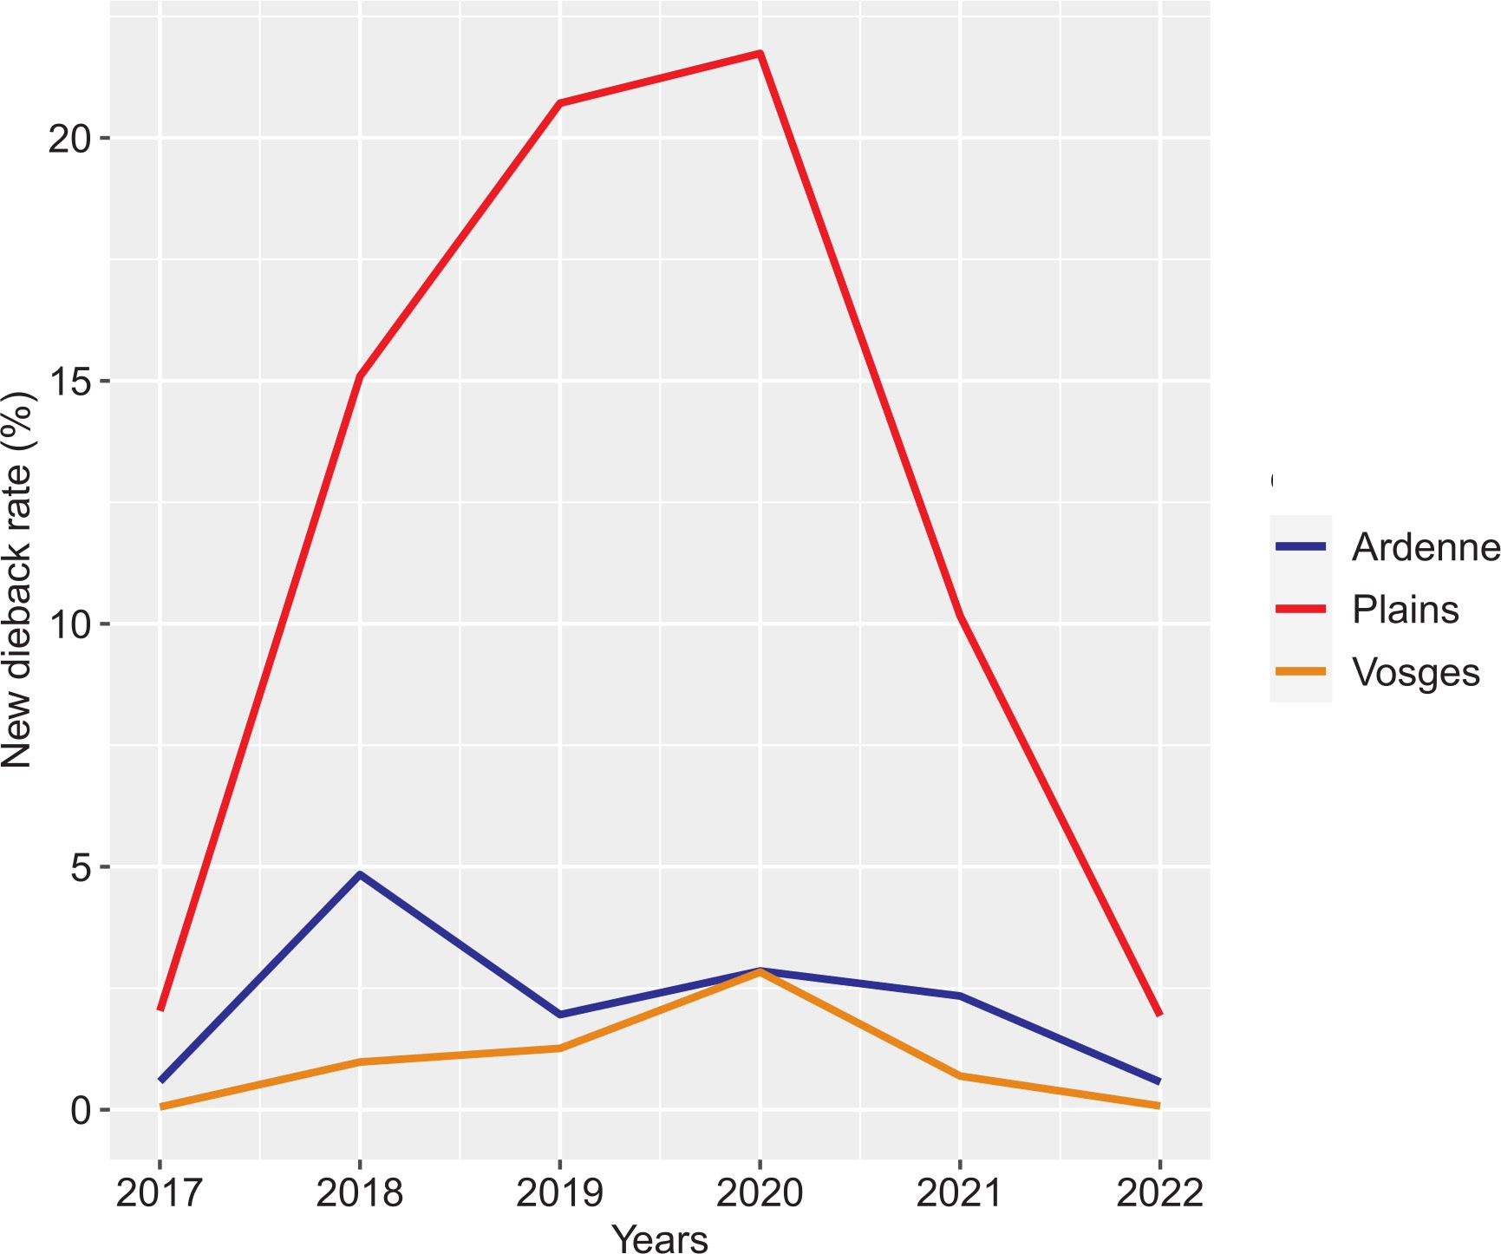

Fig. 4: Proportion of Norway spruce area affected each year by bark beetle according to the region.

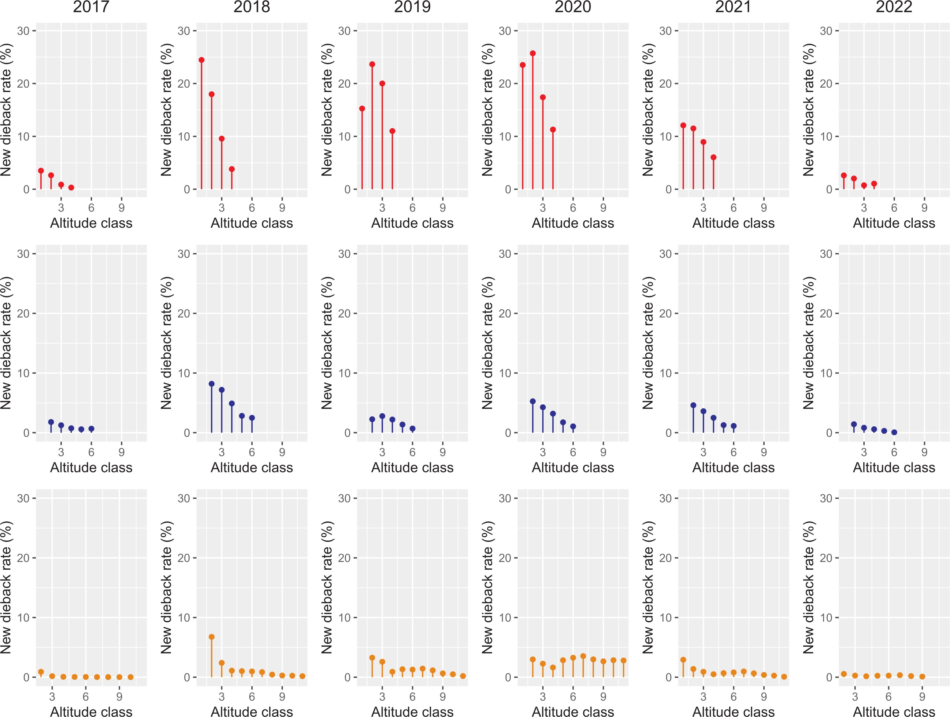

Fig. 5: Variation of the dieback rate from 2017 to 2022 according to the altitude which has been subdivided into 11 altitude classes of 100 m amplitude for the three regions: Plains (red), Ardenne (blue) and Vosges (orange).

213 is increasing. Except during 2018, at the peak of the crisis, spruce forest above 500 m were not

214 severely affected. In the Vosges, the dieback rate is globally low during the crisis comparatively to the other regions, except for 2020.

215 No clear trend seems to emerge according to the altitude except in the beginning of the crisis in

216 2018 in the lower stands below 400 m altitude. However,Vosgian spruces are rare below 400 m.

If I sum mortality rates at low altitude for plains I have something near 80% ? It should be interesting to provide some statistics for low altitudes and the different regions

217 *3.4. Influence of exposure on the Norway spruce mortality.*

218 The cumulative killed areas of Norway spruce during five years of crisis according to the exposures is presented in the table 4 and shows contrasted results according to the region.

220 For plains, the north-facing slopes are significantly but slightly more affected than the plateaus or the south-

221 facing slopes. In Ardenne, the plateaus are significantly less impacted than the north and south

222 facing slopes. In this region, the south-facing slopes are significantly more affected. As opposed

223 to the Ardenne, in the Vosges, the plateaus are significantly more impacted than the north and south-facing slopes.

Table 4: Par of the studied area killed by bark beetle according to the exposures during the 2017-2022 period. The same letters (a, b, c) identify homogenous groups with no significant differences for each exposures (based on Pearson’s chi-squared test statistic, p-value *<* 0*.*05)

|  |  |  |  |
| --- | --- | --- | --- |
|  | Dieback rate (%) | | |
| Plains | Ardenne | Vosges |
| Plateau | 51*.*8*a* | 11*.*9*a* | 7*.*2*a* |
| South-facing slopes | 51*.*5*a* | 15*.*2*b* | 5*.*4*b* |
| North-facing slopes | 54*b* | 14*.*4*c* | 5*.*1*c* |

|  |  |
| --- | --- |
| 224 | Mettre les effectifs les pentes dans les plaines doivent être peu nombreuses / vosges … |
| 225 | **4. Discussion** |
| 226 | *4.1. Potential methodological limitations* |
| 227 | The detection of dieback is based on dense time series of Sentinel 2 satellite imagery. |
| 228 | The sanitary map uses a species composition map that depend of the spectral response of the |
| 229 | vegetation.. In |
| 230 | pure even-aged Norway spruce stand, the spectral response is stable in the absence od mortality, but at edge of this stand and |
| 231 | in mixed stand, this response can varies with season due to the deciduous tree or herbaceous species. In |
| 232 | mixed forest and in the border of the stands, the species composition map is less accurate than in |
| 233 | pure even aged stand. In Ardenne and in the Plains, Norway spruce occurs principally in pure even- |
| 234 | aged stands of but in the Vosges forests are more finely mixed. The annual dieback rate is influenced |
| 235 | by Norway spruce area of the composition map. In Ardenne and in the Plains, the area is correctly |
| 236 | estimated. However, in the mixed stands of the Vosges, the area is more difficult to evaluate. An |
| 237 | underestimation of dieback rate is not excluded. Another limitation of the methodology is linked |
| 238 | to the felled trees. To limit the damage of bark beetles, it is recommended to quickly remove |
| 239 | the attacked trees from the forest. However, if the trees are felled before three images are |
| 240 | taken by the satellite, the area will be considered as cutted for normal harvesting rather than for |
| 241 | a sanitary thinning. On the contrary, some felled trees of sanitary thinnings can be healthy but |
| 242 | considered as attacked. |
| 243 | *4.2. Dynamic of the dieback* |
| 244 | In forest, sanitary crisis lasts on average between three and ten years (Brunier et al., 2020). In |
| 245 | our study, the spruce dieback have begun in 2018 and decrease in 2022 in all the regions. |
| 246 | The annual dieback rate has recover in 2022 the same level than in 2017. The Plains bioclimatic region is the |
| 247 | most impacted region. Since the first year of the study, the new dieback rate has increased until |
| 248 | it reached its peak in 2020. In the Ardenne, the peak were reached directly in 2018 during the |

249 first drought period. A decrease of the dieback occurred during the year 2019. After the peak the

250 dieback rate has stabilised below 3 %. The Vosges were the less impacted bioclimatic area. The

251 peak of the crisis was reached in 2020 with 2.8 % of affected spruce. During the five years of the

252 crisis, the new dieback rate remained below 3 %.

253 *4.3. Regional impact of the bark beetle attacks*

254 The impact of the bark beetle attacks is different between the three main regions. It could be

255 explained through three parameters which differentiate them : the climate, the stand structure and

256 composition, and the current spruce forest management. Warm and dry climate, as in the Plains,

257 does not meet the autecological requirements of the spruce species, especially during extreme dry

258 or warm events as in the period 2018-2020 (Rousi et al., 2022) which stressed the spruce. Moreover

259 during warm seasons, the bark beetle produce multiple generations in a year (Annila, 1969; Baier

260 et al., 2007) that can easily attack these stressed trees. At the other hand, pure even-aged spruce

261 stands of the Plains and Ardenne are significantly more sensible to pests attacks (Faccoli and

262 Bernardinelli, 2014; Jactel et al., 2021) than the spruce trees beneficing from continuous cover

263 forestry in mixed stands of the native forest in the Vosges mountains. Rapid harvesting of trees

264 attacked by bark beetles protects stands from severe outbreaks (Stadelmann et al., 2013) but this

265 operation is not systematic in region such as Plains where softwood forestry is not part of the

266 tradition and is not supported by local industry. Faced with these three parameters, the three

267 main regions are not equal. In the Vosges, all parameters are favourable, which could explain

268 the limited outbreak during the crisis ( 5.7% of initial area). Indeed, on the opposite, in the

269 Plains all parameters are unfavourable : the warm and dry climate stressed the trees and favoured

270 the beetles which produced large outbreaks in even-aged pure stands, probably less concerned by

271 sanitary thinning. These conditions explain that the outbreak was not controlled and reached 52

272 % of the spruce area. The Ardenne spruce forest is an intermediate situation. The climate is the

273 coldest of the three bioclimatic areas, but less humid then the Vosges. The forest manager generally

274 make the necessary sanitary felling which is part of the silvicultural tradition. However, spruce

275 grows in pure even-aged stands. These conditions could explain an intermediate situation with

276 damages on 12.2 % of the spruce initial area.

277 *4.4. Influence of the topographical exposures on the dieback of Norway spruce.*

278 The exposure influences received radiation and water balance. South facing slopes are warmer than north

279 facing ones (reference ?). As the life cycle of the bark beetle is influenced by temperature (Baier et al., 2007), this

280 insect should produce more generations in south-facing slopes and thus cause more damage in this

281 exposure (Jakuˇs, 1995). Moreover, there is 50 % less water reserve in south-facing slopes than in

282 north-facing slopes in spring (Rouse and Wilson, 1969). Thus, Norway spruces that growth in this

283 orientation should be more often in a situation of water stress and should be more attacked than

284 the north-facing slopes. And what do you expect for flat areas ? However, our results do not clearly fit with this hypothesis. In the Plains

285 , the south-facing slopes and the flat areas are more or less attacked at the same way

286 than the north-facing slopes. In Europe and in north America, Gazol (Gazol et al., 2017) observed

287 that species that grow in drier condition area are more resilient to drought. Piedallu (Piedallu et al.,

288 2022) confirmed this observation in the Vosges during the last outbreak. Moreover in France, a

289 recent study of Nardi et al. (2022) showed that Norway spruce stand on the steep slopes and soils with

290 low water availability are less attacked. In the Vosges, spruce trees growing on the southern slopes

291 and plains have suffered of drier conditions throughout their lives and therefore have been less

292 stressed than spruce trees growing on the north-facing slopes. In Ardenne, the south-facing slopes

293 are more affected by bark beetle than other position. Norway spruce that growth in south-facing

294 slopes should be more often in a situation of water stress and should be more attacked than the

295 north facing-slopes. However the north-facing slopes are not the less attacked. The shallow soil

296 depth on the slopes could explain the dieback rate difference between de slope and the plateaus. In

297 the Ardenne and in the Vosges, the result are opposed for the plateaus. The damage caused in the

298 Vosges plateaus could be explained by the more important presence of pure even-aged stand in this

299 topographical orientation than in the slope. This stand structure is more sensible to bark beetles.

300 The trend of bark beetle attacks following the topographical exposures need further investiga-

301 tions. In view of these results, it seems difficult to give global advice for forest managers.

302 **5. Conclusion and perspectives**

303 Our study aimed to assess the evolution of the bark beetle crisis in the spruce forest with

304 a remote sensing approach. The methodology used to identify the damaged stands is robust

305 and effective as far as reliable species composition maps are available. Indeed, to improve the result in

306 the Vosges, a new Norway spruce map is necessary to better distinguish spruce from fir. Taking

307 this limitation into account, remote sensing could be the basis for monitoring bark beetle attacks

308 in spruce forest. This crisis triggered by the dry and warm events from 2018 to 2020 lasted five

309 years and destroyed 14 % (29.000 ha) of the spruce area in Wallonia and Grand-Est of France. In

310 2022, new bark beetle attacks recover its level of 2017 and seems then over. The damages were

311 not equally distributed on the territory : the Plains are the most impacted regions with more than

312 50% of the spruce area impacted by bark beetles. The devastated area by this pest is estimated

313 around 11,000 ha. The Ardenne is the second region that has lost the most spruce area with 12,4

314 % of his spruce area attacked or around 13,400 ha. The Vosges is the less attacked region with

315 5.7 % of his spruce area killed. The total area impacted in this mountain region is around 4,300

316 ha. This situation could be linked to the climate, the structure and the composition of the stands,

317 and the current forest monitoring and management which differ between the three regions. Taking

318 into account to the climate change, which will favour warm and dry events in the near future, our results

319 does not support new plantations of Norway spruce in Plains. In Ardenne, we advise not to plant

320 any more Norway spruce at lower altitude then 400 m except in specific micro-climate. In the

321 Vosges, the trend differs of the two others regions. More investigation specially dedicated to this

322 region is necessary to draw conclusions. A study taking into account the effects of environment,

323 climate and silvicultural factors would be interesting to better understand the determining factors

324 of these bark beetle attacks of this important species for the wood industry.

325 **6. Acknowledgements**

326 This research has been funded thanks to the *RegioWood II* project and to the *Plan quinquennal*

327 *de recherches foresti`eres* of the Service Public de Wallonie (forest administration).

328 **References**

329 Abdullah, H., Darvishzadeh, R., Skidmore, A. K., Groen, T. A., and Heurich, M., 2018. European spruce bark beetle

330 (Ips typographus, L.) green attack affects foliar reflectance and biochemical properties. *International journal of*

331 *applied earth observation and geoinformation*, 64:199–209.

332 Ali, A. M., Abdullah, H., Darvishzadeh, R., Skidmore, A. K., Heurich, M., Roeoesli, C., Paganini, M., Heiden, U.,

333 and Marshall, D., 2021. Canopy chlorophyll content retrieved from time series remote sensing data as a proxy for

334 detecting bark beetle infestation. *Remote Sensing Applications: Society and Environment*, 22:100524.

335 Annila, E., 1969. Influence of temperature upon the development and voltinism of Ips typographus L.(Coleoptera,

336 Scolytidae). In *Annales Zoologici Fennici*, pages 161–208. JSTOR.

337 Baier, P., Pennerstorfer, J., and Schopf, A., September 2007. PHENIPS—A comprehensive phenology model of Ips

338 typographus (L.) (Col., Scolytinae) as a tool for hazard rating of bark beetle infestation. *Forest Ecology and*

339 *Management*, 249(3):171–186. ISSN 03781127.

340 Bolyn, C., Michez, A., Gaucher, P., Lejeune, P., and Bonnet, S., 2018. Forest mapping and species composition using

341 supervised per pixel classification of Sentinel-2 imagery. *Biotechnologie, Agronomie, Soci´et´e et Environnement*,

342 22(3):16.

343 Bolyn, C., Lejeune, P., Michez, A., and Latte, N., 2022. Mapping tree species proportions from satellite imagery

344 using spectral–spatial deep learning. *Remote Sensing of Environment*, 280:113205.

345 Brunier, L., Delport, F., and Gauquelin, X., 2020. Guide de gestion des crises sanitaires en forˆet. page 188.

346 B´arta, V., Lukeˇs, P., and Homolov´a, L., 2021. Early detection of bark beetle infestation in Norway spruce forests of

347 Central Europe using Sentinel-2. *International Journal of Applied Earth Observation and Geoinformation*, 100:

348 102335.

349 Dalponte, M., Solano-Correa, Y. T., Frizzera, L., and Gianelle, D., 2022. Mapping a European Spruce Bark Beetle

350 Outbreak Using Sentinel-2 Remote Sensing Data. *Remote Sensing*, 14(13):3135. Publisher: MDPI.

351 De Frenne, P., Lenoir, J., Luoto, M., Scheffers, B. R., Zellweger, F., Aalto, J., Ashcroft, M. B., Christiansen, D. M.,

352 Decocq, G., De Pauw, K., Govaert, S., Greiser, C., Gril, E., Hampe, A., Jucker, T., Klinges, D. H., Koelemeijer,

353 I. A., Lembrechts, J. J., Marrec, R., Meeussen, C., Og´ee, J., Tyystj¨arvi, V., Vangansbeke, P., and Hylander, K.,

354 June 2021. Forest microclimates and climate change: Importance drivers and future research agenda. *Global*

355 *Change Biology*, 27(11):2279–2297.

356 Delvaux, J. and Galoux, A., 1962. *Les territoires ´ecologiques du Sud-Est belge*. Centre d’´ecologie g´en´erale.

357 Dutrieux, R., Feret, J.-B., Ose, K., and De Boissieu, F., 2021. Package Fordead. URL [https://doi.org/10.15454/](https://doi.org/10.15454/4TEO6H)

358 [4TEO6H](https://doi.org/10.15454/4TEO6H).

359 European Union, 2022. Copernicus land monitoring service. URL [https://land.copernicus.eu/imagery-in-situ/](https://land.copernicus.eu/imagery-in-situ/eu-dem/eu-dem-v1.1)

360 [eu-dem/eu-dem-v1.1](https://land.copernicus.eu/imagery-in-situ/eu-dem/eu-dem-v1.1).

361 Faccoli, M. and Bernardinelli, I., 2014. Composition and Elevation of Spruce Forests Affect Susceptibility to Bark

362 Beetle Attacks: Implications for Forest Management. *Forests*, 5(1):88–102.

363 Gazol, A., Camarero, J. J., Anderegg, W. R. L., and Vicente-Serrano, S. M., 2017. Impacts of droughts on the

364 growth resilience of northern hemisphere forests. *Global Ecology and Biogeography*, 26(2):166–176.

365 Grabska, E., Hostert, P., Pflugmacher, D., and Ostapowicz, K., 2019. Forest stand species mapping using the

366 Sentinel-2 time series. *Remote Sensing*, 11(10):1197.

367 Grizonnet, M., Michel, J., Poughon, V., Inglada, J., Savinaud, M., and Cresson, R., 2017. Orfeo toolbox: Open

368 source processing of remote sensing images. *Open Geospatial Data, Software and Standards*, 2(1):15.

369 Guinier, P., January 1959. Trois Conif`eres de la flore vosgienne. *Bulletin de la Soci´et´e Botanique de France*, 106

370 (sup2):168–183.

371 Hanewinkel, M., Cullmann, D. A., Schelhaas, M.-J., Nabuurs, G.-J., and Zimmermann, N. E., 2013. Climate change

372 may cause severe loss in the economic value of european forest land. *Nature climate change*, 3(3):203–207.

373 Hl´asny, T., K¨onig, L., Krokene, P., Lindner, M., Montagn´e-Huck, C., Mu¨ller, J., Qin, H., Raffa, K. F., Schelhaas,

374 M.-J., Svoboda, M., Viiri, H., and Seidl, R., 2021. Bark Beetle Outbreaks in Europe: State of Knowledge and

375 Ways Forward for Management. *Current Forestry Reports*, 7(3):138–165.

376 Institut National de l’Information G´eographique et Foresti`ere, 2018. BD Forˆet - version 2.0.

377 Inventaire forestier national fran¸cais, 2022. Donn´ees brutes, Campagnes annuelles 2005 et suivantes. URL [https:](https://inventaire-forestier.ign.fr/dataIFN/)

378 [//inventaire-forestier.ign.fr/dataIFN/](https://inventaire-forestier.ign.fr/dataIFN/).

379 Jactel, H., Moreira, X., and Castagneyrol, B., 2021. Tree diversity and forest resistance to insect pests: Patterns,

380 mechanisms, and prospects. *Annual Review of Entomology*, 66(1):277–296.

381 Jakuˇs, R., 1995. Bark beetle (col., scolytidae) communities and host and site factors on tree level in norway spruce

382 primeval natural forest. *Journal of Applied Entomology*, 119(1-5):643–651.

383 J¨onsson, A. M., Appelberg, G., Harding, S., and Bˆarring, L., 2009. Spatio-temporal impact of climate change on

384 the activity and voltinism of the spruce bark beetle, ips typographus. *Global Change Biology*, 15(2):486–499.

385 Kautz, M., Schopf, R., and Imron, M. A., February 2014. Individual traits as drivers of spatial dispersal and

386 infestation patterns in a host–bark beetle system. *Ecological Modelling*, 273:264–276.

387 Kuhn, A., Hautier, L., and San Martin, G., September 2022. Do pheromone traps help to reduce new attacks of *Ips*

388 *typographus* at the local scale after a sanitary cut? *PeerJ*, 10:e14093.

389 K¨ostler, J. N., Bru¨ckner, E., and Bibelriether, H., 1968. Die wurzeln der waldb¨aume. *Zeitschrift fu¨r Pflanzen-*

390 *ern¨ahrung und Bodenkunde*, 120.

391 Lejeune, P., Michez, A., Perin, J., Gilles, A., Latte, N., Ligot, G., Lisein, J., and Claessens, H., 2022. L’´epic´ea

392 wallon: ´etat de la ressource en 2021. *Silva Belgica*, 2:7.

393 Lindner, M., Maroschek, M., Netherer, S., Kremer, A., Barbati, A., Garcia-Gonzalo, J., Seidl, R., Delzon, S.,

394 Corona, P., Kolstr¨om, M., Lexer, M. J., and Marchetti, M., 2010. Climate change impacts, adaptive capacity,

395 and vulnerability of European forest ecosystems. *Forest Ecology and Management*, 259(4):698–709.

396 Lisein, J., Michez, A., Claessens, H., and Lejeune, P., 2015. Discrimination of deciduous tree species from time series

397 of unmanned aerial system imagery. *PLoS One*, 10(11):e0141006.

398 L¨ow, M. and Koukal, T., 2020. Phenology Modelling and Forest Disturbance Mapping with Sentinel-2 Time Series

399 in Austria. *Remote Sensing*, 12(4191).

400 Ma, M., Liu, J., Liu, M., Zeng, J., and Li, Y., 2021. Tree Species Classification Based on Sentinel-2 Imagery and

401 Random Forest Classifier in the Eastern Regions of the Qilian Mountains. *Forests*, 12(12):1736.

402 Marini, L., Ayres, M. P., Battisti, A., and Faccoli, M., November 2012. Climate affects severity and altitudinal

403 distribution of outbreaks in an eruptive bark beetle. *Climatic Change*, 115(2):327–341.

404 Modrzyn´ski, J., 2007. Outline of Ecology. In Tjoelker, M. G., Boratyn´ski, A., and Buga-la, W., editors, *Biology and*

405 *Ecology of Norway Spruce*, volume 78, pages 195–253. Dordrecht. Series Title: Forestry Sciences.

406 Mu¨ller, M., Olsson, P.-O., Eklundh, L., Jamali, S., and Ard¨o, J., 2022. Features predisposing forest to bark beetle

407 outbreaks and their dynamics during drought. *Forest Ecology and Management*, 523:120480.

408 Nardi, D., Jactel, H., Pagot, E., Samalens, J., and Marini, L., September 2022. Drought and stand susceptibility to

409 attacks by the European spruce bark beetle: A remote sensing approach. *Agricultural and Forest Entomology*.

410 Netherer, S., Matthews, B., Katzensteiner, K., Blackwell, E., Henschke, P., Hietz, P., Pennerstorfer, J., Rosner, S.,

411 Kikuta, S., Schume, H., and Schopf, A., February 2015. Do water-limiting conditions predispose norway spruce

412 to bark beetle attack? *New Phytologist*, 205(3):1128–1141.

413 Netherer, S., Kandasamy, D., Jirosov´a, A., Kalinov´a, B., Schebeck, M., and Schlyter, F., June 2021. Interactions

414 among Norway spruce, the bark beetle Ips typographus and its fungal symbionts in times of drought. *Journal of*

415 *Pest Science*, 94(3):591–614.

416 Noirfalise, A. and Thill, A., 1975. Spruce woods and their pedobotanical types in ardenne (belgium). *Beitrage zur*

417 *naturkundlichen Forschung in Su¨dwestdeutschland*, 34:251–257.

418 Nystedt, B., Street, N. R., and Wetterbom, 2013. The Norway spruce genome sequence and conifer genome evolution.

419 *Nature*, 497(7451):579–584.

420 Piedallu, C., Perez, V., Seynave, I., Gasparotto, D., and G´egout, J.-C., 2014. Pr´esentation du portail web SILVAE:

421 syst`eme d’informations localis´ee sur la v´egetation, les abres et leur environement. *Revue Foresti`ere Francaise*,

422 (1):41.

423 Piedallu, C., Dallery, D., Bresson, C., Legay, M., G´egout, J.-C., and Pierrat, R., 2022. Spatial vulnerability assess-

424 ment of silver fir and Norway spruce dieback driven by climate warming. *Landscape Ecology*.

425 Puhe, J., 2003. Growth and development of the root systern of Norway spruce (Picea abies) in forest stands-a review.

426 *Forest Ecoiogy and Management*, 175:253–273.

427 Rouse, W. R. and Wilson, R. G., 1969. Time and space variations in the radiant energy fluxes over sloping forested

428 terrain and their influence on seasonal heat and water balances at a middle latitude site. *Geografiska Annaler:*

429 *Series A, Physical Geography*, 51(3):160–175.

430 Rousi, E., Kornhuber, K., Beobide-Arsuaga, G., Luo, F., and Coumou, D., 2022. Accelerated western European

431 heatwave trends linked to more-persistent double jets over Eurasia. *Nature Communications*, 13:3851.

432 Stadelmann, G., Bugmann, H., Meier, F., Wermelinger, B., and Bigler, C., October 2013. Effects of salvage logging

433 and sanitation felling on bark beetle (Ips typographus L.) infestations. *Forest Ecology and Management*, 305:

434 273–281.

435 Theia Team, 2022. Value-added data processed by CNES for the Theia data cluster [www.theia.land.fr](http://www.theia.land.fr/) from Coper-

436 nicus data. The processing uses algorithms developed by Theia’s Scientific Expertise Centers.

437 Thonfeld, F., Gessner, U., Holzwarth, S., Kriese, J., Da Ponte, E., Huth, J., and Kuenzer, C., 2022. A First

438 Assessment of Canopy Cover Loss in Germany’s Forests after the 2018–2020 Drought Years. *Remote Sensing*, 14

439 (3):562.

440 Walthert, L. and Meier, E. S., November 2017. Tree species distribution in temperate forests is more influenced by

441 soil than by climate. *Ecology and Evolution*, 7(22):9473–9484.

442 Wermelinger, B., 2004. Ecology and management of the spruce bark beetle Ips typographus—a review of recent

443 research. *Forest Ecology and Management*, 202(1-3):67–82.

444 Zolubas, P. and Byers, J. A., 1995. Recapture of dispersing bark beetle ips typographus l. (col., scolytidae) in

445 pheromone-baited traps: regression models. *Journal of Applied Entomology*, 119(1-5):285–289.