Dashboard Section showcases all the total balance and the sphere represents where most of the expenses go.

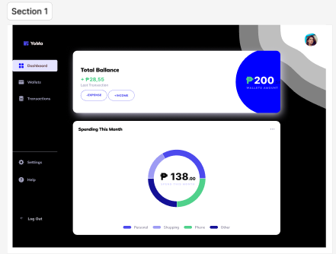

When you want to input your expenses click “-Expense” and the bottom figure of the first image will fade and the top figure will begin to expand and shows the input. The vertical circles show the logos of your recent transaction expenses. Same output will be given on the “+Income”. The text beside the vertical circles are the latest transactions of the “expenses” only.

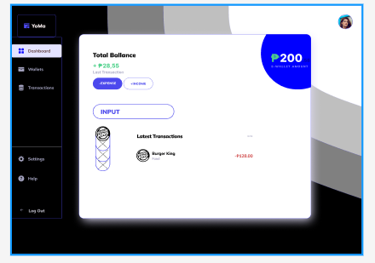

The transaction pages shows the overall transactions including those payment to other people or the income and expenses and their time/date.

