Jbi4Corba

Table of Contents

1. Introduction 4
2. Getting Started 5
2.1 Integration Scenario 5
2.2 Environment Setup 5
2.3 Installing and starting Jbi4Corba Binding Component 6
2.4 Creating a service assembly 6
2.4.1 Jbi4Corba service unit 7
2.4.2 HTTP service unit 8
2.4.3 BPEL service unit 8
2.4.4 The service assembly 9
2.5 Deploying a service assembly 9
3. NetBeans Plugin 12
3.1 Description 12
3.2 Install 12
3.3 Create Jbi4Corba WSDL from IDL 13
4. Architecture 17
4.1 Provider 17
4.1.1 The Deploy 17
4.1.2 The Runtime 19
4.2 Consumer 20
4.2.1 The Deploy time 20
4.2.2 The Runtime 22
5. User Guide 23
5.1 How to configure the component 23
5.1.1 Configuring the SU in provider role 23
5.1.2 Configuring the SU in consumer role 28
5.2 Inout IDL parameters 30
5.2.1 Introduction 30
5.2.2 Provider Role - Synchronous Communication with InOut parameters 30
5.3 Asyncronous Communication 31
5.3.1 Introduction 31
5.3.2 Provider Role - Asynchronous Communication 31
5.3.3 Consumer Role - Asynchronous Communication 32
6. Appendix 33
6.1 Appendix A: Supported IDL data types 33
6.2 Appendix B: Supported XML schema data types 36
6.3 Appendix C: IDL to WSDL code generation 39
6.4 Appendix D: WSDL to CORBA code generation 41
6.5 Appendix E: Array 43
6.6 Appendix F: ORB Configuration 45

Figures
Figure 1 – Integration scenario 5
Figure 2 - Component install 6
Figure 3 - Jbi4Corba endpoint 7
Figure 4 - BPEL mediator 8
Figure 5 - The Service Assembly 9
Figure 6 - Service Assembly deploy 10
Figure 7 - The deployed SA 11
Figure 8 - NMBs modules selection 13
Figure 9 - Create a IDL file 14
Figure 10 - The IDL interface 14
Figure 11 - The plugin wizard 15
Figure 12 - The Jbi4Corba Endpoint WSDL 16
Figure 13 - The Jbi4Corba provider architecture 17
Figure 14 - Provider deploy 18
Figure 15 - Provider Runtime 19
Figure 16 - The Jbi4Corba consumer architecture 20
Figure 17 - Consumer deploy 21
Figure 18 – Consumer runtime 22

Introduction
Jbi4Corba is a JBI compliant Binding Component. It allows to map a CORBA service as an internal JBI endpoint. This is simply done by deploying a service unit containing the IDL defining the CORBA service into a JBI ESB; no coding is required. Having an internal JBI endpoint opens a wide range of possibilities because the endpoint can participate in the message streams and the orchestrations that take place inside the ESB. For instance, the endpoint could be externally exposed as a SOAP/HTTP Web Service.

Getting Started
This getting started guide shows how to install Jbi4Corba and a sample service assembly in GlassfishESB environment.

Integration Scenario
A binding component using Jbi4Corba exposes on the internal BUS an external service provided by a CORBA servant. To locate the servant, the Jbi4Corba component must use an active CORBA name server or other localization mechanism (see section “Configuring the SU in provider role – Deployment” ).
Thus the integration scenario is shown in the figure:

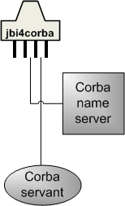
Figure 1 – Integration scenario

Environment Setup
Install GlassFishESB. This bundle contains the NetBeans IDE with JBI tools and the GlassFish JBI runtime.

Installing and starting Jbi4Corba Binding Component
Download the Jbi4Corba component. Install and start the component using the contextual menu on the server JBI module.

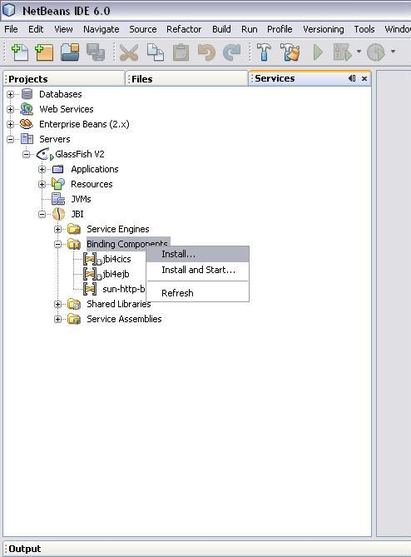
Figure 2 - Component install

After those operations, you can deploy a Service Assembly that uses the Jbi4Corba component.

Creating a service assembly
A service assembly is a deployable item that configures one or more endpoint inside a JBI ESB. We are going set up a configuration that take a CORBA service and expose it a SOAP/HTTP WebService. The configuration is shown in the following figure:
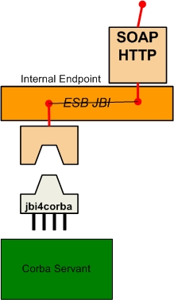
Figure 3 - Jbi4Corba endpoint
The Jbi4Corba component creates an internal (i.e. visible inside the ESB) endpoint. This internal endpoint is exposed as an external endpoint with the http-soap Binding Component. In this example the invocation is mediated by a BPEL process. The http component will proxy the incoming external calls to the internal endpoint exploiting the JBI routing mechanisms.
A Service Assembly (SA) is a zip file containing one or more Service Unit (SU) file, each Service Unit defining one or more endpoint. In our example, we need three Service Units (SU):
- JBI4Corba containing the definition for the Jbi4Corba endpoint.
- HTTP containing the definition for the http endpoint.
- BPEL containing the definition for the BPEL process.

Jbi4Corba service unit
To create a Jbi4Corba service unit follow the NetBeans Plugin guide (3).

HTTP service unit
To create a HTTP service unit follow ‘HTTP Binding Component User's Guide’ and ‘Understanding the HTTP Binding Component’.

BPEL service unit
To create a BPEL service engine follow ‘BPEL Service engine User's Guide’ and ‘Developer Guide to BPEL Designer’.
For example a BPEL that implement a simple Business process between a Jbi4corba (SU) and a HTTP (SU) is:

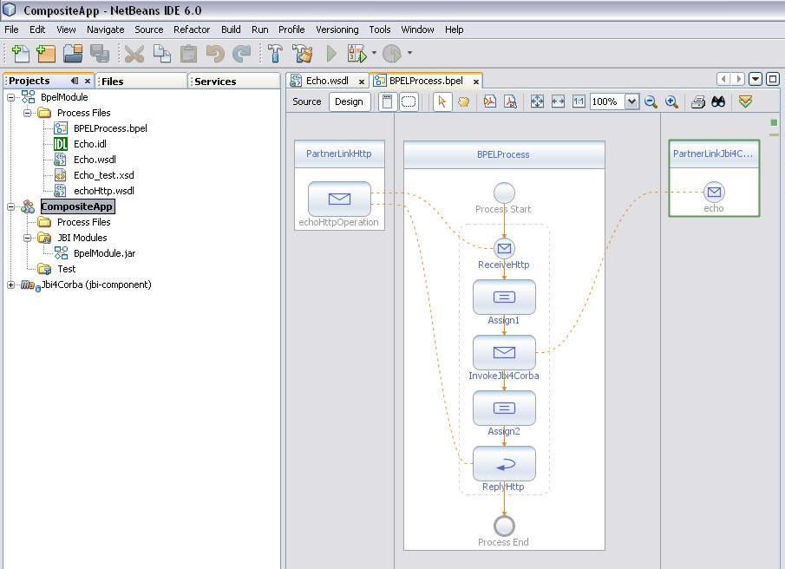
Figure 4 - BPEL mediator

The service assembly
The service assembly is unit of deployable configuration in JBI. In our example it has the following layout:
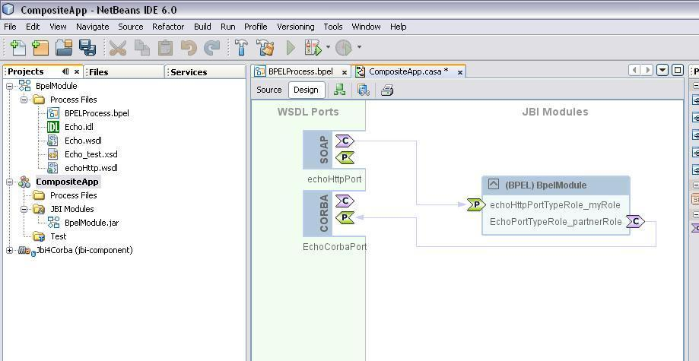
Figure 5 - The Service Assembly

Deploying a service assembly
In NetBeans, with the server started, select from "CompositeApp" the "Deploy" option and start it.
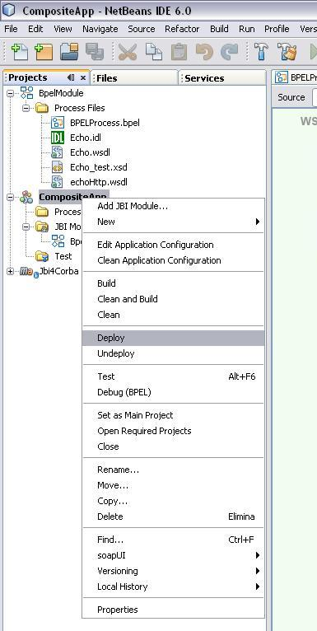
Figure 6 - Service Assembly deploy

If the Service Assembly starts correctly, you should see both the BC running

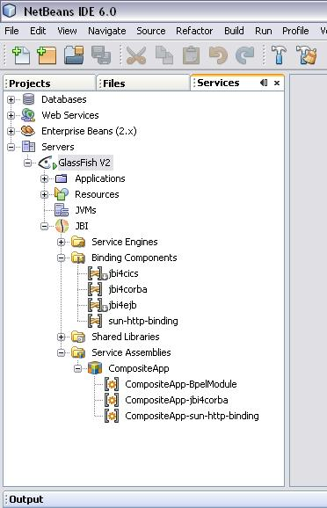
Figure 7 - The deployed SA

Now you can test the service assembly sending a SOAP message to the HTTP endpoint. For the component to work, the CORBA servant must be running and reachable when the SOAP message is processed by the Service Assembly.

NetBeans Plugin
This guide shows you how to install and use the Jbi4Corba netbeans plugin.

Description
With the Jbi4Corba Netbeans plugin, you can create a WSDL file starting from a CORBA Interface Definition language (IDL) file. Now, the NetBeans plugin, generate the WSDL file that import the abstract definition of XML Schema in the separated xsd file. If you select a file with extension idl and IDL, the Jbi4Corba plugin is automatically activated.
In addition, you can also modify a WSDL file adding a binding to the Jbi4Corba component, so the WSDL will be suitable to be deployed inside a JBI service unit. This feature is available using the NetBeans WSDL editor.
The plugin is tested with NetBeans IDE 6, with Enterprise Pack installed.

Install
To install the plugin, follow these steps:
- Download the latest netbeans-plugin zip
- Unzip the netbeans plugin in a temporary directory. Some .nbm files should be unpacked
- Start the Netbeans IDE and then select:
  - Tools -> Plugins
  - Select the Downloaded tab -> Add Plugins
  - Selects the unpacked nbm files -> Install -> next
  - Accept the License Agreement
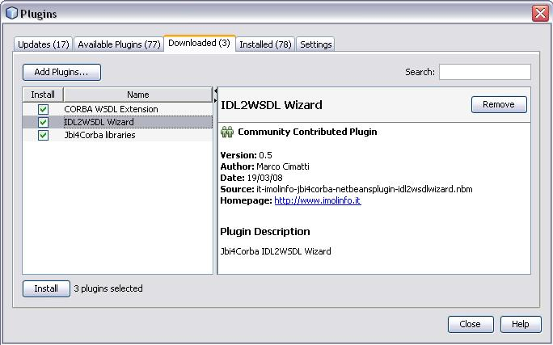
Figure 8 - NMBs modules selection

Create Jbi4Corba WSDL from IDL
After the plugin installation, you are ready to create a new WSDL from a CORBA IDL interface. You can use this WSDL to integrate the component in Composite Applications. For example, you can add the servant as a partner-link in a BPEL process. To create the WSDL, select an IDL file.
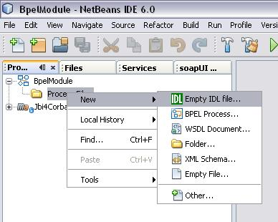
Figure 9 - Create a IDL file

Now, Right-click the IDL file and select Create WSDL .
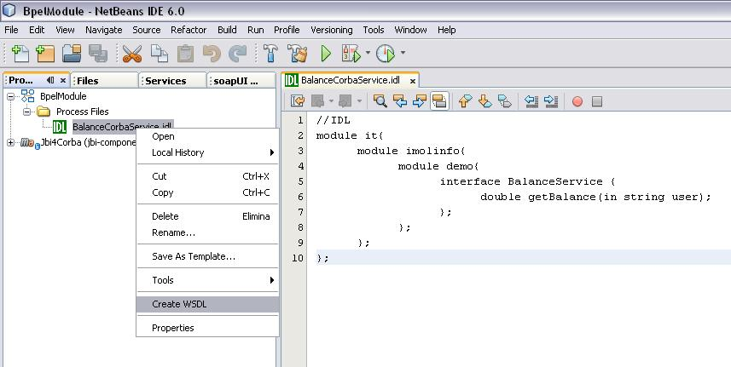
Figure 10 - The IDL interface
The Jbi4Corba wizard now should appear asking you about some configuration data that must be specified. In addition to information required to locate the CORBA servant (the ORB properties and the CORBA name to look for) you must specify:
- The endpoint name (used to register the service inside the BUS)
- The service namespace
- The localization type
- The localization value
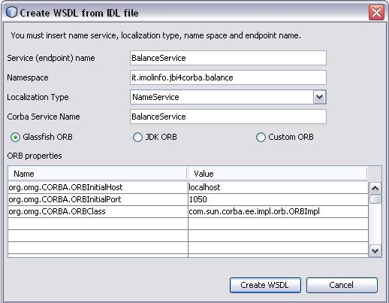
Figure 11 - The plugin wizard
The Create WSDL creates the WSDL. Notice that the Jbi4Corba extensibility elements are automatically added.

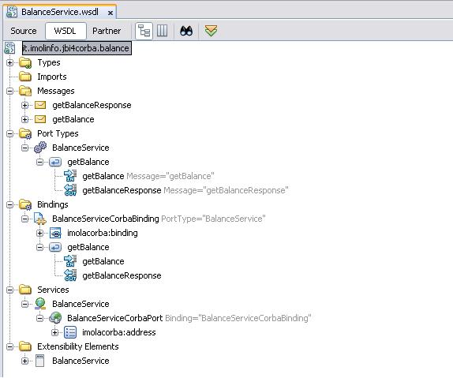
Figure 12 - The Jbi4Corba Endpoint WSDL
Now, if you want, you can manually configure the component. See the User Guide section to know how to correctly set the Jbi4Corba addresses and binding.

Architecture
Jbi4Corba is a JBI Binding Component that may act as a provider, a consumer or both. Provider and consumer follow different behaviours during the two phases of their lifecycle: the deploy and the runtime.

Provider
When run in provider mode, Jbi4Corba is based on this simple pseudo equation:

idl2java + java2wsdl = idl2wsdl

In the following figure we can see the Provider mode architecture:

E
S
B
J
B
I
J
b
i
4
C
o
r
b
a
C
o
r
b
a
S
e
r
v
a
n
t
N
a
m
e
S
e
r
v
i
c
e
r
e
g
i
s
t
e
r
i
n
v
o
k
e
l
o
o
k
u
p
A
n
y
e
n
d
p
o
i
n
t

Figure 13 - The Jbi4Corba provider architecture

We analyze separately the deploy and the runtime.

The Deploy
At deploy time, the following sequence of events occurs:
- The IDL file is parsed and used to generate Java classes (see Appendix C). To verify which IDL’s features are supported, please visit the page of the supported IDL data types (see Appendix A).
- The generated Java classes are compiled.
- One JBI Web Service per IDL interface is created.
- When the endpoint is activated, the underlying CORBA object is located using the CORBA Name Service.
- Each JBI Web Service is published as an internal JBI endpoint.
The following figure shows this process in an unformal sequence diagram:

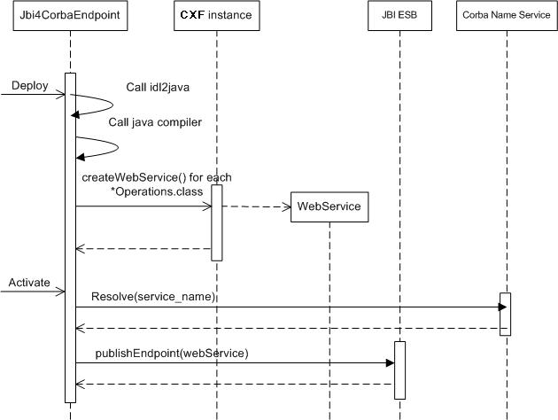
Figure 14 - Provider deploy

The Runtime
At runtime the following sequence of events occurs:
- The JBI internal endpoint is called by another JBI endpoint.
- The CXF dynamic interface and the CORBA dynamic interface are used together to forward any port called on the Web Service to the corresponding CORBA method.
- The result is marshalled into the reply payload.
- The reply payload is posted into the JBI bus.
The following figure shows this process in an unformal sequence diagram:

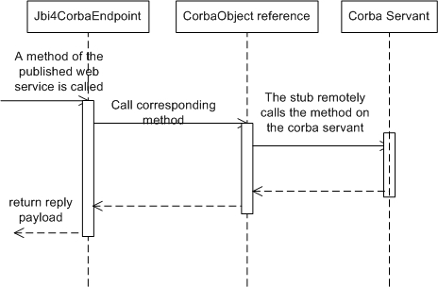
Figure 15 - Provider runtime

Consumer
When run in consumer mode, Jbi4Corba is based on this simple pseudo equation:

wsdl2java + java2idl = wsdl2idl

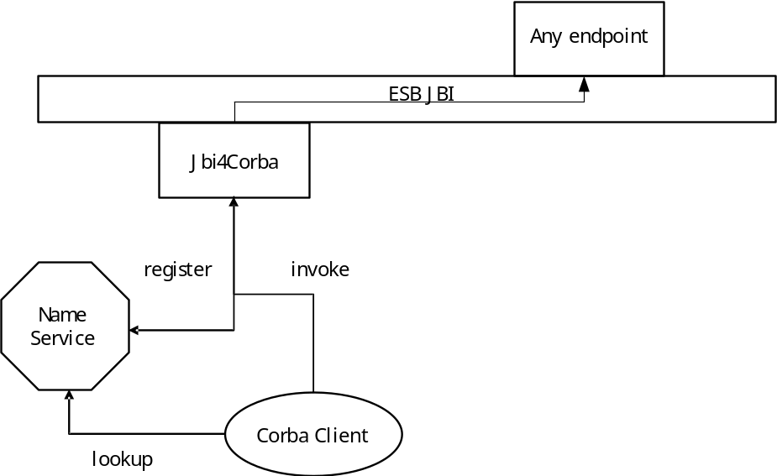

Figure 16 - The Jbi4Corba consumer architecture

As in the provider case, we analyze separately the deploy and the runtime.

The Deploy time
At deploy time, the following sequence of events occur:
- The component gets the WSDL and generates the CORBA servant classes (see Appendix C) and the associated IDL files. (For a more detailed discussion about the WSDL’s supported features, please see Appendix B)
- Generated Java classes are compiled
- One JBI Web Service is created for each PortType
- The endpoint is published
- A new instance of the servant is created and registered on the CORBA service name.
The following figure shows this process in an unformal sequence diagram:

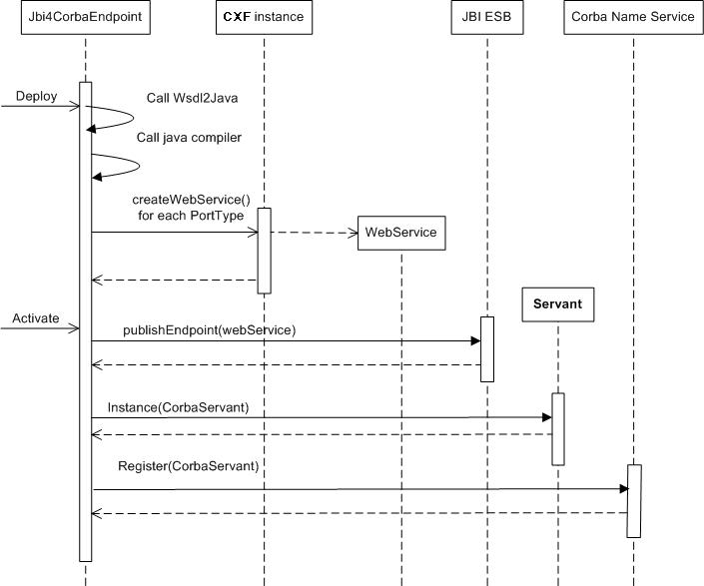
Figure 17 - Consumer deploy

The Runtime
- A CORBA client calls a method on the CORBA servant
- The CORBA servant calls Jbi4CorbaEndpoint to handle the request
- The Endpoint sends the MessageExchange on the bus to obtain the response
The following figure shows this process in an unformal sequence diagram:

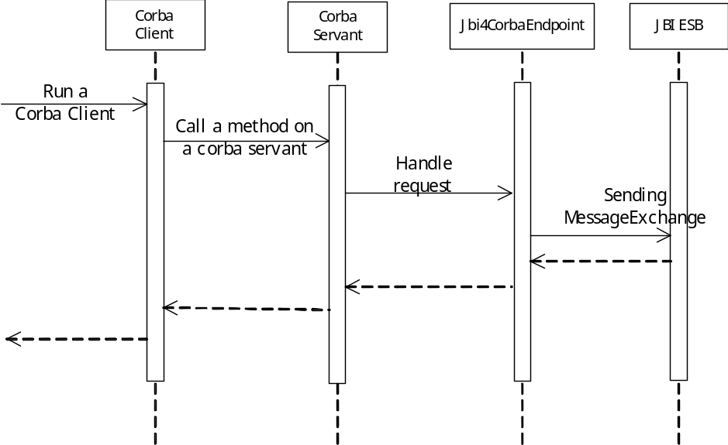

Figure 18 – Consumer runtime

User Guide
Given CORBA inter-ORB interoperability, it should theoretically be possible to use just one ORB in Jbi4Corba to talk with different ORBs running the CORBA servants. This, however, could result as not being possible in many actual situations; thus, in Jbi4Corba it is possible to use different ORBs even simultaneously. At the moment Jbi4Corba is tested with the Sun, Glassfish and JacORB implementations, but, as it uses only standard CORBA API, it should support any orb implementation (in Appendix F is shown how to configure a different orb). The ORB is specified per IDL, so every service defined inside a single IDL will use the same ORB implementation; anyway, it will have its own ORB to allow different endpoints to be managed (activated/deactivated) independently. The localization mode is specified per IDL too, so every service defined inside the same IDL will share the localization mode. It is the user responsibility to make ORB classes available to Jbi4Corba. The easiest way would be to copy ORB jars into an extension directory (jre extension or your JBI ESB extension/optional directory). Another cleaner possibility is to create a shared library with your ORB jars (and possibly configuration files) and then deploy it into the JBI ESB. In this case you will need to tweak Jbi4Corba’s jbi.xml and declare its dependency to the ORB shared library.

How to configure the component
Jbi4Corba may work either in provider mode or in consumer mode. The service unit configuration, however, is slightly different in the two modes. Here we describe the configurations separately.

Configuring the SU in provider role

Introduction
The Jbi4Corba component may act in provider mode using a particular configuration of the service unit.
In this scenario the component uses an IDL file to create the classes for a CORBA client. When the client is created, it looks for the CORBA servant (via CORBA Name Service) called as indicated in the element 'imolacorba:address' defined in the wsdl file.
When the component is properly configured, you can use it inside the ESB to integrate other services. For example, you can use a HTTP component to expose your CORBA client to use it with other technologies.

Requirements
- Service name
The service unit uses the CORBA Name Service to look for the CORBA servant, so you should make it active before starting the SU.
- Start order
First of all you should start the Name Service. When run in provider mode, the component must be started after the CORBA servant has registered itself in the Name Service to avoid problems caused by different IOR used by the client and the servant.
- Supported IDL types and constructs
Jbi4Corba supports the main IDL types; see Appendix A to further know on supported types.

Deployment
In this scenario we create a standard WSDL that represents our service with our types and operations as usual, but before use it inside the bus we must add some extra information using the extensibility element in the WSDL.
The first step is adding the namespace of the extensibility element in the wsdl description

<wsdl:definitions ...

xmlns:imolacorba="uri://schemas.imola.it/jbi/wsdl-extensions/corba/"

The second step involves the binding section of the WSDL where we indicate all the information previously described in xbean file.

<wsdl:binding name="EchoWSDLJBIPortBinding" type="tns:EchoWSDLPortType">
<imolacorba:binding>
<imolacorba:idl>
<IDL_FILE>
</imolacorba:idl>
</imolacorba:binding>
</wsdl:binding>

The component needs the IDL file to construct a specific corba client. This file in the wsdl way is specified inside the wsdl within the 'imolacorba:idl' element.
For example:

<imolacorba:idl>
module it{
module imolinfo{
interface Echo {
string echo(in string msg);
};
};
};
</imolacorba:idl>

The last step is adding, in the wsdl:port, the element that instructs the component about the name of the corba servant and the name of the corba service name and where we indicate all the information the other properties used by the component.
For example:

<wsdl:service name="EchoWSDL">
<wsdl:port binding="tns:EchoWSDLJBIPortBinding" name="EchoWSDLJBIPort">
<imolacorba:address name="<CORBA_SERVANT>" localizationType="<LOCALIZATION_TYPE>">
<imolacorba:orb>
<imolacorba:property name="org.omg.CORBA.ORBInitialPort"
value="<SERVICE_NAME_PORT>"/>
<imolacorba:property name="org.omg.CORBA.ORBInitialHost"
value="<SERVICE_NAME_HOST>"/>
</imolacorba:orb>
</imolacorba:address>
</wsdl:port>
</wsdl:service>

The name of the corba servant is defined by the user and must be the name used by the servant when registering into the NameService.
The localization type is the way used to localize the corba servant.
The localization mechanisms should be used with the 'name' property to specify where to localize the corba service.

<wsdl:service name="ServantCorbalocWsdl">
<wsdl:port binding="tns:ServantCorbalocWsdlJBIPortBinding"
name="ServantCorbalocWsdlJBIPort">
<imolacorba:address localizationType="corbaloc"
name="corbaloc:iiop:1.2@127.0.0.1:1061/ServantCorbalocWsdl" />
</wsdl:port>
</wsdl:service>

Name | Optional | Default | Description
localizationType | no |  | It is the localization mechanism.  At this moment the component support 4 localization mechanisms:  NameService, corbaloc, corbaname and IOR (saved on a file).

Moreover, we have indicated the properties used within the ORB using the 'imolacorba:orb' element. Those properties will be used by the corba instance of this service unit. You can configure any orb property that you need using the name value couple. Remember that the properties are orb's specific.
The following example shows how to locate the corba name service using the jdk orb. In fact, the org.omg.CORBA.ORBInitialPort and org.omg.CORBA.ORBInitialHost is where the service is listening and where the provider looking for a specific corba servant.
For example:

<imolacorba:orb>
<imolacorba:property name="org.omg.CORBA.ORBInitialPort" value="1050"/>
<imolacorba:property name="org.omg.CORBA.ORBInitialHost" value="localhost"/>
</imolacorba:orb>

Localization Type
A corba service can be localized using some different mechanisms: NameService, IOR, corbaname and corbaloc.
The JBI4CORBA component supports all of these methods when it is configured as a provider.
In this configuration the component is a client corba and it looks for the associated servant during the startup of the ServiceUnit, so the user must specify a way to localize the service using a property called localizationType .
The localizationType property can assume the following values: NameService, IOR, corbaname and corbaloc.
The name changes with the localizationType:

localizationType | name
NameService | Object
IOR | The absolute path where there is a file that contains a IOR
corbaname | The corbaname url of the service
corbaloc | The corbaloc url of the service
Sample - WSDL deploy and NameService
In this example the binding component is deployed using the WSDL file and the localizationType is NameService.

<wsdl:binding name="EchoWSDLJBIPortBinding" type="tns:EchoWSDLPortType">
<imolacorba:binding>
<imolacorba:idl>
... the idl file content.
</imolacorba:idl>
</imolacorba:binding>

[...]
</wsdl:binding>

<wsdl:service name="EchoWSDL">
<wsdl:port binding="tns:EchoWSDLJBIPortBinding" name="EchoWSDLJBIPort">
<imolacorba:address name="ServantTestSimpleWsdl" localizationType="NameService">
<imolacorba:orb>
<imolacorba:property name="org.omg.CORBA.ORBInitialPort" value="1050"/>
<imolacorba:property name="org.omg.CORBA.ORBInitialHost" value="localhost"/>
</imolacorba:orb>
</imolacorba:address>
</wsdl:port>
</wsdl:service>
Sample - WSDL deploy and IOR
In this example the binding component is deployed using the WSDL file and the localizationType is IOR. (The servant can avoid the registration in the NameService)

[...]

<wsdl:service name="EchoIorWSDL">
<wsdl:port binding="tns:EchoIorWSDLJBIPortBinding" name="EchoIorWSDLJBIPort">
<imolacorba:address localizationType="IOR" name="c:/wolv/EchoIorWsdlImpl.txt" />
</wsdl:port>
</wsdl:service>

Sample - WSDL deploy and IOR
In this example the binding component is deployed using the WSDL file and the localizationType is IOR. (The servant can avoid the registration in the NameService)
[...]

<wsdl:service name="EchoIorWSDL">
<wsdl:port binding="tns:EchoIorWSDLJBIPortBinding" name="EchoIorWSDLJBIPort">
<imolacorba:address localizationType="IOR" name="c:/wolv/EchoIorWsdlImpl.txt" />
</wsdl:port>
</wsdl:service>

Sample - WSDL deploy and corbaname
In this example the binding component is deployed using the WSDL file and the localizationType is corbaname. (The IP and port used in the name is the network address of the NameService where the servant registered itself previuosly with the name indicated after the '#' character.)
[...]

<wsdl:service name="ServantCorbanameWsdl">
<wsdl:port binding="tns:ServantCorbanameWsdlJBIPortBinding" name="ServantCorbanameWsdlJBIPort">
<imolacorba:address localizationType="corbaname"
name="corbaname::127.0.0.1:1050#ServantCorbanameWsdl" />
</wsdl:port>
</wsdl:service>

Sample - WSDL deploy and corbaloc
In this example the binding component is deployed using the WSDL file and the localizationType is corbaloc.
In this configuration the servant can avoid the NameService registration, but it must publish itself with an IP, port and name. This features is usually provided with a specific method of the vendor implementation of the ORB.
For the ORB of SUN Microsystem the corba service published using the following code

((com.sun.corba.se.impl.orb.ORBImpl) orb).
register_initial_reference(
"ServantCorbaloc", rootPOA.servant_to_reference(servant) );

[...]
<wsdl:service name="ServantCorbalocWsdl">
<wsdl:port binding="tns:ServantCorbalocWsdlJBIPortBinding" name="ServantCorbalocWsdlJBIPort">
<imolacorba:address localizationType="corbaloc"
name="corbaloc:iiop:1.2@127.0.0.1:1061/ServantCorbalocWsdl" />
</wsdl:port>
</wsdl:service>

Configuring the SU in consumer role

Introduction
The Jbi4Corba component may act in consumer mode using a particular configuration of the service unit.
In this scenario, the component gets the WSDL from the “target endpoint” and creates a CORBA servant that consumes the operations exposed by that endpoint.
Now, you can create a CORBA client to communicate to the target endpoint via Jbi4Corba in consumer mode; in fact, the SU produces the IDL files generated during the dynamic construction of the servant and those files are the contract between client and servant.
Otherwise, you can create another SU that uses this component inside the ESB (e.g.: the Jbi4Corba component in provider mode).

Requirements
- Service name
The service unit must register che CORBA servant in the CORBA Name Service, so you should make it active before starting the SU.
- Start order
First of all you should start the Name Service. If you have a CORBA Client you should active it after the CORBA servant has registered itself in the Name Service to avoid problems caused by different IOR used from the client and the servant.
- Supported WSDL types and constructs
Jbi4Corba supports the main WSDL types; see Appendix B to further know on supported types.

Deployment
In this scenario we create a standard WSDL that represents our service with our types and operations as usual, but before use it inside the bus we must add some extra information using the extensibility element in the WSDL.
The first step is adding the namespace of the extensibility element in the WSDL description

<wsdl:definitions ...

xmlns:imolacorba="uri://schemas.imola.it/jbi/wsdl-extensions/corba/"

The second step involves the binding section of the wsdl where we indicate the 'imolacorba:idl' element empty inside the 'imolacorba:binding' element. The component don't needs the IDL file, because in the consumer mode the component use all information in the wsdl to generate the IDL file to construct a specific corba servant.

<binding name="EchoServiceWSDLJBIBinding" type="tns:EchoServiceWSDLPortType">
<imolacorba:binding>
<imolacorba:idl/>
</imolacorba:binding>
[...]
</binding>

The last step to prepare the wsdl is adding, in the wsdl:port, the element that instructs the component about the name of the corba servant and the name of the corba service name. For example:

<service name="EchoServiceWSDL">
<port binding="tns:EchoServiceWSDLJBIBinding" name="EchoServiceWSDLJBIPort">
<imolacorba:address name="<CORBA_SERVANT>" localizationType="NameService">
<imolacorba:orb>
<imolacorba:property name="org.omg.CORBA.ORBInitialPort" value="1050"/>
<imolacorba:property name="org.omg.CORBA.ORBInitialHost" value="localhost"/>
</imolacorba:orb>
</imolacorba:address>
</port>
</service>

The localizationType is the way used to make available the servant, the only supported mode at moment is via the Name Service so NameService is the only allowed value.
The name of the corba servant is defined by the user, the corba client must use the same name when looking up the corba servant in the Name Service.
In the XML code above we can find an example of some properties required by the jdk orb for the correct service unit initialization:

  - org.omg.CORBA.ORBInitialPort
This is the port where the CORBA Name Service is listening
  - org.omg.CORBA.ORBInitialHost
This is the host where the CORBA Name Service is listening

Inout IDL parameters

Introduction
The component support inout IDL parameter, while the communication with out parameters is not completely supported by JBI4CORBA. Currently, the out parameters is managed with the inout parameters.

Provider Role - Synchronous Communication with InOut parameters
In CORBA the Synchronous communications with inout parameters is implemented using the parameter passing mode inout .
An example of IDL operation generated.

interface EchoInOut{

string echo(inout string msg);

};

From the perspective of a corba system this kind of communication is totally delegated to the stub (client) implementation. In fact the skeleton of a corba servant generated is the same for both communication types (asynchronous and synchronous).
The WSDL of the endpoint that exposes a inout operation is similar to the others, then the operation has the input message and the output message (Conforming to the WSDL specifications) and the BUS recognises the InOut MEP thanks this characteristic.

<xsd:element name="echoResponse">
<xsd:complexType>
<xsd:sequence>
<xsd:element minOccurs="0" name="return" type="xsd:string"/>
<xsd:element minOccurs="0" name="msgout" type="xsd:string"/>
</xsd:sequence>
</xsd:complexType>
</xsd:element>
[...]
<wsdl:operation name="echo">
<wsdl:input name="echo">
</wsdl:input>
<wsdl:output name="echoResponse">
</wsdl:output>
</wsdl:operation>

This scenario is completely managed by the component and the user configure it using the standard IDL syntax.

Asyncronous Communication

Introduction
An asynchronous communication is referred to a process that calls an operation and does not wait until that operation is finished but it continue its activity. (Sometimes the developers calls this kind of operations "send and forget method" to emphasize their behavior.) The component support the asynchronous communication in both roles.

Provider Role - Asynchronous Communication
In CORBA the asynchronous communications is implemented using the keyword oneway defined directly in IDL file used as a modifier of a corba operation.

interface EchoOnewayInterface{

oneway void echoOneway(in string message);

};

The CORBA specifications defines some limitations for this kind of operations. In fact, the requirement is the following:
- They must not contain any output parameters.
- They must specify a void return type.
- They must not declare any application exception (but they should raise a system one).
From the perspective of a corba system this kind of communication is totally delegated to the stub (client) implementation. In fact the skeleton of a corba servant generated is the same for both communication types (asynchronous and synchronous).
The WSDL of the endpoint that exposes a oneway operation is similar to the others but the operation has only the input message (Conforming to the WSDL specifications) and the BUS recognises the In Only MEP thanks this characteristic.

<wsdl:operation name="echoOneway">
<wsdl:input name="echoOnewayRequest">
</wsdl:input>
</wsdl:operation>

This scenario is completely managed by the component and the user configure it using the standard IDL syntax.

Consumer Role - Asynchronous Communication
This kind of communication is also supported by JBI4CORBA when it acts as a consumer. The endpoint created has an interface (WSDL) that contains the operations without the output message.

<wsdl:operation name="echoOneway">
<wsdl:input name="echoOnewayRequest">
</wsdl:input>
</wsdl:operation>

The component creates one or more IDL files that can be used to implement the corba client for our service, but the IDL file generated that defines the corba interface does not contain the oneway declaration (This problem is already registered in our issue tracking system), so if you want use it to create a corba client that invoke asynchronously our operations you should add this information to the IDL file.
No other tasks are required to the user.
From the perspective of the BUS the sending operation is performed using the appropriate API (i.e. It is the component that recognise the asynchronous operations).
An example of IDL operation generated.

interface EchoOnewayInterface{

void echoOneway(in string message);

};

An example of how the IDL should be modified by the user.

interface EchoOnewayInterface{

oneway void echoOneway(in string message);

};

Appendix

Appendix A: Supported IDL data types
The Jbi4Corba component supports the following data types defined in the CORBA specification.
Supported Basic Data Types
IDL Types | Java Types | WSDL Types
boolean | boolean | xsd:boolean
char | char | xsd:string
wchar | char | xsd:string
string | String | xsd:string
wstring | String | xsd:string
short | short | xsd:short
unsigned short | short | xsd:short
long | int | xsd:int
unsigned long | int | xsd:int
long long | long | xsd:long
unsigned long long | long | xsd:long
float | float | xsd:float
double | double | xsd:double
octet | byte | xsd:byte
Unsupported Basic Data Types
IDL Types | Java Types | WSDL Types
fixed | java.math.BigDecimal | xsd:decimal
? | java.math.BigInteger | xsd:integer
long double | not available at this time in IDL to Java mapping
any
Note about unsupported basic data types
The fixed data type is not supported because to generate the stub code the component use the standard idlj tool provided with the Sun JDK, and this tool does not support it.
For more information see the idlj documentation (section restrictions).

Supported Constructed Data Types
Type | Java Types | WSDL Types
Struct | The IDL struct is mapped in a Java class implementing org.omg.CORBA.portable.IDLEntity.  In this class there is a public attribute for each attribute of the struct. | The IDL struct is mapped in a xsd:complexType with the name of the struct. This complexType contains a sequence of elements (one element for each attribute of struct).
Sequence | There are two type of sequence: 1. a sequence of a primitive data type; 2. a sequence of a non primitive data type.  A sequence of a primitive is mapped in a Java class that implements org.omg.CORBA.portable.StreamableValue and contains a public attribute array of a type defined in the IDL file. A sequence of a non primitive data type is not mapped in any Java class. Both types of sequence generate the helper and the holder class. | The IDL sequence is mapped in a xsd:complexType that contains a xsd:sequence of one element where minOccurs=0; nillable=true and the name is the same of the element defined in the IDL file.
Enum | The CORBA and the JAVA implementation of the enumeration are different.  The component provides a standard  implementation with all the methods used  inside the associated corba helper class. | <xsd:simpleType name="myEnum">  <xsd:restriction base="xsd:string">  <xsd:enumeration alue="A"/>  <xsd:enumeration value="B"/>  <xsd:enumeration value="C"/>  </xsd:restriction>  </xsd:simpleType>
Array | Supported with limitations (see Appendix E).
Unsupported Constructed Data Types
Type | Java Types | WSDL Types
Union
Value Types
The IDL value types are partially supported; in fact the component is able to manage all the value types that can be represented as a JavaBean. The “factory” and the other “operations” of the value type are ignored. The abstract value type is unsupported because it does not have attributes, but only operations.

Type | Supported
regular | yes
boxed | yes
abstract | no

Appendix B: Supported XML schema data types
The Jbi4Corba component supports some of the data types defined in the XML schema specification.
Supported Built-in Data Types
XML Schema types | Java Types | IDL Types
anySimpleType | String | wstring
boolean | boolean | boolean
float | float | float
double | double | double
long | long | long long
int | int | long
unsignedInt | long | long long
unsignedShort | int | long
unsignedByte | short | short
anyURI | String | wstring
string | String | wstring
normalizedString | String | wstring
token | String | wstring
language | String | wstring
Name | String | wstring
NMTOKEN | String | wstring
NCName | String | wstring
ID | String | wstring
ENTITY | String | wstring
short | short | short
byte | byte | octed
Unsupported Built-in Data Types
XML Schema types | Java Types | IDL Types
anyType | Object
duration | javax.xml.datatype.Duration
dateTime | javax.xml.datatype.XMLGregorianCalendar
time | javax.xml.datatype.XMLGregorianCalendar
date | javax.xml.datatype.XMLGregorianCalendar
gYearMonth | javax.xml.datatype.XMLGregorianCalendar
gYear | javax.xml.datatype.XMLGregorianCalendar
gMonthDay | javax.xml.datatype.XMLGregorianCalendar
gDay | javax.xml.datatype.XMLGregorianCalendar
gMonth | javax.xml.datatype.XMLGregorianCalendar
base64Binary | array of byte
hexBinary | array of byte
QName | javax.xml.namespace.QName
NOTATION
decimal | BigDecimal
integer | BigInteger
nonPositiveInteger | java.lang.Number
nonNegativeInteger | java.lang.Number
negativeInteger | java.lang.Number
positiveInteger | java.lang.Number
unsignedLong | java.lang.Number
short | java.lang.Number
byte | java.lang.Number
NMTOKENS | java.util.List
IDREF | Object
IDREFS | java.util.List
ENTITIES | java.util.List
simpleType

The XML Schema specification defines a tag called simpleType used to define a new type from a built-in data type. This tag has some features but the only one supported by Jbi4Corba is the restriction.

<xsd:element name="simpleStringRequest">
<xsd:simpleType>
<xsd:restriction base="xsd:string"/>
</xsd:simpleType>
</xsd:element>
complexType
The XML schema definition defines a tag called complexType used to define new types with an advanced structure. A complexType has many features and Jbi4Corba supports many of them. For a detailed discussion about the complexType, please visit the w3c.org web site).

- group

<xsd:group name="MyGroup">
<xsd:all>
<xsd:element name="user" type="xsd:string" minOccurs="1" maxOccurs="1"/>
<xsd:element name="pass" type="xsd:string" minOccurs="1" maxOccurs="1"/>
</xsd:all>
</xsd:group>

<xsd:element name="TReqGroup">
<xsd:complexType>
<xsd:group ref="tns:MyGroup"/>
</xsd:complexType>
</xsd:element>

- All
<xsd:element name="TReqAll">
<xsd:complexType>
<xsd:all>
<xsd:element name="user" type="xsd:string" minOccurs="1" maxOccurs="1"/>
<xsd:element name="pass" type="xsd:string" minOccurs="1" maxOccurs="1"/>
</xsd:all>
</xsd:complexType>
</xsd:element>

<xsd:element name="TResAll">
<xsd:complexType>
<xsd:all>
<xsd:element name="user" type="xsd:string" minOccurs="1" maxOccurs="1"/>
<xsd:element name="pass" type="xsd:string" minOccurs="1" maxOccurs="1"/>
</xsd:all>
</xsd:complexType>
</xsd:element>
- Sequence
A complexType that contains a sequence is allowed but there are some limitations:
  - the nillable attribute must be false
  - the minOccurs attribute must be 0 or 1
  - the maxOccurs attribute must be 0 or 1
<xsd:element name="TResSeq">
<xsd:complexType>
<xsd:sequence>
<xsd:element name="dataString" type="xsd:string" nillable="false" minOccurs="1" maxOccurs="1" />
<xsd:element name="dataBoolean" type="xsd:boolean" nillable="false" minOccurs="1" maxOccurs="1" />
<xsd:element name="dataFloat" type="xsd:float" nillable="false" minOccurs="1" maxOccurs="1" />
<xsd:element name="dataDouble" type="xsd:double" nillable="false" minOccurs="1" maxOccurs="1" />
<xsd:element name="dataAnyURI" type="xsd:anyURI" nillable="false" minOccurs="1" maxOccurs="1" />
<xsd:element name="dataLong" type="xsd:long" nillable="false" minOccurs="1" maxOccurs="1" />
<xsd:element name="dataInt" type="xsd:int" nillable="false" minOccurs="1" maxOccurs="1" />
</xsd:sequence>
</xsd:complexType>
</xsd:element>

Appendix C: IDL to WSDL code generation
This component is based on this simple pseudo equation
idl2java + java2wsdl = idl2wsdl
The algorithm used is the following:
- idlj
The first step is the “IDL to Java” code generation. To implement this operation, the component uses a tool by Sun, which is distributed with the standard JDK: idlj.
This tool has several options and if you want a more detailed discussion about it, please visit the java.sun.com. The command line used is
idlj -fall -td targetdir -i includedir file.idl
where targetdir is the directory to place the source files and includedir is the directory where the IDL file is located.
com.sun.tools.corba.se.idl.toJavaPortable.Compile.main(
new String[] { "-fall",
"-td",
targetdir,
"-i",
includedir,
idlFilename });

At the end, if the IDL is correct, the just generated Java source files will be put in the targetdir.
- value type implementation
If the IDL file contains one or more value types, the source files produced don’t compile; in fact the developers must supply an implementation class for each value type. For example, if you have an IDL file that contains a value type like the following

valuetype FooValueType {
public short fooField;
};
we generate 2 classes: the class of the value type and the factory
public abstract class FooValueType
implements org.omg.CORBA.portable.StreamableValue {

// ... some code
}
public class FooValueTypeDefaultFactory
implements org.omg.CORBA.portable.ValueFactory {

public java.io.Serializable read_value (
org.omg.CORBA_2_3.portable.InputStream is) {

return is.read_value(new FooValueTypeImpl ());
}
}

But the class FooValueTypeImpl does not exist, so in the source’s directory we generate an empty class that extends FooValueType and call it FooValueTypeImpl.
public class FooValueTypeImpl extends FooValueType {
}
Now the generated code compiles!
- javac
Compiling the generated Java source code.
- bytecode manipulation
The generated compiled code is not ready to be used by XFire, so we inspect all the Operations class (generated by the CORBA interface) and extract from this class all the data types used in the methods.
For each data type found, we modify their bytecode to comply the XFire behavior:
  - for each public or protected member, we add the getter and setter method.
  - if the class is abstract,we remove this keyword.
  - if the class contains one or more array, we append the code instantiating the array to the default constructor, in order to avoid NullPointerException.
- CXF
Now, the classes are ready to be analyzed by CXF to generate the related WSDL.

Appendix D: WSDL to CORBA code generation
This component is based on this simple equation
wsdl2java + java2idl = wsdl2idl
The algorithm used is the following:
- retrieving the WSDL
The first step is retrieving the WSDL used in the code generation.
- copying ord.idl and ir.idl
When the WSDL is obtained, we copy the orb.idl and the ir.idl in the same directory where we have saved the WSDL. Those files are needed for CORBA type binding and are standard.
- preparing workspace
In this phase, we create all the directories used during the code ganeration; in particular, we create a directory for the Java source files and for the class files.
- WSDL to Java
The “WSDL to Java” code generation is executed using CXF. In XFire, the default mapping from WSDL to Java data types is good, but you should control which of those data types are supported by our component. In fact, we must convert every type defined in the WSDL into an IDL type, and not all of them are currently supported.
- javac
When the component has created the Java source files, we compile them using the standard Java compiler.

int result = com.sun.tools.javac.Main.compile(
params.toArray(new String[] {}), printstream);
- bytecode manipulation
One of the generated classes has the PortType suffix: it represents the interface (in WSDL language) that contains all our operations. The bytecode of this class must be manipulated to be used with “rmic” compiler: thus, we add the java.rmi.Remote interface to the class and we add the java.rmi.RemoteException to the exceptions thrown by every method.
- rmic
When the ServicePortType class is ready, we use the rmic compiler to produce the IDL files that represent the CORBA contract between the client and the servant. To compile this class, we use the standard rmic provided with the JDK.

List<String> params = new ArrayList<String>(
Arrays.asList(new String [] {"-classpath",
cp,
"-d",
classesDir,
"-idl",
"-always",
"-iiop",
"-nolocalstubs",
"-verbose",
className}));
sun.rmi.rmic.Main main = new sun.rmi.rmic.Main(printstream, "rmic");
boolean result = main.compile(params.toArray(new String[] {}));
- idlj
The previously generated IDLs are used to create the CORBA servant classes. This operation is performed using idlj twice: the first time with the option -fall and the second time with the option -fallTIE. This procedure is used to create stub and skeleton classes and the POA class to comply the “POA programming model”.

log.debug("Compile. 1) -fall");

com.sun.tools.corba.se.idl.toJavaPortable.Compile.main(
new String[] { "-fall",
"-td",
sourceDirName,
"-v",
"-i",
wsdlDirName,
"-emitAll",
destIdlFileName });

log.debug("Compile. 2) -fallTIE");

com.sun.tools.corba.se.idl.toJavaPortable.Compile.main(
new String[] { "-fallTIE",
"-td",
sourceDirName,
"-v",
"-i",
wsdlDirName,
"-emitAll",
destIdlFileName });
- bytecode manipulation
At this point we have almost finished our job, but the classes associated with the value type are not ready to use in a CORBA environment, so we must manipulate them. These classes must have 2 main characteristics:
  - they must implement the org.omg.CORBA.portable.ValueBase interface.
  - every value type implementation class must have the method _truncatable_ids() and it must return an array of String with one element retrievied using the method String id() in the helper class associated to the current value type.
- javac
Now we can compile all the classes and the result is our CORBA servant.

Appendix E: Array
The JBI4CORBA component supports the IDL array but there are some limitations.
Size Definition
The IDL syntax used to declare an array is the following

typedef string ArrayString[2];

and is used with the operations as well as all the others data types.

ArrayString echoArrayString(in ArrayString e);

The major difference between this kind of data type and the Java array is the size declaration. In fact, in Java we usually define the arrays without indicating the associated size that it will be passed during the construction of the object. The IDL syntax, instead, obligates the developer to define the array size.
This situation creates a little problem during the wsdl generation of the endpoint. In fact, the Java source of the corba interface produced does not contain the information about the array size and when this code is visited to generate the WSDL the result does not contain the size too (of course).

String [] echoArrayString(String [] e);

The WSDL generated does not express the equivalent interface defined in the IDL file because the minOccurs and the maxOccurs of the type are wrong.

<xsd:complexType name="ArrayOfString">
<xsd:sequence>
<xsd:element maxOccurs="unbounded" minOccurs="0" name="string" nillable="true" type="xsd:string"/>
<xsd:sequence>
<xsd:complexType>

Unfortunately the stub of the corba client generated is compliant with the IDL file, but we expose our service using the WSDL file.
At runtime, the corba client fails if you don't pass an array with a correct size but this information is reported only in the IDL file.
Usupported array of object
byte[] echoArrayOctet (byte[] e);

The component supports any kind of array except the array of octet because it is translated in a wsdl data type not supported (xsd:base64Binary).

<xsd:element name=”echoArrayOctet”>
<xsd:complexType>
<xsd:sequence>
<xsd:element maxOccurs="1" minOccurs="1" name="e" nillable="true" type="xsd:base64Binary"/>
<xsd:sequence>

This data type is managed in a different way beacause the java to wsdl specifications maps an array of byte (the associated Java type of the octet IDL data type) directly to a XML Schema data type called base64Binary .

Appendix F: ORB Configuration
Introduction
An ORB makes it possible for CORBA objects to communicate with each other by connecting objects making requests (clients) with objects servicing requests (servers). Java provides the ORB class to obtain references to objects implemented anywhere on the network. The ORB class also provides "pluggable ORB implementation" APIs that allow another vendor's ORB implementation to be used. To choose an orb implementation we have to specify standard java corba properties and how obtain a reference to the NameService.
Standard Java CORBA Properties
Property name | Property Value
org.omg.CORBA.ORBClass | class name of an ORB implementation
org.omg.CORBA.ORBSingletonClass | class name of the ORB returned by init()

Reference to the NameService
We have to specify in the ORB implementation used how to obtain an initial object reference to the NameService.
If we use JACORB, we have to add a property named ORBInitRef.NameService in the wsdl file.
Here's an example of how to set all the informations needed for the JACORB implementation in the wsdl file:

<imolacorba:address name="<CORBA_SERVANT>" localizationType="<LOCALIZATION_TYPE>">
<imolacorba:orb>
<imolacorba:property name="org.omg.CORBA.ORBClass" value="org.jacorb.orb.ORB"/>
<imolacorba:property name="org.omg.CORBA.ORBSingletonClass"
value="org.jacorb.orb.ORBSingleton"/>
<imolacorba:property name="ORBInitRef.NameService"
name="ORBInitRef.NameService"
</imolacorba:orb>
</imolacorba:address>

Even if it’s possible to connect directly two bindings, the most common use case is to mediate the invocations using a JBI service engine.

