Steps to reproduce the XSLT request-reply service issue.

- Unzip the attached file 'SelectionProcessor.zip' and import the project into netbeans.
NOTE: The artifacts 'CandidateInfoEvent.wsdl', 'Candidate.xsd', 'process.wsdl' have all been physically copied into the XSLT project from other project and the project reference way of importing them failed.
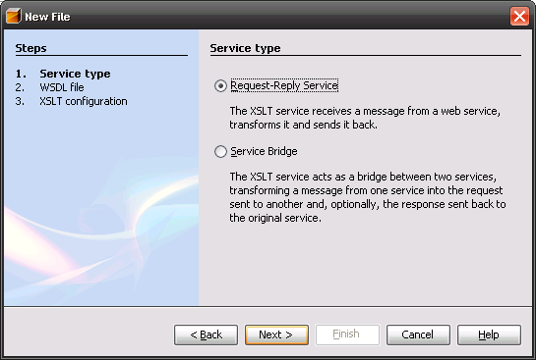
- Select new XSLT service and select 'Request-Reply' option on the dialog
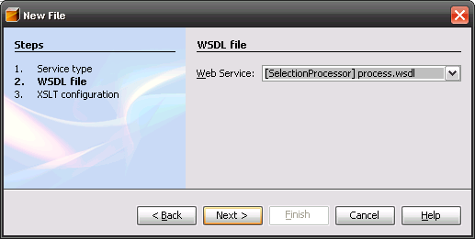
- On the next page select the wsdl file as shown
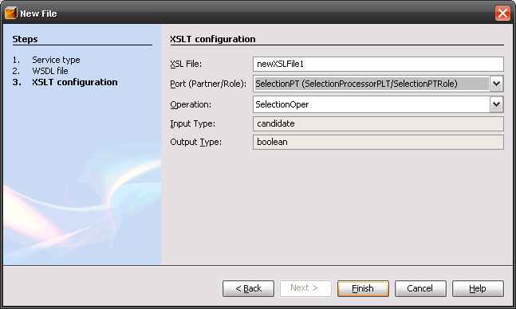
- on the next page select the interface and the operations to use as shown
- clicking finish leads to a blank screen followed by (on refresh) the screen shown
- The wsdl in question has only the following schema import
<xsd:schema targetNamespace="http://j2ee.netbeans.org/wsdl/process">
<xsd:import schemaLocation="candidate.xsd" namespace="http://xml.netbeans.org/schema/candidate"/>
This schema file (candidate.xsd) is part of the project as shown in the project tree as shown in the figure in point 5.

The error message provided in not useful, in that it does not convey the actual issue and there is no means to correct the issue.

