Steps to reproduce the issue.

- Unzip the attached file 'SelectionProcessor.zip' and import the project into netbeans.
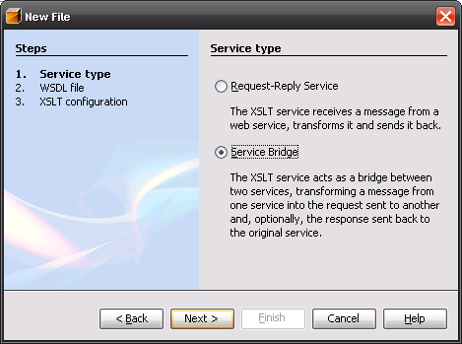
- Select new XSLT service and select 'Service Bridge' option on the dialog
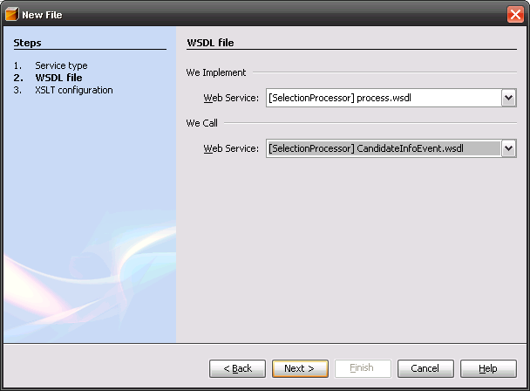
- On the next screen select the following wsdl's as shown
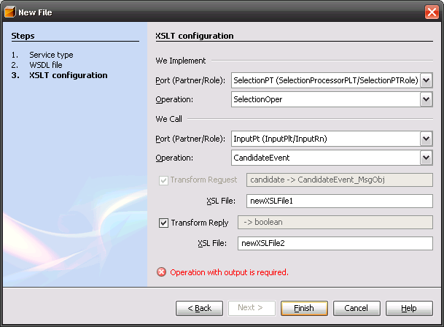
- In the next screen select the operations as shown and click the finish button.
- Observer that the creation fails as the 'we call' operation is one-way (InOnly ME) and hence fails, it seems that the 'we call' operation has to be two-way. The runtime would not have issues processing such a service and hence the design time should allow this.

