**Websocket SSL setup**

Server (WebsocketServer)

var server = new WebSocketServer(IPAddress.Parse(ServerModel.Server), ServerModel.Port, ServerModel.IsSsl);

* Get a self signed (or signed) certificate, let’s say file is **ssl.pfx** and password is **12345**

static X509Certificate2 GetCesrtificate()

{

return new X509Certificate2("ssl.pfx", "12345");

}

* + Load it to server ssl configuration, see the WebsocketServer code for more clear idea
* There are many way an ssl certificate can be loaded to server configuration. Use the one you like the most.
* Check out this link to create a test self signed certificate <https://technet.microsoft.com/en-us/library/ff710475(v=ws.10).aspx>

Client (WebsocketClient and index.html)

Now if you have a self signed ssl and you want to connect to server using javascript, then the browser will give a private connection error, please see the below image 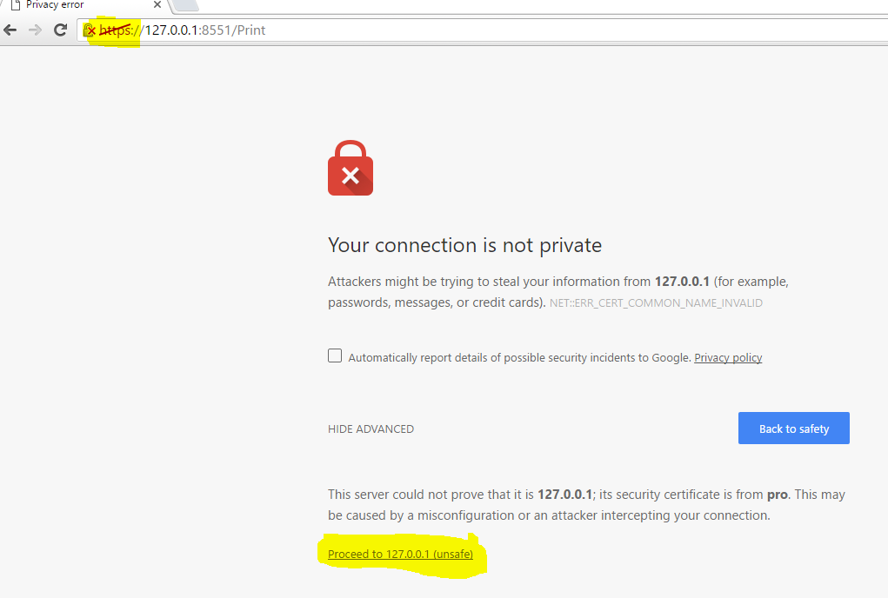

Add this to you exception list just by proceeding to it.

This error occurs only if you try to connect with an app which checks if the certificate is invalid (like chrome browser)

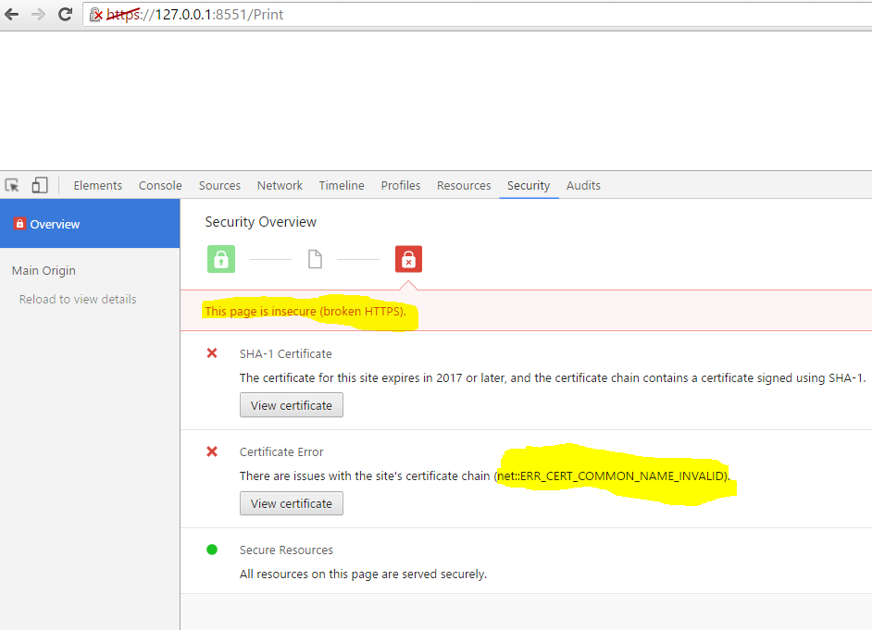

This won’t happen to the console app client, WebsocketClient or if the certificate is a valid signed one.

After you add this certificate to exception, everything will be fine. The connection and data transfer will be smooth.

