**Computer Basics Worksheet**

#### Directions: Complete this worksheet by filling in the blanks or as directed by your instructor.

***To learn about each section click on the section headings then answer the section questions. Pay close attention to the directions for each section.***

***When finished study the answers CAREFULLY. Turn in the worksheet to your instructor unless directed otherwise.***

# Start by reviewing the [Computer Basic Overview](http://www.egusd.net/franklinhs/techstandards/Computer%20Tech%20Files/Computer%20Basics%20Standard/Computer%20Basics%20Overview.pdf). Click here for [Vocabulary](http://www.egusd.net/franklinhs/techstandards/computer%20tech%20files/computer%20basics%20standard/vocabulary.pdf)

**Section 1 -** [**Input/Output**](http://www.egusd.net/franklinhs/techstandards/Computer%20Tech%20Files/Computer%20Basics%20Standard/Input%20output%20lesson.pdf)

#### Click on the link above (Input/Output) and review the power point about peripheral devices. As you read the information decide which of the following peripheral items INPUT information or OUTPUT information. Designate the type of peripheral component by writing INPUT or OUTPUT by each of the items below

1. Monitor
2. Keyboard
3. Scanner
4. Laser Printer
5. Mouse
6. Speakers
7. Digital Camera

# Section 2 – [What’s Inside a Computer?](http://www.egusd.net/franklinhs/techstandards/Computer%20Tech%20Files/Computer%20Basics%20Standard/What%20is%20Inside%20a%20Computer.pdf)

outside

#### Click on the link above (What’s Inside a Computer) and review the power point. After reading the material answer the questions below about each components responsibility. Fill in the blank with the correct answer from the box. Some may be used more than once or not at all.

CPU

BIOS

power supply hard drive

network card

Motherboard RAM

USB Port

ROM

video card

1. I connect computers and allow them to talk to each other.
2. I wake up the computer and remind it what to do.
3. I am the brain of the computer.
4. Information is stored on my magnetic cylinders.
5. I hold all of the other circuit boards.
6. I handle the graphics that are displayed on the monitor.
7. I am the type of port used by flash drives

# Section 3 - [Storage](http://www.egusd.net/franklinhs/techstandards/Computer%20Tech%20Files/Computer%20Basics%20Standard/Storage.pdf)

#### Click on the link above (Storage) and review the power point. Fill in the blanks with the vocabulary words from the box. Use each word only once. You may want to refer back to the vocabulary list that was given above.

information flash drive CD primary DVD secondary

1. memory is stored on chips located on the motherboard. 2. memory is stored on the hard drive.

1. A can hold information greater than a CD or DVD.
2. A usually holds up to 650 to 700 MB.
3. A holds even more information at least 7 GB.
4. The purpose of storage in a computer is to hold or data.

# Section 4 - [Programs](http://www.egusd.net/franklinhs/techstandards/Computer%20Tech%20Files/Computer%20Basics%20Standard/Programs.pdf)

#### Click on the link above (Programs) and review the power point. After reading the material answer the questions below about each components responsibility. Fill in the blank with the correct answer from the box. Some may be used more than once or not at all.

|  |  |  |
| --- | --- | --- |
| Research | Spreadsheet | Database |
| Entertainment | Desktop Publishing | Word processing |

* 1. Creating a birthday card for a friend.
  2. Balancing your checkbook.
  3. Finding information on pyramids.
  4. Playing solitaire.
  5. Calculating Math
  6. Keeping an address book.
  7. Writing an essay.
  8. Making a newsletter.
  9. Writing a story about aliens.

# Section 5 - [Programs](http://www.egusd.net/franklinhs/techstandards/Computer%20Tech%20Files/Computer%20Basics%20Standard/Programs.pdf)

#### Click on the link above (Vocabulary) and review the power point. After reading the material answer the questions below. Fill in the blank with the correct answer from the box. Some may be used more than once or not at all.

downloaded translators installing programming program programmers

1. A is a set of instructions that tells the computer how to perform a specific task.
2. Programs are like that allow people to work with computers without learning the computer’s language.
3. Using bits and bytes in different combinations to represent a code is known as
4. Copying a program onto your computer’s hard drive from another source is known as

the program.

1. People who write codes to create programs are known as computer
2. Some programs can be from the internet directly to your hard drive

# Section 6 - [Operating Systems](http://www.egusd.net/franklinhs/techstandards/Computer%20Tech%20Files/Computer%20Basics%20Standard/Operating%20Systems.pdf)

#### Click on the link above (Operating Systems) and review the power point. After reading the material answer the questions below. Fill in the blank with the correct answer from the box. Some may be used more than once or not at all.

Windows operating system graphics upgraded user friendly

1. The large program that controls how the CPU communicates with other hardware components is the
2. A computer that is easy to operate is called
3. is the most common operating system for PCs.
4. Operating systems are constantly being as technology advances.
5. A Graphical User Interface (GUI) uses to help the user navigate within the computer system.

# Section 7 - [The Windows Desktop](http://www.egusd.net/franklinhs/techstandards/Computer%20Tech%20Files/Computer%20Basics%20Standard/Windows%20Desktop.pdf)

#### Click on the link above (The Windows Desktop) and review the power point. After reading the material answer the questions below. Fill in the blank with the correct answer from the box. Some may be used more than once or not at all.

|  |  |  |  |  |
| --- | --- | --- | --- | --- |
| GUI | icon | Recycle Bin | Start Menu | task bar |
| windows | tool bar | scroll bar | wallpaper | title bar |

1. You put things in the that you no longer need or want.
2. A uses graphics or pictures to help the user navigate and access programs.
3. The Start Menu and clock are found on the .
4. An is a small picture that links to a file or program.
5. At the top of each window, the contains the title and buttons to close, minimize and resize.
6. Moving the up or down allows you to see all of the information in a window.
7. Programs and applications run inside that can be opened, closed or resized.
8. The is like a backdrop on your desktop that can be changed.
9. Found below the menu bar in some windows, the contains icons or options that allow you to perform specific tasks.
10. The contains basic operations such as run, shut down, log off and find.

# Section 8 - [System Requirements](http://www.egusd.net/franklinhs/techstandards/Computer%20Tech%20Files/Computer%20Basics%20Standard/System%20Requirements.pdf)

***Directions: New software always has a minimum system requirement. Meaning that the computer CPU, RAM, etc. has to be of a certain quality to run that program. Look at the sample below, then, look at each specification listed to determine whether or not it will support the software. Check “yes” if the specification meets the system requirements, or check “no” if it does not.***

**THE SOFTWARE’S MINIMUM SYSTEM REQUIREMENTS ARE:**

|  |  |
| --- | --- |
| Windows 2000/XP  Pentium 333 MHz or faster | 32 MB RAM or more  16x CD-ROM drive or faster |
| 56 MB available hard disk space |  |

**THEN WILL THE FOLLOWING SYSTEMS WORK?**

|  |  |  |
| --- | --- | --- |
| 1. Yes | No | Windows XP, Pentium 333, 64 MB RAM, 150 MB free hard disk space, 24x CD-ROM. |
| 2. Yes | No | Windows 98, Pentium 100, 8 MB RAM, 32 MB free hard disk space, 8x CD-ROM |
| 3. Yes | No | Windows 2000, Pentium 333, 64MB RAM, 150 MB free hard disk space, 24x CD-ROM drive. |
| 4. Yes | No | Windows XP, Pentium 4 (1.70 GHz), 256 MB RAM, 12 GB free hard disk space, 24x CD-ROM drive |

# Section 9 - [Hardware Basics](http://www.egusd.net/franklinhs/techstandards/Computer%20Tech%20Files/Computer%20Basics%20Standard/HARDWARE%20BASICS.pdf)

***Label the parts by finding the diagram in the presentation link above.***



**2**

**1**

**12**

**3**

**13**

**4**

**5**

**11**

**10**

**9**

**8**

**6**

**7**

**14**

Hard Drive Sound

Power Supply CD/DVD CPU

Motherboard BIOS

RAM

Video USB

Network (NIC) Graphics Port Key Board Mouse

1)

2)

3)

4)

5)

6)

7)

8)

9)

10)

11)

12)

13)

14)

# Section 10 - [Organizing files and folders](http://www.egusd.net/franklinhs/techstandards/Computer%20Tech%20Files/Computer%20Basics%20Standard/Files%20and%20folders.pdf)

#### Click on the link above (The Windows Desktop) and review the power point. After reading the material answer the questions below. Under each Program Name and folder, write the appropriate file name and extension.

**Organizing Files**

|  |  |  |
| --- | --- | --- |
| rentals.xlsx | brochure.pub | mla.docx |
| maze.pptx | gpa.xlsx | france.pptx |
| tabs.doc x | calendar.pub | card.pub |
| memo.docx |  |  |

 Excel

 PowerPoint

 Publisher

 Word

Section 11 – Parts of a Computer

*Fill in the blanks #1-#7*

4 Main Parts of a Computer

# Part 1: This type of device is known as a(n) devise. (Section 1)

## It enables information to be passed into the computer.

* It includes the: Keyboard, mouse, scanner, digital camera, microphone, etc.

# Part 2: This device is responsible for (Section 3)

## A unit that holds and gives information to the processor as needed.

* There are two types of storage:

## Temporary storage which holds information for short periods and only when the computer is on.

* 1. Examples of temporary storage include RAM

## (R A M ) RAM allows stored [data](http://en.wikipedia.org/wiki/Data) to be accessed in any order. (i.e., at [random](http://en.wikipedia.org/wiki/Random_access)).

1. Long term storage holds information for as long as you want it.
   1. Examples of Long-term storage include Hard Disk Drive, CD-Rom, DVD, Flash Drive.

# Part 3: This is the brains of the computer.

**The _ (Section 6)**

## It controls all functions.

* The processor is called the CPU

## (C P U )

* The motherboard holds the CPU and physically connects all the other main parts of the computer.
* Cases and chassis house the motherboard and the CPU.

# Part 4: This type of device is known as a(n) devise. (Section 1)

## A devise that receives information from the processor in the form of words, sounds or pictures.

* These devises include printers, speakers and Monitor.

**Section 12** – Fill in the blank areas with the correct answer

### 1.

**W :** Backdrop (background) on the desktop

**3.**

**Bar:** Contains icons or options that allow you to perform specific tasks

|  |  |
| --- | --- |
|  | |
| **4.** |  |
| **W** | **:** |
| Programs and |  |
| applications that |  |
| can be opened, |  |
| closed or resized |  |

### 2.

**I :**

A small picture that links to a file or program

**6.**

**Bar:** Contains title and buttons to close, minimize and resize

**5.**

**: G**raphical **U**ser **I**nterface Helps user navigate & access programs

### 7.

**Bar:** Allows you to see all of the information in a

**8.**

**:** Where you put things you no longer want

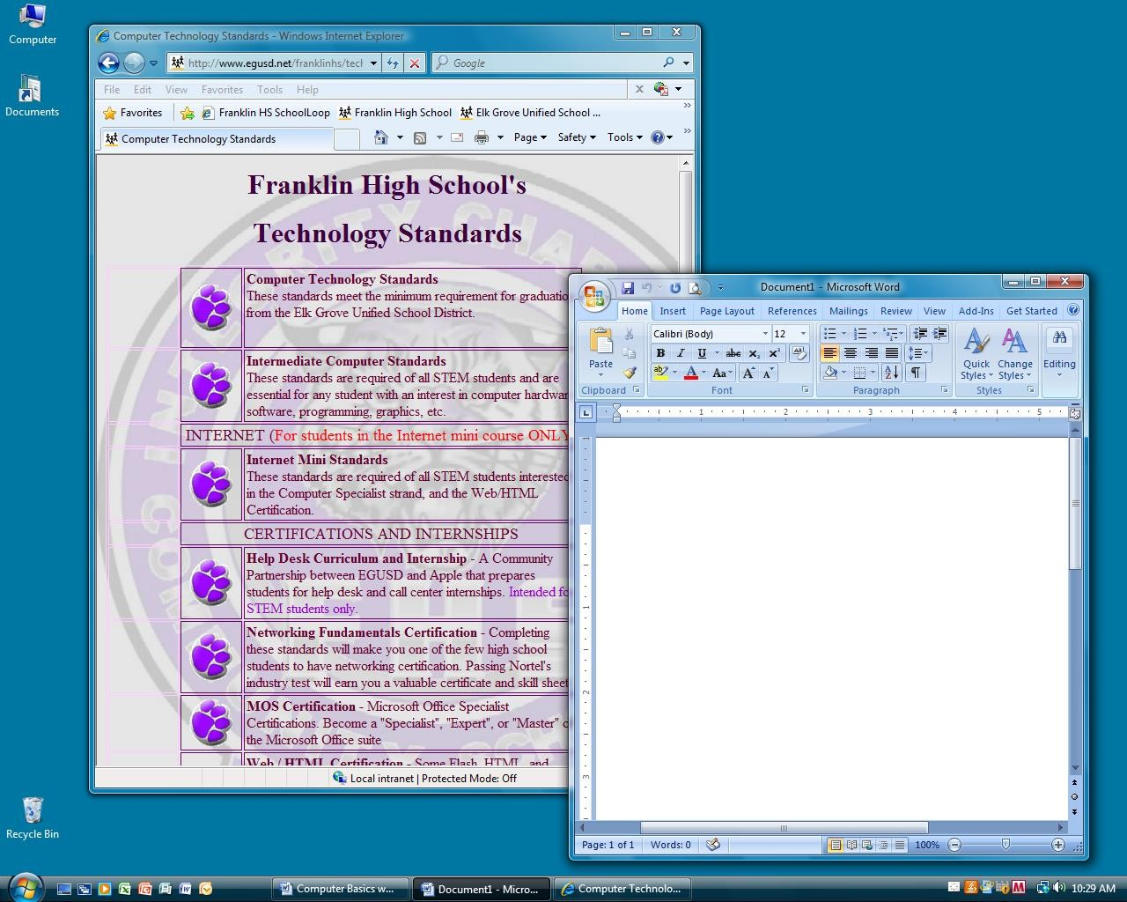

**9.**

**Menu:** Contains basic operations such as run, shut down, log off and find

**10.**

**Bar:** Includes the Start Menu and the Clock