

**TINF21C, SWE I Praxisprojekt 2022**

Project Handbook (PM)

**Project: AAS-Management**

**Customer:** Rentschler & Holder  
 Rotebühlplatz 41  
 70178 Stuttgart

**Supplier:** Team 2 (Selvana Dwi Ayunda, Paul Brenner, Jonas Alexander Graubner, Mohaddeseh Tibashi, Luka Dominik Pavic)  
Rotebühlplatz 41  
70178 Stuttgart

**Version 0.1**

|  |  |  |  |
| --- | --- | --- | --- |
| **Version** | **Date** | **Author** | **Comment** |
| 0.1 | 30.10.2021 | Selvana Ayunda | Document created and edited |

CONTENTS

1. Project Order 3

2. Project Kontext 4

3. Project Organization 5

4. Project Structure Plan (PSP) 6

*5.* Risks 7

6. Gantt-Charts 8

7. Milestone 9

8. Activities and Responsibilities 10

# Project Order

|  |  |
| --- | --- |
| **Project Order** | |
| Goal:  The goal of this project is to develop a web application that acts as a management system for the "Asset Administration Shell" (AAS). This specific web application shall have an identity and access management as well as a user administration with persistent data storage in MongoDB. The user administration enables a role distribution of the users in the user groups "Admin", "Advanced" and "Basic", whereby the role distribution is carried out manually via the Admin. Each role is equipped with different access rights and read permissions ("Advanced" gets full read access to all AAS and their submodels and "Basic" gets read access only to the basic submodels to all AAS), with the admin also having functions for managing AAS content and user management. This uses the specification of the concept as a REST API in openapi. | |
| Product Environtment:  The AAS is a concept of the Industrie 4.0 platform for the standardized implementation of "Industrie 4.0 components", consisting of the digital twin in the form of the AAS and the associated physical object (the asset). This makes it possible in industry to provide digital twins that can be shared and combined across manufacturers and accessed via standardized interfaces. | |
| Costomer: M. Rentschler; C. Holder | Project Manager: Mohaddeseh Tibashi |
| Supplier:   * Selvana Dwi Ayunda * Paul Brenner * Jonas Alexander Graubner * Mohaddeseh Tibashi * Luka Dominik Pavic | |
| Main Task:   * Documentation * Requirementsanalysis * Design * Development * Test | Milestone:   * Requirementsanalysis * Design * Coding * Test * Presentation |
| Project start: Requirementsanalysis | Project start: 26 September 2022 |
| Project Product: presentation product | Deathline: |

# Project Kontext

|  |
| --- |
| **Ausgangssituation und Problembeschreibung** |
| A web application for managing the digital twins of the respective Industry 4.0 devices. The administration should be made available via user management with the user groups "Admin", "Advanced" and "Basic" mentioned there.  The web application should communicate with the backend of the AASX server using the REST API to be created. The interface can be designed in such a way that the information of the digital twins can be saved, changed and read out. Depending on the role of the logged in user. This means the application communicates with the backend and presents this information via the web application (a classic MVC application).  The web application is to be created with the REST API. In addition, you should implement a connection to a MongoDB in the backend of the server, in which the digital twins are stored, with all properties (can be implemented relatively "easily" using a REST API to use the web application to manage the digital twins). In addition, the user administration is also placed in the MongoDB. Everything is in one central place. |

|  |  |  |  |
| --- | --- | --- | --- |
| **Social context (project environmental analysis)** | | | |
| **Stakeholder** | **Potentials / Opportunities** | **Conflicts / Risks** | **Measures** |
| Customer | Satisfaction with the implemented solution | Change requests during the project | Constant communication between supplier and customer |
| Supplier | development of an appropriate solution | Misjudgment of effort, time pressure, miscommunication | Documentation, meeting , schedules |
| User | Benefits of the application, increase in efficiency, ease of use | Lack of understanding of the application, incorrect operation | Creation of a usability concept and constant testing of the program |

# Project Organization

|  |  |  |
| --- | --- | --- |
| **Project Organization** | | |
| **project role** | **Rollenbeschreibung** | **Name** |
| Costumer | * Defines requirements | Holder, Christian / Rentschler, Markus |
| Project Manager | * Coordination of members, tasks and other resources | Mohaddeseh Tibashi |
| Project team members | * Product manager * System architecture * Technical Editor * Lead Developer | Selvana Dwi Ayunda  Paul Brenner  Jonas Alexander Graubner  Luka Dominik Pavic |

# Project Structure Plan (PSP)

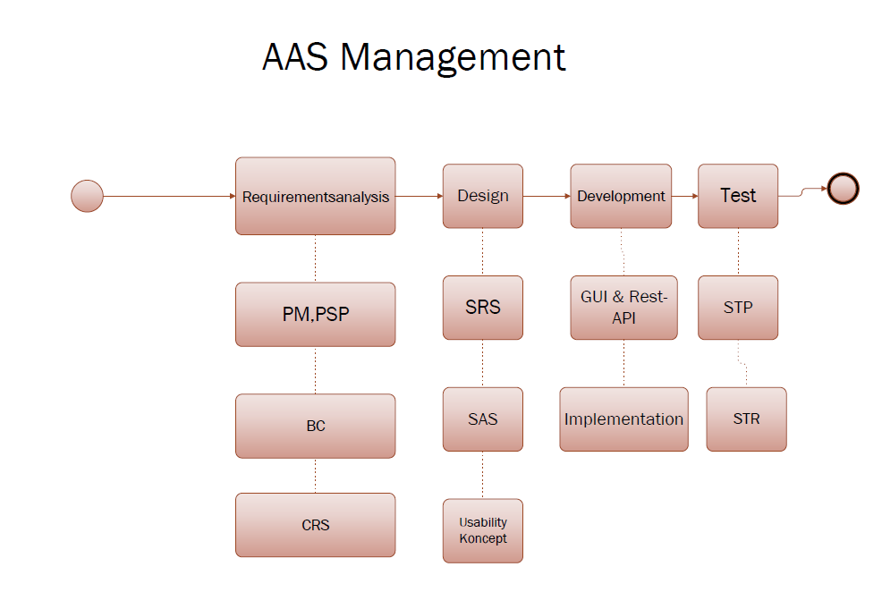

# Risks

***• Financial risk***: It is possible that the project planning is misestimated and the actual number of hours per person is higher than actually planned.

***Measure:*** The risk is minimized through precise planning of the project. Work packages and time expenditure must be defined.

***• Planning risk:*** Fixed deadlines cannot be met, which delays the entire process, especially if there are dependencies between the work packages.

***Measure:*** The project plan must contain sufficient time buffers to absorb delays.

***• Communication risk***: Lack of or incorrect communication between individual team members.

***Measure:*** Regular exchange in the team, in the form of calls and proactive communication in the event of uncertainties or problems of individual members

***• Personal risk:*** Members could leave the company during the project period, or be lost due to limitations such as illness, accidents, etc

***Measure:*** Sufficient buffer and distribution of tasks among several members. It is not possible to replace the member in the project!

# Gantt-Charts

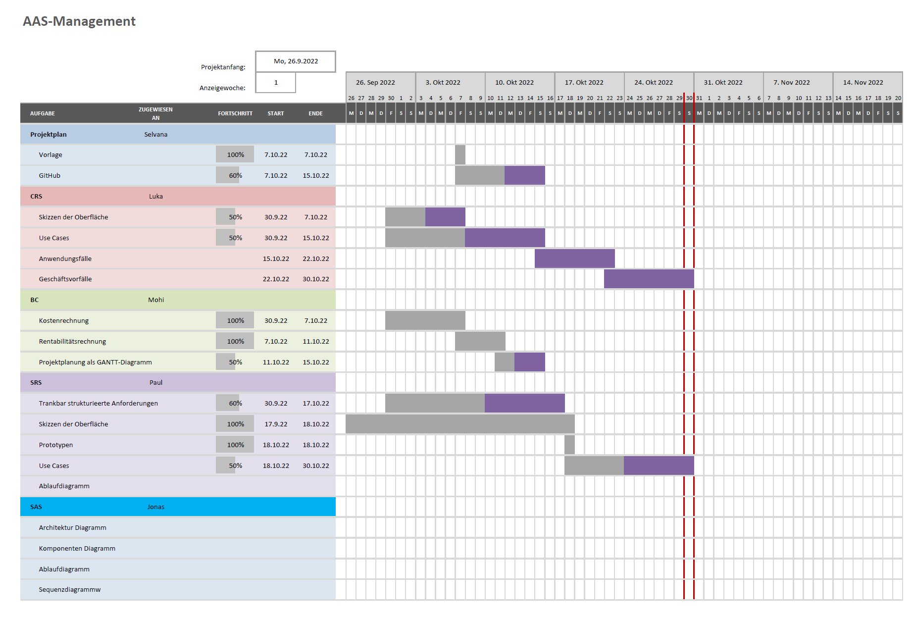

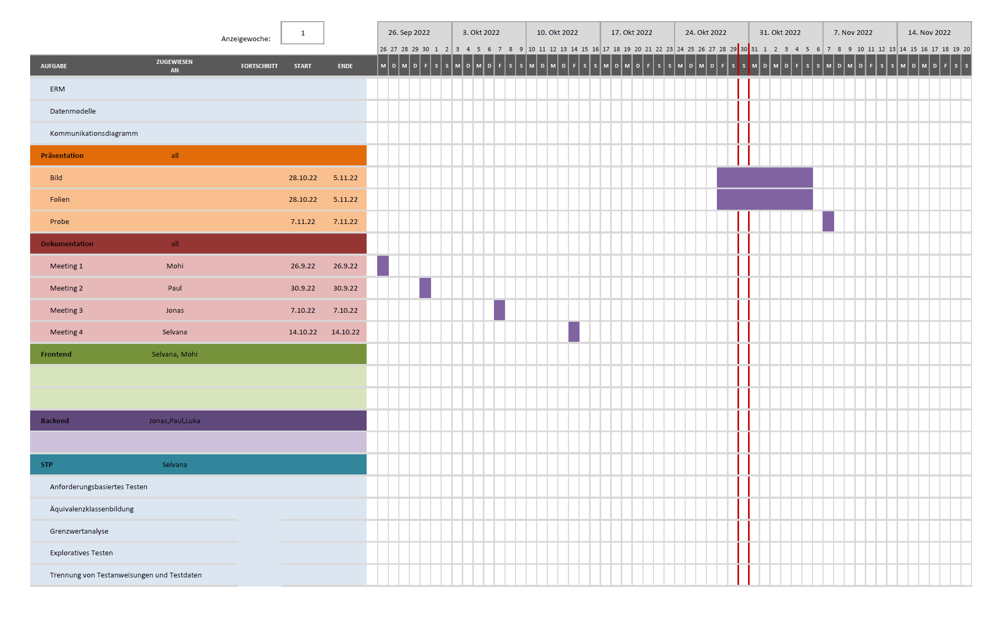

# Milestone

|  |  |  |
| --- | --- | --- |
| **Meilenstein- Name** | **Deadline** | **Person in charge** |
| **Requirmentsanalysis** |  |  |
| PM, PSP |  | Selvana Dwi Ayunda |
| BC |  | Mohaddeseh Tibashi |
| CRS |  | Luka Dominik Pavic |
| **Design** |  |  |
| SRS |  | Paul Brenner |
| SAS |  | Jonas Alexander Graubner |
| **Coding** |  |  |
| GUI-Prototyp  Frontend |  | Selvana Dwi Ayunda, Mohaddeseh Tibashi |
| Rest-API  Backend |  | Paul Brenner, Jonas Alexander Graubner Luka Dominik Pavic, |
| **Test** |  |  |
| Systemtestplan (STP) |  | Selvana Dwi Ayunda |
| Systemtestreport (STR) |  |  |
| AAS-Management |  | Team member |

# Activities and Responsibilities

|  |  |  |
| --- | --- | --- |
| **Activities and Responsibilities** | | |
| **Person** | **Category** | **Task** |
| **Mohaddeseh Tibashi**  **Role**: Project Manager  **GitHub-Name**: [Mohitibashi](https://github.com/Mohitibashi) | **Dokumentation, Organisation,**  **Tests** | * Business Case (BC) * Gantt-Charts * Presentation |
| **Development** | * Frontend Developer |
| **Luka Dominik Pavic**  **Role:** Productmanager  **GitHub-Name**:  LukaDPavic | **Dokumentation, Design** | * Customer Requirement Specification (CRS) * Usability Konzept * Presentation * Costomer exchange |
| **Development** | * Backend Developer |
| **Jonas Graubner**  **Role:** Systemarchitekt  **GitHub-Name**:  [JoTec2002](https://github.com/JoTec2002) | **Dokumentation** | * System Architecture Specification (SAS) * Usability Konzept * Presentation |
| **Development** | * Backend Developer * Rest-API Implementation * MongoDB |
| **Paul Brenner**  **Rolle:** Tech. Documentation  **GitHub-Name**:  Paulbrenner2 | **Dokumentation** | * Dokumentation des Codes * Software Requirements Specification (SRS) |
| **Development** | * Backend Developer * GUI |
| **Selvana Dwi Ayunda**  **Rolle:** Test Manager  **GitHub-Name:** selvanadwiayunda | **Dokumentation** | * Project Handbook (PM) * GitHub Organisation * Test * Gantt-Charts |
| **Development** | * Frontend Developer |