

**TINF21C, SWE I Praxisprojekt 2022**

Software Architecture Specification (SAS)

**Project: AAS-Management**

**Customer:** Rentschler & Holder  
 Rotebühlplatz 41  
 70178 Stuttgart

**Supplier:** Team 2 (Paul Brenner, Jonas Alexander Graubner, Mohaddeseh Tibashi, Selvana Dwi Ayunda, Luka Dominik Pavic)  
Rotebühlplatz 41  
70178 Stuttgart

**Version 0.1**

Version History

|  |  |  |  |
| --- | --- | --- | --- |
| Version | Date | Author | Comment |
| 0.1 | 30.10.2022 | Jonas Graubner | Created |
| 0.2 | 09.11.2022 | Jonas Graubner | Added Subsystem Specification |

Table of contents

Version History 2

1 Introduction 3

2 System Overview 3

2.1 System Environment 3

2.2 Software Environment 3

3 Architecture 4

3.1 Architectural Concept 4

3.2 Architectural Model 4

4 System Design 4

5 Subsystem Specification 4

5.1 MOD01 MongoDB 4

5.2 MOD02 Backend API 5

5.3 MOD03 Web Application 5

6 Technical Concepts 6

7 References 8

# Introduction

The goal of this project is to develop a web application that acts as a management system for the "Asset Administration Shell" (AAS). This specific web application shall have an identity and access management as well as a user administration with persistent data storage in MongoDB. The user administration enables a role distribution of the users in the user groups "Admin", "Advanced" and "Basic", whereby the role distribution is carried out manually via the Admin. Each role is equipped with different access rights and read permissions ("Advanced" gets full read access to all AAS and their sub models and "Basic" gets read access only to the basic sub models to all AAS), with the admin also having functions for managing AAS content and user management. This uses the specification of the concept as a REST API in openapi.

# System Overview

## System Environment

The AAS-Management shall be implemented as a full stack solution with a web application as the user frontend. The Browser hereby acts as the code execution platform for the user frontend by running JavaScript. The Data is served by the Hypertext Transfer Protocol Secure (HTTPS) to the frontend. The backend consists of a MongoDB Database and an Rest-API which communicate with the frontend. The Frontend fetches all Data via the REST-API.

## Software Environment

The Frontend is Build using the React framework, a JavaScript library for building user interfaces (UI). For broad compatibility the proprietary code is compiled into HTML, CSS and JavaScript Code after the development process. A node,js Server is used during local development.

The Rest-API is developed in PHP with the MongoDB Driver Extension to enable connectivity between the Websever and der MongoDB Database. The webserver herby creates an HTML5 Rest-API to serve all necessary Data to the Frontend.

# Architecture

## Architectural Concept

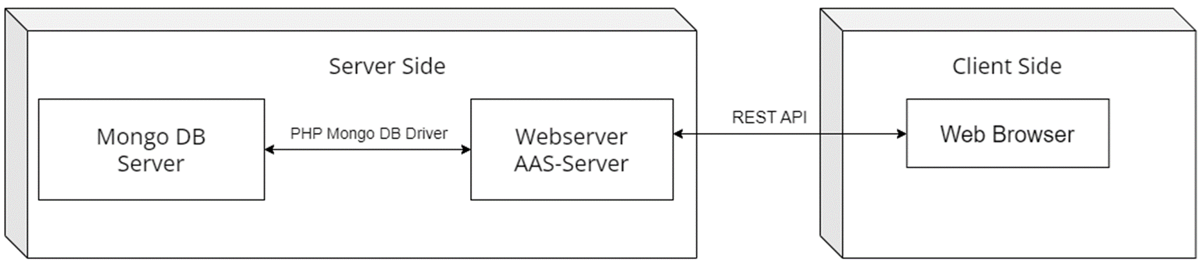

## Architectural Model

# System Design

# Subsystem Specification

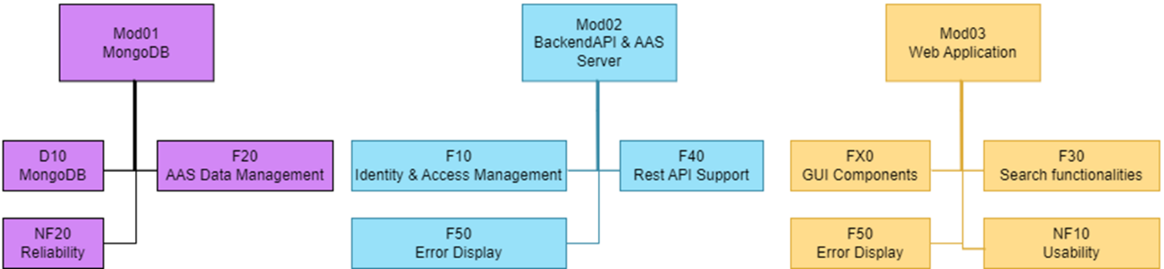

## MOD01 MongoDB

|  |  |
| --- | --- |
| Subsystem specification ID | MOD01 |
| System requirements covered | * AASM-F20 AAS content data management * AASM-D10 MongoDB * AASM-NF20 Reliability |
| Service | The MongoDB Server provides a reliable place to store all AAS Assets. |
| Interfaces | PHP MongoDB Driver |
| External data | none |
| Storage location | *This shall be added in the fourth semester* |
| Module documentation | --- |

## MOD02 Backend API

|  |  |
| --- | --- |
| Subsystem specification ID | MOD02 |
| System requirements covered | * AASM-F10 Identity & Access Management * AASM-F40 Rest-API Support * AASM-F50 Error Display |
| Service | The connection between the Backend and the Frontend is realised via the REST-API. All Data that is shown in the Frontend is provided via the REST-API. The API is sending the Data according to the user role. |
| Interfaces | software |
| External data | none |
| Storage location | *This shall be added in the fourth semester* |
| Module documentation | --- |

## MOD03 Web Application

|  |  |
| --- | --- |
| Subsystem specification ID | MOD03 |
| System requirements covered | * AASM-FX0 GUI Components * AASM-F30 Search functionalities * AASM-F50 Error Display * AASM-NF10 Usability |
| Service | The Web Application represents the User Interface to the AAS Management. The user can login an perform actions according to his user role. Any unsolvable error is presented to the user. |
| Interfaces | Software, REST-API |
| External data | none |
| Storage location | *This shall be added in the fourth semester* |
| Module documentation | --- |

# Technical Concepts

Release / Approval

Approval is made by the customer and the suppliers

|  |  |
| --- | --- |
| Date: |  |
| Signature Customer: |  |
| Signature Suppliers: |  |

# References

1. Blablabla