Interactive News Recommendation Algorithm Explorer
Joachim Grech
Supervisor: Dr. Dylan Seychell

June 2026
Submitted in partial fulfilment of the requirements
for the degree of Bachelor of Science in Information Technology (Honours)
(Artificial Intelligence).


Abstract
With the rapid growth of digital news consumption, recommendation algorithms have become a central mechanism through which users access information. According to a 2023 Eurobarometer survey, 49% of Maltese citizens obtain their news from online news platforms, while 70% rely on social media platforms [1]. A subsequent 2025 Eurobarometer survey reported that 74% of Maltese citizens receive information on current social and political affairs from social media, while 38% use printed newspapers or their online versions and 43% rely on search engines, compared with 48% who obtain their information from television [2]. These statistics highlight the dominant role of algorithm-driven platforms in modern news consumption.
Despite this influence, public understanding of recommendation algorithms remains limited. Only 9% of EU citizens claim to know a lot about recommendation systems, while 44% report knowing little about them. Furthermore, only 41% of EU citizens were aware in 2019 that algorithms are used to personalise news and information [3]. This lack of awareness raises serious concerns related to filter bubbles, confirmation bias, manipulation, and data exploitation.
This project proposes the development of an interactive news recommendation algorithm explorer in the form of a dashboard. Unlike traditional "black-box" systems, this dashboard allows users to manipulate key algorithmic parameters and observe, in real time, how these changes affect the content they are exposed to. Crucially, the system introduces visual explainability mechanisms, such as multi-dimensional radar charts mapping user profiles against article topics, to transparently communicate why specific recommendations are made. By simulating different recommendation strategies and making their internal logic visible and interpretable, the project seeks to foster a deeper public understanding of how algorithmic systems shape information access.

Acknowledgements
This section should be used to record any debt for the use of facilities or help from particular sources. You should mention any organisations that have helped fund the project. Also, for placement students, it would be diplomatic to include the name of the supervisor in the host organisation where the student was placed and any of his or her colleagues who helped you.
Contents
Abstract ii
Acknowledgements iii
Contents iv
List of Figures vi
List of Tables vii
List of Abbreviations viii
1 Introduction 1
1.1 Problem Definition 2
1.2 Motivation 2
1.3 Aim and Objectives 3
1.4 Document Structure 3
2 Background 4
2.1 2.1 The Role of Recommendation Algorithms in Modern News Consumption 4
2.2 Foundations of Recommendation Systems 4
2.2.1 Content-based Filtering 4
2.2.2 Collaborative Filtering 5
2.2.3 The Limitations of Hard Clustering in News 5
2.2.4 Probabilistic Topic Modelling via Gaussian Mixture Models (GMM) 6
2.2.5 Deep Semantic Embeddings and Probabilistic Clustering 6
3 Specification and Design 7
3.1 Further use of Captions 7
3.1.1 Tables 7
3.1.2 Lemmas, Theorems, Corollaries etc. 8
3.2 Chapter Headers 10
3.3 Printing the Dissertation on Both Sides 11
3.4 Writing the Specification and Design Chapter 14
4 Implementation 15
4.1 Writing the Implementation Chapter 15
5 Testing and/or Evaluation 16
5.1 Writing the Evaluation and/or Evaluation Chapter 16
6 Future Work 17
6.1 Writing the Future Work Chapter 17
7 Conclusions 18
7.1 Writing the Conclusions Chapter 18
References 19
Bibliography 20
Appendix A When to Use Appendices (Style: Appendix Heading 1) 21
A.1 Appendices Headings (Style: Appendix Heading 2) 21
A.1.1 Appendix Sub-Headings (Style: Appendix Heading 3) 21
A.2 What to put in Appendices 21
Appendix B Version Information 22
B.1 Copyright Information 22
B.2 Suggestions 22

List of Figures
Figure 1 Comparative analysis of Average Relevance Score as the Top-N recommendation list size increases.
Figure 2 Evaluation of Topic Coverage against Top-N list size.
Figure 3 Algorithmic resilience to stochastic diversity injection.
Figure 4 Intra-List Similarity (ILS) measured against increasing diversity injection.
Figure 5 Algorithmic sensitivity to cluster count (K).
Figure 6 Average Relevance Score across distinct user behavioural archetypes.
List of Abbreviations
AI Artificial Intelligence
BERT Bidirectional Encoder Representations from Transformers
CF Collaborative Filtering
EU European Union
FYP Final Year Project
GMM Gaussian Mixture Models
ILS Intra-List Similarity
LDA Latent Dirichlet Allocation
SBERT Sentence-BERT
TF-IDF Term Frequency-Inverse Document Frequency

Introduction
Recommendation algorithms play a fundamental role in shaping how users discover and consume digital content, particularly in online news. As evidenced by recent Eurobarometer surveys, a significant proportion of Maltese citizens now rely on online platforms and social media as their primary sources of information [1], [2]. This shift highlights the extent to which automated recommendation systems act as primary gatekeepers of information in contemporary society.
Despite their growing societal influence, only a limited proportion of the population possesses a strong understanding of how these algorithms operate. While many users are aware that some level of personalisation exists, far fewer understand the mechanisms behind content selection or the long-term implications of algorithmic curation [3]. This knowledge gap is problematic, as recommender systems are closely linked to issues such as filter bubbles, echo chambers, algorithmic bias, manipulation, and unequal representation of viewpoints. In response to these challenges, increased attention is being given to transparency, explainability, and user control within algorithmic systems.
Making recommendation mechanisms more understandable to non-experts is essential for fostering critical engagement with digital media. Interactive tools that allow users to explore and experiment with algorithm behaviour offer a promising approach to addressing this issue by exposing the relationship between algorithmic parameters and content visibility. This project focuses on the development of an interactive simulation environment for news recommendation algorithms. By enabling hands-on experimentation with different recommendation strategies, the system aims to provide users with practical insight into how personalised news delivery operates on real-world platforms, as well as the potential social and ethical implications that arise from algorithm-driven information exposure.

Aim and Objectives
The main aim of this project is to design and develop an interactive dashboard that allows users to explore, manipulate, and understand the behaviour of news recommendation algorithms in a controlled and transparent environment. To achieve this aim, the following objectives have been defined as:
• To design and implement simulations of core news recommendation algorithms, including content-based and collaborative filtering approaches.
• To enable real-time manipulation of key algorithmic parameters by users.
• To visualise how changes in algorithmic configuration influence the distribution and diversity of recommended news content.
• To demonstrate the effects of personalisation, bias, and filter bubbles through interactive experimentation.
• To develop and evaluate visual explainability interfaces (such as multi-dimensional radar charts) that transparently communicate the rationale behind specific news recommendations based on aggregated user reading history.
• To improve user awareness of the societal and ethical implications of algorithm-driven news delivery.

Document Structure
This section will describe the overall structure of the dissertation and provide a brief overview of the contents of each chapter.

Background

The Role of Recommendation Algorithms in Modern News Consumption
The rapid expansion of digital news has made algorithmic content filtering a central component of modern information consumption. Recommendation systems help users navigate vast volumes of online articles by predicting what content is most relevant to them. NVIDIA defines a recommendation system as a machine-learning model that uses user and item data “to help predict, narrow down, and find what people are looking for among an exponentially growing number of options” [4].
Platforms such as Google News, Facebook, and Apple News apply recommendation algorithms to personalise article feeds according to user preferences and behavioural patterns. This personalisation enhances convenience and engagement but simultaneously shapes how individuals encounter and interpret news [10]. As digital platforms increasingly mediate public discourse, recommendation systems now play a structural role in determining what users see, emphasising their relevance to both technological and societal contexts [5].

Foundations of Recommendation Systems
Recommendation systems traditionally employ a combination of content-based and collaborative filtering approaches, with many modern systems adopting hybrid methods to overcome limitations of individual techniques [9]. These methods provide the foundation upon which more advanced news recommendation systems are built.

Content-based Filtering
Content-based filtering recommends items by matching the attributes of items a user has previously engaged with. Pazzani and Billsus characterise these systems as those that “analyze item descriptions to identify items that are of particular interest to the user” [8].
In the context of news, content-based systems rely heavily on text analysis techniques, including keyword extraction, Term Frequency, Inverse Document Frequency vectors, topic modelling, and contextual embeddings. Topic modelling methods such as Latent Dirichlet Allocation (LDA) [12] identify latent thematic structures within text, while models like BERT [13] provide deep semantic representations that capture contextual meaning.
Content-based systems avoid cold-start problems on the user side and provide transparent item-feature relationships; however, they risk overspecialisation by recommending only narrowly similar articles.

Collaborative Filtering
Collaborative filtering (CF) leverages patterns in user–item interactions to generate predictions. User-user CF assumes that users with similar historical preferences will favour similar items, while item-item CF compares items based on shared audience engagement [6].
Matrix factorisation techniques, presented by Koren et al. [7], significantly improved CF by representing users and items in a shared latent space, enabling scalable and accurate predictions. CF remains a core technique in commercial recommendation platforms but suffers from cold-start limitations for new users and new items.
In news contexts, CF is challenged further by rapidly changing content and short article lifecycles, making hybridisation with content-based methods especially valuable.

Advanced Content Representation and Soft Clustering
Traditional content-based recommendation systems often rely on "hard clustering" techniques, such as K-Means, which strictly assign an article to a single, mutually exclusive topic. While computationally efficient, this approach struggles to accurately represent news content, which is inherently multi-dimensional. For example, an article discussing AI regulations intersects both "Technology" and "Politics". Forcing such articles into a single category results in a loss of semantic nuance and limits the accuracy of content-based recommendations.

Probabilistic Topic Modelling via Gaussian Mixture Models (GMM)
To address the limitations of hard boundaries, advanced systems increasingly employ "soft clustering" methods like Gaussian Mixture Models (GMM). A GMM is a probabilistic model that assumes data points are generated from a mixture of a finite number of Gaussian distributions [27]. Instead of a binary topic assignment, GMM calculates posterior probabilities—a probability distribution indicating an article's likelihood of belonging to each cluster. This allows the system to understand that an article is, for example, 60% Topic A and 40% Topic B, enabling far more accurate content matching and representation [27].

Synergising Deep Semantic Embeddings with Probabilistic Clustering
Modern recommendation architectures frequently combine probabilistic clustering with deep semantic embeddings to create robust representations of textual content. Sentence-BERT (SBERT), a modification of the pre-trained BERT network, generates semantically meaningful, dense vector representations of sentences or documents [25]. When SBERT embeddings are processed using clustering algorithms, the system can capture deep contextual meanings that traditional frequency-based models (like TF-IDF or LDA) miss [26]. By applying GMM over these dense semantic vectors, recommender systems can map complex text into overlapping topic distributions, significantly improving both the accuracy and explainability of the resulting recommendations.

Literature Review

Algorithmic Influence on News Exposure and Information Access
Recommendation algorithms strongly influence how individuals encounter information. By filtering news based on predicted relevance, algorithms can increase personalisation but also limit exposure to diverse viewpoints.
Das et al. demonstrated how personalised large-scale systems such as Google News adapt article selection based on user behaviour [10]. Liu et al. further showed that real-time click behaviour can meaningfully alter users’ news feeds [11].
While these systems enhance usability, they have a recognised impact on information access patterns, often promoting content aligned with prior behaviour. Studies indicate that algorithmic filtering can contribute to ideological segregation when users are repeatedly exposed to content confirming pre-existing preferences [15].
Thus, recommendation algorithms not only distribute information but also actively shape news consumption patterns and public understanding.

Public Understanding and Awareness of Algorithmic Personalisation
Despite their ubiquity, news recommendation algorithms often remain poorly understood by the general public. Gillespie argues that algorithms have become powerful “gatekeepers” of information, yet most users remain unaware of how or why certain content appears in their feeds [21].
Research shows that people tend to underestimate the degree of personalisation occurring on digital platforms and often do not recognise that the news they receive is algorithmically curated [19].
A lack of awareness can reduce users’ ability to critically evaluate the content presented to them and undermines their capacity to identify bias, manipulation, or skewed information exposure. As a result, improving public understanding of algorithmic personalisation has become a priority within digital literacy and media education initiatives.

The Black-box Nature of News Recommendation Algorithms
One of the primary challenges in recommendation systems is their opacity. Many commercial recommenders operate as black boxes, revealing little about the parameters, data, or logic used to produce recommendations.
Zhang and Chen argue that opaque systems hinder user trust and accountability, making it difficult for individuals to assess why particular items are shown [18]. Similarly, Burke and later scholars highlight how hybridised and deep-learning-based systems, now common in news platforms, further obscure explainability due to their complexity [9].
This opacity contributes to issues such as algorithmic bias, filter bubbles, and unequal representation. Pariser popularised the notion of the filter bubble, describing how opaque personalisation processes isolate users within narrow informational domains [14].
The black-box nature of news recommenders thus raises significant concerns related to transparency, fairness, and democratic accountability.

Explainability in Recommendation Systems
Explainability has become an increasingly important area of research within recommender systems, particularly as algorithmic systems play a greater role in shaping how users access digital information. Traditional recommendation algorithms, especially those based on complex machine learning or deep learning models, often operate as opaque systems whose internal decision processes are difficult for users to interpret. This lack of transparency can make it challenging for users to understand why particular items are recommended, reinforcing the perception that recommendation systems function as “black boxes” [18].
Explainable recommender systems aim to address this limitation by providing understandable reasons for algorithmic outputs. Rather than presenting recommendations without context, these systems attempt to communicate the factors that influenced the recommendation process. Zhang and Chen describe explainable recommendation methods as approaches that provide explanations to make recommendation results more transparent and interpretable to users [18]. By clarifying how recommendations are generated, explainability can improve user trust, increase perceived reliability, and encourage more informed interaction with algorithmic systems [28].
Explainability also provides important benefits from a system development perspective. Transparent recommendation mechanisms allow researchers and developers to analyse how algorithms behave, detect biases in the data, and better understand how different inputs influence the final recommendations. Tintarev and Masthoff emphasise that explanations can support both system evaluation and user satisfaction by improving transparency and helping users understand the reasoning behind algorithmic decisions [22].
Several approaches have been developed to generate explanations within recommender systems. One common technique involves feature-based explanations, which highlight the attributes of items that contributed to the recommendation. In content-based recommender systems, recommendations can be explained by identifying similarities between the recommended item and the user’s previous interactions. For example, if a user frequently reads articles related to a particular topic, the system may explain that a recommendation was generated because the article contains similar keywords or themes.
Another approach involves collaborative explanations that rely on behavioural patterns observed among similar users. In collaborative filtering systems, recommendations can be justified by referencing the behaviour of users with comparable preferences. For instance, a system may indicate that an article is recommended because it was frequently read or positively rated by users with similar reading histories. Early work by Herlocker, Konstan, and Riedl demonstrated how collaborative filtering systems can generate explanations by highlighting relationships between user preferences and recommendation outcomes [23]. Furthermore, as modern platforms increasingly adopt hybrid approaches, recent studies have demonstrated that providing personalised explanations, tailoring the explanation style to the individual user, can significantly enhance the effectiveness and transparency of hybrid recommender systems [29].
More advanced explainability techniques have also been proposed to interpret complex machine-learning models used in modern recommender systems. Methods such as influence functions and feature importance analysis aim to identify which elements of the input data most strongly affect the prediction produced by the model. These techniques provide insight into the behaviour of otherwise opaque algorithms and help researchers understand how specific training data points influence recommendation outputs [24].
Explainability is particularly important in the context of news recommendation systems. Because algorithmic recommenders influence which news articles users encounter, the transparency of these systems has implications for information exposure and public discourse. When users are unaware of how recommendations are generated, they may underestimate the degree to which algorithmic personalisation shapes their information environment. Providing explanations for recommended content can therefore help users recognise how their previous behaviour, preferences, or interactions influence the news they receive.
For these reasons, explainability has become an important design consideration for modern recommender systems. By making algorithmic decisions more transparent and interpretable, explainable recommendation systems can improve user trust, support critical engagement with personalised content, and contribute to greater accountability in algorithmic information filtering. These principles are particularly relevant for educational systems that aim to demonstrate how recommendation algorithms operate, such as the interactive news recommendation algorithm explorer proposed in this project.

Educational and Interactive Approaches to Algorithm Transparency
Interactive tools and visualisations have emerged as effective means of demystifying algorithmic processes. Systems such as TensorFlow Playground show how real-time model adjustments can help users understand model behaviour [16]. Influence-function-based interactive tools demonstrate how specific data points affect predictions, offering insight into algorithmic decision-making [24].
In the domain of recommenders, Ekstrand et al.’s LensKit framework supports transparent experimentation with recommendation algorithms, enabling users to explore algorithm behaviour and parameter effects [17].
Interactive explainability approaches, highlighted by Zhang and Chen [18], can help users build accurate mental models of system behaviour.
These precedents demonstrate the value of educational interfaces, such as the proposed Interactive News Recommendation Algorithm Explorer, in improving public comprehension of algorithmic personalisation.

Ethical Considerations in Simulated News Recommendation Systems
Simulating news recommendation systems for educational purposes requires careful ethical consideration. O’Neil warns that algorithmic systems can reinforce inequality and amplify harmful outcomes when deployed without safeguards [19]. In the context of news, these harms may manifest as sensationalism, emotional manipulation, or the reinforcement of extreme viewpoints.
Tufekci argues that automated curation systems have the power to influence public perception and behaviour, often in ways users do not recognise [20].
Simulated systems must therefore:
• Avoid replicating harmful biases.
• Clearly communicate that they are educational models, not real-world predictors.
• Present diverse and balanced news sources, and avoid oversimplifying complex algorithmic behaviour.
Ensuring transparency, fairness, and ethical integrity in such systems is crucial to promoting meaningful public understanding rather than contributing to misinformation or misunderstandings about real-world algorithms.

Methodology
This chapter describes the research methodology and technical approach adopted for the development of the Interactive News Recommendation Algorithm Explorer. It outlines the overall research design, the process of data collection and corpus preparation, the algorithmic modelling techniques employed, the evaluation strategy used to assess the system, and the ethical considerations associated with the project. The methodology was designed to support both the technical implementation of the recommendation engine and the educational objectives of improving transparency and user understanding of algorithmic news personalisation.

Research Design
This project adopts a Design Science Research (DSR) methodology. DSR is fundamentally concerned with the iterative creation and evaluation of innovative IT artefacts designed to solve identified societal or technical problems. In the context of this project, the identified problem is the opaque “black box” nature of modern news recommendation algorithms, which hinders public understanding of digital information curation.
The proposed artefact is the Interactive News Recommendation Algorithm Explorer. DSR was selected because it naturally supports an iterative cycle of building, evaluating, and refining the system, ensuring that the final dashboard is not only technically functional but also pedagogically effective in demystifying algorithmic behaviour.
Furthermore, the methodology aligns closely with the project’s educational and exploratory objectives, as it supports continuous refinement of both the recommendation algorithms and the explainability interfaces based on testing and evaluation outcomes.

Data Collection and Corpus Curation
A critical methodological decision involved the selection and handling of data. Deploying experimental recommendation algorithms on live, real-time user streams carries significant ethical risks, including the unintentional reinforcement of filter bubbles or exposure to unverified information. Consequently, this research utilises a static, controlled dataset.
Over 5,000 news articles were aggregated from a deliberately diverse set of reputable international and local news sources, including The New York Times, EuroNews, and UN News. This purposive sampling strategy ensures broad thematic variance across categories such as politics, technology, business, science, health, entertainment, and sports.
Methodologically, the use of a fixed corpus provides a safe and reproducible environment in which algorithmic behaviour can be isolated, rigorously tested, and demonstrated without interference from external confounding variables. It also ensures consistency during experimentation, evaluation, and user testing.
Before processing, the dataset undergoes several preprocessing stages, including text cleaning, tokenisation, stop-word removal, and metadata extraction. These preprocessing steps improve textual consistency and prepare the dataset for semantic embedding and clustering operations.

Algorithmic Modelling Approach
The methodology guiding the recommendation engine necessitates a departure from rudimentary recommendation models. Traditional recommendation systems often rely on collaborative filtering approaches, which suffer from cold-start limitations, or simple keyword matching techniques that lack semantic understanding. This research instead prioritises advanced Natural Language Processing (NLP) techniques capable of capturing contextual meaning within news articles.
To achieve this, articles are transformed into dense semantic vector representations using Sentence-BERT (SBERT) embeddings. Unlike traditional frequency-based representations such as Term Frequency–Inverse Document Frequency (TF-IDF), SBERT captures contextual relationships and semantic similarity between documents. These embeddings provide the foundation for content-based recommendation generation using cosine similarity measures.
Furthermore, to support the project’s explainability objectives, the methodology incorporates probabilistic soft clustering through Gaussian Mixture Models (GMM). Traditional hard clustering approaches, such as K-Means, assign each article to a single category, which inadequately represents the inherently multi-dimensional nature of news content. In contrast, GMM models articles as probability distributions across multiple latent topics, allowing articles to simultaneously belong to multiple thematic groups.
This probabilistic representation enables the system to visualise topic relationships and recommendation reasoning more effectively through explainability interfaces such as radar charts and topic-distribution visualisations. The recommendation pipeline therefore combines semantic embeddings, similarity-based retrieval, and probabilistic topic modelling to generate recommendations that are both accurate and interpretable.
Additionally, user interaction parameters within the dashboard allow real-time manipulation of recommendation settings, enabling users to observe how changes in similarity thresholds, topic weighting, or diversity parameters influence the resulting recommendations.

Evaluation Strategy
The evaluation phase of this methodology is divided into two complementary components: technical validation and user-centred evaluation.

Technical Validation
Before the artefact can be reliably used for educational purposes, the underlying recommendation algorithms must be technically validated. Automated evaluation procedures will therefore be conducted using standard information retrieval and recommender-system metrics.
The primary evaluation metrics include:
- Relevance (Cosine Similarity): Measures how semantically similar recommended articles are to the user profile or previously interacted content.
- Coverage (Topic Diversity): Evaluates the extent to which recommendations expose users to a broad range of topics rather than narrowly focused content.
- Intra-List Similarity (ILS): Measures similarity among recommended items themselves, allowing analysis of recommendation diversity and potential filter bubble effects.
These metrics collectively support evaluation of both recommendation quality and the broader explainability and diversity objectives of the project.
Additional validation will involve testing the stability and coherence of topic clusters generated by the Gaussian Mixture Model to ensure meaningful thematic grouping of articles.

User Study
The ultimate success of a Design Science Research artefact is determined by its utility and effectiveness for end users. Consequently, a small-scale user study will be conducted to assess the dashboard’s pedagogical effectiveness and usability.
Participants will interact with the visual explainability tools and complete predefined exploration tasks involving recommendation parameter manipulation and recommendation analysis. Following interaction with the system, participants will complete questionnaires designed to evaluate:
- Their understanding of recommendation algorithms before and after interaction.
- Their awareness of concepts such as personalisation, bias, and filter bubbles.
- Their perception of transparency and trust within explainable recommendation systems.
- The usability and clarity of the visualisation interfaces.
Qualitative feedback collected during the study will additionally help identify areas for improvement in both the recommendation engine and the explainability interfaces.

Ethical Considerations
Given the sensitive nature of algorithmic bias and news dissemination, ethical considerations are embedded throughout the methodology. The reliance on a static, curated dataset prevents the simulation from dynamically generating harmful real-world echo chambers or reinforcing problematic behavioural feedback loops.
Additionally, the system is explicitly framed as an educational simulation rather than a real-world predictive news platform. This distinction ensures that users engage with the dashboard as a learning environment intended to demonstrate algorithmic behaviour and transparency principles.
To minimise bias within the simulation, the dataset incorporates articles from diverse and reputable news organisations representing a broad range of topics and perspectives. Care is also taken to avoid misleading visualisations or oversimplified representations of algorithmic behaviour that could distort users’ understanding of recommendation systems.
All user testing will be conducted using informed consent procedures. Participant anonymity, voluntary participation, and data privacy will be strictly maintained throughout the evaluation process. Any collected questionnaire data will be anonymised and used solely for academic research purposes.
Ensuring transparency, fairness, and ethical integrity throughout the project is essential to promoting meaningful public understanding of recommendation algorithms without contributing to misinformation or misconceptions regarding real-world systems.

System Design

High-Level Architecture
The system architecture centres around an interactive, web-based explainability dashboard designed to demystify how content-based news recommendations are formed. To ensure a highly responsive user experience devoid of server-side latency, the system employs a decoupled architecture. The backend is designed as an offline data-processing pipeline that aggregates data, executes complex machine learning models, and serializes the outputs into static JSON files. The frontend then operates entirely client-side, consuming these pre-computed datasets to simulate dynamic algorithmic adjustments in real time.

Content Representation and Dimensionality Reduction
At its core, the system relies on a semantic topic-modelling pipeline to derive interpretable features from raw text. The design utilizes a Sentence-Transformer model (SBERT) to convert article text into dense, 384-dimensional semantic embeddings. However, a 384-dimensional space is impossible for human users to visualise or comprehend. Therefore, the system incorporates a vital dimensionality reduction layer via clustering algorithms. By grouping the 384-dimensional embeddings into 8 distinct latent topics, the system translates abstract computational semantics into a highly interpretable 8-axis format.
Rather than treating algorithmic decisions as an opaque black box, the platform utilizes soft clustering. This design choice represents each news article not as a single category, but as a proportional probability distribution across the 8 latent topics. This scaling allows the system to accurately represent articles with intersecting themes (e.g., an article that is 70% Politics and 30% Economics).

Recommendation Engine Logic
The core recommendation engine is designed to simulate content-based filtering. The architectural cornerstone is the "User DNA"—a mathematical representation of a user's reading history. As users "read" articles within the simulation, the system aggregates the soft-clustered topic vectors of those articles. To mimic real-world temporal dynamics, this aggregation uses an exponential time-decay function (decay factor of 0.85), ensuring that recent interactions exert a stronger influence on the profile than older ones. Recommendations are subsequently generated by calculating the cosine similarity between the current User DNA vector and the topic vectors of unread articles, serving the highest-scoring matches.

Hybrid Augmentation Mechanisms
To simulate the complexities of modern, real-world platforms, the system design incorporates two hybrid augmentation mechanisms:
- Community Matching: A collaborative filtering proxy designed to find content popular among similar users. The system uses Principal Component Analysis (PCA) to project the 8-dimensional user vectors into a 2-dimensional space, identifying topological "nearest neighbours."
- Stochastic Injection: A mechanism designed to actively combat filter bubbles by periodically injecting highly diverse, low-similarity articles into the user's feed, categorized as "Algorithmic Discoveries."

Explainable AI (XAI) Design Paradigm
The overarching design paradigm of the frontend is visual explainability. The abstract mathematical logic of cosine similarity is translated into interactive visual elements. By superimposing the user's historical reading preferences over an individual article's topic distribution on a multi-dimensional radar chart, the system graphically explains the multivariable logic linking the user to the recommended content. Every recommendation is accompanied by an explicit "Why was this recommended?" module, categorizing the algorithmic rationale.

Evaluation

Technical Evaluation Methodology
The technical evaluation of the recommendation algorithms was conducted mechanically using custom Python evaluation scripts. The scripts simulated reading behaviour for diverse personas across the 5,000-article dataset. The objective was to quantitatively compare the baseline K-Means algorithm against the advanced Spherical Gaussian Mixture Model (GMM) under differing variables. Four primary metrics were evaluated: Average Relevance (cosine similarity), Topic Coverage (number of distinct clusters in the feed), Intra-List Similarity (ILS, measuring filter bubble strength), and Hit Rate.

Experiment 1: Scalability of Recommendations (Top-N Sweep)
The first experiment evaluated algorithmic performance as the number of recommended articles (Top-N) increased from 5 to 25, with no artificial diversity injected.
Relevance: As the recommendation list size increased, both models exhibited a steady decline in average relevance as the system drew from progressively lower-ranked candidates. However, K-Means declined at approximately twice the rate of GMM. By the Top-25 mark, GMM maintained a relevance score of ~0.983, whereas K-Means fell to ~0.915, a gap of approximately 6.8 percentage points. This demonstrates that GMM’s soft-clustering allows it to sustain high-quality recommendations for longer by drawing from overlapping topic boundaries.
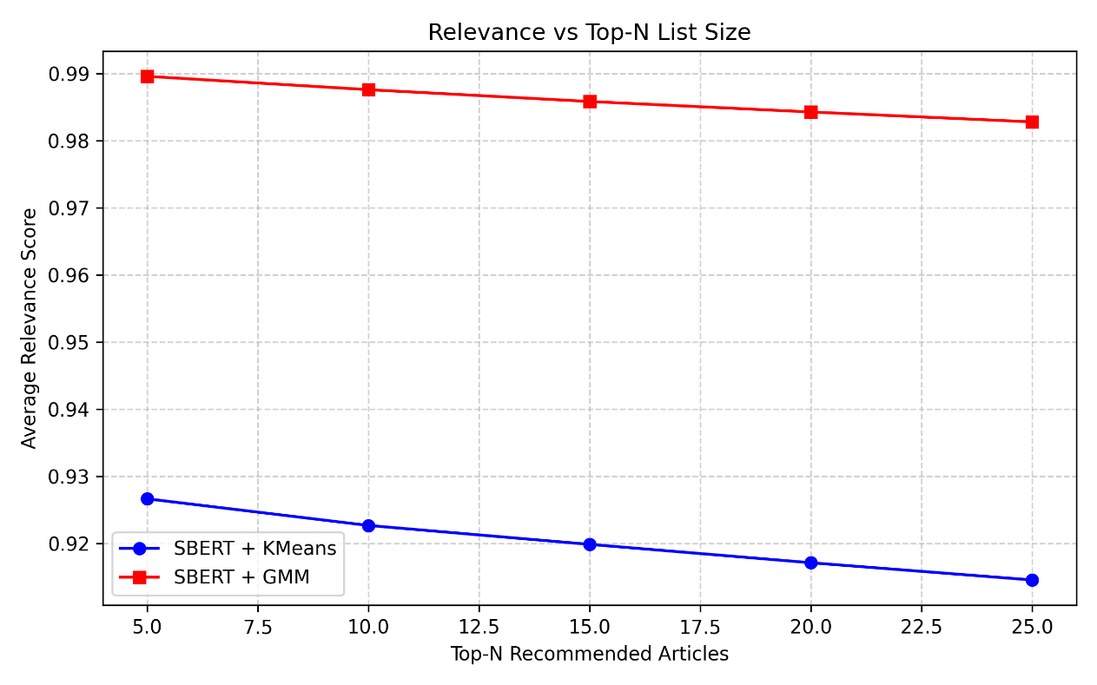
Coverage: K-Means consistently restricted recommendations to approximately 1.25 topics regardless of list size, a near-flat line indicating a mathematically enforced single-topic filter bubble. The GMM, by contrast, naturally expanded its topic coverage from 2 topics at Top-5 to over 3.25 topics at Top-25, providing a genuinely multi-faceted feed without sacrificing relevance.
Figure 1: Comparative analysis of Average Relevance Score as the Top-N recommendation list size increases. The GMM algorithm maintains a higher, more stable relevance score (~0.98+) by utilizing soft-clustering, while the baseline K-Means algorithm exhibits a more pronounced steady decline.
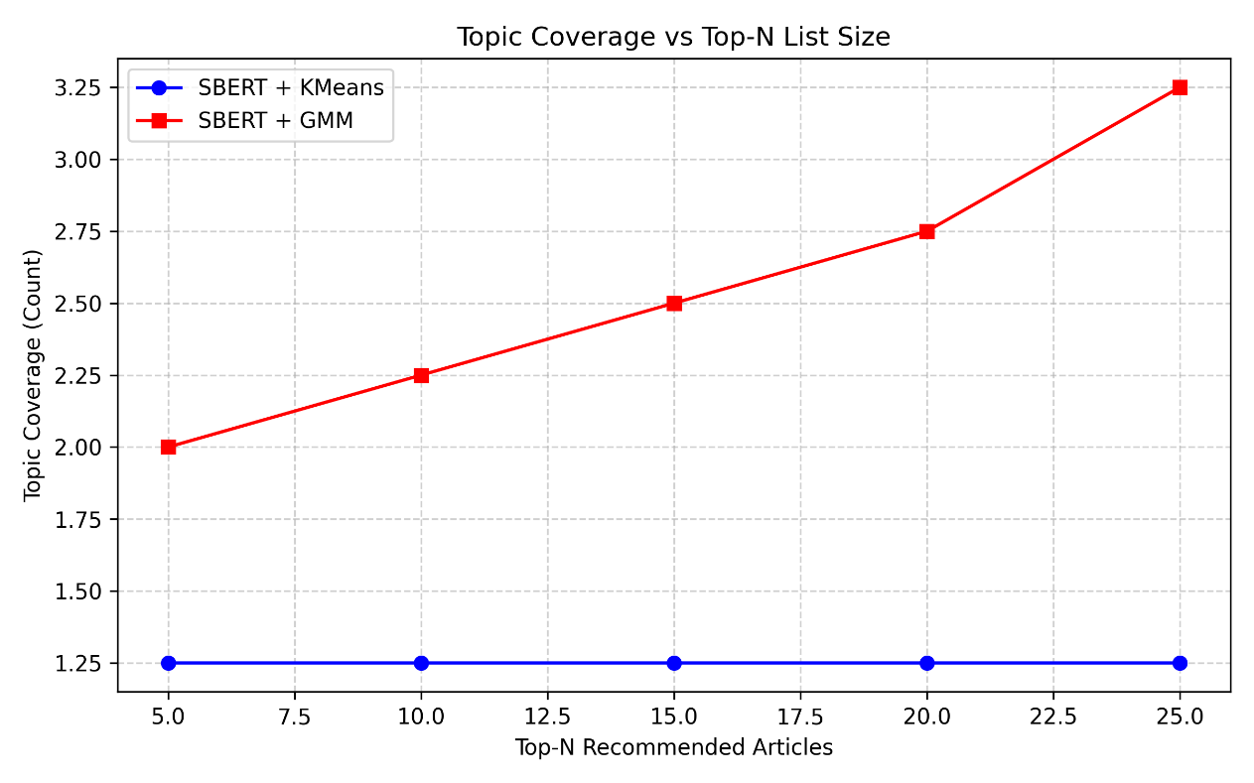
Figure 2: Evaluation of Topic Coverage against Top-N list size. The GMM algorithm demonstrates superior topic diversity, expanding from 2 to 3.25 distinct topics as the list grows, whereas K-Means remains rigidly constrained to approximately 1.25 topics throughout, enforcing a filter bubble.

Experiment 2: Algorithmic Resilience to Diversity Injection
The second experiment held the recommendation size at Top-10 and swept a stochastic diversity parameter from 0.0 to 0.4, injecting up to 40% noise to actively break filter bubbles.
Relevance vs Diversity: When forced to include diverse articles, K-Means relevance showed a steady decline, falling to ~0.89 at 40% noise. Remarkably, the GMM at its most diverse state (0.4) still maintained a higher relevance score (~0.96) than K-Means in its most focused state (0.0). This indicates that the GMM’s understanding of overlapping semantic spaces allows it to “hide” diversity within related topics, preserving the user experience while breaking filter bubbles.
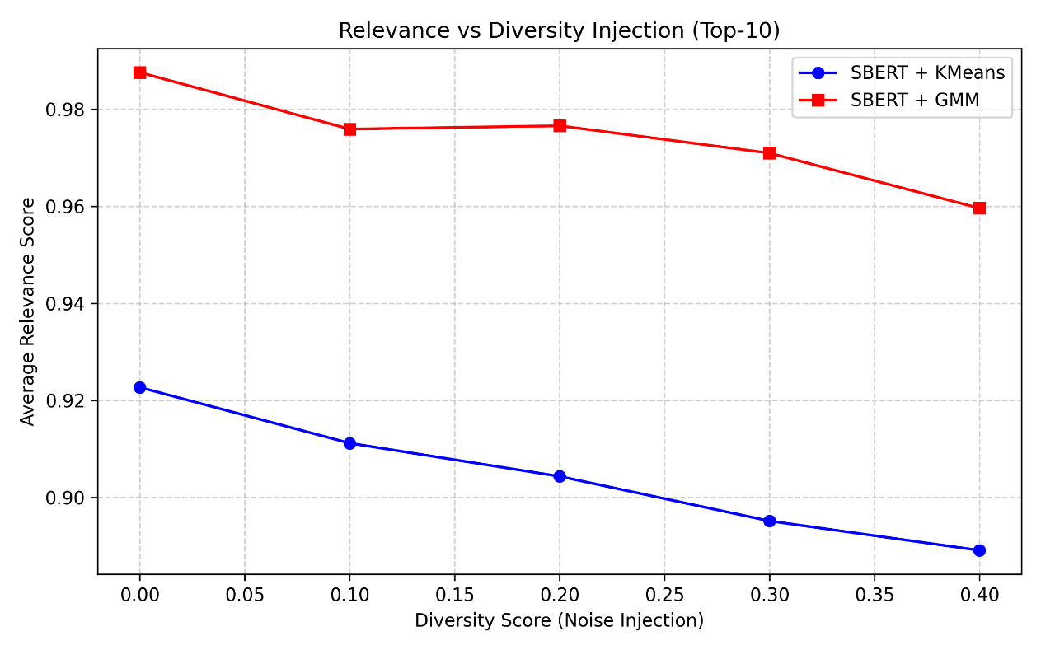
Figure 3: Algorithmic resilience to stochastic diversity injection. The GMM maintains a higher relevance floor even at high diversity (0.4) than K-Means does at zero diversity, proving its superior semantic robustness.

Filter Bubble Strength: Both models lowered Intra-List Similarity (ILS) as diversity was injected, indicating that the diversity mechanism is effective in both cases. Notably, GMM began from a slightly higher baseline ILS (~0.981 vs ~0.980 at 0.0 diversity) but exhibited a significantly steeper reduction, falling to ~0.931 at 40% noise compared to K-Means’ ~0.952. This steeper descent indicates that GMM’s probabilistic framework responds more dynamically to diversity injection, when pushed, it is architecturally more capable of genuinely diversifying its output.
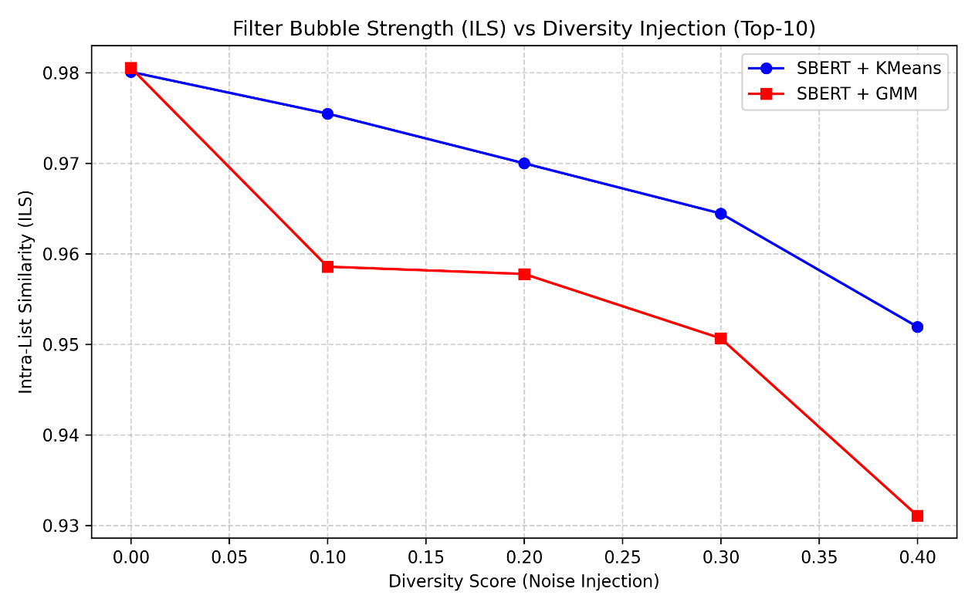
Figure 4: Intra-List Similarity (ILS) measured against increasing diversity injection. GMM exhibits a more significant reduction in filter bubble strength (lower ILS) compared to K-Means as diversity is introduced.

Experiment 3: Cluster Granularity Sensitivity (K-Sweep)
A common technical critique of K-Means is that its rigidity can be mitigated by increasing the number of clusters (K). This experiment swept K across {5, 8, 15, 30, 50} to empirically test this hypothesis.
Results: Increasing K did not close the performance gap, it widened it. At K=5, both models performed similarly (~0.993 vs ~0.985, a 0.8% gap). However, as K increased, K-Means relevance degraded sharply, falling to ~0.830 at K=50, while GMM fell more gradually to ~0.879, producing a gap of nearly 5 percentage points. This reveals that K-Means becomes increasingly fragile at high granularity as articles are forced into hyper-specific clusters from which the recommender cannot escape.
An interesting trade-off was also observed in Hit Rate (categorical matching): at K=50, K-Means actually achieved a higher Hit Rate (~0.80 vs GMM’s ~0.66) by locking onto the user’s dominant topic label. However, this came at the direct cost of semantic depth, the recommendations matched the user’s category but were less semantically coherent overall. GMM sacrifices rigid categorical matching in favour of genuine semantic proximity.
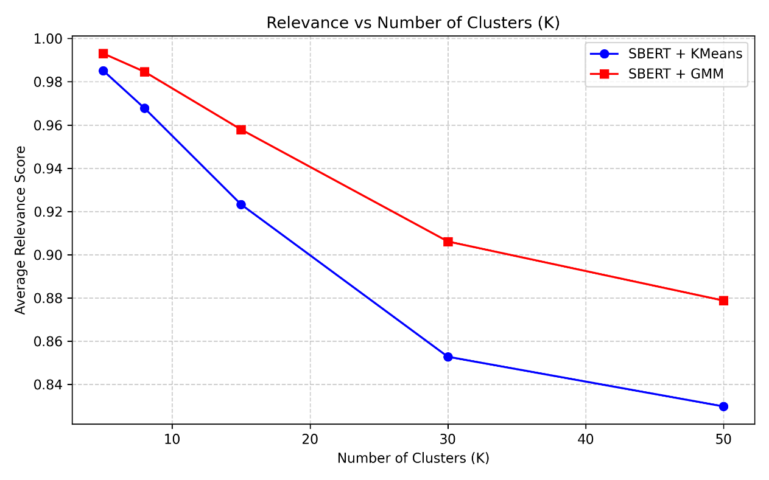
Figure 5: Algorithmic sensitivity to cluster count (K). Both models exhibit declining relevance at higher K values, but K-Means degrades more rapidly, widening the performance gap from ~0.8% at K=5 to ~5% at K=50. GMM’s probabilistic architecture proves more resilient to increased granularity.

Experiment 4: User Archetype Performance Analysis
To simulate a realistic and diverse user population, eight behavioural archetypes were defined, each characterised by a specific distribution of topic interest and reading volume. The Hardcore Fan dedicates 90% of their reading to a single dominant topic, with minimal secondary interest and very low noise, representing a prototypical filter bubble scenario with a reading history of 15–40 articles. The Casual Follower similarly focuses on one topic (75%) but reads less intensively, with a history of only 5–15 articles. The Dual Niche reader splits interest evenly between two topics (50%/40%), reflecting a balanced dual-interest profile across 10–30 articles. The Primary Leaner also maintains two interests but skews more heavily toward one (65%/25%), with a history of 8–25 articles. The Eclectic reader spreads attention across three topics with a high degree of random browsing (40% noise), accumulating between 20–50 articles, representing a broad but unfocused consumer. The News Junkie reads voraciously across four or more topics with 50% noise, building the largest histories of 30–60 articles. The Light Browser reads very little (3–8 articles), gravitating toward a single topic with limited secondary exposure. Finally, the Occasional Reader engages sporadically across two topics (4–10 articles), with moderate randomness in content selection. The final experiment evaluated performance across these simulated user archetypes.
Analysis: For single-topic users (e.g., “Hardcore Fan”), K-Means performed competitively, achieving a relevance score virtually indistinguishable from GMM (~0.99 for both). However, for multi-topic archetypes, particularly “Eclectic” (~0.93 vs ~0.98) and “News Junkie” (~0.93 vs ~0.98), GMM provided an absolute boost of approximately 5 percentage points. While modest in absolute terms, this represents a reduction in “relevance error” of nearly 70% (from 0.07 unexplained relevance gap to 0.02), confirming that the GMM architecture provides its strongest advantage for users whose interests span multiple intersecting topics.
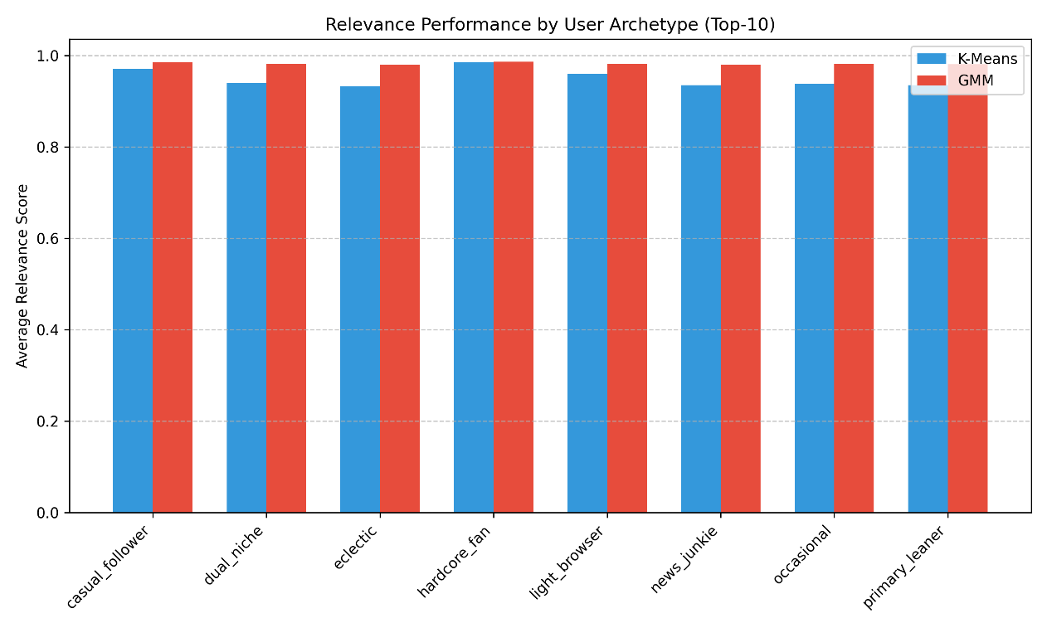
Figure 6: Average Relevance Score across distinct user behavioural archetypes. GMM shows significant performance gains over K-Means for multi-topic “Eclectic” and “News Junkie” readers.

Summary of Technical Findings
The quantitative evaluation confirms the central hypothesis: a probabilistic Gaussian Mixture Model, when applied to SBERT embeddings, provides a recommendation engine that is more relevant, more diverse, and more resilient to filter bubbles than a traditional K-Means baseline. The soft-clustering approach effectively bridges the gap between mathematical similarity and human semantic nuance.

Proposed User Study Methodology
Having mathematically validated the recommendation logic, the final phase of evaluation will involve a pedagogical user study to assess how effectively the visual radar charts communicate these algorithmic differences to non-expert users. Usability and educational effectiveness will be assessed through a small user study. Participants will be asked to complete predefined exploration tasks and provide feedback using questionnaires. Changes in user understanding before and after interaction with the system will be analysed.

Conclusions

Writing the Conclusions Chapter
The Conclusions section should be a summary of the project and a restatement of its main results, i.e. what has been learnt and what it has achieved. An effective set of conclusions should not introduce new material. Instead, it should draw out, summarise, combine and reiterate the main points that have been made in the body of the report and present opinions based on them.
The Conclusions section marks the end of the report proper.
References
[1] European Commission, “Media & News Survey 2023,” europa.eu, 2023. Available: https://europa.eu/eurobarometer/surveys/detail/3153. [Accessed: Sep. 26, 2025]
[2] European Commission, “Social Media Survey 2025,” europa.eu, 2025. Available: https://europa.eu/eurobarometer/surveys/detail/3592. [Accessed: Nov. 19, 2025]
[3] Bertelsmann Stiftung, “What Europe Knows and Thinks About Algorithms,” bertelsmann-stiftung.de, 2019. Available: https://www.bertelsmann-stiftung.de/fileadmin/files/BSt/Publikationen/GrauePublikationen/WhatEuropeKnowsAndThinkAboutAlgorithm.pdf. [Accessed: Sep. 26, 2025].
[4] NVIDIA, “Recommendation System,” NVIDIA Glossary, 2024. [Online]. Available: https://www.nvidia.com/en-us/glossary/recommendation-system/
[5] F. Ricci, L. Rokach, and B. Shapira, Recommender Systems Handbook, Springer, 2015.
[6] J. B. Schafer, D. Frankowski, J. Herlocker, and S. Sen, “Collaborative Filtering Recommender Systems,” in The Adaptive Web, Springer, 2007, pp. 291–324.
[7] Y. Koren, R. Bell, and C. Volinsky, “Matrix Factorization Techniques for Recommender Systems,” Computer, vol. 42, no. 8, pp. 30–37, 2009.
[8] M. Pazzani and D. Billsus, “Content-based Recommendation Systems,” in The Adaptive Web, Springer, 2007, pp. 325–341.
[9] R. Burke, “Hybrid Recommender Systems: Survey and Experiments,” User Modeling and User-Adapted Interaction, vol. 12, no. 4, pp. 331–370, 2002.
[10] A. Das, M. Datar, A. Garg, and S. Rajaram, “Google News Personalization: Scalable Online Collaborative Filtering,” in Proc. WWW, 2007, pp. 271–280.
[11] J. Liu, P. Dolan, and E. R. Pedersen, “Personalized News Recommendation Based on Click Behavior,” in Proc. IUI, 2010, pp. 31–40.
[12] D. M. Blei, A. Y. Ng, and M. I. Jordan, “Latent Dirichlet Allocation,” Journal of Machine Learning Research, vol. 3, pp. 993–1022, 2003.
[13] J. Devlin, M. Chang, K. Lee, and K. Toutanova, “BERT: Pre-training of Deep Bidirectional Transformers for Language Understanding,” arXiv:1810.04805, 2019.
[14] E. Pariser, The Filter Bubble, Penguin, 2011.
[15] S. Flaxman, S. Goel, and J. Rao, “Filter Bubbles, Echo Chambers, and Online News Consumption,” Quarterly Journal of Economics, vol. 131, no. 2, pp. 665–704, 2016.
[16] TensorFlow Playground, “Interactive Neural Network Visualizer.” [Online]. Available: https://playground.tensorflow.org/
[17] M. D. Ekstrand et al., “LensKit for Research: Tools for Recommender System Experiments,” in Proc. RecSys, 2022.
[18] Y. Zhang and X. Chen, “Explainable Recommendation: A Survey and New Perspectives,” Foundations and Trends in Information Retrieval, vol. 14, no. 1, pp. 1–101, 2020.
[19] C. O’Neil, Weapons of Math Destruction, Crown, 2016.
[20] Z. Tufekci, “Algorithmic Harms Beyond Facebook and Google,” First Monday, vol. 20, no. 11, 2015.
[21] T. Gillespie, “The Relevance of Algorithms,” in Media Technologies, MIT Press, 2014.
[22] N. Tintarev and J. Masthoff, “Explaining Recommendations: Design and Evaluation,” in Recommender Systems Handbook, F. Ricci, L. Rokach, and B. Shapira, Eds. Boston, MA, USA: Springer, 2015, pp. 353–382.
[23] J. L. Herlocker, J. A. Konstan, and J. Riedl, “Explaining Collaborative Filtering Recommendations,” in Proc. ACM Conf. Computer Supported Cooperative Work, Philadelphia, PA, USA, 2000, pp. 241–250.
[24] P. W. Koh and P. Liang, “Understanding Black-box Predictions via Influence Functions,” in Proc. 34th Int. Conf. Machine Learning (ICML), Sydney, Australia, 2017, pp. 1885–1894.
[25] N. Reimers and I. Gurevych, “Sentence-BERT: Sentence Embeddings using Siamese BERT-Networks,” in Proc. Empirical Methods in Natural Language Processing (EMNLP), 2019.
[26] M. Grootendorst, “BERTopic: Neural topic modeling with a class-based TF-IDF procedure,” arXiv preprint arXiv:2203.05794, 2022.
[27] C. M. Bishop, Pattern Recognition and Machine Learning, Springer, 2006.
[28] F. Gedikli, D. Jannach, and M. Ge, “How should I explain? A comparison of different explanation types for recommender systems,” International Journal of Human-Computer Studies, vol. 72, no. 4, pp. 367–382, 2014.
[29] P. Kouki, J. Schaffer, J. Pujara, J. O’Donovan, and L. Getoor, “Personalized explanations for hybrid recommender systems,” in Proc. 24th International Conference on Intelligent User Interfaces, 2019, pp. 379–390.

- When to Use Appendices (Style: Appendix Heading 1)
When inserting a new appendix use the Appendix Heading 1 style. The appendix numbering and the word “Appendix” are inserted automatically.
- Appendices Headings (Style: Appendix Heading 2)
When inserting appendix headings, use the corresponding Appendix Heading style according to the required level.
- Appendix Sub-Headings (Style: Appendix Heading 3)
Only three levels are defined for appendices.
- What to put in Appendices
Appendices are repositories for material which the student wishes to include in the report, but which would seriously obstruct the flow of ideas put anywhere in the main body. Copies of the final version of any code should be avoided – the code must be available digitally on accompanying media.
Examples of items that could go in appendices are:
- A glossary of terms.
- Fundamental and basic theory.
- Schematic Diagrams and PCB/IC layout snap shots.
- Detailed notes on the programming language chosen or hardware platform used or technology used in an IC environment.
- A user’s guide.

- Version Information
Version Number: | 1.1
Date: | 30 November 2022
Version Information: | - Changed fonts to Lato.  - Given instructions how to install Lato font.  - Clarified location of IEEE – Faculty of ICT style.
Author: | Prof Inġ Victor Buttigieg
Version Number: | 1.0
Date: | 19 November 2022
Version Information: | First version of the FYP dissertation template.
Author: | Prof Inġ Victor Buttigieg
- Copyright Information
The copyright of this template belongs to the Faculty of Information and Communication Technology (ICT), University of Malta. Students of the Faculty of ICT are allowed to use this template to write their FYP dissertation. No part of this template is allowed to be used by other third parties without prior authorisation.
- Suggestions
If you have any suggestions how this template can be improved, or if you think that there is a specific issue with this template, please email these to victor.buttigieg@um.edu.mt.

