Chapter 6: Mechanism of Limited Direct Execution

LDE Technique
- Time shared and virtualization are the same?
- The crux How to virtualize and implment time sharing by the time maintaing performance and control?
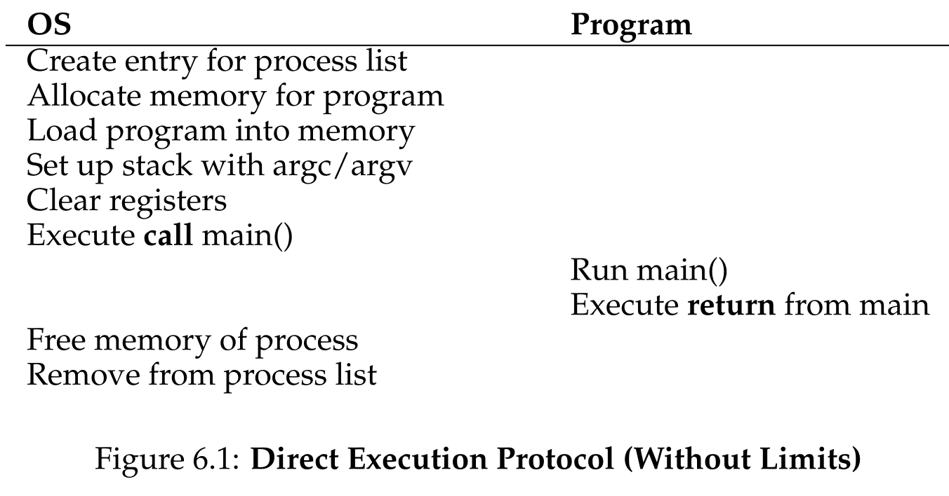
- For implement time sharing we need to virtualize the CPU in addition for control a process we need to virtualize it.
- Without control, the OS will be just a library.

Problem: Restricted Operations
- Problem: “How the OS & Hardware work togueter to provide the ability a process to run restricted operations but without giving the control of the entire system”
- Without OS many kind of systems are not possible to accomplish.
- Aside: “Why syscalls looks like procedure calls? Well actually are procedure but inside that C library hides the trap instruction putting params in register conventions and calling a specific syscall by register conventions (assembly)”
- Processor mode know as user mode, issuing a I/O request will raise an Exception letting OS kill that process
- Software that is really Software (portable-engineered-designed) is the OS that is built using it Computer System available and making use of it. But other software is virtualized.
- All modern hardware provides the ability to user-programs to perform system calls by providing different modes of execution
- User process can trap(software interruption instruction of CPU) into the kernel, where process triggers a mechanism to tell CPU switch to kernel (is only of kernel) and jumps to kernel-location process to handle request (transfer mechanism – not transformation)(intentional – not a fault)
- For resuming (returning from trap) the hardware in Intel save information pushing state of user-process in kernel-stack with the purpose that returning pop kernel-stack per process.
- Problem: How does the trap know which code to run inside OS? Obviously user-programs not specify addres to jumps as calling procedure
- When machine boots is in kernel mode and configure hardware as needed.
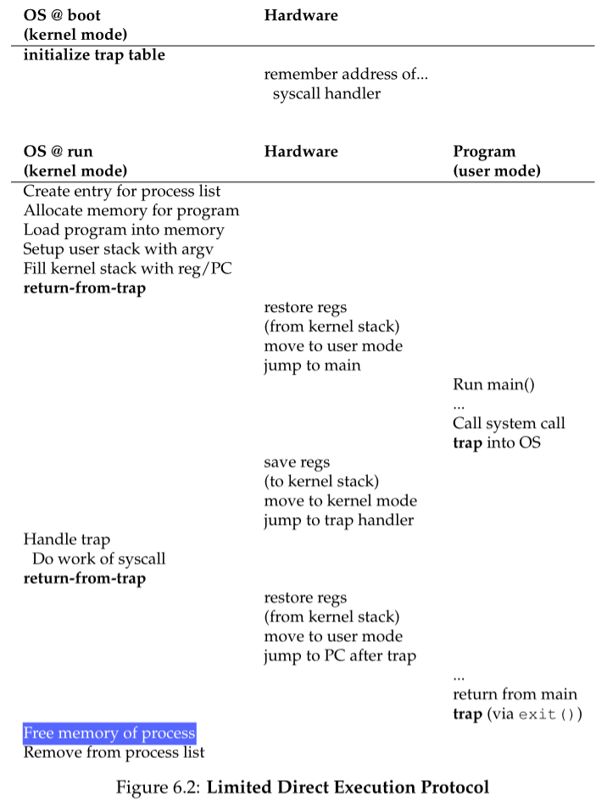
- Now by hardware trap mechanism and trap OS handlers all syscalls and exceptions are routed, so all arguments must be examined for security
- The syscall hardware interruption instruction for trapping must also specify a syscall number that the trap-handler (OS) examines and jumps to correspond code, so this level of indirection asking for service provides protection
- Example of privilaged operation like telling software where the trap tables will raise Exception(software) or other kind of hardware handler if you are in user mode. Other examples are return from trap(only OS) and trapping(user-process makes this requests)

Problem: Switching between process
- The crux is how to regain control of CPU (the OS) if OS is not running. In spite of a philosophycal problematic, is a real problem that direct execution of processes has
- Cooperative Approach where OS trusts processes where are assumed will give up the CPU so OS run other task
- The yield system call and the OS passive Macintosh
- OS is waiting for processes to do system calls and also process can yield cpu resource to OS (utopian world)
- The crux is how to gain control of the machine without cooperation?
- The solution is a timer device programmed to interrupt every milliseconds (timer interrupt)
- A interrupt handler preconfigured in OS is executed and this code is informed to hardware at boot time.
- With malicious or bugs the OS terminates it
- At boot time also its important to start the timer
- As with system calls a timer interruption executes saved state instructions
- Now a mini problem arise after yielding syscalls or timer interruption (Coop or non-coop approach) what decision take about swithing to other process or continue the recent one?
- If we switch then a context switch is executed
- Kernel Stack is essential DSA
- Without Kernel Stack (Robustness-Security-Concurrency)
- Security: User stack can be manipulated when a syscall is pending like ret-address
- Robustness: User stack can overflow and if a syscall is request a overflow in kernel occur
- Concurrency: Because kernel is C, calls to functions and use kernel stack of a process to deal with syscalls of that process
- Problem: Solved by topic Concurrency, What happens when you OS is dealing with a syscall in a trap handler and a timer interrupt occurs? What if dealing with an interrupt handler and another interruption occurs
- The OS disable interrupts during interrupt processing, but this in long time slice is bad because means some interruption are lost
- Locking Schema to protect concurrent acces to internal data structure
- Aside Performance: from 1996 Linux 1.3.36 with 200MhZ from now with 2-3GhZ Context switch and syscalls takes from 4 microseconds to 4 submicroseconds

OS baby proofing analogy with process
At boot time set up trap handlers and timer interrupt and running process in restricted mode, requiring OS intervetion for performing restricted-privilaged operations

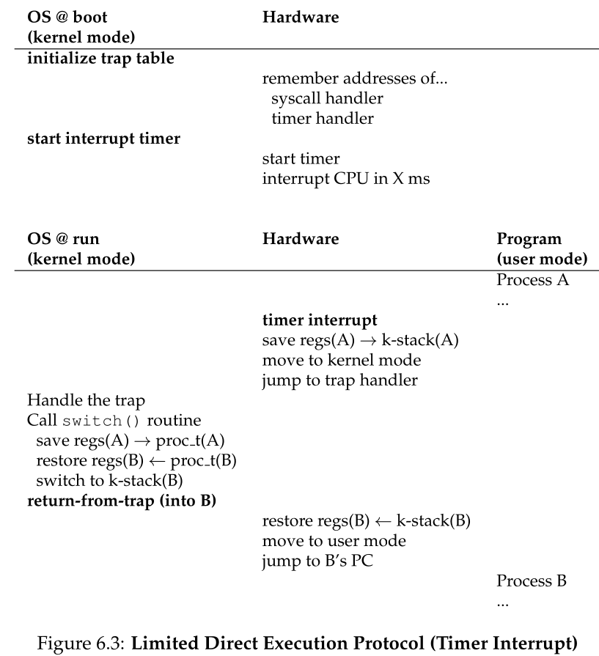
- Saving context is done by hardware when time-interrupt, saving in curr_kernel_stack
- And by OS where vitual context switch allows return from trap to execute B instead of A
- Note that by convention hardware use kernel stack for updating
- AT&T syntax vs Intel syntax & x86 xv6 vs RISC-V xv6
- In 32-xv6 args on stack in reverse and calls are [arg2 arg1 (%esp)->ret_addr]

