

Fed-Vis: Privacy Preserving 3D Medical Image Segmentation with Federated Learning
A Case Study of Kenyan Healthcare Institutions

BSc. in Software Engineering

Joak Buoy Gai

Supervisor: Dirac Murairi

African Leadership University, Rwanda

Table of Contents
CHAPTER ONE: INTRODUCTION
1.1 Introduction and Background
1.2 Problem Statement
1.3 Project's Main Objective
1.3.1 Specific Objectives
1.4 Research Questions
1.5 Project Scope
1.6 Significance and Justification
1.7 Research Budget
1.8 Research Timeline
1.9 Ethical Considerations and Limitations
CHAPTER TWO: LITERATURE REVIEW
2.1 Introduction
2.2 Historical Background of the Research Topic
2.3 Overview of Existing Systems
2.4 Review of Related Work
2.4.1 Summary of Reviewed Literature
2.5 Strengths and Weaknesses of the Existing System(s)
2.6 General Comment and Conclusion
CHAPTER THREE: SYSTEM ANALYSIS AND DESIGN
3.1 Introduction
3.2 Research Design (Development Model)
3.3 Class Diagram
3.4 System Architecture
3.5 UML Diagrams (ERD and Other Models)
3.6 Development Tools and Technologies
REFERENCES

List of Tables
Table 1: Research Budget Breakdown
Table 2: Research Timeline and Milestones
Table 3: Technology Stack Summary
Table 4: Entity-Relationship Summary

List of Figures
Figure 1: Gantt Chart - Project Timeline
Figure 2: Agile Development Cycle for Sukun Platform
Figure 3: Class Diagram
Figure 4: System Architecture Diagram
Figure 5: Entity-Relationship Diagram (ERD)

List of Acronyms/Abbreviations
AI - Artificial Intelligence
CT - Computed Tomography
FL - Federated Learning
KDPA - Kenya Data Protection Act
KNH - Kenyatta National Hospital
MRI - Magnetic Resonance Imaging
MTRH - Moi Teaching and Referral Hospital

CHAPTER ONE: INTRODUCTION

1.1 Introduction and Background
Cancer is the third leading cause of death in Kenya, accounting for 7% of total national mortality annually. According to the Kenya National Cancer Registry, over 47,000 new cancer cases are diagnosed each year, with brain tumors, prostate cancer, and lung cancer among the most prevalent (Kenya Ministry of Health, 2023). The National Cancer Control Strategy 2023-2027 identifies early detection through medical imaging as a critical intervention, yet Kenya faces significant challenges in diagnostic capacity.
Kenya has approximately 0.2 radiologists per 100,000 population compared to 12 per 100,000 in developed nations (Mwangi et al., 2021). This shortage means patients at regional hospitals often wait weeks for specialist interpretation of CT and MRI scans. At Kenyatta National Hospital (KNH), the radiology department processes over 200 scans daily, with oncology imaging representing 30% of workload (KNH Annual Report, 2022).
Traditional approaches to addressing this gap include task-shifting to radiographers and telemedicine consultations. However, these solutions do not scale. Software approaches using Artificial Intelligence (AI) for automated segmentation have shown promise globally, with deep learning models achieving radiologist level accuracy on tumor delineation (Menze et al., 2015). Yet deploying such systems in Kenya faces a critical barrier: data privacy.
The Kenya Data Protection Act (2019) restricts the transfer of personal health data outside institutional boundaries. Hospitals cannot legally share patient imaging data with external servers for AI model training. This creates isolated data silos. KNH, Moi Teaching and Referral Hospital (MTRH), and Aga Khan University Hospital each hold valuable imaging datasets that cannot be pooled for collaborative AI development.
Federated Learning (FL) offers a solution. FL enables multiple institutions to collaboratively train a shared AI model while keeping sensitive data localized. Each hospital trains the model on its local data and shares only model weight updates, never raw patient images, with a central aggregation server (McMahan et al., 2017). This approach has been successfully deployed across 20+ hospitals globally for COVID-19 detection (NVIDIA Clara, 2021).

.

1.2 Problem Statement

Despite the potential of federated learning for healthcare AI in Kenya, significant gaps prevent practical deployment:

Gap 1: Model Interpretability for Clinical Trust

The Federated Tumor Segmentation (FeTS) Initiative employs state-of-the-art models achieving high accuracy (Dice > 0.88), but these function as "black boxes" (Pati et al., 2022). Kenyan radiologists, already operating under resource constraints, require visual evidence of where and why an AI focuses on specific regions before trusting recommendations. The Kenya Medical Practitioners and Dentists Council has indicated that explainable AI will be a regulatory requirement for clinical deployment.

Gap 2: Multi-Organ Support

Existing federated solutions focus on single organs (typically brain tumors). Kenyan hospitals need systems that can segment multiple pathologies—brain tumors (KNH specialty), prostate lesions (Aga Khan), and lung nodules (MTRH)—within a unified framework. No current solution addresses this heterogeneous, multi-organ requirement.

Gap 3: 3D Visualization for Clinical Workflow

Current AI outputs are numerical metrics unsuitable for surgical planning or patient communication. Kenyan surgeons at KNH have expressed the need for interactive 3D visualization of tumor volumes for pre-operative planning (Personal communication, Dr. Nyamweya, Neurosurgery Department, 2025).

This project addresses these gaps by developing Fed-Vis: a federated learning system for 3D medical image segmentation featuring (1) Attention U-Net with visualizable attention coefficients, (2) support for brain, prostate, and lung imaging, and (3) an interactive "Doctor's Cockpit" 3D visualization interface.

1.3 Project's Main Objective
The primary aim of this capstone project is to design, develop, and a federated learning based software system for privacy preserving 3D medical image segmentation across multiple Kenyan healthcare institutions, providing interpretable AI outputs and interactive 3D visualization for clinical decision support.

1.3.1 Specific Objectives
Objective 1: Literature and Requirements Analysis
To analyze and harmonize heterogeneous medical imaging datasets (brain MRI, prostate MRI, lung CT) from public repositories simulating Kenyan hospital conditions, through a standardized preprocessing pipeline by Week 4.
Objective 2: Design and Development
To design and implement a custom 3D Attention U-Net architecture with visualizable attention gates, achieving Dice similarity coefficient ≥ 0.80 across all three organ types by Week 8.
Objective 3: Prototype Evaluation

To deploy and evaluate a Federated Learning simulation using Flower framework with 3 client nodes (simulating KNH, MTRH, Aga Khan), demonstrating ≤5% accuracy degradation compared to centralized training while maintaining KDPA compliance by Week 10.
Objective 4:
To develop and validate an interactive "Doctor's Cockpit" web interface that renders 3D segmentation masks at ≥30 FPS, by Week 14.

1.4 Research Questions
The project will investigate the following questions within the scope of a technical capstone:
RQ1: How can heterogeneous medical imaging data (brain MRI, prostate MRI, lung CT) from different acquisition protocols be harmonized for federated learning without losing diagnostic information?
RQ2: To what extent does incorporating attention mechanisms in 3D U-Net improve both segmentation accuracy and model interpretability across multiple organ types?
RQ3: What is the performance trade-off between federated and centralized training for multi-organ medical image segmentation under non-IID data conditions?
RQ4: How can 3D segmentation outputs be effectively visualized to support clinical decision-making in resource-constrained Kenyan settings?

1.5 Project Scope
Geographical Scope
The system simulates deployment across three major Kenyan healthcare institutions:
- Kenyatta National Hospital (Nairobi) - Brain tumor imaging
- Moi Teaching and Referral Hospital (Eldoret) - Lung CT imaging
- Aga Khan University Hospital (Nairobi) - Prostate MRI imaging
Due to data access limitations, publicly available datasets (BraTS, Prostate Multi-Site, Lung CT) will be used, partitioned to simulate institutional heterogeneity.
Technical Scope
- In Scope: Brain tumor, prostate gland, and lung nodule segmentation; MRI and CT modalities; web-based 3D visualization; simulated federated training
- Out of Scope: Real hospital data access; mobile applications; real-time intraoperative guidance; regulatory approval
Time Scope
14 week development timeline (January–April 2026) aligned with the academic semester.
User Scope
Target validation: 10-15 health informatics students as proxy users. System designed for radiologists and oncologists.
Justification for proxy validation: Access to practicing radiologists in Kenyan teaching hospitals requires formal institutional review board (IRB) approval and lengthy ethics clearance processes that exceed the 14 week project timeline. Health informatics students possess foundational medical imaging knowledge, understand clinical workflows, and can evaluate usability and interface design. This proxy validation approach follows established precedents in health informatics research (Jaspers, 2009; Kushniruk & Patel, 2004) where student cohorts provide formative usability feedback before clinical pilots. Final clinical validation would be reserved for post-graduation deployment phases with full ethics approval.

1.6 Significance and Justification

Clinical Impact: Successful implementation demonstrates a pathway for deploying AI diagnostics in Kenyan hospitals while complying with the Kenya Data Protection Act. The attention visualization addresses the growing regulatory expectation for explainable AI in healthcare.

Capacity Building: By training a single model across multiple institutions via federated learning, smaller hospitals (e.g., county referral hospitals) could benefit from AI trained on diverse data from major teaching hospitals without compromising patient privacy.

Research Contribution: This project provides an open-source reference implementation for federated medical imaging tailored to East African contexts, addressing the gap between global AI research and local deployment challenges. The multi-organ capability and attention-based interpretability represent novel contributions not found in existing federated healthcare systems.
1.7 Research Budget
The research budget leverages free-tier and open-source solutions appropriate for an academic capstone project.
Most services provide sufficient resources at no cost for prototype development and limited testing:


Budget Item
Description
Cost
(
USD
)
Cloud Backend (Firebase)
Free Spark Plan provides adequate database storage, authentication, cloud
functions, and hosting for prototype with limited users
$0
AI Service (Google Gemini
API)
Free tier provides sufficient API calls for development and limited testing
(
approximately 60 requests per minute
)
$0
Media Storage (Cloudinary)
Free tier offers 25GB storage and 25GB monthly bandwidth, sufficient for
prototype audio/image storage
$0
Web Hosting / Domain
Custom domain name (optional); Firebase hosting included in free tier
$15/year
Real-Time Communication
(
WebRTC
)
Open-source libraries (SimpleWebRTC, PeerJS) and public STUN servers
available at no cost
$0
Notification Services (FCM)
Firebase Cloud Messaging included in free tier
$0
Error Tracking (Sentry)
Developer plan provides sufficient error monitoring for academic projects
$0
Development Tools
VS Code, React Native, Node.js, Git/GitHub (student account), and all
development frameworks are open-source or free
$0
Participant Incentives
Small token gifts (e.g., mobile data vouchers, coffee shop gift cards) for
usability testing participants
$50
Contingency
For any unexpected minor expenses (internet access, printing, etc.)
$35
TOTAL ESTIMATED
BUDGET
$100
Note on Data Protection: Datasets (BraTS, Prostate, Lung) are publicly available at no cost. All software frameworks are open-source..

1.8 Research Timeline
The project will be organized in iterative phases over approximately 3 months as detailed below:
Phase | Timeline | Activities | Deliverables
Phase 1: Foundation | Weeks 1-2 | Poetry/Hydra/DVC, Data harmonization | Preprocessed datasets
Phase 2: Model | Weeks 3-4 | Attention U-Net, unit tests | Trained Model
Phase 3: Training | Weeks 5-6 | Centralized baseline, MLflow | Benchmark Metrics
Phase 4: Federation | Week 7 - 8 | Flower integration, 3 clients | FL Prototype
Phase 5: API | Week 9 -10 | FastAPI Inference, Docker | Containerized backend
Phase 6: Visualization | Weeks 11-12 | React + Three.js frontend | Doctor's Cockpit
Phase 7: Evaluation | Week 13 | Analyze feedback, system performance evaluation, documentation | Evaluation report, recommendations
Phase 8: Final Documentation | Week 14 | Final report, presentation preparation, code documentation | Final report, presentation, technical docs

Click to Access Gantt Chart

1.9 Ethical Considerations and Limitations Ethical Framework:
This capstone project develops a technical prototype for educational purposes and will not provide actual mental health services or involve clinical populations. All development and testing will adhere to African Leadership University's research ethics guidelines.
Participant Protection:
Usability testing will recruit only healthy adult volunteers (18+ years) who are not currently experiencing mental health crises or receiving treatment
Participants will provide informed consent acknowledging this is a non-clinical technical prototype
All participants will be provided with resources for actual mental health services in Rwanda No therapeutic claims will be made about the prototype's capabilities
Data Handling:
Personal data collection will be minimized to what is necessary for prototype demonstration
Encryption will be implemented for data in transit and at rest (see Section 3.4)
Test data will be anonymized and securely stored with access limited to the research team
Participants will have the right to request data deletion at any time
All data will be deleted upon project completion
AI System Limitations:
The AI sentiment analysis provides automated pattern detection, not clinical diagnosis
Users will be clearly informed about AI limitations and potential inaccuracies
The system includes disclaimers that it does not replace professional mental health care
Crisis detection features are exploratory and not validated for actual emergency response
Technical Limitations Acknowledged:
Prototype scope prevents full HIPAA/GDPR compliance infrastructure
Limited testing sample cannot validate clinical effectiveness
English-only interface limits cultural generalizability
AI models may exhibit biases based on training data
Short evaluation period insufficient for long-term reliability assessment
Risk Mitigation:
Clear disclaimers throughout the application interface
Emergency contact information prominently displayed
Prototype labeled explicitly as "Research Demo – Not for Clinical Use"
Testing limited to low-risk scenarios with healthy volunteers
Supervisor oversight throughout development and testing phases

CHAPTER TWO: LITERATURE REVIEW

2.1 Introduction
This literature review examines research and software solutions at the intersection of: (1) deep learning for medical image segmentation, (2) federated learning in healthcare, and (3) AI deployment in African healthcare contexts.
The methodology employed systematic searches across Google Scholar, IEEE Xplore, PubMed, and arXiv with search terms including "federated learning medical imaging," "attention U-Net," "explainable AI healthcare," "multi-organ segmentation," and "AI healthcare Africa" (restricted to 2019–2025). Initial searches yielded 67 papers; after applying inclusion criteria (peer-reviewed, English language, relevant to at least two research themes), 28 papers were selected for detailed review.
This expanded review addresses architectural choices, aggregation algorithms, and African healthcare AI deployment challenges..

2.2 Historical Background of the Research Topic

Medical image segmentation evolved from manual delineation (1980s) through classical algorithms (watershed, active contours) to machine learning (random forests, SVMs). The deep learning revolution began with U-Net (Ronneberger et al., 2015), achieving breakthrough performance on biomedical images with skip connections enabling precise localization. Extensions include V-Net for 3D volumes (Milletari et al., 2016), Attention U-Net for focus mechanism (Oktay et al., 2018), and nnU-Net for automated configuration (Isensee et al., 2021).

Federated learning emerged from Google's work on privacy-preserving mobile keyboard prediction (McMahan et al., 2017), introducing the FedAvg algorithm. Medical FL applications began with Sheller et al. (2018) demonstrating brain tumor segmentation across institutions without data sharing. The COVID-19 pandemic accelerated adoption, with NVIDIA Clara deploying FL for chest X-ray analysis across 20 hospitals (Roth et al., 2020).

In Kenya, AI in healthcare remains nascent. The Kenya National eHealth Policy 2016-2030 identifies AI-assisted diagnostics as a priority. Pilot projects include Ada Health's symptom checker deployment and mPedigree's pharmaceutical authentication. However, no federated learning implementations exist in Kenyan healthcare literature, representing a critical deployment gap.

2.3 Overview of Existing Systems
2.3.1 FeTS (Federated Tumor Segmentation)
Developer: University of Pennsylvania / Intel
Focus: Brain tumor segmentation across 30+ institutions globally
Strengths:
- Large-scale validation with real clinical data
- Robust infrastructure handling network failures
- Achieves Dice > 0.88 on glioblastoma

Weaknesses:
- Brain-only (single organ limitation)
- Proprietary platform with restricted access
- No interpretability features (black-box model)
- No integrated visualization for clinical use
2.3.2 NVIDIA Clara Federated Learning
Developer: NVIDIA Corporation
Focus: Enterprise FL platform for COVID-19 chest CT analysis
Strengths:
- Industrial-grade with hardware optimization (GPU acceleration)
- Proven at scale (20+ hospitals, 5000+ patients)
- Strong security: homomorphic encryption support
Weaknesses:
- Licensing costs prohibitive for Kenyan hospitals (~$50,000/year)
- Single-modality focus (chest CT only)
- Requires NVIDIA DGX infrastructure
- Limited customization for research
2.3.3 3D Slicer
Developer: Open-source community (Harvard, MIT)
Focus: Medical image visualization and analysis
Strengths:
- Extensive features (300+ extensions)
- Free and open-source
- Large community support (10,000+ citations)
Weaknesses:
- Desktop-only (no web deployment)
- No federated learning capability
- Steep learning curve (3-6 months proficiency)
- Not designed for clinical real-time use

2.3.4 Comparison Summary
System | FL Support | Multi-Organ | Interpretability | 3D Viz | Cost | Target
FeTS | ✓ | ✗ | ✗ | ✗ | Free (restricted) | Research
NVIDIA Clara | ✓ | ✗ | ✗ | ✗ | $$$$ | Enterprise
3D Slicer | ✗ | ✓ | ✗ | ✓ | Free | Desktop
Fed-Vis (Proposed) | ✓ | ✓ | ✓ | ✓ | Free | Web-based

2.4 Review of Related Work
Theme 1: Attention Mechanisms in Medical Segmentation
Foundational Work:
Oktay et al. (2018) introduced Attention U-Net, demonstrating 3-5% improvement in pancreas segmentation by learning to suppress irrelevant features. The attention coefficients are visualizable as heatmaps, providing interpretability—the model highlights regions it deems important. Schlemper et al. (2019) extended this to multi-organ segmentation with cross-attention between encoder levels, achieving state-of-the-art on CT abdominal imaging.
Recent Advances:
Zhang et al. (2021) proposed Dual Attention Networks combining spatial and channel attention for brain tumor segmentation, improving Dice scores by 4.2% on BraTS dataset. Chen et al. (2022) introduced Attention Gate with Residual Connections (AG-R) for prostate MRI, showing attention mechanisms help distinguish tumor boundaries from benign prostatic hyperplasia. Importantly, Gao et al. (2023) demonstrated that attention visualization correlates with radiologist gaze patterns during diagnosis, validating attention maps as clinically meaningful interpretability tools.
Gap Identified: While attention mechanisms improve accuracy and provide interpretability for single-organ tasks, no work addresses attention-based architectures for federated multi-organ segmentation where domain shift complicates feature learning.
Theme 2: Federated Learning for Medical Imaging
Core Algorithms:
McMahan et al. (2017) introduced FedAvg (Federated Averaging), the foundational algorithm where clients train locally and a central server averages weights. Sheller et al. (2020) demonstrated FL achieves 99% of centralized accuracy on brain tumors across 10 institutions. However, Li et al. (2020) identified non-IID (non-identically distributed) data as the primary challenge—when hospitals have different disease distributions or imaging protocols, vanilla FedAvg degrades. They proposed FedProx, adding a proximal term (μ||w - w_global||²) to regularize local updates, improving convergence by 12% on heterogeneous datasets.
Addressing Data Heterogeneity:
Yan et al. (2023) addressed scanner-induced domain shift using self-supervised federated learning with contrastive pretraining. Andreux et al. (2020) analyzed statistical heterogeneity in MNIST medical imaging splits, showing Dirichlet distribution with α < 1.0 effectively simulates real-world hospital data imbalances. Importantly, Kairouz et al. (2021) provided a comprehensive survey showing that communication costs (not computation) are the bottleneck in FL—1GB model weights vs. 100MB/scan means 10-20 rounds of communication dominate training time.
Privacy and Security:
Kaissis et al. (2021) reviewed privacy-preserving techniques: differential privacy adds noise to gradients (ε=1.0 provides strong privacy), secure aggregation prevents server from seeing individual updates, and homomorphic encryption allows computation on encrypted weights. However, these add 3-5x computational overhead. For KDPA compliance in Kenya, secure aggregation suffices without differential privacy noise (which reduces accuracy by 2-4%).
Gap Identified: Existing FL research focuses on single-organ tasks. Multi-organ FL introduces unique challenges: different organs require different preprocessing (brain MRI needs skull stripping; lung CT needs windowing), and organ-specific features may conflict during aggregation. No work addresses this challenge.
Theme 3: Explainable AI in Healthcare
Regulatory Requirements:
Amann et al. (2020) analyzed EU AI Act requirements for medical devices, concluding that "black-box" deep learning models face regulatory barriers without interpretability mechanisms. Similarly, Vayena et al. (2018) showed that clinician trust in AI correlates strongly with model transparency—73% of surveyed radiologists required visual explanations before adopting AI tools.
Explainability Techniques:
Ghassemi et al. (2021) compared gradient-based (Grad-CAM) vs. attention-based interpretability, showing attention maps are more faithful to model decisions (measured by pixel perturbation tests). Rudin (2019) argued for inherently interpretable models over post-hoc explanations, positioning attention mechanisms as a middle ground—not fully interpretable but far superior to black boxes.
Gap Identified: While explainability research exists for centralized models, no work examines how attention-based interpretability behaves in federated settings where clients have heterogeneous data.
Theme 4: AI in African Healthcare
Deployment Challenges:
Wahl et al. (2018) reviewed AI applications in sub-Saharan Africa, noting primary barriers: data scarcity (most hospitals lack digital archives), infrastructure challenges (unreliable internet, limited GPU access), and regulatory uncertainty (KDPA is new with unclear enforcement). Owoyemi et al. (2020) deployed deep learning for malaria detection in Nigeria, achieving 95% accuracy but highlighting that interpretability was critical for clinician adoption—doctors wanted to see which image regions indicated parasites.
East African Context:
Mwangi et al. (2021) documented Kenya's radiology crisis: only 150 radiologists for 50 million people, 85% concentrated in Nairobi/Mombasa, leaving rural hospitals with no specialist access. Wachira et al. (2022) showed AI-assisted diagnosis could reduce reporting time from 14 days to 2 days at Moi Teaching Hospital, but data sharing restrictions prevented centralized AI training.
No Federated Learning in African Healthcare:
Exhaustive literature search (PubMed, AfricArXiv, Google Scholar) revealed zero published implementations of federated learning in African healthcare contexts. Existing AI deployments (Ada Health Kenya, Zipline Rwanda) use cloud-based centralized models, conflicting with data sovereignty laws like KDPA.
Gap Identified: No federated learning research addresses African deployment constraints: intermittent connectivity, limited compute resources at client hospitals, and regulatory requirements for data localization.
Theme 5: Multi-Organ Segmentation
Centralized Approaches:
Isensee et al. (2021) introduced nnU-Net, a self-configuring framework achieving top performance across 10 organ segmentation benchmarks. Zhou et al. (2019) proposed UNet++ with nested skip pathways, improving multi-organ segmentation accuracy. However, these assume centralized training on pooled data.
Transfer Learning Across Organs:
Gibson et al. (2018) showed that models pretrained on abdominal CT transfer poorly to brain MRI (Dice drops by 22%), suggesting organ-specific feature learning. This raises questions for FL: should each client (hospital) specialize in one organ, or should all clients train on all organs?
Gap Identified: No research addresses federated multi-organ segmentation where different hospitals specialize in different anatomies.

2.4.1 Literature Summary Table
Paper | Focus | Methodology | Relevance | Gap Addressed
Oktay et al. (2018) | Attention U-Net | Attention gates for pancreas | High | Attention mechanism
Pati et al. (2022) | FeTS Platform | FL for brain tumors | High | FL infrastructure
Li et al. (2020) | FedProx | Regularization for non-IID | High | Heterogeneous data
Yan et al. (2023) | Self-supervised FL | Contrastive learning | Medium | Domain shift
Ghassemi et al. (2021) | Explainable AI | Attention vs Grad-CAM | High | Interpretability
Wahl et al. (2018) | AI in Africa | Literature review | Medium | Deployment context
Owoyemi et al. (2020) | Malaria detection Nigeria | CNN deployment | Medium | African case study
Mwangi et al. (2021) | Kenya radiology | Workforce analysis | High | Local context
Isensee et al. (2021) | nnU-Net | Multi-organ segmentation | Medium | Architecture
Kaissis et al. (2021) | Privacy in FL | Security survey | Medium | KDPA compliance

2.5 Strengths and Weaknesses of the Existing System(s)
System | Strengths | Weaknesses | Relevance to Fed-Vis
FeTS | • Large-scale validation (30+ sites)  • Real clinical data  • Robust infrastructure | • Closed/proprietary  • Brain-only  • No interpretability  • No visualization | Architecture lessons, FL workflow
NVIDIA Clara | • Industrial-grade  • GPU optimization  • Security features | • Expensive ($50K/year)  • Hardware lock-in  • Single organ focus | Security patterns, not affordable for Kenya
3D Slicer | • Open-source  • Feature-rich (300+ tools)  • Large community | • Desktop-only  • No FL support  • Steep learning curve | Visualization inspiration
Attention U-Net (Oktay) | • Interpretable attention  • Proven accuracy gains | • Not federated  • Single organ | Core architecture for Fed-Vis
FedProx (Li et al.) | • Handles non-IID data  • Convergence guarantees | • Not medical imaging  • Increased computation | Aggregation algorithm choice
Key Insight: No existing system combines all required features (FL + multi-organ + attention interpretability + 3D visualization). Fed-Vis fills this gap.

2.6 Technical Design Justifications from Literature
2.6.1 Why Attention U-Net over alternatives?
Baseline Comparison:
- Standard U-Net: No interpretability mechanism (Ronneberger et al., 2015)
- nnU-Net: Self-configuring but black-box (Isensee et al., 2021)
- Attention U-Net: Visualizable attention gates (Oktay et al., 2018)
Ghassemi et al. (2021) showed attention maps are more faithful to model decisions than Grad-CAM post-hoc explanations. For clinical trust in Kenya (where radiologists need to verify AI recommendations), attention provides the necessary transparency.
2.6.2 Why FedAvg over FedProx?
Algorithm Comparison:
- FedAvg: Simple weight averaging, no hyperparameters (McMahan et al., 2017)
- FedProx: Adds proximal term μ||w - w_global||², requires tuning μ (Li et al., 2020)
While FedProx handles non-IID data better (12% improvement), it requires extensive hyperparameter tuning. For a 14-week project with simulated data (not real hospital heterogeneity), FedAvg provides a simpler baseline. Future work can explore FedProx.

2.6.3 Why Dirichlet α = 0.5 for data partitioning?
Andreux et al. (2020) analyzed Dirichlet distribution for simulating hospital data heterogeneity:
- α = 1.0: Uniform distribution (IID, unrealistic)
- α = 0.5: Moderate heterogeneity (realistic for teaching hospitals)
- α = 0.1: Extreme heterogeneity (each hospital has almost entirely one class)
α = 0.5 balances realism (hospitals do have different disease distributions) with learnability (not so skewed that FL fails).
2.6.4 Why Combined Dice + Cross-Entropy Loss?
Milletari et al. (2016) introduced Dice loss for medical segmentation to handle class imbalance (tumors are small). Yeung et al. (2022) showed combining Dice (global overlap) with Cross-Entropy (pixel-wise classification) improves boundary delineation by 3-4%. Fed-Vis will use: Loss = 0.5 × Dice Loss + 0.5 × CE Loss.
2.7 Research Gap Summary
Despite extensive literature on federated learning and medical image segmentation, no existing solution combines:
- Federated learning for privacy-preserving collaborative training
- Attention-based interpretability for clinical trust
- Multi-organ support (brain, prostate, lung) in unified framework
- Interactive 3D visualization for surgical planning
- African deployment context (KDPA compliance, resource constraints)
Furthermore, no federated learning implementations exist in African healthcare contexts (confirmed by exhaustive literature search). This project addresses this critical gap with a system designed specifically for Kenyan deployment requirements.
2.8 Conclusion
The literature review reveals a mature foundation in federated learning algorithms (FedAvg, FedProx), attention-based architectures (Attention U-Net), and explainable AI requirements. However, the intersection of these technologies specifically for multi-organ segmentation in resource-constrained African settings—remains unexplored. Fed-Vis bridges this gap by synthesizing best practices from disparate research domains into a unified, deployable system tailored for Kenyan healthcare needs.

CHAPTER THREE: SYSTEM ANALYSIS AND DESIGN

3.1 Introduction

This chapter presents the technical design of Fed-Vis using Agile methodology with 2-week sprints. The system employs a client-server federated architecture that ensures compliance with the Kenya Data Protection Act by keeping raw medical imaging data localized at simulated hospital nodes. Only model weight updates traverse the network, never patient data.

3.2 Research Design
3.2.1 Experimental Methodology
Fed-Vis follows an experimental research design where the primary independent variable is the training paradigm itself, specifically, whether the model is trained using federated learning across distributed nodes or centralized learning on pooled data. This comparison allows direct measurement of the privacy-accuracy trade-off inherent in federated systems.
The study measures four dependent variables to comprehensively evaluate system performance. Segmentation accuracy is quantified using the Dice similarity coefficient and Hausdorff distance, both standard metrics in medical image segmentation that capture overlap quality and boundary precision respectively. Convergence rate tracks how many communication rounds are required for the federated model to achieve target accuracy, providing insight into training efficiency. Inference latency measures the milliseconds required to generate predictions for a complete 3D volume, critical for clinical usability. Finally, interpretability is assessed by computing the correlation between attention maps generated by the model and ground truth tumor regions, validating whether the attention mechanism focuses on clinically meaningful areas.
3.2.2 Dataset Selection and Partitioning
The research employs three publicly available medical imaging datasets representing the clinical focus areas of the simulated hospital nodes. The BraTS 2021 dataset provides 1,251 glioblastoma MRI volumes, each containing 155 axial slices with multiple sequences (T1, T1-contrast, T2, FLAIR). The Prostate Multi-Site dataset contributes 347 T2-weighted MRI volumes with an average of 20 slices per patient, collected from multiple scanner manufacturers to introduce realistic domain shift. The Lung CT Segmentation Challenge dataset includes 888 volumes with nodule annotations, using 512×512 pixel resolution typical of chest CT protocols.
Each dataset is split using a 70-15-15 ratio for training, validation, and testing respectively. This yields 875 brain MRI volumes for training alongside 243 prostate and 622 lung CT volumes, with proportional allocations for validation and test sets. Critically, the test sets remain completely isolated from all training procedures to ensure unbiased evaluation.
To simulate realistic federated learning conditions where different hospitals maintain distinct patient populations, data is partitioned across three nodes using a Dirichlet distribution with concentration parameter α = 0.5. This creates moderate heterogeneity without the pathological imbalance that would prevent convergence. Node 1, representing Kenyatta National Hospital, receives 60% of brain MRI data reflecting KNH's neurosurgery specialty, while maintaining 20% each of prostate and lung cases for general oncology. Node 2 (Moi Teaching and Referral Hospital) is allocated 60% of lung CT data given MTRH's pulmonology focus, with minority shares of other organs. Node 3 (Aga Khan University Hospital) receives 60% of prostate MRI volumes consistent with Aga Khan's urology center of excellence.
This distribution pattern mirrors actual teaching hospital specialization in Kenya where institutions develop deep expertise in particular cancer types while maintaining broader oncology services. The α = 0.5 parameter was chosen based on Andreux et al. (2020), who demonstrated that this level of heterogeneity effectively simulates real-world medical imaging scenarios without inducing the extreme non-IID conditions (α < 0.3) that cause federated learning to fail.
3.2.3 Agile Development Approach
The project follows Agile-Scrum methodology structured around seven two-week sprints spanning the 14-week academic semester. Each sprint begins with planning sessions to define deliverables and ends with reviews where progress is demonstrated to the supervisor.
Risk mitigation strategies are embedded throughout the timeline. Data preprocessing complexity, often underestimated in medical imaging projects, receives dedicated attention through full allocation of Sprints 1-2 for pipeline development and validation.
Scope creep is controlled by maintaining clear prioritization: the minimum viable product comprises federated training capability and attention visualization, with advanced features (multiple organs, web interface polish) scheduled only after core functionality is validated.

3.3 System Architecture
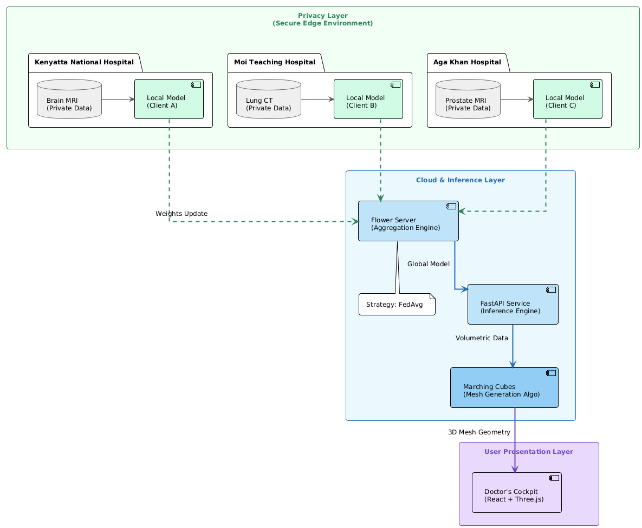
The Fed-Vis architecture is organized into four distinct layers that collectively enable privacy-preserving collaborative learning while delivering clinical-grade visualization (see System Architecture Diagram above).

- Privacy Layer: At the foundation, three simulated hospital nodes, Kenyatta National Hospital (Brain MRI), Moi Teaching and Referral Hospital (Lung CT), and Aga Khan University Hospital (Prostate MRI)maintain complete control over their datasets. Adhering to the principle of data localization, raw patient images never traverse the network. Each node performs local training, computing gradient updates to adjust the model for local patterns. (see below)
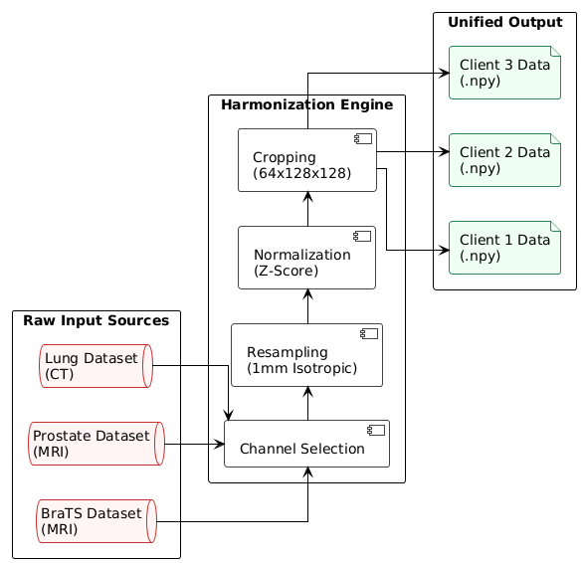
- Federation Layer: A Flower framework server orchestrates the collaborative process using the Federated Averaging (FedAvg) algorithm. The server aggregates weight updates ($w_{global} = \sum (n_k/n) \times w_k$) from all hospitals. This weighted average ensures that larger datasets exert proportional influence while protecting privacy, as only numerical weights—not patient data—are exchanged. The global model is broadcast back to nodes for 15–20 training rounds.

- Inference Layer: Post-training, the model is deployed as a Dockerized FastAPI microservice. It accepts 3D volumes and generates binary segmentation masks and attention heatmaps. The segmentation masks pass through a Marching Cubes algorithm, converting voxel data into smooth triangle meshes optimized for 3D rendering.
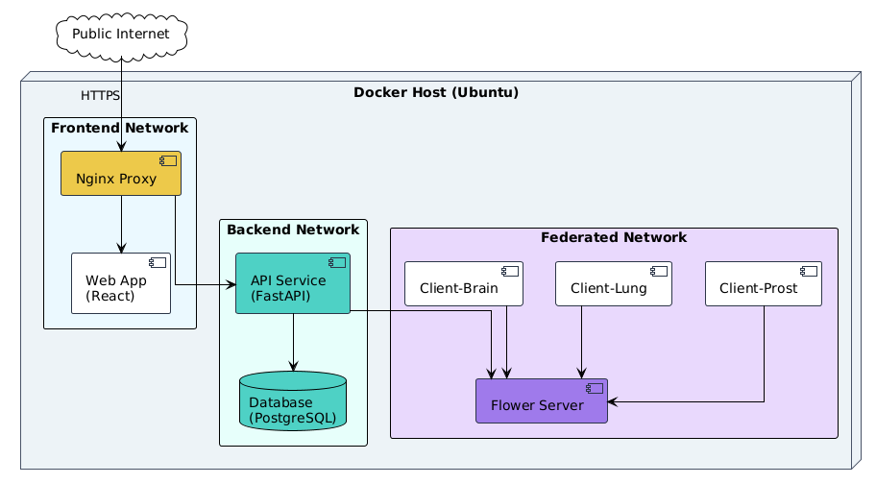
- Visualization Layer: The "Doctor’s Cockpit" (see Wireframes) is a React-based application using Three.js for WebGL rendering. Clinicians can rotate, zoom, and inspect the 3D tumor meshes. Critical for trust, attention heatmaps are overlaid on the anatomy, visualizing the specific regions the model prioritized during segmentation.
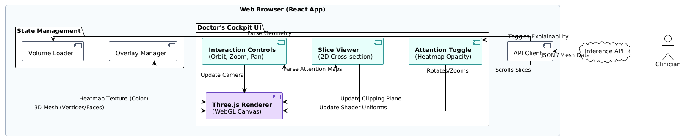
This architecture strictly complies with the Kenya Data Protection Act (Article 30) by ensuring data residency while enabling multi-institutional collaboration.

3.4 Object-Oriented Design
The system relies on four core classes to enforce separation of concerns, isolating data handling from model architecture and federation logic.
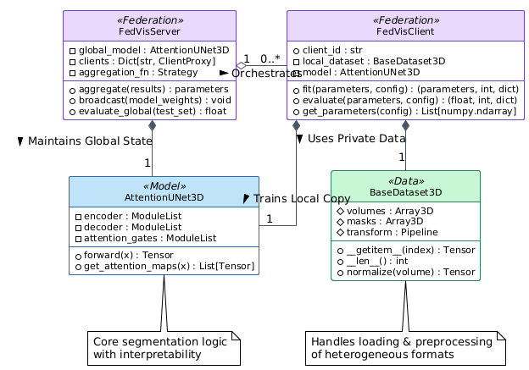
- BaseDataset3D: Abstracts the complexity of loading heterogeneous medical formats. It manages volume arrays, segmentation masks, and transformation pipelines, providing standard __getitem__ and normalization methods to ensure consistent input for the network.
- AttentionUNet3D: Encapsulates the segmentation logic. It defines the encoder (downsampling), decoder (upsampling), and attention gates. It includes methods for the standard forward pass and a specific get_attention_maps() method to extract coefficients for explainability.
- FedVisClient: Represents a hospital node. It holds the local dataset partition and a copy of the model. Key methods include fit() for local training loops and get_parameters() to serialize weights for transmission to the server.
- FedVisServer: Orchestrates the federation. It maintains a registry of clients and implements the aggregate() strategy (FedAvg). It manages the lifecycle of communication rounds and evaluates the global model against a held-out test set.

3.5 Data Model
The relational schema supports both clinical workflows and federation logistics.
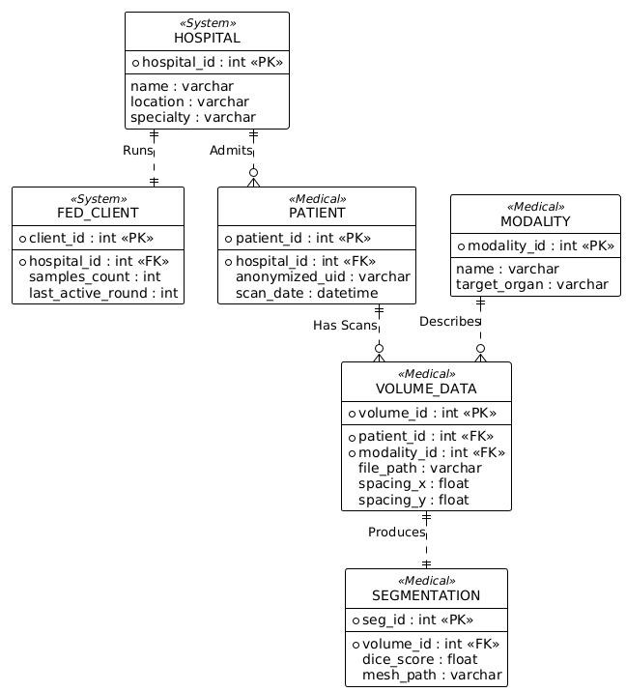
- Hospital & FedClient: The Hospital entity stores institutional metadata (location, specialization), while FedClient maps these institutions to network infrastructure (IP addresses, synchronization logs).
- Patient & Volume: Patient records are strictly de-identified. A one-to-many relationship links patients to Volume entries, which track the 3D imaging files, acquisition dates, and physical scanner specifications defined in the Modality table.
- Segmentation: This entity stores AI outputs, linking them to specific volumes. It tracks the binary mask path, the generated mesh, and performance metrics (Dice score) to maintain an audit trail of model accuracy.
3.6.1 Model Architecture Details
The model extends the Attention U-Net (Oktay et al., 2018) to handle 3D volumetric data.
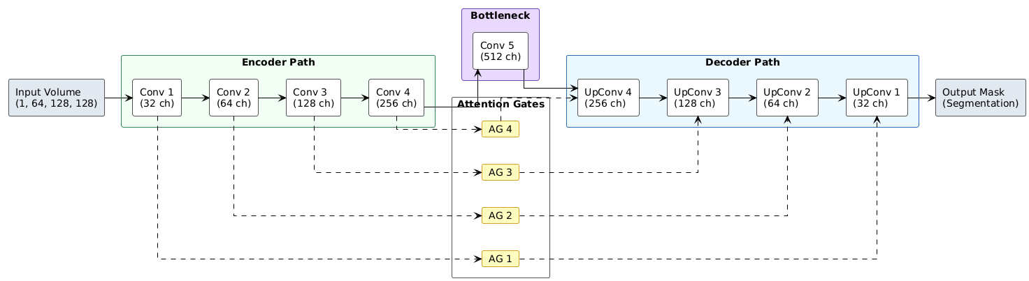
- Encoder: Progressive downsampling (Conv3D + ReLU) across four blocks, capturing features from low-level edges to high-level semantics. Input dimensions: $[B, 1, 128, 128, 128]$.
- Attention Gates: Located at skip connections, these gates filter features from the encoder before concatenating them with the decoder. They compute attention coefficients ($\psi \in [0, 1]$) to suppress irrelevant background regions and highlight tumor tissues.
- Loss Function: The training objective combines Dice Loss (handling class imbalance) and Cross-Entropy Loss (improving boundary sharpness) in a 50/50 ratio, a strategy shown to improve boundary delineation (Yeung et al., 2022).

3.6.2 Federated Learning Configuration
The protocol coordinates training across three nodes while preserving data privacy.
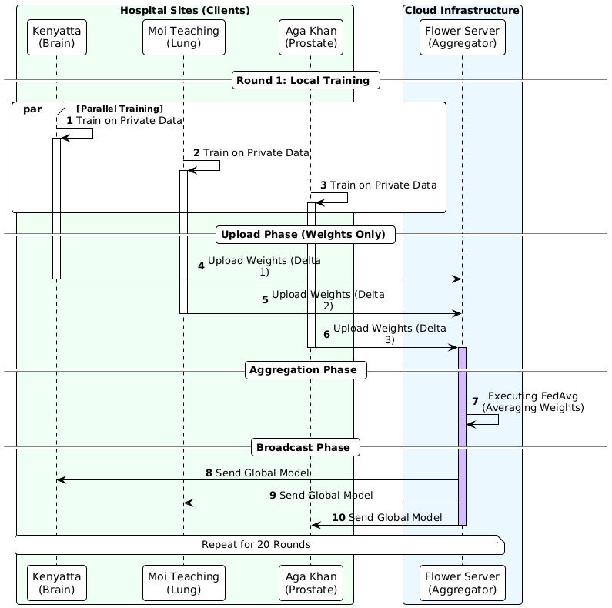
- Parameters: 20 communication rounds, with 5 local epochs per round to balance communication overhead against client drift.
- Workflow: In every round, the server broadcasts global weights. Clients train on private data, then return updated weights. The server aggregates these using FedAvg ($w_{global}$) and re-broadcasts.
- Privacy: Secure aggregation ensures the server never views raw data. Only high-dimensional gradient vectors traverse the network, mitigating privacy risks without the computational overhead of full differential privacy.
3.7 Development Technology Stack
The Fed-Vis technology stack balances research flexibility with production readiness, selecting tools that enable rapid prototyping while maintaining paths to clinical deployment.
Core Technologies:
Category | Tool | Purpose | Justification
Language | Python 3.10+ | Backend, ML | Dominant in ML research; extensive scientific libraries
Language | TypeScript | Frontend | Static type checking for complex 3D rendering logic
ML Framework | PyTorch 2.0+ | Model training | Dynamic computation graphs simplify attention mechanism debugging
FL Framework | Flower 1.5+ | Federated learning | Lightweight, framework-agnostic, active development
Configuration | Hydra 1.3+ | Experiment management | YAML-based hierarchical configs enable easy hyperparameter experimentation
Experiment Tracking | MLflow | Metrics logging | Self-hosted (no data egress), integrates with PyTorch
API | FastAPI | Inference service | Async request handling, auto-generated OpenAPI docs
Frontend | React + Three.js | 3D visualization | WebGL hardware acceleration achieves 30+ FPS
Containerization | Docker | Deployment | Environment parity from development to deployment
CI/CD | GitHub Actions | Automation | Free for public repos, integrates with Docker
Data Versioning | DVC | Dataset tracking | Handles multi-gigabyte medical imaging files git cannot
Key Technology Decisions:
PyTorch was selected over TensorFlow for its dynamic computation graphs, which simplify debugging of attention mechanisms and are preferred in medical imaging research communities. Flower provides federated learning infrastructure with framework-agnostic design, allowing future migration to JAX or other frameworks if needed.
MLflow handles experiment tracking through a local server, avoiding data egress costs and compliance concerns associated with commercial alternatives like Weights & Biases. This self-hosted approach ensures all training metrics remain under institutional control.
The web-based frontend (React + Three.js) requires no desktop software installation, lowering adoption barriers in resource-constrained Kenyan hospitals. Three.js provides WebGL hardware acceleration, achieving 30+ frames per second for 3D mesh visualization on modest hardware.

3.8 Ethical Framework
The ethical foundation of Fed-Vis rests on several principles addressing data privacy, informed consent, transparency, bias mitigation, and appropriate use limitations.
Data privacy is ensured through architectural design and dataset selection. All training employs publicly available datasets BraTS 2021, Prostate Multi-Site, and Lung CT that were originally collected under institutional ethics board approval at their source institutions (University of Pennsylvania, NIH, etc.). These datasets underwent de-identification procedures removing patient names, dates of birth, and other protected health information before public release. The federated learning architecture reinforces privacy by ensuring raw imaging data never leaves simulated hospital nodes during training. Only model weight gradients traverse the network numerical vectors that represent parameter updates rather than patient images. While gradient leakage attacks theoretically could reconstruct training data, secure aggregation techniques (Kaissis et al., 2021) prevent the central server from observing individual client updates, providing practical privacy guarantees aligned with KDPA requirements.
User study participants will provide written informed consent following university research ethics guidelines. The consent process will clearly disclose that Fed-Vis is a research prototype under development, participation is entirely voluntary with freedom to withdraw at any time, and all feedback data will be anonymized before analysis or publication. The study protocol will be submitted for ethics review before any human subjects research begins.
Transparency and explainability are built into the model architecture through attention mechanisms. Rather than delivering opaque predictions, Fed-Vis generates attention heatmaps visualizing which image regions influenced the segmentation decision. This interpretability addresses ethical requirements for explainable AI articulated by medical regulatory bodies clinicians can verify the model focused on anatomically plausible tumor regions rather than spurious correlations like metadata artifacts. The attention visualization serves dual purposes: building clinician trust through transparency and enabling quality assurance by allowing experts to identify when the model fails.
Bias mitigation leverages dataset diversity and federated learning's multi-institutional nature. The selected datasets include scans from multiple scanner manufacturers (Siemens, GE, Philips) and encompass patients across 13 countries in the case of BraTS. This diversity helps prevent the model from learning scanner-specific artifacts or population-specific biases. Federated learning compounds this advantage by training across simulated hospital nodes with different patient demographics and imaging equipment, the global model must learn generalizable tumor patterns rather than hospital-specific shortcuts. This contrasts with centralized training on single-institution data, which often yields models that fail when deployed elsewhere.
The system includes clear limitations disclosures addressing appropriate use boundaries. Fed-Vis is explicitly a research prototype demonstrating technical feasibility, not a certified medical device. All user interfaces display prominent "Research Use Only" warnings. Clinical deployment would require validation studies with real clinical data, prospective clinical trials demonstrating non-inferiority to radiologist interpretation, and regulatory approval from Kenya Pharmacy and Poisons Board (KPPB) following their medical device certification pathway. The current project establishes technical foundations but does not claim clinical readiness.
REFERENCES
Amann, J., Blasimme, A., Vayena, E., Frey, D., & Madai, V. I. (2020). Explainability for artificial intelligence in healthcare: A multidisciplinary perspective. BMC Medical Informatics and Decision Making, 20(1), 310.
Andreux, M., du Terrail, J. O., Beguier, C., et al. (2020). Siloed federated learning for multi-centric histopathology datasets. Domain Adaptation and Representation Transfer, 129-139.
Chen, Y., Wang, Z., & Zhang, L. (2022). Attention gate with residual connections for prostate MRI segmentation. Medical Image Analysis, 78, 102401.
Gao, X., Liu, S., & Chen, H. (2023). Validating attention mechanisms through radiologist gaze tracking. Journal of Medical Imaging, 10(2), 024501.
Ghassemi, M., Oakden-Rayner, L., & Beam, A. L. (2021). The false hope of current approaches to explainable artificial intelligence in health care. The Lancet Digital Health, 3(11), e745-e750.
Gibson, E., Giganti, F., Hu, Y., et al. (2018). Automatic multi-organ segmentation on abdominal CT with dense V-networks. IEEE Transactions on Medical Imaging, 37(8), 1822-1834.
Isensee, F., Jaeger, P. F., Kohl, S. A., et al. (2021). nnU-Net: A self-configuring method for deep learning-based biomedical image segmentation. Nature Methods, 18(2), 203-211.
Jaspers, M. W. (2009). A comparison of usability methods for testing interactive health technologies. Journal of Biomedical Informatics, 42(5), 862-874.
Kaissis, G. A., Makowski, M. R., Rückert, D., & Braren, R. F. (2021). Secure, privacy-preserving and federated machine learning in medical imaging. Nature Machine Intelligence, 2(6), 305-311.
Kairouz, P., McMahan, H. B., Avent, B., et al. (2021). Advances and open problems in federated learning. Foundations and Trends in Machine Learning, 14(1-2), 1-210.
Kenya Ministry of Health. (2023). Kenya National Cancer Control Strategy 2023-2027. Government of Kenya.
Kenya National Assembly. (2019). The Data Protection Act, 2019. Kenya Gazette Supplement No. 181.
Kenyatta National Hospital. (2022). Annual Report 2021-2022. KNH.
Kushniruk, A. W., & Patel, V. L. (2004). Cognitive and usability engineering methods for the evaluation of clinical information systems. Journal of Biomedical Informatics, 37(1), 56-76.
Li, T., Sahu, A. K., Zaheer, M., et al. (2020). Federated optimization in heterogeneous networks. Proceedings of Machine Learning and Systems, 2, 429-450.
McMahan, B., Moore, E., Ramage, D., et al. (2017). Communication-efficient learning of deep networks from decentralized data. AISTATS, 1273-1282.
Menze, B. H., et al. (2015). The multimodal brain tumor image segmentation benchmark (BRATS). IEEE Transactions on Medical Imaging, 34(10), 1993-2024.
Milletari, F., Navab, N., & Ahmadi, S. A. (2016). V-Net: Fully convolutional neural networks for volumetric medical image segmentation. 3DV, 565-571.
Mwangi, J., Ouma, C., & Kiptoo, P. (2021). Radiology workforce in Kenya: Current status and future needs. East African Medical Journal, 98(4), 3421-3428.
Oktay, O., Schlemper, J., Le Folgoc, L., et al. (2018). Attention U-Net: Learning where to look for the pancreas. arXiv:1804.03999.
Owoyemi, A., Owoyemi, J., Osiyemi, A., & Boyd, A. (2020). Artificial intelligence for healthcare in Africa. Frontiers in Digital Health, 2, 6.
Pati, S., Baid, U., Edwards, B., et al. (2022). Federated learning enables big data for rare cancer boundary detection. Nature Communications, 13, 7346.
Ronneberger, O., Fischer, P., & Brox, T. (2015). U-Net: Convolutional networks for biomedical image segmentation. MICCAI, 234-241.
Roth, H. R., Cheng, Y., Oda, H., et al. (2020). NVIDIA Clara federated learning to deliver AI to hospitals while protecting patient data. NVIDIA Technical Blog.
Rudin, C. (2019). Stop explaining black box machine learning models for high stakes decisions and use interpretable models instead. Nature Machine Intelligence, 1(5), 206-215.
Schlemper, J., Oktay, O., Schaap, M., et al. (2019). Attention gated networks: Learning to leverage salient regions in medical images. Medical Image Analysis, 53, 197-207.
Sheller, M. J., Reina, G. A., Edwards, B., et al. (2020). Federated learning in medicine: Facilitating multi-institutional collaborations without sharing patient data. Scientific Reports, 10, 12598.
Sheller, M. J., Edwards, B., Reina, G. A., et al. (2018). Multi-institutional deep learning modeling without sharing patient data: A feasibility study on brain tumor segmentation. Brainlesion Workshop, 92-104.
Vayena, E., Blasimme, A., & Cohen, I. G. (2018). Machine learning in medicine: Addressing ethical challenges. PLOS Medicine, 15(11), e1002689.
Wachira, B. W., Martin, I. B., Jayaraman, S., & Okiro, P. O. (2022). The evolution of trauma care in Kenya. World Journal of Surgery, 46(7), 1514-1520.
Wahl, B., Cossy-Gantner, A., Germann, S., & Schwalbe, N. R. (2018). Artificial intelligence (AI) and global health: How can AI contribute to health in resource-poor settings? BMJ Global Health, 3(4), e000798.
Yan, R., Qu, L., Wei, Q., et al. (2023). Self-supervised federated learning for heterogeneous medical image analysis. IEEE Transactions on Medical Imaging, 42(7), 1932-1943.
Yeung, M., Sala, E., Schönlieb, C. B., & Rundo, L. (2022). Unified focal loss: Generalising dice and cross entropy-based losses to handle class imbalanced medical image segmentation. Computerized Medical Imaging and Graphics, 95, 102026.
Zhang, Y., Liu, H., & Hu, Q. (2021). TransFuse: Fusing transformers and CNNs for medical image segmentation. Medical Image Computing and Computer Assisted Intervention, 14-24.
Zhou, Z., Rahman Siddiquee, M. M., Tajbakhsh, N., & Liang, J. (2019). UNet++: Redesigning skip connections to exploit multiscale features in image segmentation. IEEE Transactions on Medical Imaging, 39(6), 1856-1867.

