

**Tehnička dokumentacija za sajt**

**Y2 Technologies**

https://y2technologies.000webhostapp.com/

**Student**:

**Joakim Zebić 107/17**

**Smer**: Internet Tehnologije

**Modul**: Web Programiranje

**Predmet**: Web Programiranje 1

**Sadržaj**

1. **Uvod**
   1. Korišćeni programski i markup jezici
   2. Opis funkcionalnosti
   3. Template
   4. ***CSS***
      1. jquery-letterfx.css
2. **Šeme i funkcionalnost**
   1. Organizaciona šema
   2. Sitemap
   3. ***Funkcionalnost***
      1. Home
      2. Leviathan X
      3. More Specs
      4. Forma
      5. Author
3. **Kodovi**
   1. Index.html
   2. style.css
   3. main.js
   4. jQuery plugin : jquery-letterfx.js

**UVOD**

* 1. **Korišćeni programski i markup jezici**
* HTML4
* CSS3
* JavaScript
* JQuery – verzija 3.3.1
* Korišćeni text editor je SublimeText 3
  1. **Opis Funkcionalnosti**

Sajt Y2 Technologies je osmišljen kao single-page website i zbog toga se sve njegove funkcionalnosti nalaze na stranici index.html

* **Navigacioni meni** koji se klikom na dugme u gornjem desnom uglu ekrana otvara sa desne na levu stranu. Klikom na bilo koji od linkova se menja sadržaj u centralnom („crnom“) delu sajta u zavisnosti od izabranog linka. Izbranom linku se dodaje klasa „active“ tako da je na njega ne moguce ponovo kliknuti dok se ne izabere neki drugi link.
* **Kontakt forma** koja se pojavljuje klikom na sliku papirnog aviona u donjem levom uglu ekrana i koja se proverava regularnim izrazima u JQuery-u.
* **Meni za društvene mreže** koji se klikom na sliku otiska ruke u donjem desnom uglu ekrana otvara polukružno. Pored linkova za društvene mreže u ovom meniju se nalazi i link za Asus ZenBook Pro laptop koji je poslužio kao inspiracija za izradu sajta.
* **Sakriveni meni za dokumentaciju i link o autoru** koji se otvara klikom na providni beli trougao direktno iznad „slova Y“.
  1. **Template**

Template je u celosti pisan samostalno.

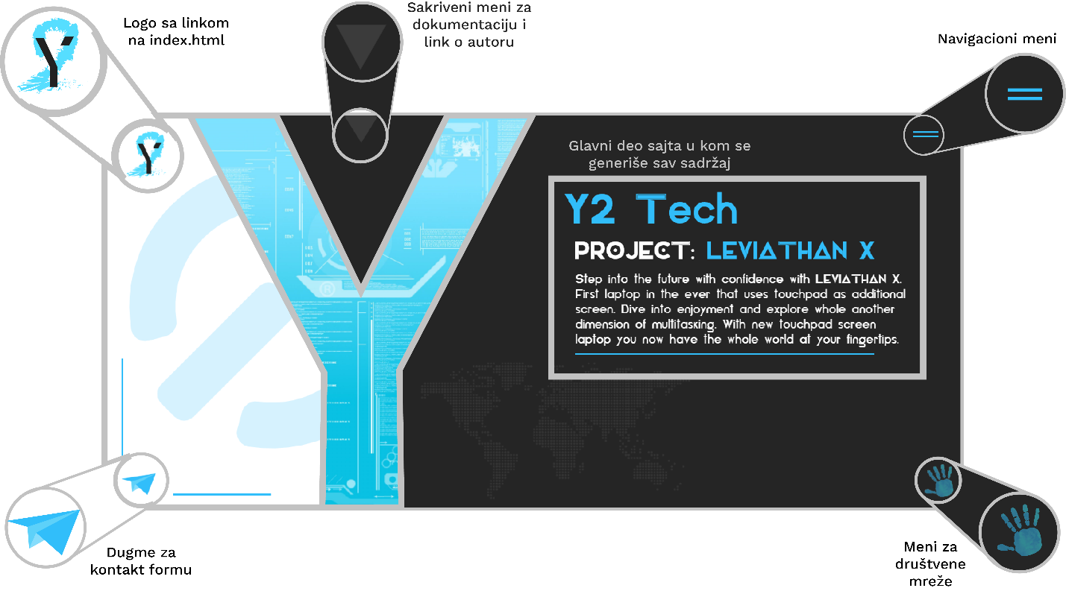

* 1. ***CSS***

Eksterni CSS je korišćen iz letterfx plugin-a za ispisivanje teksta pri učitavanju strane.

1.4.1 jquery-letterfx.css

letterfx-container{}

.letterfx{

display:inline-block;

margin:0;

padding:0;

transition: all 1s; -ms-transition: all 1s; -webkit-transition: all 1s;

}

/* Spin FX */

.letterfx-spin-before{

transform:rotate(3600deg); -ms-transform:rotate(3600deg); -webkit-transform:rotate(3600deg);

}

.letterfx-spin-after{

transform:none;

}

/* Fade FX */

.letterfx-fade-before{

opacity: 0;

}

/* Grow FX */

.letterfx-grow-before{

transform:scale(0,0); -ms-transform:scale(0,0); -webkit-transform:scale(0,0);

}

.letterfx-grow-after{

transform:none;

}

/* Smear FX */

.letterfx-smear-before{

color: transparent;

text-shadow:-1px -1px 25px transparent;

}

.letterfx-smear-after{

color:inherit;

text-shadow:0 0 #333;

}

/* Fall FX */

.letterfx-fall-before

{

visibility: hidden;

transform:scale(3,3); -ms-transform:scale(3,3); -webkit-transform:scale(3,3);

}

.letterfx-fall-after{

transform:scale(1,1); -ms-transform:scale(1,1); -webkit-transform:scale(1,1);

text-shadow:0;

}

/* Swirl FX */

.letterfx-swirl-before

{

visibility: hidden;

transform:scale(3,3) rotate(3600deg); -ms-transform:scale(3,3) rotate(3600deg); -webkit-transform:scale(3,3) rotate(3600deg);

}

.letterfx-swirl-after{

transform:none;

text-shadow:0;

}

/* Wave FX */

.letterfx-wave-container .letterfx

{

position:relative;

}

.letterfx-wave-before

{

bottom:0;

}

.letterfx-wave-after{

bottom:15px;

}

/* FLY FX */

.letterfx-fly-left-container .letterfx,

.letterfx-fly-right-container .letterfx,

.letterfx-fly-top-container .letterfx,

.letterfx-fly-bottom-container .letterfx

{

position:relative;

}

.letterfx-fly-left-before{ left:-50em; }

.letterfx-fly-left-after{ left:0; }

.letterfx-fly-right-before{ right:-50em; }

.letterfx-fly-right-after{ right:0; }

.letterfx-fly-top-before{ top:-20em; }

.letterfx-fly-top-after{ top:0; }

.letterfx-fly-bottom-before{ bottom:-20em; }

.letterfx-fly-bottom-after{ bottom:0; }

**ŠEME I FUNKCIONALNOST**

**2.1 Organizaciona šema**

**Index.html**

Sobzirom da je single-page sajt nema eksternih linkova koji bi vodili na neku drugu stranicu (osim linkova za društvene mreže).

* *https://www.facebook.com*
* *https://www.instagram.com*
* *https://www.youtube.com*
* *https://www.asus.com/us/Laptops/ASUS-ZenBook-Pro-15-UX580GE/*

**2.2 Sitemap**

<?xml version="1.0" encoding="UTF-8" ?>

<urlset xmlns="http://www.sitemaps.org/schemas/sitemap/0.9">

<url>

<loc>

https://y2technologies.000webhostapp.com/

</loc>

<lastmod>2018-03-10</lastmod>

<changefreq>weekly</changefreq>

<priority>1</priority>

</url>

</urlset>

**2.3 Funkcionalnost**

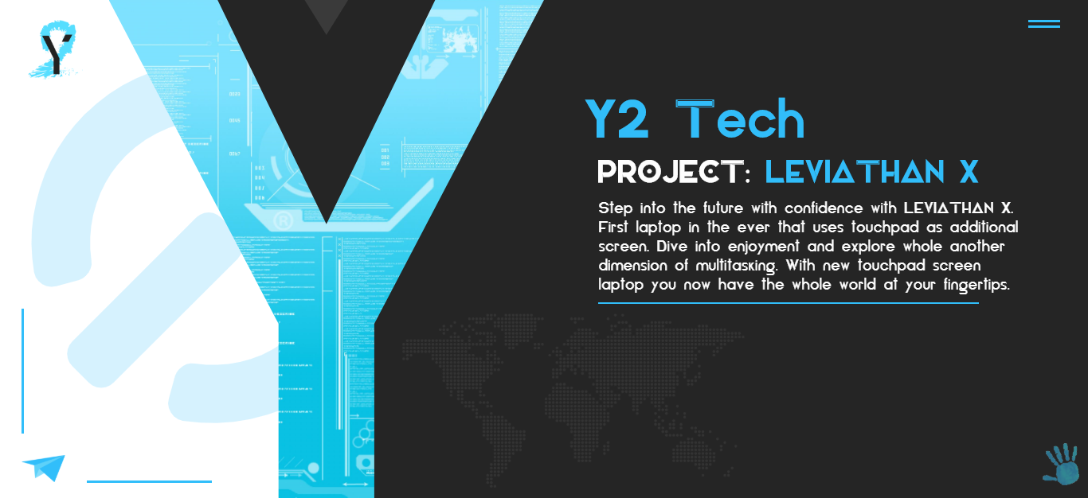2.3.1 Home

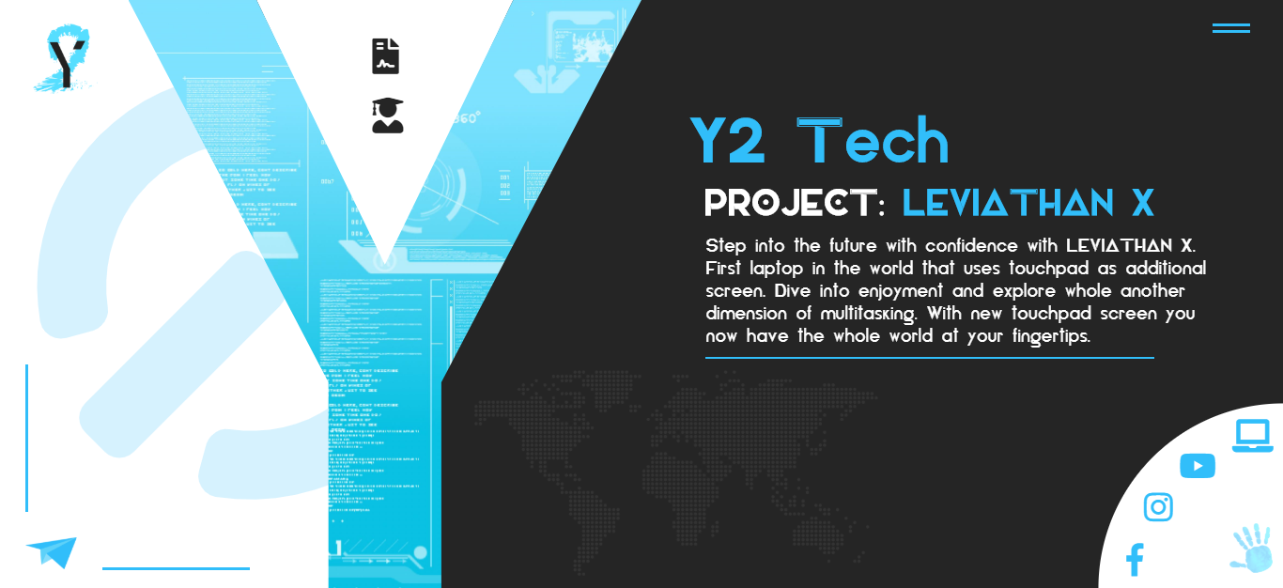Ovo je početna stranica sajta. Pri njenom učitavanju se pomoću letterfx plugin-a ispisuje „beli“ tekst ispod naslova, kao i reči „LEVIATHAN X“.

Takođe pri samom učitavanju sajta se različitim animacijama pojavljuju meni za društvene mreže i sakriveni meni za dokumentaciju i link o autoru.

2.3.2 Leviathan X

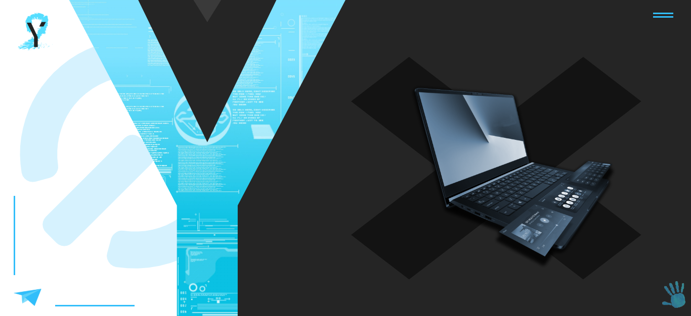

Sledeća stavka u navigacionom meniju je link Leviathan X. Klikom na taj link, u centralnom delu sajta se menja sadržaj i animacijom „flickr“ se pojavljuje slika laptopa,a iza slike sa pojavljuje animirani div u obliku slova „X“.

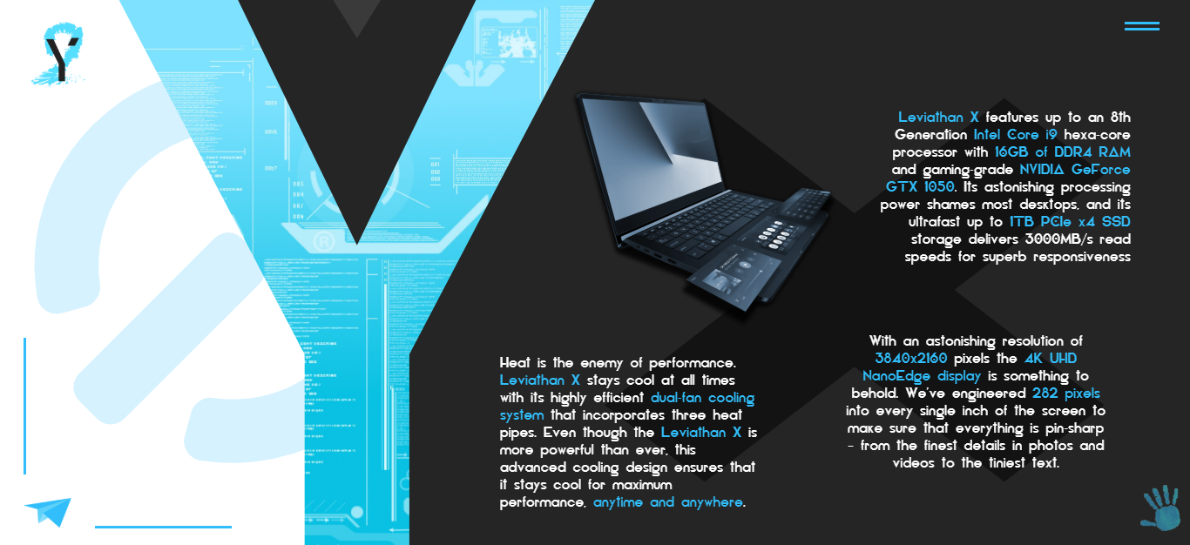

Klikom na sliku laptopa , ona se smanjuje i pomera u gornji levi ugao,a zatim se različitim animacijama pojavljuje tekst o samom laptopu.

2.3.3 More Specs

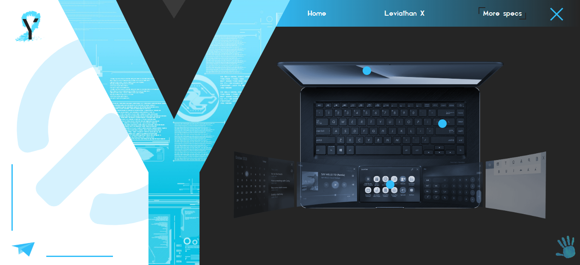

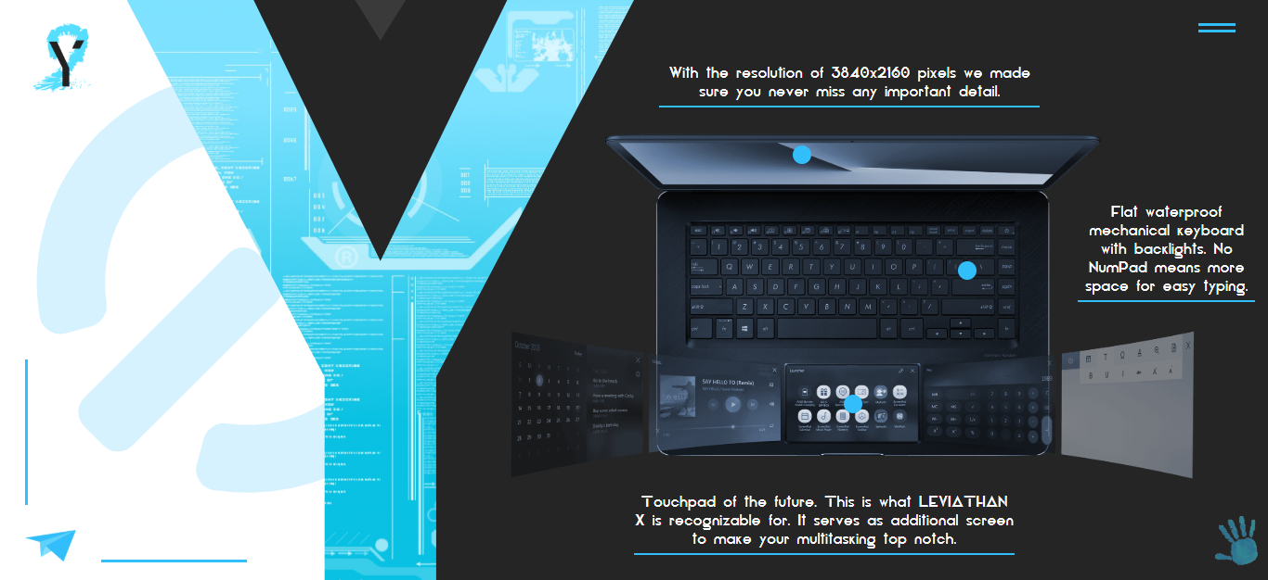Sledeća stavka u navigacionom meniju je link More specs. Klikom na taj link, u centralnom delu sajta se menja sadržaj i pojavljuje se druga slika laptopa na kojoj se animacijom „fade“ pojavljuju plave tačke koje označavaju mesta gde treba da se klikne da bi se prikazao sadržaj o tom delu leptopa.

Ovako izgleda sajt kada su sve 3 tačke kliknute i kada je prikazan sav tekst.

2.3.4 Forma

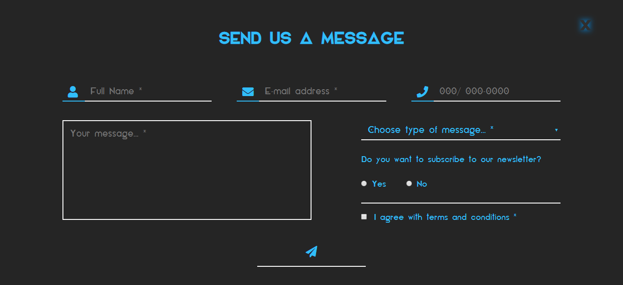

Klikom na plavi papirni avion u samom donjem levom uglu sajta, otvara se kontakt forma. Obavezna polja koja moraju da se popune su označena znakom „*“ unutar placeholder-a svakog polja. Unos podataka se proverava regularnim izrazima klikom na dugme na dnu forme.

Takođe, svako polje se zasebno proverava na dogadjaje blur/click/change u zavisnosti od tipa polja.

Dobro popunjena polja se obeležavaju zelenom bojom okvira i teksta, a loše popunjena polja crvenom bojom.

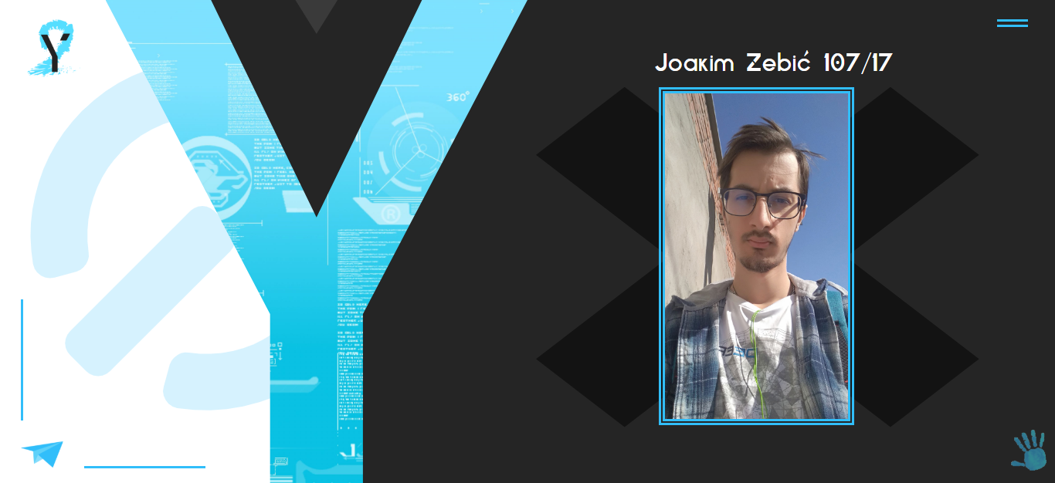2.3.5 Author

Klikom na ikonicu „studenta“ u sakrivenom meniju za dokumentaciju i link o, u centralnom delu sadržaja se pojavljuje slika autora sajta, a iznad nje piše ime, prezime i broj indeksa studenta.

Osim toga ovaj deo sajta nema nikakvu funkcionalnost.

**KODOVI**

**3.1 index.html**

<!DOCTYPE html>

<html>

<head>

<title>Y2 Technologies | Leviathan X - Touchpad screen Laptop</title>

<link rel="icon" href="favicon.ico" />

<meta charset="utf-8"/>

<meta name="description" content="Y2 Technologies proudly present you new multi-screen laptop Leviathan X. Its touchpad screen is something you have never seen before and it will completely change the concept of laptops in the world." />

<meta name="keywords" content="leviathan,touchpad,screen,laptop" />

<meta name="viewport" content="width=device-width, initial-scale=1.0" />

<link rel="stylesheet" href="https://use.fontawesome.com/releases/v5.5.0/css/all.css" integrity="sha384-B4dIYHKNBt8Bc12p+WXckhzcICo0wtJAoU8YZTY5qE0Id1GSseTk6S+L3BlXeVIU" crossorigin="anonymous">

<link rel="stylesheet" type="text/css" href="css/jquery-letterfx.min.css">

<link rel="stylesheet" type="text/css" href="css/style.css" />

</head>

<body>

<div id="beforeY">

<i id="power" class="fa fa-power-off" aria-hidden="true"></i>

<a href="index.html"><img id="logo" src="images/logo.png" alt="2y logo" /></a>

<div id="plane"></div>

</div>

<div id="contact">

<span id="X" aria-hidden="true">×</span>

<h2>Send us a message</h2>

<form method="post" action="#">

<div class="formHolder">

<div class="formImg"><i class="fa fa-user" aria-hidden="true"></i></div>

<input type="text" id="Name" placeholder="Full Name *" />

</div>

<div class="formHolder">

<div class="formImg"><i class="fa fa-envelope" aria-hidden="true"></i></div>

<input type="text" id="Email" placeholder="E-mail address *" />

</div>

<div class="formHolder">

<div class="formImg"><i class="fa fa-phone" aria-hidden="true"></i></div>

<input type="text" id="Phone" placeholder="000/ 000-0000" />

</div>

<textarea id="txtA" placeholder="Your message... *"></textarea>

<div id="choose">

<select id="ddl">

<option value="0">Choose type of message... *</option>

<option value="1">Business</option>

<option value="2">Product info</option>

<option value="3">Other</option>

</select>

<div id="radioB">

<p>Do you want to subscribe to our newsletter?</p>

<input type="radio" name="yn" value="Yes">Yes

<input type="radio" name="yn" value="No">No

</div>

<input type="checkbox" id="agree" value="Agree"><p id="chkP">I agree with terms and conditions *</p>

</div>

<div id="formButton"><i class="fa fa-paper-plane" aria-hidden="true"></i></div>

</form>

</div>

<div id="Y"></div>

<div id="afterY">

<div id="nav">

<span class="navline"></span>

<span class="navline"></span>

</div>

<div id="navigationSlide">

<p id="home" class="active" >Home</p>

<p id="LeX">Leviathan X</p>

<p id="specs">More specs</p>

</div>

<div id="tekst">

<h1 id="th1">Y2 Tech</h1>

<h2 id="th2">PROJECT: <span id="leviathan">LEVIATHAN X</span></h2>

<p id="tp">Step into the future with confidence with LEVIATHAN X. First laptop in the ever that uses touchpad as additional screen. Dive into enjoyment and explore whole another dimension of multitasking. With new touchpad screen laptop you now have the whole world at your fingertips.</p>

<img id="map" src="images/map.png" alt="world map" />

</div>

<div id="triangle"></div>

<img id="hand" src="images/hand.png" alt="blue handprint" />

<div id="handDiv">

<a href="https://www.facebook.com" target="_blank"><i class="fab fa-facebook-f"></i></a>

<a href="https://www.instagram.com" target="_blank"><i class="fab fa-instagram"></i></a>

<a href="https://www.youtube.com" target="_blank"><i class="fab fa-youtube"></i></a>

<a href="https://www.asus.com/us/Laptops/ASUS-ZenBook-Pro-15-UX580GE/" target="_blank"><i class="fas fa-laptop"></i></a>

</div>

<script type="text/javascript" src="https://ajax.googleapis.com/ajax/libs/jquery/3.3.1/jquery.min.js"></script>

<script type="text/javascript" src="js/jquery-letterfx.min.js"></script>

<script type="text/javascript" src="js/main.js"></script>

</div>

</body>

</html>

**3.2 style.css**

@font-face{

font-family: Elianto;

src: url("../fonts/Elianto-Regular.ttf");

}

*{

margin: 0;

padding: 0;

box-sizing: border-box;

font-family: Elianto;

cursor: url("../cursor.png"), auto;

}

#beforeY{

position: fixed;

left: -100%;

top: 0;

width: 67vw;

height: 100vh;

clip-path: polygon(0 0, 21% 0, 39% 65%, 39% 100%, 0 100%);

background-color: #fff;

z-index: 21;

animation: whiteOut 1s forwards;

}

@keyframes whiteOut{

from{

left: -100%;

}

to{

left: 0;

}

}

#beforeY:before{

position: absolute;

content: "";

width: 3px;

height: 0px;

background: #31befa;

bottom: 13vh;

left: 2vw;

animation: planeB 1s 5s forwards;

}

#beforeY:after{

position: absolute;

content: "";

width: 0px;

height: 3px;

background: #31befa;

bottom: 3vh;

left: 8vw;

animation: planeA 1s 5s forwards;

}

@keyframes planeA{

from{

width: 0px;

}

to{

width: 25vh;

}

}

@keyframes planeB{

from{

height: 0px;

}

to{

height: 25vh;

}

}

#logo{

height: 75px;

margin: 25px 35px;

transform: scale(0);

transition: 0.2s;

animation: zoomIn 1s 5.5s forwards;

}

@keyframes zoomIn {

from {

transform: scale(0);

}

100% {

transform: scale(1)

}

}

#logo:hover{

height: 80px;

transition: 0.2s;

}

#plane{

position: fixed;

width: 4vw;

height: 10vh;

left: -100%;

bottom: -100%;

background-image: url(../images/plane.png);

background-repeat: no-repeat;

background-size: contain;

background-position: center;

animation: planeIn 0.5s 4.5s forwards;

transition: 0.5s;

}

@keyframes planeIn{

from{

left: -100%;

bottom: -100%;

}

to{

left:2vw;

bottom: 1vh;

}

}

#plane:hover{

transform: translate(15px, -15px);

transition: 0.5s;

cursor: pointer;

}

#power{

position: fixed;

opacity: 0.2;

font-size: 75vh;

z-index: -2;

top: 35vh;

left: 30vw;

transform: rotate(-135deg);

}

/*************************FORM START*************************/

#contact{

width: 100vw;

height: 100vh;

position: fixed;

z-index: 99;

background-color: #252525;

left: -100%;

bottom: -100%;

opacity: 0;

transition: 0.5s;

}

#contact h2{

display: block;

text-align: center;

font-size: 35px;

margin-top: 10vh;

text-transform: uppercase;

color: #31befa;

}

#X{

font-size: 70px;

color: #2f2f2f;

opacity: 1;

text-shadow: 0px 0px 20px #0099ff;

position: absolute;

top: 2vh;

right: 5vw;

font-stretch: normal;

font-weight: bolder;

cursor: pointer;

transition: 0.5s;

}

#X:hover{

color: #fff;

transition: 0.5s;

}

form{

display: flex;

width: 80vw;

margin: 10vh auto;

flex-wrap: wrap;

justify-content: space-between;

}

.formHolder{

display: flex;

width: 30%;

}

.formImg{

width: 15%;

height: 7vh;

margin-top: 10px;

border-bottom: 2px solid #31befa;

}

.formHolder input{

width: 85%;

margin: 10px 0px;

height: 7vh;

border: none;

padding: 2vh;

background: no-repeat;

border-bottom: 2px solid #fff;

color: #31befa;

font-size: 20px;

}

input:focus,textarea:focus,select:focus{

outline: none;

}

::placeholder{

font-family: Elianto;

font-size: 20px;

}

i.fa, i.fas{

display: block;

width: 4vh;

margin: 10px auto 0px auto;

font-size: 4vh;

color: #31befa;

}

#txtA{

margin-top: 5vh;

width: 50%;

height: 35vh;

border: 2px solid #fff;

background: none;

padding: 15px;

color: #31befa;

font-size: 20px;

resize: none;

}

#choose{

width: 40%;

margin-top: 5vh;

}

select{

width: 100%;

height: 7vh;

border: none;

background: none;

border-bottom: 2px solid #fff;

color: #31befa;

font-size: 20px;

padding-left: 10px;

}

#radioB{

margin-top: 5vh;

color: #31befa;

font-size: 18px;

border-bottom: 2px solid #fff;

margin-bottom: 3vh;

}

input[type="radio"] {

margin: 35px 10px 35px 0px;

cursor: pointer;

}

input[type="radio"]:last-of-type {

margin-left: 35px;

}

input[type="checkbox"]{

margin-right: 15px;

cursor: pointer;

}

#chkP{

display: inline;

color: #31befa;

font-size: 18px;

}

#formButton{

width: 20%;

margin: 5vh auto;

height: 7vh;

padding: 10px;

box-sizing: initial;

border-bottom: 2px solid #fff;

transition: 0.5s;

}

#formButton:hover{

background-color: #fff;

box-shadow: 4px 4px 13px #000;

transition: 0.5s;

}

/*************************FORM END***************************/

#Y{

width: 40vw;

height: 0;

clip-path: polygon(50% 0%, 100% 0, 100% 43%, 100% 100%, 68% 100%, 32% 100%, 0 100%, 0% 43%, 0 0);

position: fixed;

z-index: 22;

background-image: url(../images/y2.png);

background-repeat: no-repeat;

background-size: cover;

left: 10vw;

bottom: 0;

animation: Yup 3s 1s forwards ,Yback 30s 4s infinite;

}

@keyframes Yback{

from{ background-position: left; }

50%{ background-position: right; }

to{background-position: left;}

}

@keyframes Yup{

from{

height: 0;

}

50%{

height: 100vh;

}

to{

height: 100vh;

clip-path: polygon(50% 45%, 75% 0, 100% 0, 61% 65%, 61% 100%, 39% 100%, 39% 65%, 0 0, 25% 0);

}

}

#afterY{

position: fixed;

right: 0;

top: 0;

width: 100vw;

height: 100vh;

background: #252525;

}

/********************* NAVIGATION - START *********************/

#nav{

position: fixed;

right: 1vw;

top: 1vh;

width: 6vw;

height: 8vh;

padding-top: 15px;

}

.navline{

position: relative;

display: block;

width: 0px;

height: 3px;

background-color: #31befa;

margin: 4px auto;

transition: 0.5s;

animation: navLs 0.5s 16s forwards;

}

.navline:last-of-type{

animation: navLs 0.5s 16.5s forwards;

}

@keyframes navLs{

from{

width: 0px;

}

to{

width: 40px;

}

}

.navline:last-of-type:before{

position: absolute;

content: "";

width: 0px;

height: 3px;

background-color: #31befa;

transform: rotate(45deg);

right: 20px;

bottom: 10px;

}

#nav:hover{

cursor: pointer;

}

#nav:hover .navline{

width: 15px;

background-color: #fff;

transition: 0.5s;

transform: rotate(90deg) translateX(5px);

cursor: pointer;

animation-fill-mode: none

}

#nav:hover .navline:first-of-type{

width: 20px;

transform: rotate(45deg) translate(-5px, 3px);

}

#nav:hover .navline:last-of-type:before{

width: 10px;

transition: 0.5s 0.5s;

}

#nav.active .navline:first-of-type{

width: 40px;

transform: rotate(-45deg) translate(-5px, 5px);

}

#nav.active .navline:last-of-type{

width: 40px;

transform: rotate(45deg);

}

#nav.active .navline:last-of-type:before{

display: none;

}

#navigationSlide{

width: 55vw;

height: 10vh;

background: linear-gradient(to right, #31befa, transparent);

display: none;

position: fixed;

right: 0vh;

z-index: -1;

justify-content: space-around;

box-sizing: border-box;

color: #fff;

padding:3.5vh 5vw 3.5vh 3vw;

}

#navigationSlide p{

position: relative;

cursor: pointer;

}

#navigationSlide p:after{

content: "";

position: absolute;

width: 14px;

height: 14px;

opacity: 0;

right: -10px;

bottom: -5px;

border-bottom: 2px solid #fff;

border-right: 2px solid #fff;

transform: translate(100%, 50%);

transition: 0.5s;

}

#navigationSlide p:before{

content: "";

position: absolute;

width: 14px;

height: 14px;

opacity: 0;

top: -5px;

left: -10px;

border-top: 2px solid #fff;

border-left: 2px solid #fff;

transform: translate(-100%, -50%);

transition: 0.5s;

}

#navigationSlide p:hover:after, #navigationSlide p:hover:before{

transform: translate(0%, 0%);

opacity: 1;

}

#navigationSlide p.active:after, #navigationSlide p.active:before{

transform: translate(0%, 0%);

border-color: #252525;

opacity: 1;

}

/********************* NAVIGATION - END *********************/

#map{

position: fixed;

z-index: -2;

bottom: 2vh;

left: 37vw;

height: 35vh;

opacity: 0;

animation: appearMap 0.5s 6.5s forwards;

}

#hand{

position: fixed;

height: 15vh;

bottom: -2vh;

right: -2vh;

opacity: 0;

animation: appearHand 1s 7s forwards;

z-index: 22;

}

@keyframes appearMap {

from {

opacity: 0;

}

100% {

opacity: 1;

}

}

@keyframes appearHand {

from {

opacity: 0;

}

100% {

opacity: 0.5;

}

}

#hand:hover{

animation-fill-mode: none;

opacity: 1;

}

#handDiv{

position: fixed;

clip-path: circle(75% at 100% 100%);

bottom: 0;

right: 0;

background: #fff;

width: 20vw;

height: 40vh;

z-index: 21;

transform: scale(0);

transform-origin: bottom right;

transition: 0.5s;

}

#handDiv i{

position: fixed;

font-size: 35px;

left: 17vh;

color: #31befa;

text-align: center;

transition: 0.5s;

}

#handDiv a:first-of-type i{

bottom: 2vh;

}

#handDiv a:first-of-type:hover i{

color: #4267B2;

transition: 0.5s;

}

#handDiv a:nth-of-type(2) i{

bottom: 11vh;

left: 20vh;

}

#handDiv a:nth-of-type(2):hover i{

color: #DD337A;

transition: 0.5s;

}

#handDiv a:nth-of-type(3) i{

bottom: 18vh;

left: 26vh;

}

#handDiv a:nth-of-type(3):hover i{

color: #f00;

transition: 0.5s;

}

#handDiv a:last-of-type i{

display: inline-block;

width: initial;

margin: initial;

bottom: 23vh;

left: 35vh;

}

#handDiv a:last-of-type:hover i{

color: #252525;

transition: 0.5s;

}

#tekst{

position: fixed;

width: 0px;

height: 43vh;

color: #fff;

top: 18vh;

right: 10vw;

opacity: 1;

border-bottom: 2px solid #31befa;

animation: blueLine 1s 15s forwards;

}

@keyframes blueLine{

from{

width: 0px;

}

to{

width: 35vw;

}

}

#tekst.ex:before{

content: "";

position: absolute;

width: 120%;

height: 165%;

top: 0%;

left: -12%;

background-color: #000;

transform: scale(0);

clip-path: polygon(20% 0%, 0 0, 0 50%, 0 100%, 20% 100%, 50% 100%, 80% 100%, 100% 100%, 100% 50%, 100% 0, 80% 0%, 50% 0);

opacity: 0.5;

z-index: -1;

animation: tekstX 1.5s 1.5s forwards;

}

#tekst.ex2:before{

content: "";

position: absolute;

width: 120%;

height: 165%;

top: 0%;

left: -12%;

background-color: #000;

transform: scale(1);

clip-path: polygon(20% 0%, 0% 20%, 30% 50%, 0% 80%, 20% 100%, 50% 70%, 80% 100%, 100% 80%, 70% 50%, 100% 20%, 80% 0%, 50% 30%);

opacity: 0.5;

z-index: -1;

}

@keyframes tekstX{

from{

background-color: #31befa;

transform: scale(0);

clip-path: polygon(20% 0%, 0 0, 0 50%, 0 100%, 20% 100%, 50% 100%, 80% 100%, 100% 100%, 100% 50%, 100% 0, 80% 0%, 50% 0);

}

50%{

transform: scale(1);

}

80%{

transform: scale(0);

clip-path: polygon(20% 0%, 0% 20%, 30% 50%, 0% 80%, 20% 100%, 50% 70%, 80% 100%, 100% 80%, 70% 50%, 100% 20%, 80% 0%, 50% 30%);

}

to{

transform: scale(1);

clip-path: polygon(20% 0%, 0% 20%, 30% 50%, 0% 80%, 20% 100%, 50% 70%, 80% 100%, 100% 80%, 70% 50%, 100% 20%, 80% 0%, 50% 30%);

}

}

#tekst h1{

color: #31befa;

font-size: 10vh;

position: fixed;

top: 18vh;

right: 26vw;

opacity: 0;

animation: appearMap 1s 7.5s forwards;

}

#tekst h2{

position: fixed;

font-size: 6vh;

top: 31vh;

right: 10vw;

opacity: 0;

animation: appearMap 1s 7.5s forwards;

}

#leviathan{

color: #31befa;

}

#tekst p{

position: fixed;

font-size: 3vh;

top: 40vh;

right: 5vw;

width: 40vw;

opacity: 0;

animation: appearMap 1s 7.5s forwards;

}

#triangle{

position: fixed;

width: 4vw;

height: 7vh;

z-index: -1;

background: #fff;

left: 28vw;

top: -100%;

clip-path: polygon(50% 100%, 0 0, 100% 0);

cursor: pointer;

animation: trDown 0.5s 4s forwards;

overflow: hidden;

opacity: 0.1;

}

#documentation, #author{

color: #252525;

position: fixed;

transition: 0.5s;

left: 29vw;

top: 5vh;

font-size: 6vh;

opacity: 0;

animation: appearMap 1s forwards;

}

#author{

top: 15vh;

animation-delay: 0.5s;

}

#JZ{

position: fixed;

height: 70vh;

right: 19vw;

border: 8px double #31befa;

}

#tekst p#JZp{

top: 10vh;

font-size: 5vh;

right: -2vw;

animation: none;

opacity: 1;

}

#prezime{

position: relative;

}

#prezime:after{

content: "`";

position: absolute;

font-size: 6vh;

top: -12px;

right: 10px;

transform: rotate(65deg);

}

#documentation:hover, #author:hover{

color: #31befa;

transition: 0.5s;

}

.letterfx{

display: initial;

}

#triangle:hover{

opacity: 1 !important;

}

@keyframes trDown{

from{

top: -100%;

}

to{

top:0;

}

}

#laptop{

position: fixed;

height: 60vh;

top: 25vh;

right: 10vw;

animation: laptop 1.5s linear both;

cursor: pointer;

}

#laptop.laptopClick{

animation:laptopMove 1s forwards;

cursor: url("../cursor.png"), auto;

}

@keyframes laptop{

from,10%,10.2%,20%,20.6%,30%,30.6%,45%,55.1%,57%,60.1%,65%,75.1%,77%,85.1%,86% {

opacity: 0;

}

10.1%,20.1%,30.1%,30.5%,45.1%,50%,55%,57.1%,60%,65.1%,75%,77.1%,85%,86.1%,100% {

opacity: 1;

}

}

@keyframes laptopMove{

from{

top: 25vh;

right: 10vw;

height: 60vh;

}

to{

top: 15vh;

right: 29vw;

height: 45vh;

}

}

#tekst p#p1, #tekst p#p2, #tekst p#p3{

color: #fff;

width: 22vw;

font-size: 2.5vh;

}

#tekst p#p1>span, #tekst p#p2>span, #tekst p#p3>span{

color: #31befa;

}

#tekst p#p1{

top: 20vh;

right: 5vw;

transform: translate(100%, 0);

opacity: 0;

text-align: right;

animation: slideInRight 1s 1s forwards ;

}

#tekst p#p2{

top: 61vh;

right: 7vw;

opacity: 0;

transform: scale(0);

text-align: center;

animation: pLast 1s 3s forwards;

}

#tekst p#p3{

top: 65vh;

right: 36vw;

transform: translate(-100%, 0);

opacity: 0;

animation: slideInLeft 1s 2s forwards ;

}

@keyframes slideInLeft {

from {

transform: translate(-100%, 0);

opacity: 0;

}

to {

transform: translate(0, 0);

opacity: 1;

}

}

@keyframes slideInRight {

from {

transform: translate(100%, 0);

opacity: 0;

}

to {

transform: translate(0, 0);

opacity: 1;

}

}

@keyframes pLast{

from{

transform: scale(0);

opacity: 0;

}

50%{

transform: scale(2);

opacity: 1;

}

to{

transform: scale(1);

opacity: 1;

}

}

.laptopSpecAnimation{

animation: slide-in-elliptic-bottom-bck 1s 0.5s cubic-bezier(0.250, 0.460, 0.450, 0.940) both;

}

#laptopSpec{

position: fixed;

height: 65vh;

right: 5vw;

top: 20vh;

}

@keyframes slide-in-elliptic-bottom-bck {

0% {

transform: translateY(600px) rotateX(-30deg) scale(6.5);

transform-origin: 50% -100%;

opacity: 0;

}

100% {

transform: translateY(0) rotateX(0) scale(1);

transform-origin: 50% 500px;

opacity: 1;

}

}

.dot{

position: fixed;

width: 20px;

height: 20px;

border-radius: 50%;

background: #31befa;

cursor: pointer;

opacity: 0;

transition: 1s;

}

.dot:after {

position: absolute;

content: "";

width: 30px;

height: 30px;

top: -7px;

right: -7px;

border: 2px solid #31befa;

border-radius: 50%;

transition: 0.5s;

opacity: 0;

transform: scale(0);

}

.dot:hover:after {

transition: 0.5s;

opacity: 1;

transform: scale(1);

}

.reveal{

opacity: 0;

color: #fff;

position: fixed;

width: 30vw;

border-bottom: 2px solid #31befa;

padding-bottom: 5px;

text-align: center;

}

#shorter{

width: 14vw;

}

**3.3 main.js**

// *********** JQUERY START *********** //

$(document).ready(function(){

// Jquey letter plugin call - START//

setTimeout(function(){

$(document).ready(function(){

$("#leviathan").letterfx({"fx":"fade","backwards":false,"timing":300,"fx_duration":"100ms","letter_end":"stay","element_end":"stay"})})

},7350);

setTimeout(function(){

$(document).ready(function(){

$("#tekst p").letterfx({"fx":"fade","backwards":false,"timing":35,"fx_duration":"100ms","letter_end":"stay","element_end":"stay"})})

},7450);

//Jquery letter plugin call - END//

//SlideOut navigation -START//

var x=0;

$("#nav").on("click", function(event){

event.stopImmediatePropagation(); //NE RADIIII !!!!!!!!!!!!!!!!!!!!!!!!!!!!!

$("#navigationSlide").animate({width:'toggle', paddingRight: 'toggle', paddingLeft: 'toggle'}, 800);

if(x==0){

x=1;

$(this).addClass("active");

$("#navigationSlide").css({display:"flex"});

}

else{

x=0;

$(this).removeClass("active");

}

});

//SlideOut navigation - END//

//TRIANGLE - START //

var y=false;

$("#triangle").click(function(){

if (!y){

$(this).animate({width: "20vw", left:"20vw", height:"46vh", opacity:"1"}, 500);

setTimeout(function(){$("#triangle").html("<a href='documentation.pdf'><i id='documentation' class='fas fa-file-contract' title='Documentation'></i></a><i id='author' class='fas fa-user-graduate' title='Author'></i>")},500);

y=true;

setTimeout(function(){var author= document.querySelector("#author");

author.addEventListener("click", autorF);},1000);

}

else{

$(this).animate({width: "4vw", left:"28vw", height:"7vh", opacity:"0.1"}, 500);

$(this).html("");

y=false;

}

});

function autorF(){

tekst.innerHTML="";

navHome.setAttribute("class","");

navLeX.setAttribute("class","");

navSpecs.setAttribute("class","");

tekst.setAttribute("class","ex2");

tekst.setAttribute("style", "border-color:transparent")

tekst.innerHTML="<img id='JZ' src='images/me.jpg' alt='Joakim Zebic'><p id='JZp'>Joakim Zebi<span id='prezime'>c</span> 107/17</p>"

}

//TRIANGLE - END //

//FORM - START//

var nameRe= /^[A-ZČĆŽŠĐ][a-zčćžšđ]+(\s[A-ZČĆŽŠĐ][a-zčćžšđ]+)+$/;

var emailRe= /^[\w\d\.\_\-]+\@[\w\d\.\-]+\.\w{2,}$/;

var phoneRe= /^\d{3}\/\s\d{3}\-\d{3,4}$/

var name= $("#Name");

var email= $("#Email");

var phone= $("#Phone");

var ddl= $("#ddl");

var txtA= $("#txtA");

var agree= $("#agree");

$("#formButton").click(function(){

var radio= $("input[type='radio']:checked");

var flag= true;

var formData= [];

if(!nameRe.test(name.val())){

name.css("borderBottomColor", "crimson");

$(".formImg:eq(0)").css("borderBottomColor", "crimson").html("<i class='fas fa-times'></i>");

$("form i:eq(0)").css("color","crimson");

flag= false;

}

else{

name.css("borderBottomColor", "mediumspringgreen");

$(".formImg:eq(0)").css("borderBottomColor", "mediumspringgreen").html("<i class='fas fa-check'></i>");

$("form i:eq(0)").css("color","mediumspringgreen");

formData.push(name.val());

}

if(!emailRe.test(email.val())){

email.css("borderBottomColor", "crimson");

$(".formImg:eq(1)").css("borderBottomColor", "crimson").html("<i class='fas fa-times'></i>");

$("form i:eq(1)").css("color","crimson");

flag= false;

}

else{

email.css("borderBottomColor", "mediumspringgreen");

$(".formImg:eq(1)").css("borderBottomColor", "mediumspringgreen").html("<i class='fas fa-check'></i>");

$("form i:eq(1)").css("color","mediumspringgreen");

formData.push(email.val());

}

if(phone.val().trim()!=""){

if(!phoneRe.test(phone.val())){

phone.css("borderBottomColor", "crimson");

$(".formImg:eq(2)").css("borderBottomColor", "crimson").html("<i class='fas fa-times'></i>");

$("form i:eq(2)").css("color","crimson");

flag= false;

}

else{

phone.css("borderBottomColor", "mediumspringgreen");

$(".formImg:eq(2)").css("borderBottomColor", "mediumspringgreen").html("<i class='fas fa-check'></i>");

$("form i:eq(2)").css("color","mediumspringgreen");

formData.push(phone.val());

}

}

else{

phone.css("borderBottomColor", "#fff");

$(".formImg:eq(2)").css("borderBottomColor", "#31befa").html("<i class='fa fa-phone' aria-hidden='true'>");

$("form i:eq(2)").css("color","#31befa");

}

if (txtA.val().trim()==""){

txtA.val("");

txtA.css("border-color","crimson");

flag= false;

}

else{

txtA.css("border-color", "mediumspringgreen");

formData.push(txtA.val());

}

if(ddl.val()=="0"){

ddl.css({"borderBottomColor":"crimson","color":"crimson"});

flag= false;

}

else{

ddl.css({"borderBottomColor":"mediumspringgreen","color":"mediumspringgreen"});

formData.push(ddl.val());

}

if(radio.length>0){

formData.push(radio.val());

}

if(!(agree.is(":checked"))){

$("#chkP").css("color","crimson");

flag=false;

}

else{

$("#chkP").css("color","mediumspringgreen");

}

console.log(flag);

console.log(formData);

});

name.blur(function(){

if(!nameRe.test(name.val())){

name.css("borderBottomColor", "crimson");

$(".formImg:eq(0)").css("borderBottomColor", "crimson").html("<i class='fas fa-times'></i>");

$("form i:eq(0)").css("color","crimson");

}

else{

name.css("borderBottomColor", "mediumspringgreen");

$(".formImg:eq(0)").css("borderBottomColor", "mediumspringgreen").html("<i class='fas fa-check'></i>");

$("form i:eq(0)").css("color","mediumspringgreen");

}

});

email.blur(function(){

if(!emailRe.test(email.val())){

email.css("borderBottomColor", "crimson");

$(".formImg:eq(1)").css("borderBottomColor", "crimson").html("<i class='fas fa-times'></i>");

$("form i:eq(1)").css("color","crimson");

}

else{

email.css("borderBottomColor", "mediumspringgreen");

$(".formImg:eq(1)").css("borderBottomColor", "mediumspringgreen").html("<i class='fas fa-check'></i>");

$("form i:eq(1)").css("color","mediumspringgreen");

}

});

phone.blur(function(){

if(phone.val().trim()!=""){

if(!phoneRe.test(phone.val())){

phone.css("borderBottomColor", "crimson");

$(".formImg:eq(2)").css("borderBottomColor", "crimson").html("<i class='fas fa-times'></i>");

$("form i:eq(2)").css("color","crimson");

}

else{

phone.css("borderBottomColor", "mediumspringgreen");

$(".formImg:eq(2)").css("borderBottomColor", "mediumspringgreen").html("<i class='fas fa-check'></i>");

$("form i:eq(2)").css("color","mediumspringgreen");

}

}

else{

phone.css("borderBottomColor", "#fff");

$(".formImg:eq(2)").css("borderBottomColor", "#31befa").html("<i class='fa fa-phone' aria-hidden='true'>");

$("form i:eq(2)").css("color","#31befa");

}

});

txtA.blur(function(){

if (txtA.val().trim()==""){

txtA.val("");

txtA.css("border-color","crimson");

}

else{

txtA.css("border-color", "mediumspringgreen");

}

});

ddl.blur(function(){

if(ddl.val()=="0"){

ddl.css({"borderBottomColor":"crimson","color":"crimson"});

}

else{

ddl.css({"borderBottomColor":"mediumspringgreen","color":"mediumspringgreen"});

}

});

agree.click(function(){

if(!(agree.is(":checked"))){

$("#chkP").css("color","crimson");

flag=false;

}

else{

$("#chkP").css("color","mediumspringgreen");

}

});

//FORM - END//

});

// *********** JQUERY END *********** //

var tekst= document.querySelector("#tekst");

var navHome= document.querySelector("#home");

var navLeX= document.querySelector("#LeX");

var navSpecs= document.querySelector("#specs");

navHome.addEventListener("click", Home);

navLeX.addEventListener("click", LeX);

navSpecs.addEventListener("click", Specs);

function Home(){

if (navHome.getAttribute("class")=="active")return;

else{

tekst.setAttribute("class","");

navHome.setAttribute("class", "active");

tekst.innerHTML="<h1 id='th1'>Y2 Tech</h1><h2 id='th2'>PROJECT: <span id='leviathan'>LEVIATHAN X</span></h2><p id='tp'>Step into the future with confidence with LEVIATHAN X. First laptop in the world that uses touchpad as additional screen. Dive into enjoyment and explore whole another dimension of multitasking. With new touchpad screen you now have the whole world at your fingertips.</p><img id='map' src='images/map.png' alt='world map' />";

navLeX.setAttribute("class","");

navSpecs.setAttribute("class", "");

tekst.setAttribute("style","width:35vw");

document.querySelector("#map").setAttribute("style","animation:none; opacity:1");

document.querySelector("#th1").setAttribute("style","animation:none; opacity:1");

document.querySelector("#th2").setAttribute("style","animation:none; opacity:1");

document.querySelector("#tp").setAttribute("style","animation:none; opacity:1");

}

}

var pLaptop=["<span>Leviathan X</span> features up to an 8th Generation <span>Intel Core i9</span> hexa-core processor with <span>16GB of DDR4 RAM</span> and gaming-grade <span>NVIDIA GeForce GTX 1050</span>. Its astonishing processing power shames most desktops, and its ultrafast up to <span>1TB PCIe x4 SSD</span> storage delivers 3000MB/s read speeds for superb responsiveness","With an astonishing resolution of <span>3840x2160</span> pixels the <span>4K UHD NanoEdge display</span> is something to behold. We’ve engineered <span>282 pixels</span> into every single inch of the screen to make sure that everything is pin-sharp — from the finest details in photos and videos to the tiniest text.","Heat is the enemy of performance. <span>Leviathan X</span> stays cool at all times with its highly efficient <span>dual-fan cooling system</span> that incorporates three heat pipes. Even though the <span>Leviathan X</span> is more powerful than ever, this advanced cooling design ensures that it stays cool for maximum performance, <span>anytime and anywhere</span>."];

var xAppear=false;

var xClick=false;

function LeX(){

if (navLeX.getAttribute("class")=="active")return;

else{

navLeX.setAttribute("class", "active");

tekst.innerHTML="<img id='laptop' src='images/laptop.png' alt='laptop' />";

document.querySelector("#laptop").addEventListener("click",

function(){

this.setAttribute("class","laptopClick");

this.setAttribute("style","");

for(var i=1;i<=3;i++){

tekst.innerHTML+="<p id='p" + i +"'>"+ pLaptop[i-1] +"</p>";

}

xClick=true;;

});

navHome.setAttribute("class","");

navSpecs.setAttribute("class","");

tekst.setAttribute("style","border-color:transparent")

if(!xAppear){

tekst.setAttribute("class","ex");

xAppear=true;

}

else{

if(!xClick){

tekst.setAttribute("class","ex2");

document.querySelector("#laptop").setAttribute("style","animation:none; opacity:1");

}

else{

tekst.setAttribute("class","ex2");

for(var i=1;i<=3;i++){

tekst.innerHTML+="<p id='p" + i +"'>"+ pLaptop[i-1] +"</p>";

}

document.querySelector("#laptop").setAttribute("class","laptopClick");

document.querySelector("#laptop").setAttribute("style","animation:none; top: 15vh; right: 29vw; height: 45vh;");

document.querySelector("#p1").setAttribute("style","animation: none; transform: translate(0, 0); opacity: 1;");

document.querySelector("#p2").setAttribute("style","animation: none; transform: scale(1); opacity: 1;");

document.querySelector("#p3").setAttribute("style","animation: none; transform: translate(0, 0); opacity: 1;");

}

}

}

}

var dotPos=["top:25vh; right:36vw", "top:45vh; right:23vw", "top:68vh; right:32vw"];

var textPos=["top:11vh; right:18vw", "top:35vh; right:1vw", "top:85vh; right:20vw"];

var clicked=false;

function Specs(){

if (navSpecs.getAttribute("class")=="active")return;

else{

tekst.setAttribute("class","");

navSpecs.setAttribute("class", "active");

tekst.innerHTML="<img id='laptopSpec' src='images/laptop2.png' alt='Laptop touchpad screens' /><div class='dot'></div><div class='dot'></div><div class='dot'></div><div class='reveal'>With the resolution of 3840x2160 pixels we made sure you never miss any important detail.</div><div id='shorter' class='reveal'>Flat waterproof mechanical keyboard with backlights. No NumPad means more space for easy typing.</div><div class='reveal'>Touchpad of the future. This is what LEVIATHAN X is recognizable for. It serves as additional screen to make your multitasking top notch.</div>";

navLeX.setAttribute("class","");

navHome.setAttribute("class", "");

tekst.setAttribute("style","border-color:transparent")

var tacke= document.querySelectorAll(".dot");

var rev= document.querySelectorAll(".reveal");

document.querySelector("#laptopSpec").setAttribute("class","laptopSpecAnimation");

for(let i=0; i<tacke.length; i++){

rev[i].setAttribute("style", textPos[i]);

tacke[i].setAttribute("style", dotPos[i]);

tacke[i].addEventListener("click", function(){rev[i].style.opacity=1;})

}

if (!clicked){

for(let i=1; i<=3; i++)setTimeout(function(){tacke[i-1].style.opacity=1;},2000+(i*500));

clicked=true;

}

else{

for(let i=1; i<=3; i++)tacke[i-1].style.opacity=1;

document.querySelector("#laptopSpec").setAttribute("class","");

}

}

}

document.querySelector("#plane").addEventListener("click", formIn);

function formIn(){

var contact=document.querySelector("#contact");

contact.setAttribute("style","left:0; bottom:0; opacity:1");

}

document.querySelector("#X").addEventListener("click",formOut);

function formOut(){

var contact=document.querySelector("#contact");

contact.setAttribute("style","left:-100%; bottom:-100%; opacity:0");

}

var hand= document.querySelector("#hand");

hand.addEventListener("click", openHand);

var handFlag=false;

function openHand(){

if(!handFlag){

document.querySelector("#handDiv").setAttribute("style","transform: scale(1);")

handFlag=true;

}

else{

document.querySelector("#handDiv").removeAttribute("style");

handFlag=false;

}

}

// 00webhost hiding ///

$(document).ready(function(){

$("body div:last").css("display","none");

});

**3.4 jQuery plugin : jquery-letterfx.js**

(function ($) {

"use strict";

var LetterFx = function (element, options) {

this.options = $.extend({}, $.fn.letterfx.defaults, options);

this.num_completed_fx = 0;

this.is_done = false;

this.monitor_timer = null;

this.killswitch=null;

this.$element = $(element);

if(this.options.restore)

this.original_html = this.$element.html();

this.init();

}

LetterFx.prototype.init = function(){

this.new_html = this.$element.text().replace( this.options.pattern, this.options.replacement );

this.$element.addClass(this.options.css.element.base).addClass( this.options.css.element.before );

this.$element.html( this.new_html );

this.$letters = this.$element.find(this.options.selector);

this.$letters

.css('transition-duration', this.options.fx_duration)

.addClass(this.options.css.letters.base)

.addClass(this.options.css.letters.before);

this.bindLetterFxEnd();

this.num_letters = this.$letters.length;

this.fx();

return this;

}

LetterFx.prototype.bindLetterFxEnd = function(){

var options = this.options;

var lfx = this;

this.$letters.bind("transitionend", function(){

options.onLetterComplete( $(this), lfx.$element, lfx );

lfx.notifyFXEnd( );

switch(options.letter_end){

case "destroy":

$(this).remove();

break;

case "rewind":

lfx.applyLetterFx( $(this), options.timing, options.css.letters.after, options.css.letters.before );

break;

case "stay":

break;

// restore

default:

$(this).replaceWith( $(this).text() );

}

});

return lfx;

}

LetterFx.prototype.terminate=function(){

this.is_done = true;

this.options.onElementComplete(this.$element, this);

clearTimeout(this.killswitch);

switch(this.options.element_end){

case "destroy":

this.$element.remove();

break;

case "stay":

break;

// restore

default:

this.$element.html( this.original_html );

this.$element.removeClass( this.options.css.element.base ).removeClass(this.options.css.element.after);

break;

}

}

LetterFx.prototype.notifyFXEnd=function(){

clearTimeout(this.monitor_timer);

this.num_completed_fx++;

var lfx = this;

this.monitor_timer = setTimeout(

function(){

if(lfx.num_completed_fx % lfx.num_letters===0){

lfx.terminate();

}

},

Math.max(this.options.timing+10, 50)

);

return this;

}

LetterFx.prototype.startKillWatch = function(){

var fx_duration = this.options.fx_duration.match(/\d+s/) ? parseInt(this.options.fx_duration) : 1;

var time = Math.ceil(1.5 * this.num_letters * this.options.timing * fx_duration );

var lfx = this;

this.killswitch = window.setTimeout(function(){

if(!lfx.isDone()){

lfx.terminate()

}

}, time)

}

LetterFx.prototype.fx = function(){

var lfx = this;

this.startKillWatch();

this.$element.removeClass(this.options.css.element.before).addClass(this.options.css.element.after);

var $letters = this.options.sort(this.$letters);

var options = this.options;

$letters.each(

function(i, letter){

lfx.applyLetterFx( $(letter), (i+1)*options.timing, options.css.letters.before, options.css.letters.after);

}

);

return this;

}

LetterFx.prototype.applyLetterFx = function($letter, timing, css_before, css_after){

var options = this.options;

window.setTimeout(

function(){

$letter.removeClass(css_before).addClass(css_after);

},

timing

);

return this

}

LetterFx.prototype.isDone = function(){

return this.is_done;

}

var LetterFxConfig = function(conf){

this.config = $.extend({}, $.fn.letterfx.defaults, conf);

this.buildCss(this.config.backwards);

// check & change to word pattern

if(this.config.words)

this.config.pattern=/(\S+)/g;

}

LetterFxConfig.prototype.buildCss = function(flip){

var options = this.config;

var before = flip ? 'after' : 'before';

var after = flip ? 'before' : 'after';

var css = { element:{}, letters:{} };

css.element.base=options.element_class+ "-container " + options.fx.replace(/(\S+)/g, options.element_class + "-$1-container");

css.element[before]=options.fx.replace(/(\S+)/g, options.element_class + "-$1-before-container");

css.element[after]=options.fx.replace(/(\S+)/g, options.element_class + "-$1-after-container");

css.letters.base = options.element_class;

css.letters[before] = options.fx.replace(/(\S+)/g, options.element_class + "-$1-before")

css.letters[after] = options.fx.replace(/(\S+)/g, options.element_class + "-$1-after")

this.config = $.extend( options, {'css':css} );

}

LetterFxConfig.prototype.getConfig = function(){

return this.config;

}

LetterFxConfig.parse=function(config){

return (new LetterFxConfig( config )).getConfig();

}

$.fn.letterfx=function(config){

config = LetterFxConfig.parse( config );

return $(this).each(function(){

var $element = $(this);

if (! $element.data('letterfx-obj') || $element.data('letterfx-obj').isDone() ){

$element.data('letterfx-obj', new LetterFx( $element, config ) );

}

});

};

$.fn.letterfx.sort={

random:function(array){

var currentIndex = array.length, temporaryValue, randomIndex;

// While there remain elements to shuffle...

while (0 !== currentIndex) {

// Pick a remaining element...

randomIndex = Math.floor(Math.random() * currentIndex);

currentIndex -= 1;

// And swap it with the current element.

temporaryValue = array[currentIndex];

array[currentIndex] = array[randomIndex];

array[randomIndex] = temporaryValue;

}

return array;

},

reverse:function($array){

return $array.toArray().reverse();

}

}

$.fn.letterfx.patterns={

letters:/(\S)/gi

}

// Plugin Configurables

$.fn.letterfx.defaults = {

// Default fx

fx:'spin fly-top',

// defaults to selecting all characters

pattern:/(\S)/gi,

// switch from letter FX to word FX.

word:false,

// fx, like fly or fade, can happen in (eg fade-in) or out (eg fade-out).

// The default is in; change backwards to true to reverse the order of the effects.

backwards:false,

// defaults to injecting spans, can be any inline element

replacement:"<span>$1</span>",

//selector -- should match replacement above

selector:'span',

// letter fx start sequentially: letters start their fx one after another.

// this sets time between the letters

timing:50,

//duration of each fx

// options the same as css property for transition-duration ("1ms", "1s", etc)

fx_duration:"1s",

// stabile dimensions

// stabilize:true,

// sort callback for custom sorting elements

sort:function($letters){ return $letters; },

// Callback when letter is done animating. Runs after each letter

onLetterComplete:function($letter, $element, LetterFXObj){},

// Runs after all are done.

onElementComplete:function($element, LetterFXObj){},

// what to do when a letter completes its animation.

// options include

// restore: return letter to plain text (default)

// destroy: get rid of the letter.

// stay: leave it as is.

// rewind: reverse the animation

letter_end:"restore",

// what to do when the entire element has completed all its letter effects

// options include:

// restore: return element to its pre-fx state (default)

// stay: do nothing

// destroy: get rid of the element... FOREVER

element_end:"restore",

// Restore container element back to original state.

// options: true, false, "element" ("element" waits until all letters complete fx before restoring)

restore:true,

// destroy element/letters after fx, useful on {out:true} fx

// options: true, false, "letters" ("letters" destroys each letter after fx, but elements original content may be restored after all letters complete fx)

destroy:false,

// default class for injected elements

element_class:'letterfx',

// placeholder values that are calculated on launch

css:{

element:{ base:'', before:'', after:''},

letters:{ base:'', before:'', after:''}

}

};

}(jQuery));