# Insights and Visualizations WeRateDogs

## Introduction

**WeRateDogs** is a Twitter account that rates people's dogs with a humorous comment about the dog. These ratings always have a denominator of 10, the numerators however are almost always greater than 10 (11/10, 12/10, 13/10, etc.). In theory, the rates should be 1 to 10. However, **WeRateDogs** disagree and admit all dogs deserve a ten and sometimes more than that.

**WeRateDogs** has over six million followers and has received international media coverage. One of those coverage was about the quote “they're good dogs Brent", this was an exchange in which **WeRateDogs** shut down a person having an issue with its rating system in humorous ways.

So, what does this rating do? What does the retweet count indicate? Which dog type or dog name is most common dog in the tweet dataset? What dog type has the highest average rating? Now, let us answer some of these questions:

## Number of Dogs per dog type

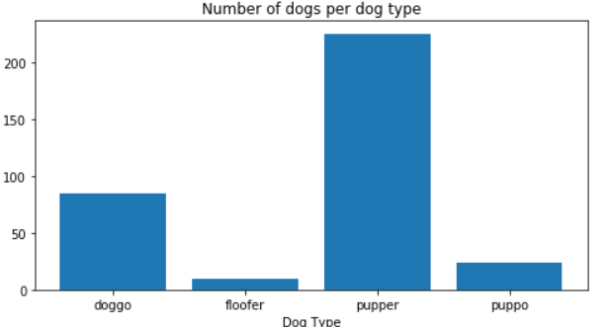

Figure 1 Count of Dogs per Dog Type

On fig 1, Pupper is most common dog type while floofer is least common.

## Rating per Dog Type

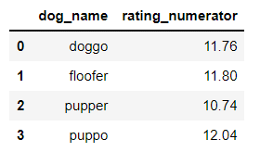

Figure 2 Average ratings per dog type

Although pupper was the most common dog type, puppo had the best rating closely followed by floofer.

## Comparison between dog type and retweet count

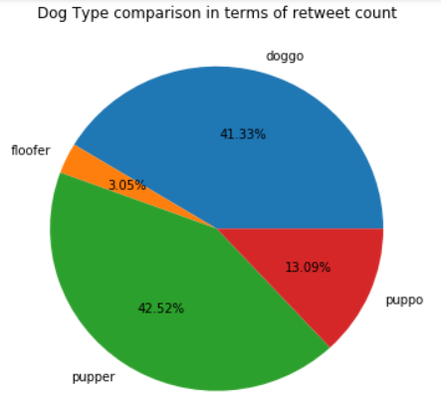

Figure 3 Relationship between Dog Type and Retweet count

Earlier we had seen pupper is the most common and so is its retweet count.

## Correlation between Ratings and Retweets

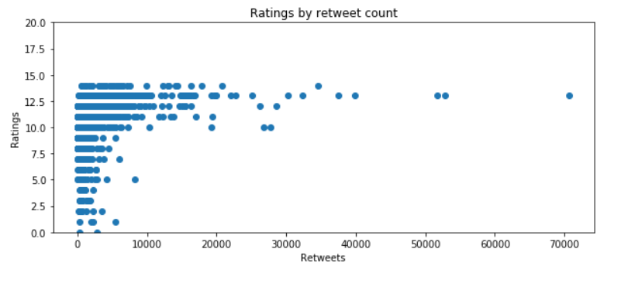

Figure 4 Relationship between ratings and retweets

From fig 4, Higher retweet count does not necessarily translate to best ratings and dogs with retweet count generally have rating.

## Correlation between Retweets and Favorites

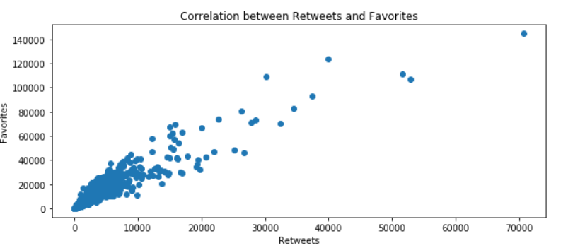

Figure 5 Correlation between Retweets and Favorites

Retweets and Favorites has a positive correlation or a linear relationship between the 2 variables.

## Rating Distribution

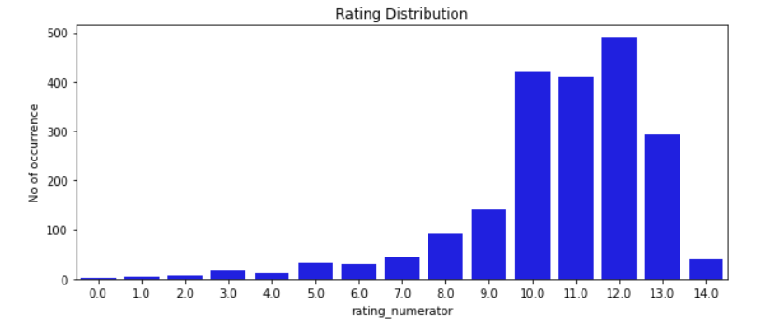Figure 6 Numerator Distribution

fig 6 shows at some point the best rating count was 10, but as stated earlier **WeRateDogs** disagree and admit all dogs deserve a ten and sometimes more than. And that’s why best rating increased to 12.

## Top 5 Dog names with highest retweet count

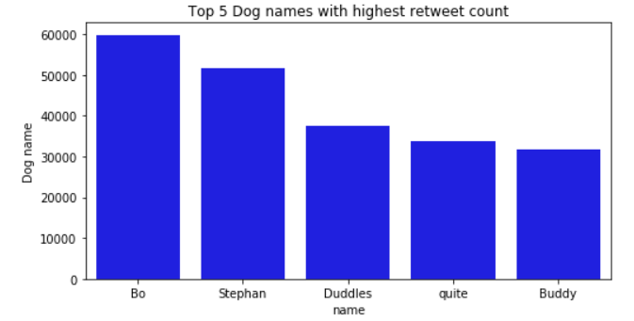

Figure Top 5 Dog names with highest retweet count

Bo takes leads in the retweet count and it is in duggo dog stage:

