1. A local television programs production company (Longevity Pte. Ltd.) is planning to develop an online real time system which allows users to watch television programs online (OnlineWatch.com). The website allows users to login and watch three local television channels’ programs archived for one month. You have successfully bid the project for your software organization and will kick start the project in a month time.
2. Explain to Longevity Pte. Ltd. on the real time system design process for OnlineWatch.com.

1. Identify the stimuli and the associated responses which need to be process by the OnlineWatch.com

2. Identify the time constrains for each of the stimulus and responses

3. Combine it into concurrent process

4. For each of the stimulus and response into design algorithm

5. Design scheduling system

6. Integrate the complete system under the control of real-time operating system

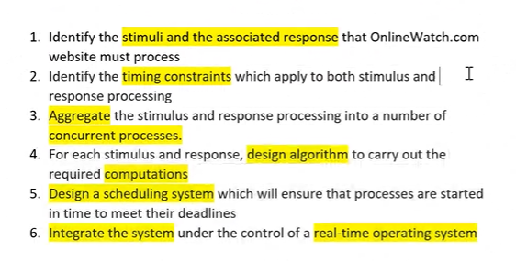

1. Provide 1 set of stimuli-response in the first step of the design process

Periodic Stimulus



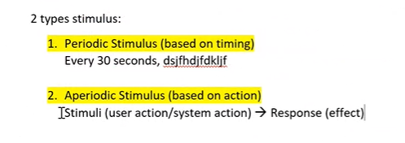Stimuli (login and watch three local television channels' programs) 🡪Response (period set to archived for one month)

Stimuli (user Login with wrong login details) 🡪Response (prompt error message)

Stimuli (user login to OnlineWatch.com) 🡪 Response (access granted to watch three local television channels’ programs)

1. You are joining a software house that specialized in developing games. A colleague has just resigned and left the company due to personal reasons. You are assigned to take over the resigned colleague’s on-going project which is to develop an online shooting game. The online gamers can choose to join any group to compete with another group of online gamers. The online game also allows gamers to invite their friends through social media.

Compose and explain 2 sets of stimuli and associating response for this real time system.

1. stimuli (group join request) -> response(group joined for competing against other groups)
2. stimuli(clicking the share button) - > response(advertisement shared on the social media)
3. iRobot is an automated vacuum cleaner that can automatically clean the floor at a pre-set time. This real time vacuum cleaner uses a high-efficiency cleaning pattern algorithm and a full suite of sensors to map and adapt to real world clutter and furniture for thorough coverage of a home. (Adapted from: http://www.irobot.com/For-the-Home/Vacuum-Cleaning/ Roomba.aspx).

Compose and explain 2 sets of stimuli and associating response for the iRobot system.

1. stimuli (pre-set cleaning time for 15 minutes) -> response (iRobot clean floor for preset time)
2. stimuli (obstacle detected in front of path) - > response (move direction by 45 degrees clockwise)
3. SmartOffice.com is a newly established company which designs and implements Internet of Things (IoT) in offices such as automation of lighting during night and in the washroom, office air-con automated temperature detection and adjustment, video monitoring system, and et cetera.

Compose 2 sets of stimuli and associating response for the automation of a lighting system.

1. stimuli (detect darkness) -> response (light switched on)
2. stimuli (door stationary for 20 minutes) - > response (bathroom lights turned off)
3. EPS Company is currently researching into Track Your Truck (TYT) application that offers an efficient and effective vehicle tracking system. TYT allows users to check real time location of their vehicles through Global Positioning System (GPS). Users can also view their vehicles’ fuel usage, mileage, performance analysis reports through TYT. In the event of vehicle theft, a notification message will be sent to police station automatically and to the owner at the same time. In order to recover the lost vehicle the real time location can be tracked by the owner. (Source :http://www.trackyourtruck.com/)

Identify 1 periodic stimulus and 2 aperiodic stimuluses with associating responses and timing constraints.

1. Periodic
   1. Every second, TYT application updates real time location of vehicles
2. Aperiodic
   1. stimuli (GPS turned on) -> response (show the current real time location)
   2. stimuli (special event happened) -> response (send notification message automatically to police station and owner of vehicle)
   3. Stimuli (request of vehicle performance analysis reports) -> Response (vehicle performance analysis reports retrieved and shown)
3. Donao is an online theatre that provide high-definition mode movie. User can watch movie online or download the movie.

Identify 2 periodic stimulus and 2 aperiodic stimulus with associating responses and timing constraints.

1. Periodic
   1. Every 24 hours, Donao system update new movie list
   2. Every 30 minutes, Danao system pop out an advertisement window
2. Aperiodic
   1. stimuli (user click on movie) -> response (Danao system play the movie)
   2. Stimuli (user click download button) -> Response (movie start downloading to user local drive)
3. You, as an appointed software engineer are in-charge for designing an online management system for Study Point Tutor center. Currently the tuition center has been using manual way to manage the center and now has decided to automate all their registration, classes scheduling, attendance, and payment processes.

Design 3 sets of aperiodic stimuli-response for Study Point Tutor online management system as mentioned above.

1. stimuli (account registration) -> response (account added into the Study Point Tutor online management system)
2. stimuli (user click pay button after details entered) -> response (fees payed)
3. stimuli (attendance mark request for late attendance) -> response (access blocked for marking attendance)
4. stimuli (Invalid name entered into registration) -> response (Study Point online management system show error message)