1. You, as an appointed software engineer are in-charge for designing an online management system for Study Point Tutor center. Currently the tuition center has been using manual way to manage the center and now has decided to automate all their registration, classes scheduling, attendance, and payment processes.

Assuming that you are adopting Component Based Software Engineering. Identify and explain 4 activities that must be carried out in developing the proposed Study Point Tutor online management system.

1. Component qualification
   1. To test whether the system is qualified to fit into the system
   2. Analyze to ensure the component that we selecting is qualified to fit the system requirement or architecture
2. Component adaptation
   1. Although the system is able to fit the new system, some component will be needed to adapt (changes/ replaced/ removed/ modified/ add) to become more fit to the new system
3. Component composition
   1. Every component will need to be separate and recompose to fit the new system
   2. An infrastructure must be established to bind the components into an operational system.
4. Component update
   1. Every component will need to keep update to fit the new system while new requirement meets or requirement changed
5. Highlight the difference among *black-box wrapping, white-box wrapping* and *grey-box wrapping* technique in Component Adaptation of CBSE.
   1. White box wrapping – examines the internal code (source code)
   2. Black box wrapping – examine the interface (UI)
   3. 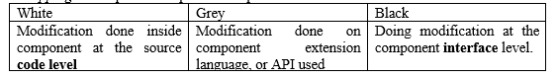Grey box wrapping (between white and black) – applied when the component library provides a component extension language or API that enables conflicts to be removed or masked.

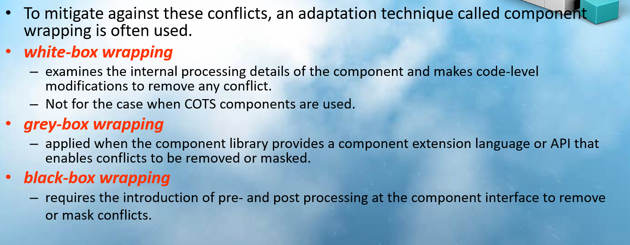

1. Discuss 2 advantages and 2 obstacles of CBSE approach on software development.
2. 2 advantages
   1. Save cost
      * Reduce development cost from scratch and testing overhead
   2. Improve productivity
      * Reduces the time required for code development therefore improve the productivity
      * Reduces the time required for code development, documentation, requirement, system modelling, and planning
3. 2 obstacles
   1. Little training is available for understanding "reusing"
      * Staff are needed to have a better understanding about ‘reusing’ to reuse the system
   2. Many software engineers believe that reusing provides more trouble instead of starting from scratch
      * They don’t know what others have done and how or what to modify to the system
4. Running Boy For You (RuBy4U) is a company that allows users to call in to select food and beverages from a list of twenty-five local restaurants and six fast food restaurants. RuBy4U will deliver the order with minimum charges from RM1 to RM5 depending on the delivery distance. Recently the owner of RuBy4U is planning to market its business online within a month. As a newly recruited software engineer in RuBy4U, you are to handle the system development all by yourself.

Suggest 4 functional categories of computer-aided software engineering (CASE) tools to help you to automate the software engineering process in accelerating the RuBy4U online system development. Explain the tools by giving 1 example for each category.

1. 4 functional categories
   1. Business process engineering tools
      * To draw chart or something which related to the system
      * MS word/ paint or something
   2. Project planning/ management tools
      * Ensure all activities follow schedule and complete within time
      * Microsoft project
   3. Web development tool
      * To develop the website of the system
      * Visual studio / bootstrap
   4. Testing tools
      * To test the system
      * Visual studio
   5. Data modelling tool
      * To store the data
      * DBMS, SQL
2. A local television programs production company (Longevity Pte. Ltd.) is planning to develop an online real time system which allows users to watch television programs online (OnlineWatch.com). The website allows users to login and watch three local television channels’ programs archived for one month. You have successfully bid the project for your software organization and will kick start the project in a month time
3. Assume that this project is adopting Computer-Aided Software Engineering (CASE). List and explain 4 appropriate CASE tools that can assist you in this project. You must select the tools from different functional classification of CASE tools.
4. Longevity Pte. Ltd. would like to reuse some screens (user interface) from their proprietary system. Briefly explain the 4 activities involved in Component-based Software Engineering (CBSE) to the customer.
5. 4 functional categories
   1. Business process engineering tools
      1. To draw chart or something which related to the system
      2. MS word/ paint or something
   2. Project planning/ management tools
      1. Ensure all activities follow schedule and complete within time
      2. Microsoft project
   3. Web development tool
      1. To develop the website of the system
      2. Visual studio / bootstrap
   4. Testing tools
      1. To test the system
      2. Visual studio
   5. Data modelling tool
      1. To store the data
      2. DBMS, SQL
6. 4 activities (same as ques1, just maybe some explain should modify)
   1. System (OnlineWatch.com)
   2. Component = User Interface