1. What are the 3 main *type of notations* used in design documents? Explain why it is important to use different notations to describe software design.
   1. Graphical Notation
      1. describe the overall picture of the system and the relationship between the components
   2. Program Description Language (PDL)
      1. use control and structuring constructs based on programming language constructs. Allow the intention of the designer to be expressed but not the details of how the design is to be implemented
   3. Informal Text
      1. for design that cannot express formally like non-functional requirements

* Different notation explains different items.
* Providing different information
* Different notation is suitable to explain different types of design or item.
* Combination of notation able to describe different view of design
* A notation cannot be used to describe every form of software design effectively

1. A software engineering project consists of 6 main *design activities*. State and briefly describe the design activities. For each design activity, determine the design notations that are appropriate to be used.

|  |  |
| --- | --- |
| Design Activities | Notation used |
| Architectural Design | Graphical |
| Abstract Specification | Informal Text |
| Interface Design | Graphical, Informal Text |
| Component Design | Graphical, PDL |
| Data Structure Design | Graphical, PDL |
| Algorithm Design | PDL, Informal Text |

1. Assuming that you are applying reverse engineering to develop design documents for your company’s legacy systems. Identify and describe 2 types of notations that can be used in documenting user interface design.

Graphical notations

describe the UI, the color used

Informal text

describe the functionality

1. Differentiate between *cohesion* and *coupling* in system design. Discuss how each of them would affect the maintainability of a system.

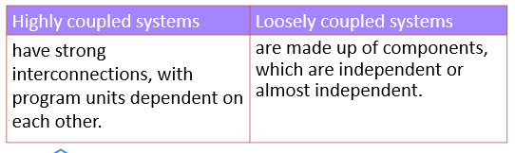 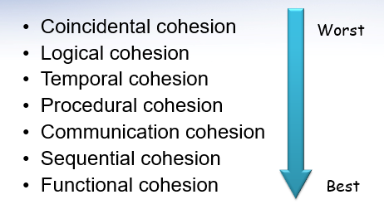

The higher the cohesiveness, the easier the maintainability of a system.

Loosely coupled. (standalone function, easier for maintain)

1. Compare and contrast between *Coincidental Cohesion* and *Functional Cohesion*. Which one is better in a software design? Justify your answer.

- Functional Cohesion (Single well-defined task of the module) (better for design)

- Coincidental Cohesion (Parts of a module are grouped arbitrarily) (worst design)

1. Around The Globe (ATG) Sdn Bhd is a travelling agency that is owned by family Berth since 1960s. The company is using a high quality legacy system to manage the staff and customers’ information. However, the maintenance cost is increasing recently as a system requires Pascal experts. Seeing that this system has low business value to the company, Berth Junior (CEO of ATG) consults your company regarding the legacy system’s management strategy.

You have found that ATG legacy system design is highly cohesive and loosely coupled. However, the design is hard to understand as it is presented in informal text. What are the 2 other notations that should be used in a system design? Explain with appropriate example for each notation.

* 1. Graphical Notation
     1. describe the overall picture of the system and the relationship between the components
     2. draw the model, user interface, and etc with graphic notation
  2. Program Description Language (PDL)
     1. use control and structuring constructs based on programming language constructs. Allow the intention of the designer to be expressed but not the details of how the design is to be implemented
     2. to describe the algorithm and logic of the system and how it is run

1. Standard Printing Company is established in 1981. The main business is designing and printing advertisement. The graphic designer is using a legacy system to design advertisement for customers. The design is stored as both PDF and DOC in the legacy system. The documentation of the legacy system is incomplete and the system is programmed in an obsoleting programming language. Recently, the company is considering purchasing Atlassian JIRA in assisting their advertisement project management. The owner of the company, Mr. S, is consulting you regarding the cost of the tool.

Suggest and explain to Mr.S 2 designs quality metrics that should be included in improving his legacy system.

* 1. Understandability
     1. The ability for a person to understand the design
     2. Factors that affect understandability are cohesion, coupling, naming, documentation and complexity
     3. Completeness of Documentation (complete and understandable)
     4. Cohesion
     5. Coupling
  2. Adaptability
     1. Programming language
        1. Change the old programming language from old language to new language
        2. Make sure the programming language can be work with the latest requirement, hardware, software, templates and etc.