1. Discuss the 5 activities involved in software reengineering process. For each activity, suggest a scenario where it is applicable.

- Source code translation
  - Translate old code to new code
- Reverse engineering
  - Analyze software with the objective of recovering its design and specification(documentation)
  - To identify the requirement, specification, design to prepare the documentation for easy to improve the system later
- Program structure improvement
  - Try to check source code, eliminate inefficient part of source code
  - Try to improve how the source code is to be read
- Program modularization
  - Try to group modules together
  - Try to improve the design part
- Data reengineering
  - Improve data in format, such as validity, consistency, missing field, naming convention, measurement units

2. Explain 2 advantages and 2 disadvantages of software reengineering.

Advantage:
- Reduced development time
- Reduce effort
- No need to develop system from scratch
Disadvantages:
- Knowledge level of engineers
- Practical limits, do we have the tools to done what we wan to done, like tools to translate old code to new code

3. Compare and contrast between Perfective Maintenance and Adaptive Maintenance. Which maintenance is invoked in improving a mobile application with new security feature? Explain your answer.
Answer:
Perfective: Implementing new software (functional/non-functional) requirements

Extra:
Adaptive: Implementing software to new environment (OS/hardware)
Corrective: fixing reported errors in the software

4. RS Pastry is a Malaysian bakery shop which has successfully extended their business to five countries which are Singapore, Indonesia, China, Myanmar, and Thailand. Their inventory system was developed since their establishment in the year of 1983. Recently you and your partner are contacted by RS Pastry to maintain their inventory system. After a preliminary study of their inventory system, you found that there is little documentation done and the system is programmed by using obsoleting programming language. There is no proper module design and therefore the system has very high coupling and low cohesiveness. You couldn’t even find any testing and validation documentation. RS Pastry is requesting for a quotation for the inventory system’s maintenance cost. You are in the midst of preparing the quotation.

- Discuss the 4 factors that could affect RS Pastry Inventory System’s maintenance cost.

- Draw a diagram to explain legacy system assessment and management. Explain and justify which strategy you should apply to RS Pastry legacy system.

- Factors
  - Module independence
    - Higher dependency between module make higher cost on maintenance
  - Programming language
    - Old programming language, so we need time to handle and learn the old programming language
  - Age of the program
    - Older the program, more maintenance required and cost higher
  - Program validation & testing
    - Lesser time use in testing the program, the more errors and more cost on maintenance (you couldn’t even find any testing and validation documentation)
  - Documentation quality
    - Documentation should be clear, so easier to know the flow of system, cost of maintenance will then be affected.
- 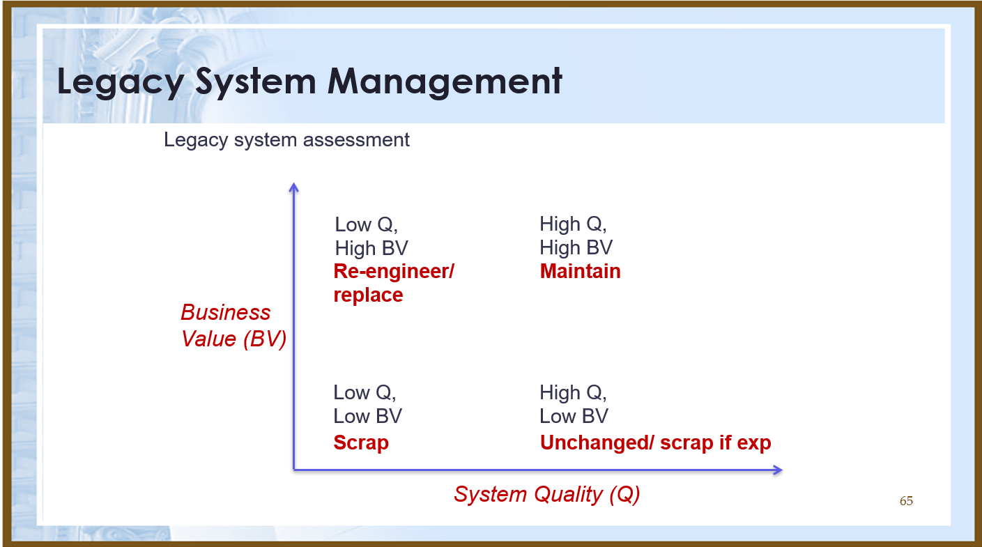
Strategy: re-engineering

- Around The Globe (ATG) Sdn Bhd is a travelling agency that is owned by family Berth since 1960s. The company is using a high quality legacy system to manage the staff and customers” information. However, the maintenance cost is increasing recently as a system requires Pascal experts. Seeing that this system has low business value to the company, Berth Junior (CEO of ATG) consults your company regarding the legacy system’s management strategy.

Advice Berth Junior regarding 4 factors affecting the ATG legacy system maintenance cost. What should Berth Junior do with the legacy system? Justify your answer.

- 4 factors
  - Programming language
    - Pascal is an old programming language
    - Difficult to maintain as the legacy use the pascal language.
  - Age of the program
    - The business has been started 1960, so this system may be very old
  - Staff stability
    - There are very less staff that familiar with Pascal anymore, so new staff are very difficult to find
  - Programming style
    - Old programming style and new programming style may be different, then affect maintenance cost
Scrap (Low Q, Low BV), since it would be hard to find pascal experts anymore and pascal system are very costly and inefficient, the maintenance system is getting higher and not worthy.

- Standard Printing Company is established in 1981. The main business is designing and printing advertisement. The graphic designer is using a legacy system to design advertisement for customers. The design is stored as both PDF and DOC in the legacy system. The documentation of the legacy system is incomplete and the system is programmed in an obsoleting programming language. Recently, the company is considering purchasing Atlassian JIRA in assisting their advertisement project management. The owner of the company, Mr. S, is consulting you regarding the cost of the tool.
What should Mr. S do to the legacy system if he is going to integrate Atlassan JIRA with the existing legacy system? Justify and discuss your answer in detail (steps to carry out the solution). [Hint: Legacy system management including Re-engineering, Maintain, Scrap, and Unchanged.]

- Source code translation
  - The legacy programming language is obslete, an old programming language
  - So we need to translate the code to become new code so can use more long time
- Reverse engineering
  - To identify requirement to understand design to create documentation
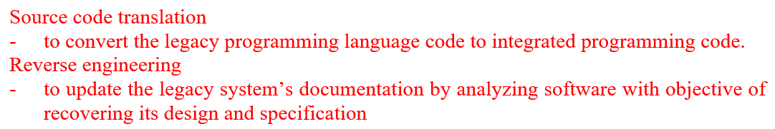

- Ladre Group’s online Human Resource Management System (HRMS) possessing the following characteristics:
- high dependency between module
- developed by high level programming language
- tested for 3 months before deployed
- all versions are stored in a configuration management system
- developed in 1995

Analyse each of the stated online HRMS’s characteristic and comment on the system’s maintenance cost.

- Module independence
  - Higher dependency between modules , harder to do maintenance, higher cost
- Programming language
  - Good language used, easier maintenance, lower cost
- Program validation & testing
  - The more time spent in testing, less error will occur and lead to low maintenance cost
- All versions are stored in a configuration management system
  - Easy to keep track of all versions of the system which can lead to low maintenance cost
- Old programming system
  - Old system means more errors hence more maintenance cost
  - (opposite thinking) System is not old, therefore less errors and lesser maintenance cost
  - (opposite thinking) The system is at average age, it still not consider hard to be maintained , low maintenance cost

