- Fit Your Body (FYB) is a gymnastic center located in the center of Kuala Lumpur. Foreseeing the increasing membership in the coming three years, the company is planning to automate all the classes timetabling, registration, and payment processes. The company has decided to adopt Aspect Oriented Software Engineering (AOSE).

Identify and construct a diagram to show 4 core concerns and 1 cross cutting concerns for this Gymnastic Center Management System (GCM).

- 4 core concerns
  - Classes Timetabling
  - Membership Registration
  - Membership Cancellation
  - Payment
- 1 cross cutting concerns
  - Security requirements
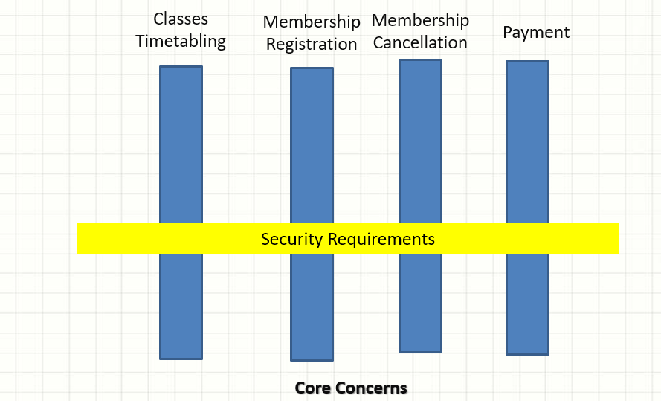

- With the aid of example(s), differentiate tangling from scattering problem in the implementation of cross-cutting concerns.

- Tangling
  - One module not only perform own function but also another module function
  - Will be difficult to perform any change or maintenance to the system
  - For the Gymnastic Centre Management System (GCM) in question 1, membership registration takes part of membership login
- Scattering
  - One module has been scattered into multiple module
  - One functional implementation code has been scattered into multiple modules
  - Very difficult while want to do any changes or maintenance to the system
  - For the Gymnastic Centre Management System (GCM) in question 1, membership login may be scattered into membership registration

- CBrat is developing Chatbox, which is a platform for all sizes of businesses to build, automate and operate personalize messaging application. This Chatbox supports SMS, Facebook, Messenger, live web chat with a single cross-channel customer history. Instant Apps is able to exchange structured data (forms, files, photos, and etc.) in-line with the conversation. Chatbox is also able to sync conversational history and structure data from Instant Apps to the data source. The Instant Apps can escalate between bot and live agent with full conversational history, measure and analyze the effectiveness of messaging through all faces of the customer experience, including tracking across all supported channels and Instant Apps. ( Source :http://chatbox.com/)

Identify 5 functional concerns and 3 cross-cutting concerns. Construct a diagram to reveal the relationship between the functional concerns and cross cutting concerns.

- 5 core concerns
  - Live chat
  - Exchange structured data
  - Synchronize data
  - Analysis reporting
  - Tracking
- 3 cross cutting concerns
  - Security requirements
  - Recoverability requirement
  - Reliability requirement
  - Usability requirement
  - Availability requirement

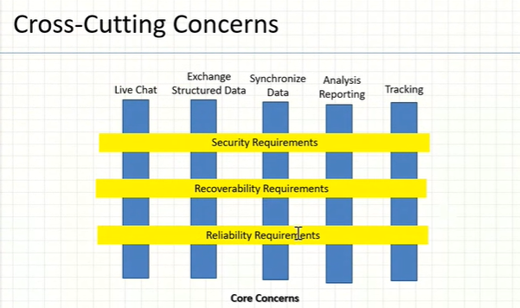
- Donao is an online theatre that provide high-definition mode movie. User can watch movie online or download the movie.

What is a Concern in Aspect Oriented Software Engineering? Identify 5 main concerns and 3 cross-cutting concerns. Present your answer with a diagram to reveal the relationship between the main concerns and cross-cutting concerns.

- 5 core concerns
  - Registration
  - Download movie
  - Search and View movie
  - Watch movie online
  - Payment
- 3 cross cutting concerns
  - Security requirements
  - Recoverability requirement
  - Reliability requirement
  - Usability requirement
  - Availability requirement
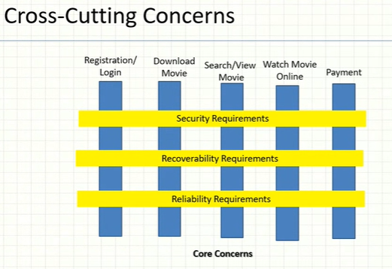
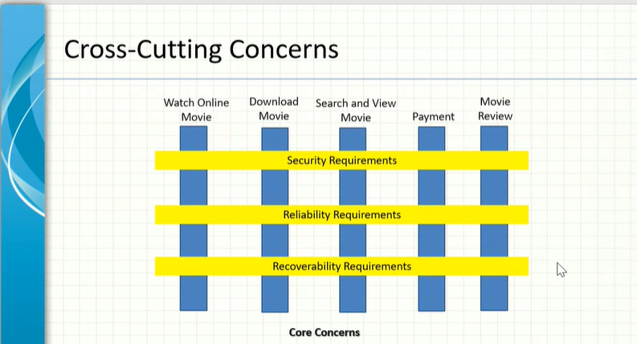
- You, as an appointed software engineer are in-charge for designing an online management system for Study Point Tutor center. Currently the tuition center has been using manual way to manage the center and now has decided to automate all their registration, classes scheduling, attendance, and payment processes.

Identify 4 main concerns and 2 cross-cutting concerns. Present your answer with a diagram to reveal the relationship between the main concerns and cross-cutting concerns for Study Point Tutor online management system.

- 4 core concerns
  - Registration
  - Class scheduling
  - Attendance
  - Payment
- 2 cross cutting concerns
  - Security requirements
  - Recoverability requirement
  - Reliability requirement
  - Usability requirement
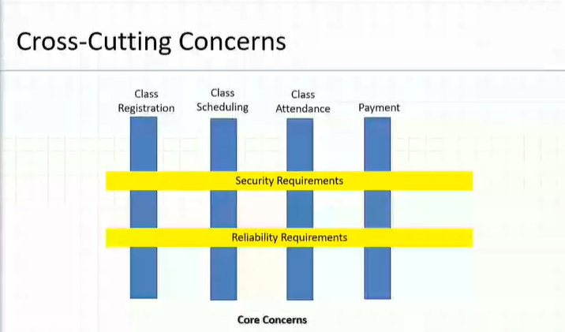
  - Availability requirement

