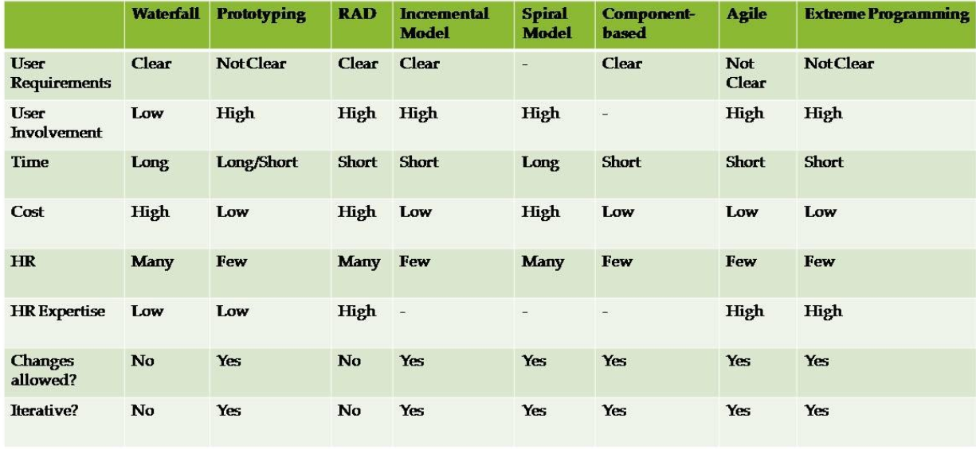

- You as an IT manager of Cozzway Direct Selling Sdn. Bhd. are required to develop an online system which will provide services for its distributors and customers. Among other services, the system should allow users to view product and promotion details, register as a distributor, make orders and payments, track order status, check on distributor’s points accumulated and perform redemption based on points entitlement.

The distributors and customers of this company basically come from all parts of Malaysia with different education background, level of computer knowledge as well as preference of language. Currently, the IT department consists of three staff under your supervision, i.e. one systems analyst and two programmers. This could be a challenging project as it concerns a new area that your team has not ventured into before. The requirements gathered were clear and could be modularized easily. The top management requires that the new online system be completed within three months.

Recommend, with explanation, an appropriate software process model to complete the project. Justify your recommendation. You may state any relevant assumptions to support your answer.

RAD. Because it contains low risk and clear requirement and need a fast development process.

- Highlight the distinct feature(s) and suggest a scenario where Spiral model is suitable to be adopted.

- High risk project with the need of very long time to plan and testing the situation and requirement of the system. These kinds of systems will cause very high risk or cause many effects which maybe cause very big mistakes like examples kill people or lost a lot of money.
- Example system: Risk analysis and management system

- JC grocery is a mid-sized family business that operates since 30 years ago. The main operations in the grocery store, i.e., stock in and stock out, are still performed manually. To ease the daily operations, the owner of JC grocery wants to computerize the stock in and stock out operations in the stores. In addition, he also wants to enable online-ordering services to the clients. Nevertheless, the owner does not have any background or knowledge in computerized and online systems.

If you are the project manager of a software solution company, analyze the description above and suggest the most suitable process model to be used in case study above. Justify your suggestion. You may state any assumptions in supporting your justifications.

- Evolutionary Prototyping model. Due to the owner do not have any computerized system knowledge, and this is not a very difficult or very big system, so the prototyping model are the suitable model for this situation.

- Discuss 3 main differences between Plan-Driven Development and Agile Software Development.
Plan-driven development | Agile software development
- User requirement change often because the user requirements are very clear  - All thing will be plan stage by stage in a document in advanced  - Development process are all in one | - Requirement might be change often because the requirements are not clear  - Not able to plan the requirement stage by stage because the time are short  - Development process are something like incremental by incremental

Lecture ans
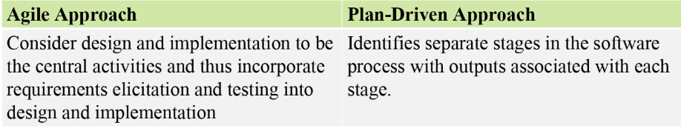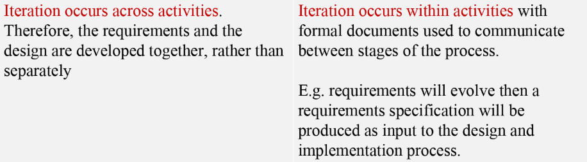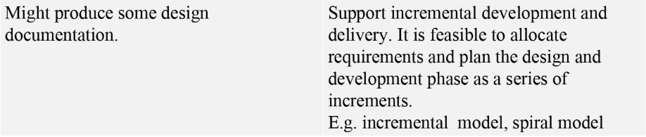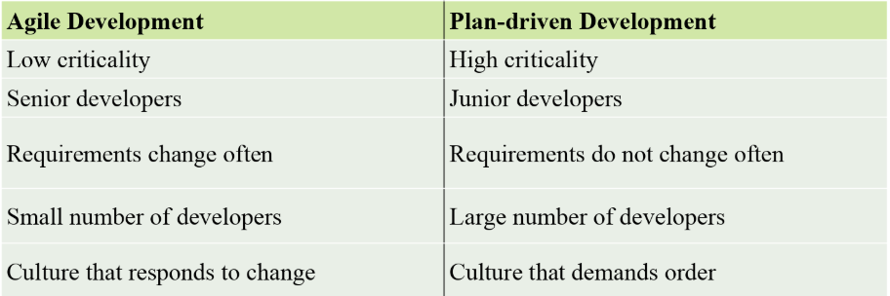

- Delicious restaurant is a new restaurant in town. The restaurant is having a soft-launch in less than a month time. To further increase the popularity of the restaurant, Delicious restaurant has decided to have a website which introduces the menu and soft-launch promotion to the customers. After that, Delicious restaurant also wants to have an online system to enable table-booking services to the customers. In the future, Delicious restaurant also wishes to extend their online system to provide wireless ordering and delivering services.

If you are the project manager of a software solution company, analyze the description above and suggest the most suitable process model to be used in the above case study. Justify your answer. You may state any assumptions in supporting your justifications.

- Incremental. First incremental should take about one week to deliver the menu and soft-launch promotions. Second incremental should take about one to two weeks to settle the table booking service. Then third incremental will take care of wireless ordering and delivering services with the rest of the time.

- With the aid of examples, discuss any 5 principles of Agile Software Development.

- Customer satisfaction
- Welcome changing requirements
- Working software is deliver frequently
- Face-to-face conversation
- Close, daily co-operation between business people and developers

