- Discuss the 5 main activities involved in Requirements Engineering Process.

Main activities
- Feasibility Studies
  - To study whether the system can be implemented, based on our resources
  - Do estimation to ensure whether this system can be done successfully
  - Can this system be done
  - Types:
    - Technical feasibility
    - Economical feasibility
    - Operational feasibility
    - Social feasibility
    - Schedule feasibility
    - Legal feasibility
- Requirement Elicitation and Analysis
  - Same like requirement gathering
  - We choose all this technique: interview, questionnaire and so on to gather the customer requirement and after that analysis based on the user need
- Requirement Specification
  - Document back all the requirement which we have gather
  - Need to prepare the software requirement specification
  - Focus on Doing the documentation of all the requirement specification
- Requirement Validation
  - Review the document, to check if all the requirement complete or not, is there any mistake error
  - Is the requirement consistent, check either the requirement can be implemented?
- Requirement Management (on going activity)
  - Manage the requirement, plan, design, coding
  - Manage the requirement, changing request by the client
  - If customer add requirement, how to make adjustment

- Nobiana specializes in swimwear and clothing for women. Started in 1995 as a small scale mail order company, Nobiana has now grown into a multi-million pound and award winning organization.

Working with an independent outsourcing consultancy Zen, Nobiana decided to implement a new point-of-sales and inventory management system. The new project was driven by the need to simplify the way in which stock information and point-of-sales applications were delivered to retail stores and to enable this to be easily scalable in order to accelerate roll-out to existing or new stores, reduce ongoing administration and support costs while providing real time and accurate view of stock across the business, minimizing stock levels and streamlining ordering across the branches.

  - Suggest and briefly explain 2 techniques for discovering requirements for the above project.

  - Assume that Zen is planning to adopt a viewpoint-oriented analysis method for the requirements analysis process. Describe viewpoint-oriented analysis in requirements analysis process.

  - Suggest 5 principal viewpoints which should be considered in the process of discovering requirements for the above project. Construct a viewpoint hierarchy to present your viewpoints.

  - Discuss 2 advantages and 1 disadvantages of using viewpoint-oriented analysis method in requirement gathering and analysis.

  - Suggest 3 aspects to be checked when validating the SRS for the above mentioned project.

- 2 techniques for discovering requirements
  - Interview the manager

  - Scenario
    - textual description of how users will make use of the system when it is deployed
    - is a baseline of the requirement gathering
  - Observation
    - Observe how the system work
- Viewpoint-oriented analysis
  - Viewpoint-oriented analysis is an approach that helps to ensure get broad stakeholder coverage when discovering requirements.
  - Viewpoints can be used to classifying stakeholders and other sources of requirements

- Viewpoint hierarchy

All VPs (Point of sales and inventory system)

Domain viewpoint
Interactor viewpoint
Indirect viewpoint

Sales Staff
Inventory Staff
Competitor
Classification Standards
UI Standards

- Viewpoint-oriented analysis
  - Advantage
    - Easily identified the valid viewpoint
    - Easily identified the invalid viewpoint
    - Can cover a huge range of viewpoint
  - Disadvantage
    - When the system is big system or growing system, the number of viewpoints will be growing more and more, it causes time and cost consuming
- 3 aspects
  - Consistent
    - There is no consistency problem
  - Validity
    - The correctness of the requirement, check with client
  - Completeness
    - Is the system complete and meet all requirement of client
  - Realism check
    - Can the requirement be implemented or not (something like feasibility)
  - Verifiability
    - Is this requirement can be tested later (can test or not)

- Discuss any 3 possible problems in Requirements Elicitation and Analysis process.

  - User/ stakeholder are not clear on what they want
    - They are not clear about what they want from the system
    - They don’t know how to say the requirement
  - Multiple people talking about a single requirement with different words
    - Not consistency words use will cause misunderstanding
  - The client gives too many requirement
    - Too many requirements will cause…..
  - Users normally express requirements in their own terms
  - Different Users have different requirements and they may express them in quite different ways

- Company KW is planning to develop an online document management system that is used by internal staff to store, share, and work on some confidential documents. You, and IT project manager, are responsible to manage this project with senior software engineers. Company KW requests you to deliver an initial version within 2 months and the subsequence increment within 2 months with active internal staff involvement.

Identify 3 viewpoints for the online document management system. Construct a viewpoint-oriented hierarchy for the system.

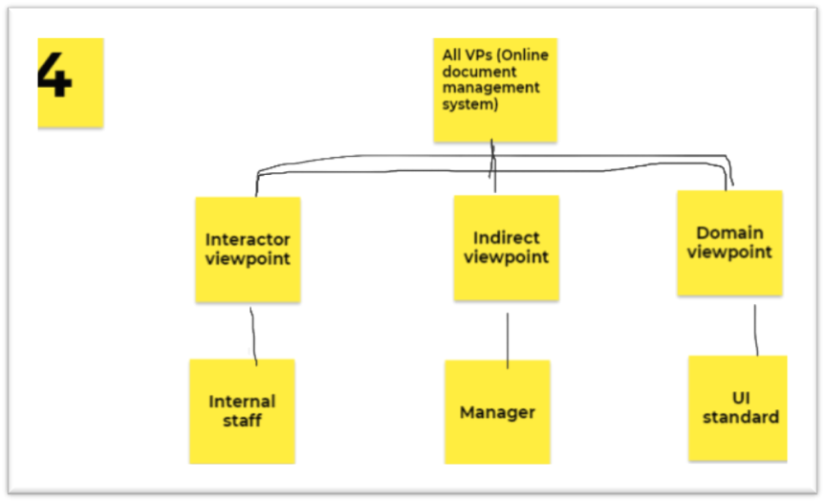

- Easy2Study.com is a global marketplace for teaching and learning online where students are mastering their skills. The system allows the students to search, view available courses, purchase, make payment, and join the courses. An access to start the course will be given once the payment is confirmed. Easy2Study.com is planning to extend their online system on mobile platforms to attract more customers as mobile users are increasing extremely.

As a software engineer for this project, you are required to prepare the system requirements document for Easy2Study.com mobile application. Recommend and explain 2 aspects that must be validated during Easy2Study.com SRS document validation process.

- Consistent
  - The requirement needs to be consistent
  - Both sides must be consistent
- Completeness
  - Ensure there are no missing requirement
- Realism check
  - Ensure that the online website can be done or not

- Ladre is a small scaled family business found in 2000s which selling computers’ hardware and software. Recently the shop owner plans to improve the business by selling the products online. He has contacted your company as a suitable software house to handle this project.
Based on the case study, construct a viewpoint-oriented hierarchy for the online computer store system with 5 possible viewpoints. You must categorize your viewpoints under 3 categories (Interactor, Indirect, and Domain) with at least one viewpoint under each category.

