- Discuss the 3 main activities that your team would perform for the architectural design of the above project.

- Three main activities
  - System organization
    - Separate the system into sub-system
    - Use Repository model/ client-server model/ layered model (based on the situation or owner)
  - Modular decomposition
    - Decompose the sub system into modules
    - Use Object-oriented decomposition/ Function-oriented decomposition (based on situation or owner)
    - Object-oriented decomposition is decompose the system into a set of objects
    - Function-oriented decomposition is decompose the system into a set of functions
  - Control modelling
    - Determine the control relationship between the modules
    - Use Centralized control/ Event-based control
    - Centralized control has a controller to control everything. Consists Call-return model and Manager model
    - Event-based control has no a particular controller to control anything. Consists Broadcast model and Interrupt-driven model

- You, as a project manager have been assigned to lead project team e-learning system for a college. The main functions of the e-learning system include programme registration and payment, on-line assessment, assignment submission, uploading and downloading course materials. The main campus of the college is located at Penang and the other branch campuses are located in Melaka, Kelantan and Sarawak.

Recommend and draw an appropriate system organization model for the above project. Explain the model and justify your recommendation.

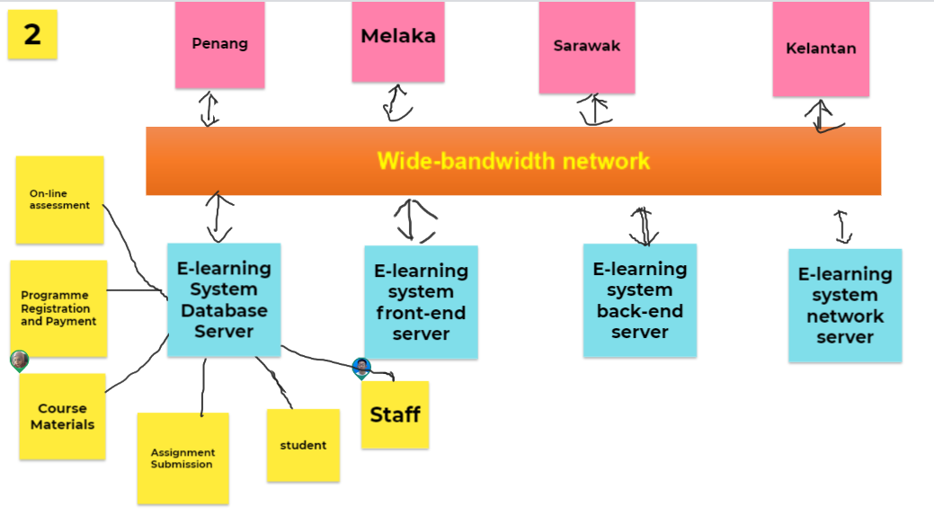
- Differentiate the following pairs of control model:

- Call-return model and manager model

- Interrupt-driven model and broadcast model
- Call-return model and manager model
Top down sub routine model – there consist one main program that control sub routine, then sub routine control sub-sub routine | There is no main program but consist of a system manager which take part of control each of the other project concurrently
Always have a sequence to follow | No sequence to follow
Both of these two models are control by centralized server | Both of these two models are control by centralized server

- Interrupt-driven model and broadcast model
Used in real-time systems where interrupts are detected by an interrupt handler and passed to some other component for processing. | Broadcast an event to all subsystem. Any subsystem which can handle the event will respond to it
No main control, but the subsystem will handle itself or pass to other to handle themselves | No main control, but they controlled by each of them

- Giving reasons for your answer, suggest an appropriate system organization model for the following systems:

- An automated ticket issuing system used by customers at a cinema.

- A Sales and Inventory System used by Sales Staff and Inventory Staff in an organization
  - Repository model
    - Efficient way to share large amounts of data
  - Client-server model
    - Set of stand-alone servers which provide specific services to specific part of system

- A Sales Invoicing System will firstly take the customer order transactions and itemize unit price from database, follow by totaling up all the items ordered prices to calculate the invoice amount. The system will then deduct the invoice amount with a discounted rate (if any) and this will produce the final invoice amount. Then the system will update the customer account and finally print the invoice for each customer.

Giving reasons for your answer suggest a suitable control model for the above system. You may state any assumptions to support your answer.

- Call return
  - Because they have a sequence order to follow

- XinJin Press is a newspaper company which started its first printed newspaper in 1960s. Recently, you are invited to attend a discussion meeting with XinJin Company’s IT department. The main agenda of the meeting is to decide on the maintenance of some of their legacy systems. One of their legacy systems is a text file storage server which stores large amount of the newspaper draft contents (original story from the interview, news draft, supporting images or news, and et cetera). The file storage system has no documentation and no proper module design. The draft contents might be useful in the future to trace the original story.

Assuming that XinJin IT department decided to re-engineer the legacy system. Propose 1 system organization/structuring design model. Explain and justify your answer.

- Repository model
  - Large amount of data
  - Going to be shared out to other organization, different department also can be use it

- Easy2Study.com is a global marketplace for teaching and learning online where students are mastering their skills. The system allows the students to search, view available courses, purchase, make payment, and join the courses. An access to start the course will be given once the payment is confirmed. Easy2Study.com is planning to extend their online system on mobile platforms to attract more customers as mobile users are increasing extremely.

Suggest and explain 1 suitable system organization model and 1 control modelling model for the Easy2Study.com mobile application. Discuss your answers.

- Client server
  - Because have to break down to several module
- Manager model
  - a system manager which will take part of control each of the other project concurrently

