**Supplemental Information**

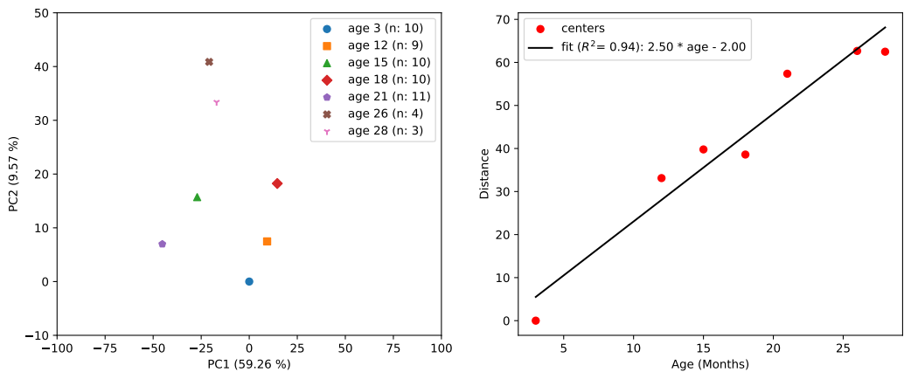**Supplementary Fig. 1. Replot of the data of Ref. [24] in a mouse model for corpus callosum, a white matter rich region.**

Left panel: Principal component analysis of the data. The centers of the subgroups of samples are shown. Ages between 3 and 28 months are considered. An aging direction is apparent. Right panel: Full distances (including all components) to the initial point (3 months). This figure shows that the projection to the (PC1, PC2) plane is a fair representation.

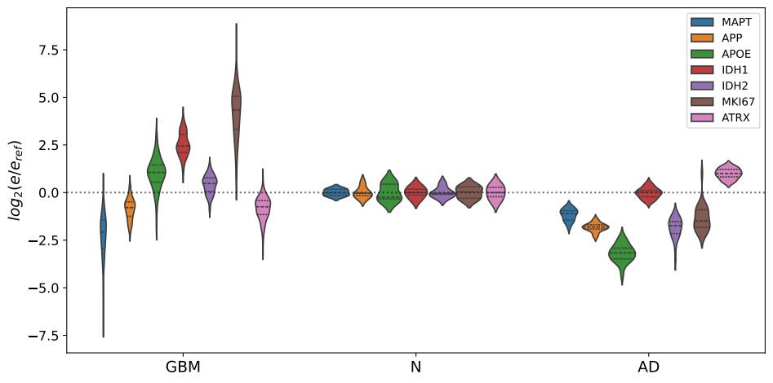**Supplementary Fig. 2. Violin plots for known markers in AD and GB.**

|  |  |
| --- | --- |
| Gene | Weight in PC1 |
| RN7SL1 | 0.04 |
| RPPH1 | 0.03 |
| RNU2-1 | 0.03 |
| SNORD3A | 0.03 |
| RNU1-2 | 0.03 |
| RMRP | 0.03 |
| RNU1-4 | 0.03 |
| RNU1-3 | 0.03 |
| RNVU1-18 | 0.03 |
| RNU1-1 | 0.03 |
| SNORA73A | 0.02 |
| RNVU1-7 | 0.02 |
| RNU2-2P | 0.02 |
| WARS2-IT1 | 0.02 |
| … | … |
| VGF | -0.02 |
| SLC12A5 | -0.02 |
| HIPK4 | -0.02 |
| SSTR1 | -0.02 |
| CPLX1 | -0.02 |
| SYT5 | -0.02 |
| MIR657 | -0.02 |
| INA | -0.02 |
| CCK | -0.02 |
| GABRD | -0.02 |
| MIR1249 | -0.02 |
| WIF1 | -0.02 |
| NECAB2 | -0.02 |
| FBXL16 | -0.02 |
| GDA | -0.02 |
| KIAA1045 | -0.02 |
| SYNPR | -0.02 |
| HMP19 | -0.02 |
| CHGA | -0.02 |
| SNCG | -0.02 |
| SVOP | -0.02 |
| LRTM2 | -0.02 |
| WNT10B | -0.02 |
| MTND4P12 | -0.02 |
| PHYHIP | -0.02 |
| RAB3A | -0.02 |
| RASAL1 | -0.02 |
| HPCA | -0.03 |
| SERTM1 | -0.03 |
| GABRG2 | -0.03 |
| CAMKV | -0.03 |
| CREG2 | -0.03 |
| SNAP25 | -0.03 |
| GAD2 | -0.03 |
| SYT13 | -0.03 |
| KLK7 | -0.03 |
| WBSCR17 | -0.03 |
| SV2B | -0.03 |
| SLC30A3 | -0.03 |
| ATP1A3 | -0.03 |
| CPNE6 | -0.03 |
| CAMK2A | -0.03 |
| SLC6A7 | -0.03 |
| GABRA1 | -0.03 |
| KCNJ4 | -0.03 |
| CDK5R2 | -0.03 |
| CALY | -0.03 |
| GNG3 | -0.03 |
| CALB2 | -0.03 |
| CHD5 | -0.03 |
| VSNL1 | -0.03 |
| CRYM | -0.03 |
| CCKBR | -0.03 |
| NEUROD6 | -0.03 |
| HRH3 | -0.03 |
| SYT1 | -0.03 |
| SNCB | -0.03 |
| CHRM1 | -0.03 |
| MAL2 | -0.03 |
| SNORD113-3 | -0.03 |
| PNMA5 | -0.03 |
| CPLX2 | -0.03 |
| TMEM130 | -0.03 |
| LOC105373377 | -0.03 |
| SYN2 | -0.03 |
| SLC6A17 | -0.03 |
| ICAM5 | -0.03 |
| NEFL | -0.03 |
| SYN1 | -0.03 |
| C1QL3 | -0.03 |
| NEFM | -0.03 |
| DDN | -0.03 |
| FAM163B | -0.03 |
| GABRA5 | -0.03 |
| NRGN | -0.03 |
| SLC32A1 | -0.03 |
| SLC8A2 | -0.03 |
| PACSIN1 | -0.03 |
| SULT4A1 | -0.03 |
| CACNG3 | -0.03 |
| GRIN1 | -0.03 |
| SLC17A7 | -0.03 |
| PDYN | -0.03 |
| PRKCG | -0.03 |
| SST | -0.04 |
| MIR770 | -0.04 |

**Supplementary Table I. The top 100 relevant genes contributing to the unitary vector along PC1 in the common plot.**

|  |  |  |  |  |  |  |
| --- | --- | --- | --- | --- | --- | --- |
| Pathway name | Entities | | | | Reactions | |
| found | ratio | p-value | FDR* | found | ratio |
| Transmission across Chemical Synapses | 20/344 | 0.022 | 3.72e-13 | 9.16e-11 | 63/167 | 0.012 |
| Neuronal System | 20/490 | 0.032 | 1.97e-10 | 2.42e-08 | 72/221 | 0.015 |

**Supplementary Table II. The main Reactome pathways related to the 100 first genes in the ranking along the PC1 direction.**

|  |  |
| --- | --- |
| Gene | Weight in PC2 |
| RN7SL1 | 0.05 |
| RPPH1 | 0.04 |
| RNU2-1 | 0.04 |
| SNORD3A | 0.04 |
| RMRP | 0.04 |
| RNU1-3 | 0.03 |
| RNU1-1 | 0.03 |
| RNU1-4 | 0.03 |
| RNVU1-18 | 0.03 |
| RNU1-2 | 0.03 |
| SNORA73A | 0.03 |
| RNU2-2P | 0.03 |
| BCYRN1 | 0.03 |
| LOC101928075 | 0.03 |
| RNY3 | 0.03 |
| SNORA63 | 0.03 |
| RNVU1-7 | 0.03 |
| SCARNA2 | 0.03 |
| SNORA48 | 0.02 |
| CYCSP30 | 0.02 |
| SCARNA10 | 0.02 |
| RN7SL2 | 0.02 |
| LOC729348 | 0.02 |
| SCARNA5 | 0.02 |
| SCARNA7 | 0.02 |
| SNORA81 | 0.02 |
| SNORD97 | 0.02 |
| DNAJC19P8 | 0.02 |
| FCF1P1 | 0.02 |
| SNORA57 | 0.02 |
| SNORD10 | 0.02 |
| SNORA49 | 0.02 |
| SNORA54 | 0.02 |
| RAB9AP2 | 0.02 |
| RAB9AP5 | 0.02 |
| RNY1 | 0.02 |
| … | … |
| TPT1P9 | -0.02 |
| RPL31P4 | -0.02 |
| RPL10P9 | -0.02 |
| GAPDHP65 | -0.02 |
| RPL12P4 | -0.02 |
| RPS20P14 | -0.02 |
| FAM64A | -0.02 |
| RPS2P46 | -0.02 |
| RPS3AP5 | -0.02 |
| RPL7P1 | -0.02 |
| YBX1P1 | -0.02 |
| FTH1P7 | -0.02 |
| RPL35P5 | -0.02 |
| RPL13AP25 | -0.02 |
| RPL37AP1 | -0.02 |
| AURKB | -0.02 |
| FAUP1 | -0.02 |
| MMP9 | -0.02 |
| FTLP2 | -0.02 |
| RPL7P9 | -0.02 |
| GPX1P1 | -0.02 |
| CHI3L1 | -0.02 |
| MIR621 | -0.02 |
| PI3 | -0.02 |
| RPL6P27 | -0.02 |
| IGFBP2 | -0.02 |
| BIRC5 | -0.02 |
| TPI1P1 | -0.02 |
| FTH1P8 | -0.02 |
| RPS27AP16 | -0.02 |
| RPS27AP5 | -0.02 |
| LOC105369550 | -0.02 |
| PLA2G2A | -0.02 |
| NDUFA4P1 | -0.02 |
| FTH1P2 | -0.02 |
| TMSB4XP8 | -0.02 |
| RPL26P19 | -0.02 |
| COL1A1 | -0.02 |
| COX6A1P2 | -0.02 |
| COL3A1 | -0.02 |
| RPS27P4 | -0.02 |
| SAA1 | -0.02 |
| RPL14P1 | -0.02 |
| RPS27P3 | -0.02 |
| SNRPGP10 | -0.02 |
| MT2P1 | -0.02 |
| RPS3AP26 | -0.02 |
| PBK | -0.02 |
| TOP2A | -0.02 |
| CPXM1 | -0.02 |
| MIR3682 | -0.02 |
| RPS18P12 | -0.03 |
| RPS3AP6 | -0.03 |
| SNRPGP2 | -0.03 |
| RPS7P1 | -0.03 |
| RPS15P4 | -0.03 |
| MYBL2 | -0.03 |
| RPL41P1 | -0.03 |
| RPLP0P9 | -0.03 |
| UBE2C | -0.03 |
| RPL18AP3 | -0.03 |
| RPL39P3 | -0.03 |
| FTLP3 | -0.03 |
| RPLP0P6 | -0.03 |

**Supplementary Table III. The top 100 relevant genes contributing to the unitary vector along PC2 in the common plot.**

|  |  |  |  |  |  |  |
| --- | --- | --- | --- | --- | --- | --- |
| Pathway name | Entities | | | | Reactions | |
| **found** | **Ratio** | **p-value** | **FDR\*** | **found** | **ratio** |
| G0 and Early G1 | 4/38 | 0.002 | 1.58e-04 | 0.032 | 4/27 | 0.002 |
| TFAP2A acts as a transcriptional repressor during retinoic acid induced cell differentiation | 2/9 | 5.86e-04 | 0.002 | 0.191 | 2/7 | 4.83e-04 |
| Interleukin-4 and Interleukin-13 signaling | 6/211 | 0.014 | 0.004 | 0.254 | 2/47 | 0.003 |
| SUMOylation of DNA replication proteins | 3/50 | 0.003 | 0.005 | 0.272 | 4/8 | 5.52e-04 |
| Transcription of E2F targets under negative control by p107 (RBL1) and p130 (RBL2) in complex with HDAC1 | 2/20 | 0.001 | 0.009 | 0.336 | 2/8 | 5.52e-04 |
| Assembly of collagen fibrils and other multimeric structure | 3/67 | 0.004 | 0.012 | 0.336 | 16/26 | 0.002 |
| Collagen degradation | 3/69 | 0.004 | 0.013 | 0.336 | 16/34 | 0.002 |
| Transcription of E2F targets under negative control by DREAM complex | 2/25 | 0.002 | 0.013 | 0.336 | 2/12 | 8.29e-04 |
| TP53 regulates transcription of several additional cell death genes whose specific roles in p53-dependent apoptosis remain uncertain | 2/28 | 0.002 | 0.017 | 0.355 | 2/19 | 0.001 |

**Supplementary Table IV. The main pathways related to the 100 first genes in the ranking along the PC2 direction.**

|  |  |  |
| --- | --- | --- |
| Gene | Extended name | Weight in PC1 |
| SNAP25 | Synaptosome Associated Protein 25 | 1.00 |
| VSNL1 | Visinin Like 1 | 0.90 |
| STMN2 | Stathmin 2 | 0.90 |
| ENC1 | Ectodermal-Neural Cortex 1 | 0.89 |
| NEFL | Neurofilament Light Chain | 0.89 |
| SYT1 | Synaptotagmin 1 | 0.88 |
| RGS4 | Regulator Of G Protein Signaling 4 | 0.86 |
| CHN1 | Chimerin 1 | 0.84 |
| GABRA1 | Gamma-Aminobutyric Acid Type A Receptor Subunit Alpha1 | 0.77 |
| GABRG2 | Gamma-Aminobutyric Acid Type A Receptor Subunit Gamma2 | 0.77 |

**Supplementary Table V. The top 10 genes in the PCA ranking for the transition from O to AD .** Results are based on calculations of Ref.[21]. Weights in the unitary vector along PC1 are normalized to the highest one.