|  |  |  |  |  |  |  |  |  |  |  |
| --- | --- | --- | --- | --- | --- | --- | --- | --- | --- | --- |
| Whitireia Logo_2010   |  | | --- | | **GROUP COVER FORM** |   **Report on Project Management**  **PROGRAMME: Project Management in Information Technology**  **COURSE CODE: IT7x25**  **ASSIGNMENT NUMBER: 3**  **TUTOR: MRS PREMLATHA SAMPATH**  **DATE OF SUBMISSION:**  **DUE DATE:**   |  |  | | --- | --- | | **STUDENT ID** | **NAME** | | **21901423** | **Vibha Chugh** | | **21900847** | **Joan Dias** | | **21900130** | **Mandeep Kaur** |  |  | | --- | | **We Certify that this is the team’s own Work:**  **Student Signatures: Vibha, Joan, Mandeep** | |

**Group Contribution Form**

The purpose of this form is to indicate to the lecturer the contribution each student has made to the overall assignment. It is completed by all group members at a meeting they must arrange on or before the due date.

Course Code: **IT7x25** Semester/Year: **2/2019**

Assignment Number: **3**

|  |  |  |  |  |
| --- | --- | --- | --- | --- |
| **Student Names** | **Student IDs** | **Percentage contribution to the assessment** | **Tasks worked on** | **Signature** |
| **Vibha Chugh** | **21901423** | **33.33%** |  |  |
| **Joan Dias** | **21900847** | **33.33%** |  |  |
| **Mandeep Kaur** | **21900130** | **33.33%** |  |  |
| **Total** |  | **100%** |  |  |

Table of Contents

**No table of contents entries found.**



# Executive Summary

Mike Trump Investments (MTI) Real Estate is one of the leading corporate and residential real estate owner and developers with multiple business offices located in Auckland, Wellington, Dunedin, Tauranga and Nelson. The company core business is to manage the residential and commercial properties and maintain the COI compliances on file. MTI collects COI certificates on annual basis for all properties. Due to non-availability of system, company has to maintain all the data in files and on papers. Moreover, the business units are not collaborated due to lack of any system.

Hence, Techie Tribe has suggested an ERP system and web application to overcome these problems. These systems will help to reduce the paper work and manage day to day operational activities smoothly. The system will increase the communication among all the business units and reduce data duplicity by storing data in system. The project should be completed within six months with in budget. This report is providing the detailed information about the different feasibility study factors such as technical, legal, operational and other factors. These factors are followed by description about the methodology that is selected to support this system and appropriate tool that is used for management of development phases and tasks that are performed for the successful completion of the project.

# 1.Feasibility Analysis

# 1.1Overview

Feasibility study has been done to analyse to ensure that project is legally, technical and economical justifiable. MTI Real Estate project feasibility is based on manage the data base centrally, collaborate all business units, manage residential and commercial properties without any compliance issues. The investment has been measured in three aspects such as cost saving, profit volume, data management, communication level, avoid loss of COI data, meet real estate association rules, provide modern facilities to MTI’s employees after implementing the system.

# 1.2. Technical feasibility

The project financial analysis has been done at the time of project initiation to figure out the technical requirement cost such as hardware, software and third-party services. The resources are also aligned in the project with technical skills of web application development such as design, develop & implementation system and test the system on different environment and release on production environment. The technical requirement work of statement has been issued to vendor.

* + 1. Requirement gathering

1. Procurement of web app domain & host server. Developer will develop the web page in word press. SSL certificate will be procured after getting the approval from MTI’s management to secure the web application.
2. Cloud service provider will be finalised after getting bids. MTI’s financial and project management team will meet with the vendor to finalise the prices and for long term service contract. Vendor should have reliable resources with technical skills to manage web application.
3. ERP system integrated with web application will help to reduce the data redundancy and manage the data remotely, but the integration of system and security are technical challengeable.
4. MTI’s IT department will be engaged in system deployment & implementation process to get the more feasibility on technical aspects.
5. Routers will be installed in MTI’s building for the system connectivity.

|  |  |  |  |
| --- | --- | --- | --- |
| **Size / Complex** | **Low** | **Medium** | **High** |
| **Small** | Banner Area |  | Database, |
| **Medium** |  | Dashboard | ERP system, |
| **Large** | Load Data | finalise cloud service provider | Integrate security System, web page design |

Figure 1: Task Evaluation

1.2.2. Design process

1.2.3. Development Process

1. documentation

2. User interface

3. Application Servers

4. Compatibility

5. Database

1.4. Testing process

1. Functional testing

2. Non- Functional testing

# 1.3. Economic feasibility

MTI Real Estate has given the approval of $60000 on project budget. The web pages content has shared with the management. Any new feature or content will impact on project cost. The project cost will be presented in fortnightly meeting. The project cost is evaluated with the help of NPV, payback period financial methods.

# 1.3.1. Cost/Benefit Analysis

The cost and benefits have been analysed in financial analysis to analyse the profits for next 3 years after implementing the new system. The tangible cost such as hardware, software, license fees or required resources cost have been considered in the financial analysis report. After milestone 2, cost & benefits have been proposed and if any new features or requirement will be added then It will impact on the cost and benefits of project. There is no variation in project cost after analysing on the revised project budget. Below factors in screen shot is considered for the cost benefit analysis.

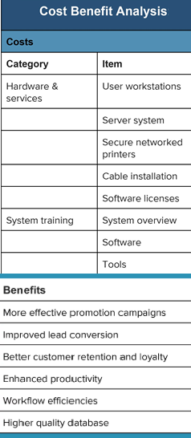

Figure: Cost Benefit Analysis

# 1.3.2. Net Present Value

As per financial analysis the Net Present value for MTI project is 196% with 8% discount rate. The NPV value is in positive with high figure rate which implies that the project is in profits. The project cost is managed by reviewing and analysing old system of MTI. The cost can be reduced by minimize the web app features, use predefined templates in word press but this will impact on user interface. MTI projects will provide benefits at the different time in the future, all costs and benefits of the projects should be viewed in relation to their present value.

# 1.3.3. Payback period

The payback period for MTI project will be start from next year. In first year, there is no profits as it requires time to generate sufficient cash flows to recover its initial cost. Payback period will start from first year and it will continue until three years because of project stability.

1.3.4. Estimated project budget template( with 60,000 initial cost)(can add templete)

# 1.4. Legal & Contractual feasibility

The legal & Contractual feasibility analysis objective is to facilitates the risk management, indicating the risks and obstacles that needs to be addressed with in technical analysis. The project contract has considered other legal factors such as copyright infringement, antitrust legislation, reporting standards (financial & COI data information) and non-disclosure infringement. The system developers and other team members should be aware from the rules that govern the industry. SOX compliance will be reviewed on monthly basis to avoid any variation in the project.

1.4.1. Executing Smart Contract

The contract includes the terms & conditions. The shared network automatically executes the contract and monitors the compliance. The assets such as customer data, COI data and application will be hosted on cloud environment hence the security, License agreement for software and hardware and ethical issues have been considered in the contract.

1.4.2. Web Application compliance

Techie Tribe will consider all the compliance factor related to web app development to implementation. The host and domain server will be procured from reliable vendor and validate all the terms. The cookies and cache should be deleted after using in the web page. Hence, user data will not be misused by the hackers.

. 1.4.3. Electronic transaction

1.4.4. Privacy and security

1.4.5. Copyright and trademark

1.4.5 Online terms and conditions

1.4.6 Policies and laws

# 1.5. Operational feasibility

In the project operational feasibility has been analysed to find the benefits of the proposed system to solve the MTI’s business problems. Operational feasibility helps to analyse how the new erp and web app systems will fit into the current day-to-day operations of MTI.

System analysts will evaluate whether the current work practices and procedures support a new system and how the organizational changes will affect the working lives of those affected by the system. Implementing the new IT/IS project may cause some obstructs and may increase difficulty to the staffs in their day-to-day operation.

* It is not only important to evaluate whether a system can work, but also evaluate whether a system will work. A workable solution might fail because of the end-user or management resistance, such as, how will the working environment of the end-users change, or whether end-users and management can and will adapt to that change

[ can add more ]

1.6. Schedule Feasibility

# The project expected to complete within six months. Schedule feasibility is used in combination with technical, operational and economic feasibility. The schedule feasibility has been analysed in Gantt chart at the time of initiation & planning phase. In the project final report, the schedule such as project team meeting, sponsor meeting, daily stand up status meeting, design, development and testing process will be finalised with deadlines in the finalised software.

# 2. Methodology Selection & Implementation

MTI Real Estate has offices throughout the country in New Zealand. The project methodology has been finalised after analysing the project requirement, company size, objective, risk analysis, Internal & external criteria, size and cost of the project. SWOT (strength, weakness, opportunities and threats are measured of MTI company before selecting the appropriate project methodology. In this project, Scrum is the best approach to manage this project. Scrum is a part of agile methodology and best to facilitates team tasks. The team can focus on the tasks independently and daily stand-up meeting will help to get the status or block road status in project. Scrum master or Product owner can make the plan accordingly for further process.

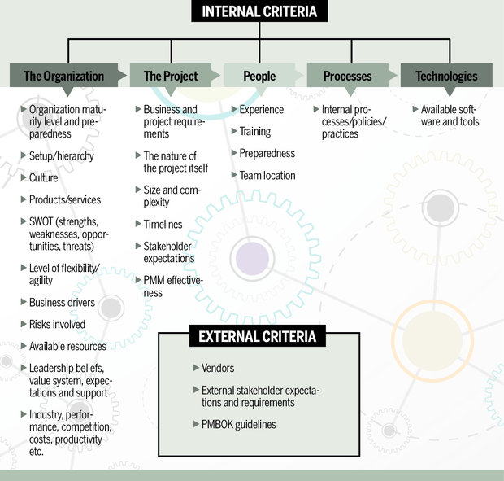

Figure: list of project methodology assessment criteria

# 2.1. Scrum Methodology

Scrum methodology helps teams work together. It also helps team to learn through experiences, self-organise when working on a problem and reflect on win & losses to continuously improve. Scrum is best for small and medium IT project. Scrum focuses on sprints which starts with planned meeting to prioritise tasks to pull for two- to three-week sprint. MTI Real Estate project requirements of website has been divided into sprints such as design the home page, login page, awards achievement ads on home page, contact page and develop all designed web page, integrate and test the quality, release sprints and deploy website are the tasks which divided in the sprints.

Techie Tribe’s product and development teams concentrated on the pulled items during the planning meeting until the sprint is completed. At the end, there was review meeting of the sprint to evaluate how it went, what worked and what needs to be changed. Then the project process started again with next sprint requirements or tasks.

The client will be engaged in every functional product sprint in the project without waiting until the last minute. Scrum is an iterative model hence changes in project requirements are considered and deliver with next sprint. It helps to give a flexibility to client in changes the requirement and add on features which reduce the project cost.

Justification of methodology selection(TEMPLATE)

2.1.1 Azure DevOps Project Implementation Plan

Azure DevOps is cloud based tool which helps to manage epic, sprints, product backlog, team activities and dashboard. Techie Tribe has implemented Azure DevOps software to manage sprints and project day to day team tasks. Earlier, the company has used Bitrix 24 project management software but due to the complexity and limited features, the company has migrated to Azure DevOps software for the project.

2.1.1.1 Project Plan

The project plan is created in Azure DevOps by using scrum methodology to manage system delivery. First the tasks have been designed on the chart in the meeting. Then, work Item has been created for each task and assigned to the employee in Azure DevOps. Each task was divided into sprint 1 to sprint 4 according to the system & project planning. Tasks were flagged with different colours. Project plan is to complete the project till December’2019, but the buffer time has been taken due to the cloud-based system and external factors.

2.1.1.2. Product Backlog

The product backlog is combined with the tasks which must be done to complete the whole project. Product managers have braked down each of the tasks into a series of steps that helps the team. The time and duration have been set to start the task and the finish the task. Once the task is completed then it removed from the product backlog list. New items added as per the changes or project requirements.

2.1.1.3. Active Sprints

In Azure DevOps active sprints have managed in to do column, in progress and Done column. The active sprints show the details of sprints that is started from the product backlog.

Once the task is completed its moved to another phase.

2.1.1.4. Report

There are many tools available in market to manage the project. Azure DevOps provides the team’s progress, improve workflow process. Each team can customise their dashboard to share the information.

2.1.1.4.1 Sprint Report

The sprint report in figure .. is presenting six columns with product backlog and five sprints. The product backlog is depicting all the tasks that will be done to complete the whole project. These tasks are divided in different sprints to complete according to specified time.

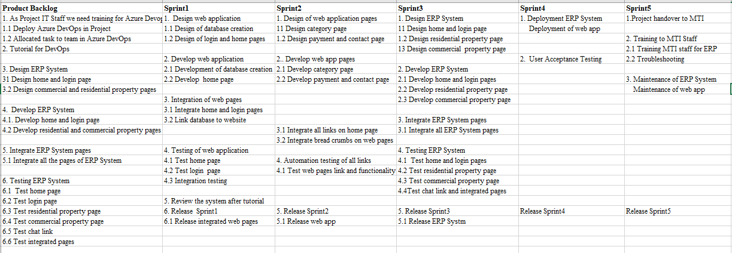

2.1.1.4.2 Burndown Chart

2.1.1.4.3 User stories

2.1.1.4.5 Issues

2.2 MTI web application

2.2.1. Web page designs

1. Home page

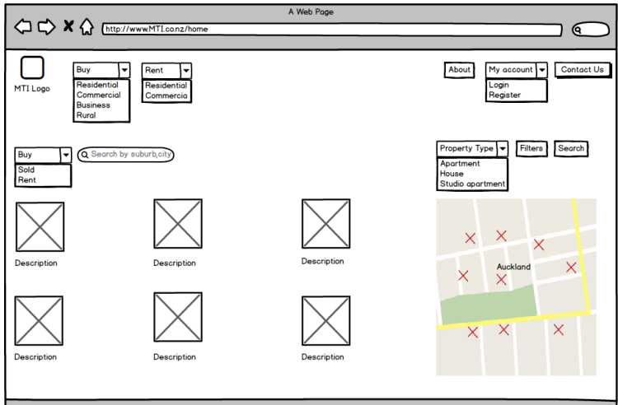

1. Login Page of web application

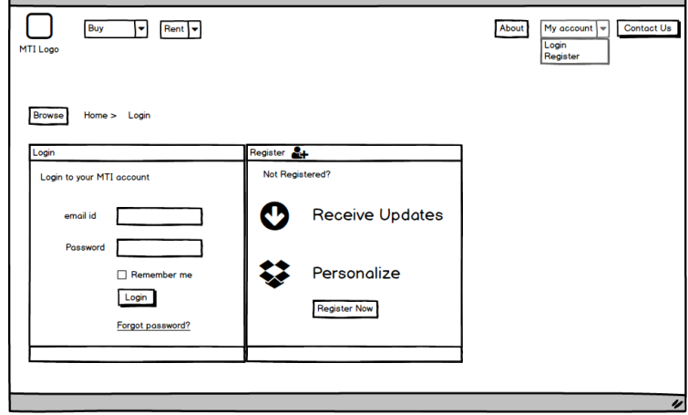

1. Contact Page

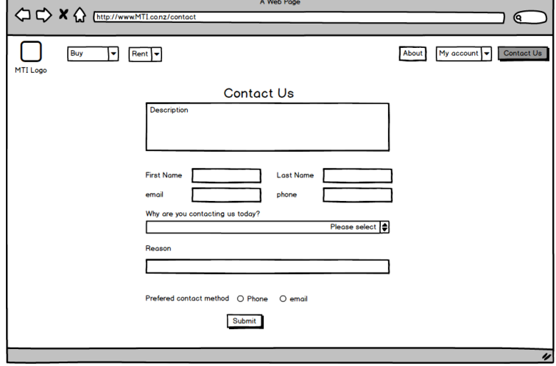

1. Category Page

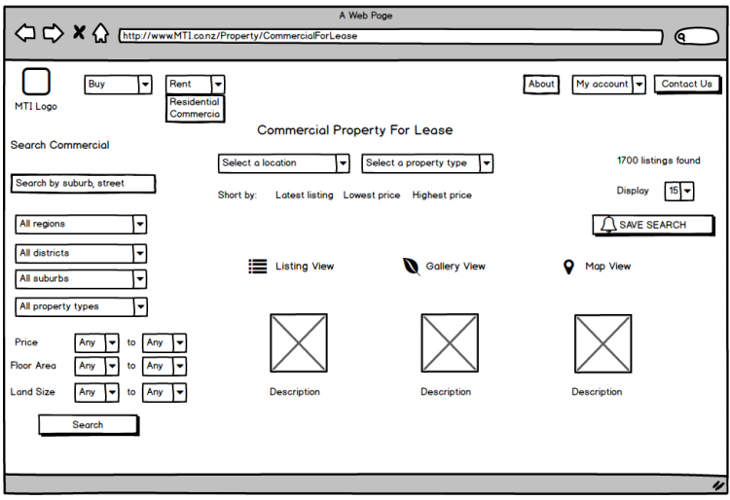

2.3 ERP system(add screen short of wire framing)

2.2.1. Home Page with Banner

Home page with user friendly of MTI web site will contains the header and footer with breadcrumbs links. The awards and achievement of MTI is highlighted on the home page. User can click on My account to login the account. The simple language is used to create the web site. After designing the site, the prototype has been showed to MTI’s stakeholders.

2.2.2. Login Page

Login page has the features to login MTI account by using email id or phone number. Forgot password link is after the submit button. Login email and password is case sensitivitie. Account will be shared within mti domain.

2.2.3. Category Page

Category page contain 2 sections which is for residential and commercial property login. The property manager can update the property status, visits, inspection, staff’s actions, maintenance and other requirements.

2.2.4. Contact Page

Contact page has contained all the business units address and contact details.

2.2.7. Chat Link

Chat link will assist to support the user or staff to communicate for business purpose and share the documents through chat section. The business units easily manage support and operational activities by communicating to other location staff through chat option.

# 3.Discussion

Techie Tribe company has awarded the project from MTI Real Estate to create the website to smooth operational work and manage the property throughout the country. The suggested system helps to manage the database and collaborate all the business units. The implementation of ERP system helps to reduce the paper work and data redundancy by using features such as to manage visits, inspections, staff’s actions, hold property and other data.

Techie Tribe team has used Bitrix 24 project management tool which is good for Agile and Scrum project methodology. The company has used this system in previous project. But due to the complexity and cloud-based system requirement, the company has changed the tool. It was analysed that Azure DevOps system is less complex, easy to manage sprints, monitor team activities and easily fetch the reports. Each sprint is released after testing and dashboard is published on fortnightly meeting to MTI stakeholders. The final view of system is displayed to client and training is provided to MTI’s staff.

**Continuous Integration** (**CI**) is a software engineering practice in which developers **integrate** code into a shared repository several times a day in order to obtain rapid feedback of the feasibility of that code. **CI** enables automated build and testing so that teams can rapidly work on a single project together

Started sw by using

Reflections

Experience

Lesson learnt

Challenges

Journey

Positive challenges

# 4.Summary

The project report has measured the feasibility analysis, consider the risks, select appropriate methodology after analysing all the business requirement as well as risks and the tool to manage the project activities. Scrum methodology is used to manage the sprints to deliver the project on time. MTI Real Estate can expect the payback with in first year. After few years, the project can again add the functional requirement or other features as per business or market strategies.

6. Reference

# 7. Appendix

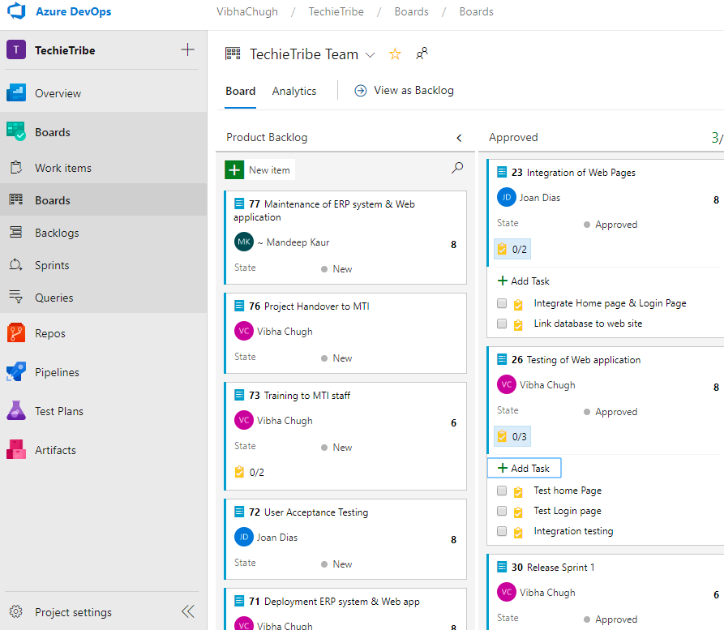

Figure1: Product backlog

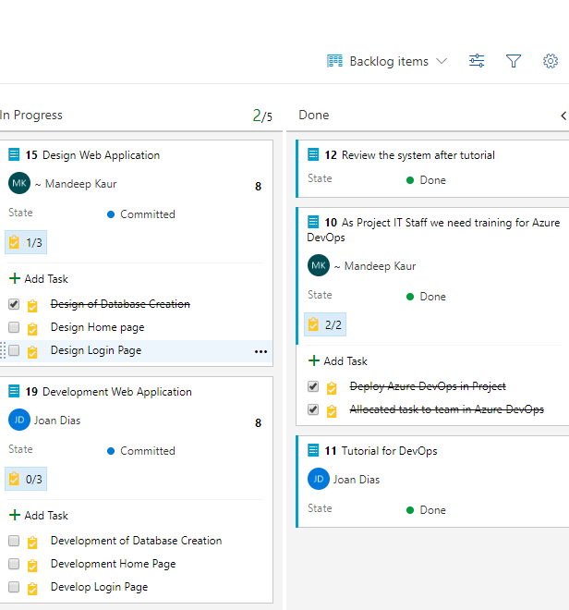

Product Backlog

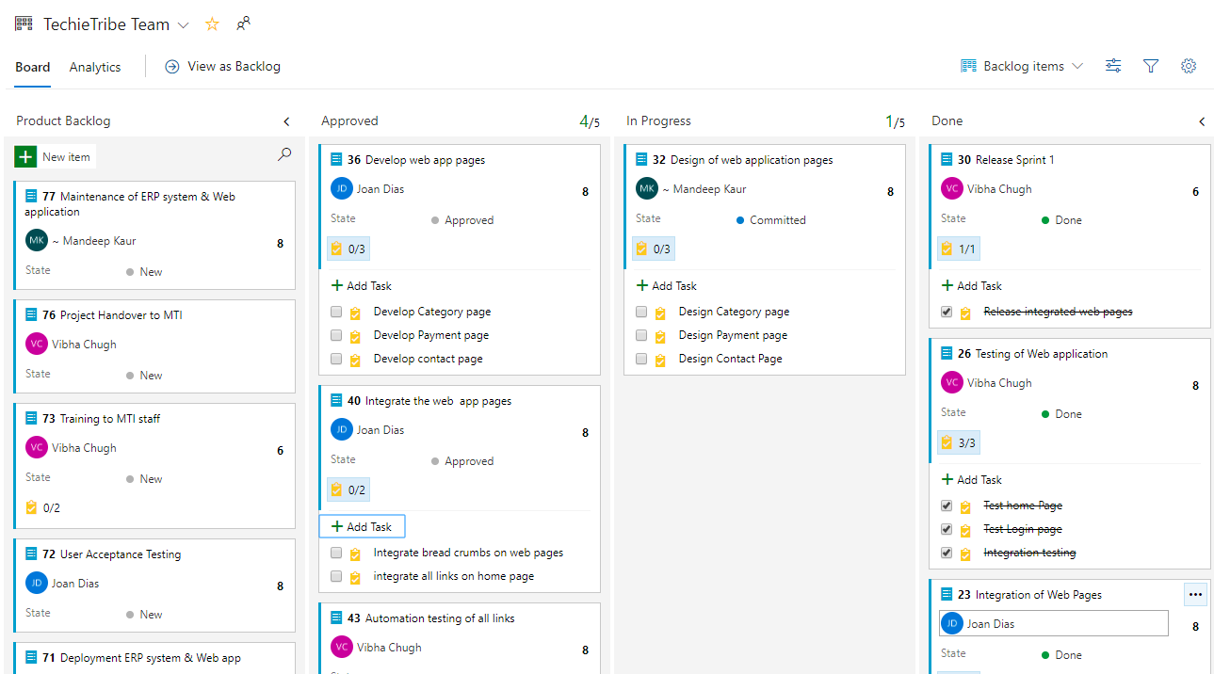

**Sprint 1 Completion and Sprint 2 progress**