**3D imaging in-vitro embryos**

**Mikel Zwarthoed, Luuk Gooijer, Malina Matricala, Andrei Ionita, Yoan Popov, Traian Dobrin**

E-mail: [mzwarthoed@tudelft.nl](mailto:mzwarthoed@tudelft.nl) , [lrgooijer@tudelft.nl](mailto:lrgooijer@tudelft.nl), [mmatricala@tudelft.nl](mailto:mmatricala@tudelft.nl), [aionita@tudelft.nl](mailto:aionita@tudelft.nl), [ypopov@tudelft.nl](mailto:ypopov@tudelft.nl), [tdobrin@tudelft.nl](mailto:tdobrin@tudelft.nl)

**Abstract**

The EmbryoScope™ is a widely employed time-lapse incubator in IVF to enable embryo development recordings. Although excellent for two-dimensional (2D) imaging, it cannot produce a three-dimensional (3D) model. Thus, it limits the ability to accurately quantify important embryo parameters, including cell volume, cell symmetry, and cell fragmentation, important determinants of embryo viability and implantation potential. To overcome this limitation, we propose a computational framework to create 3D digital models by reconstructing them from 2D images taken at 11 different focal planes over an axial range of ±75 µm. Images taken at the different focal planes were subjected to preprocessing to remove noise and focus on relevant features before binary masks were created for segmentation. To create volumetric models, these binary masks were stacked together utilizing a specified thickness. To obtain an approximate measurement of embryo volume, we performed volume estimation based on the minimum enclosing circle. Results demonstrated stable diameter (~110 µm in diameter corresponding to ~70e4 µm³ in volume) throughout the first four days of embryonic development. Then, there was a notable increase in the blastocyst size, with diameters of 178–184 µm and volumes of 300–330e4 µm³, compared well with literature. The method also recovered embryo-specific changes, showing that it can monitor developmental trajectories. Though potent, this method struggled with noise, interpolation of angular data, and the underwhelming results of a one-angle image. Suggested improvements include imaging at angles perpendicular to the 3D object to enhance spatial resolution, along with employing advanced interpolation algorithms to improve reconstruction accuracy. This non-invasive approach has the potential to give an accurate volume assessment of adherent cells and thus can be used as a tool to improve embryo selection criteria in IVF. Advancements such as these may allow for more quantifiable and informed choices to be made during embryo grading, potentially allowing for higher levels of success.

***Keywords:*** *IVF, EmbryoScope™, 3D modeling, embryo viability, image processing*

**1. Introduction**

*1.1 Device*

The EmbryoScope™ is an advanced time-lapse incubator designed for continuous monitoring and assessment of embryo development during in vitro fertilization (IVF) procedures. It integrates a high-resolution camera and microscope within a controlled incubation environment, allowing embryologists to observe embryos without disturbing their culture conditions [1].

*1.2 Purpose and Usage*

The primary function of the EmbryoScope is to provide uninterrupted observation of embryos from fertilization until the blastocyst stage. By capturing images at regular intervals, it generates time-lapse videos that offer detailed insights into embryonic development. This continuous monitoring enables embryologists to evaluate key developmental milestones and morphological features, facilitating the selection of embryos with the highest implantation potential.

*1.3 Culture Conditions*

The EmbryoScope maintains a stable and optimal environment for embryo culture. Temperature regulation is achieved through direct heat contact, ensuring precise thermal control. The system also features an integrated gas mixer, allowing for the implementation of reduced oxygen conditions, which can be beneficial for embryo development. Air quality is maintained by continuous purification through HEPA/VOC filters, minimizing the risk of contamination [1].

*1.4 Software and Tools*

EmbryoViewer™ software is utilized in conjunction with the EmbryoScope to review, annotate, and compare embryo development. This software provides a comprehensive platform for analyzing time-lapse data, enabling embryologists to assess developmental kinetics and morphological characteristics effectively. Additionally, decision support tools like KIDScore™ assign objective scores to embryos based on developmental parameters, aiding in the selection process [1].

*1.5 Development stages of an embryo*

After fertilization, the egg is placed in the EmbryoScope for approximately five days to develop into a blastocyst. During this period, the embryo progresses through the first four stages of development. In the first stage, the fertilized egg, or zygote, consists of a single cell enclosed within the zona pellucida, a protective layer measuring 100–150 micrometers in diameter [3]. Within 24 hours, the zygote undergoes its first division, beginning the second stage, known as the cleavage stage. This stage spans days 2 to 4, during which the embryo divides without increasing in overall size, progressing from two to sixteen cells. When the embryo consists of sixteen cells around day 4, the embryo will be called a morula [5]. By day 5, the morula develops into a blastocyst, characterized by the formation of a fluid-filled cavity. Over the next two days, the blastocyst continues to expand, while the zona pellucida starts to disintegrate [7]. On day 6, the embryos undergo a final grading before being removed from the EmbryoScope for transfer, freezing, or further analysis

*1.6 Current limitations and problems*

Currently, the Embryoscope lacks the support for 3D volume measurement, limiting embryologists to analysing embryo growth patterns in 2D. This restricts the ability to obtain more precise insights into embryo development.

The goal of this study is to explore the feasibility of creating a 3D model with the existing 2D data collected by the Embryoscope in a manner that’s as unsupervised as possible, meaning no additional labels that aid in object detection will be added to the 2D data. A 3D model would allow for accurate cell volume estimation throughout embryo development and it would provide a more intuitive 3D representation of the embryo. This would offer valuable insights into embryo quality and enable for better correlation of growth patterns with potential successful pregnancies.

**2. Methodology / Algorithm design**

*2.1 Data collection*

The first step in building the 3D model is gathering the 2D data of the embryos. To most accurately track the growth of the embryo it is imaged across all eleven focal planes. Ranging from -75 to +75 µm from the center plane. This is done every ten minutes to enable it to quickly observe cell divisions. The images used in this paper were provided by the Fertility Centre Vrijburg and document two embryos from day 1 to day 5. Focal planes are equidistant (15 microns), while the voxel resolution in x and y is 3 microns per pixel [2].

*2.2 Image preprocessing*

After the collection of the 2D images, the preprocessing begins. The preprocessing of the images is necessary to simplify the images for the algorithm by reducing the noise, while enhancing the relevant information, such as edges. Furthermore, preprocessing standardizes pixel output, which reduces the computational load of the algorithm.

The first step of this process involves applying a blurring effect to the outer portions of the image. The focus of the center of the image containing the embryo is maintained, while the noise of outer regions is suppressed (see Fig. 1). The image is then processed with a high-frequency Laplacian filter. By Laplacian filtering the image, the areas of rapid intensity changes are highlighted, such as the edges. To further enhance edge detection, the directional information of the intensity changes are eliminated by converting all outputs of the Laplacian filter to their absolute values. This process helps simplify the image by reducing directional gradients, which can amplify noise or create artifacts.

*Fig 1.*  *Left is the reference image, right is the preprocessed version*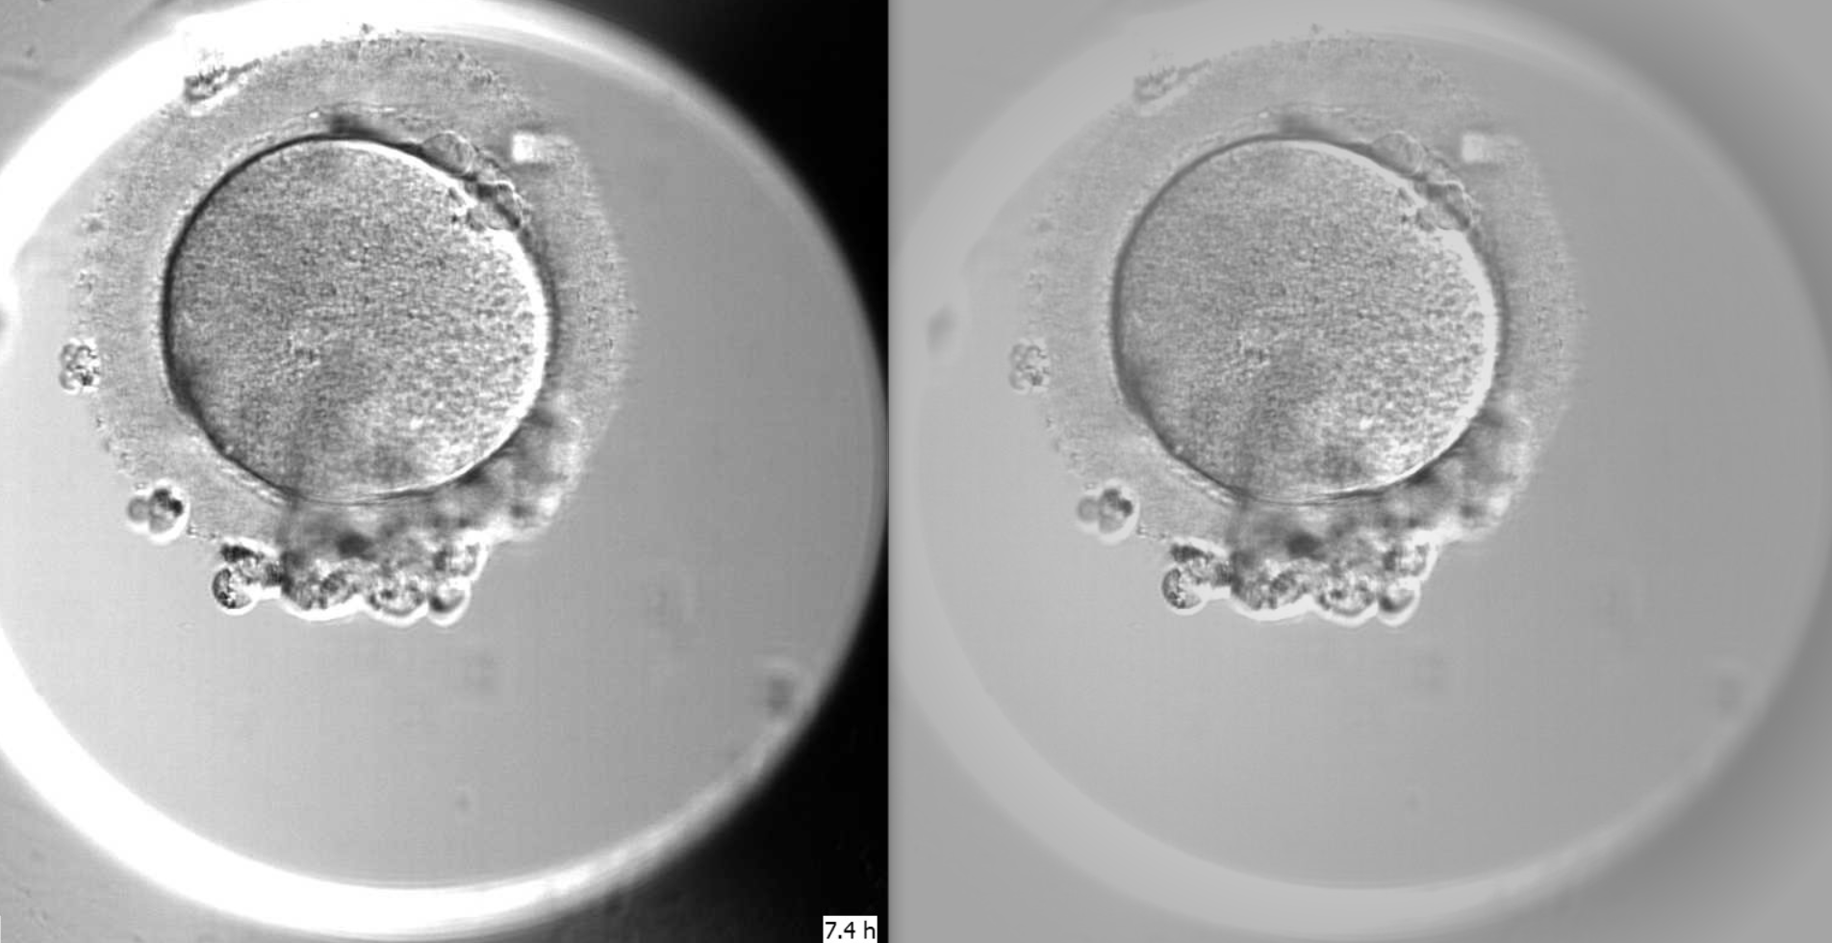

*2.3 Parameter optimization*

To optimize the preprocessing of the images, a sweet spot has to be found between reducing noise while keeping as much relevant information as possible. To determine this sweet spot, 900 combinations of the following parameters were tested:

Laplacian kernel size: [1,3,5,7,9]

Laplacian threshold: [40,50,60,70,80,90]

Dilation kernel size: [(1,1), (2,2), (3,3), (4,4), (5,5)]

Dilation iterations: [1,2,3,4,5,6]

To find the best set of parameters, a metric has to be determined to measure the sets. The goal is to find a set which is consistent and accurate.

To test this, it is assumed that the diameter of the middle focal plane is consistent over the first four days, since during this period the embryo develops inside the zona pellucida without expanding [5]. Based on this assumption, the first submetric is defined as the difference between the initial diameter and the current diameter, with smaller differences indicating better consistency. The second submetric measures the change in diameter between consecutive runs, where parameter sets with gradual changes score higher than big jumps in diameter. The formulas for both metrics can be defined as follows:

1. current_to_initial_sum =

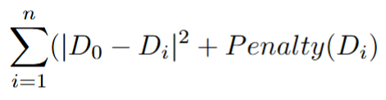

, where n=amount_of_runs, Di is the i-th diameter

Objective: minimize sum

1. pairwise_sum =

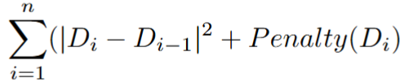

, where n=amount_of_run, Di is the i-th diameter

Objective: minimize sum

1. Penalty(Di):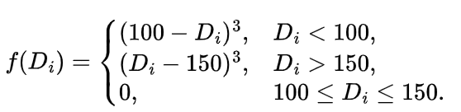

The 900 combinations are applied to the first 50 runs, equalling about the first 8-9 hours of embryo images, to minimize the computational load. The penalty applied aims to incentivize diameter results in the [100, 150] range which is the expected range for embryos throughout the first day of development [5].

All the results are normalized using inverted min-max scaling, where metric sums closest to 0 would lead to a higher min-max score (closer to 1), indicating better performance. These scaled results are then multiplied by 100 and the two submetrics are summed. Lastly, the top ten highest-scoring combinations are presented.

*2.4 Volume Reconstruction*

After the preprocessing a binary mask is created by converting all pixels with intensities above the laplacian threshold parameter to 255(white), and converting those below it to 0 (black). This segmentation separates the embryo (white) from the background(black). To refine the mask, the algorithm utilizes morphological operations (dilation and closing) to connect nearby points and fill holes. The regions of interest are then outlined with a gray (128) value, which would be needed for the 3D reconstruction in order to ensure separation between foreground and background.

Once all the masks for each focal plane are made, each is assigned a thickness of 15µm and then they are stacked in order. This process creates a 3D model of the embryo, using its 2D data.

*2.5 Volume estimation*

To assess the 3D model a rough estimate of the volume of the 3D model is made. For specific focal planes ([-15, +30] microns), the algorithm looks at the average distance between points on the outline of the largest region of interest and its minimum enclosing circle, alongside area ratios between that region and the enclosing circle (see Fig. 2). Both are normalized and scored (much like the inverted min-max system described above) to determine the object's diameter The volume is then calculated using the volume of a sphere, where the radius is the approximate 50 diameter divided by two. This method provides a plausible approximation of the volume, making it a useful benchmark for testing the accuracy of the 3D model.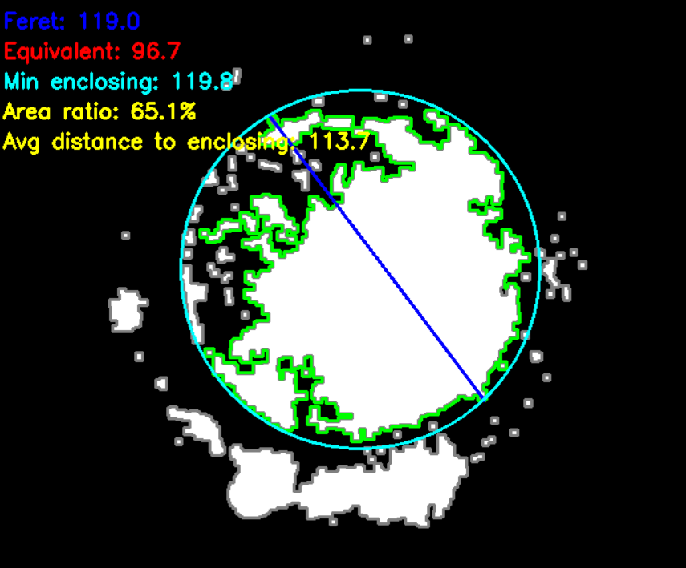

*Fig 2. Enclosing circle around the contour*

**3. Results**

*3.1 3D model visualization*

In order to visualize the stacked 2D data derived in the previous section the PyVista library in the programming language Python was utilised. This library is GPU-accelerated, meaning it can provide a smooth visualization alongside zoom in/out, rotate, and pan features. We have also added checkboxes for showing/hiding specific focal planes (see Fig. 3 and 4). The algorithm used for creating the 3D mesh is Marching Cubes.

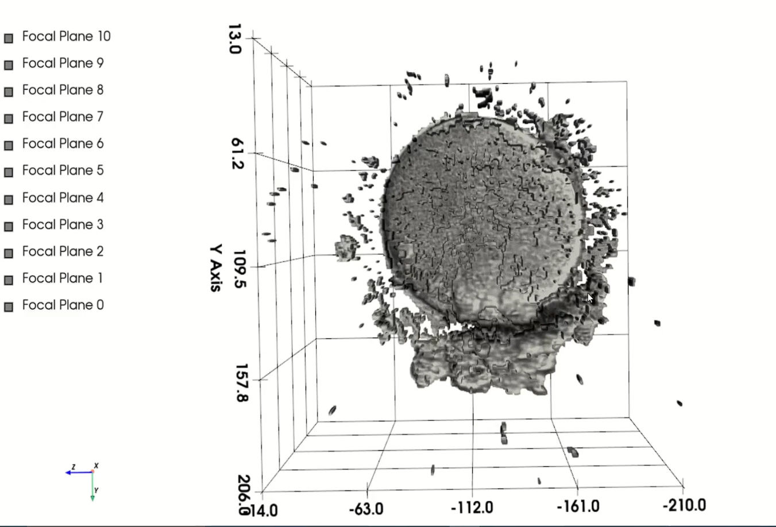

*Fig 3. 3D model, all planes visible*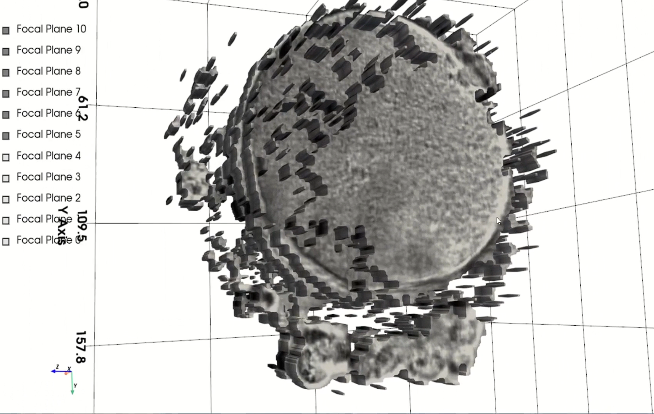

*Fig 4. 3D model, specific planes visible*

*3.2 Volume progression*

To track the volume of the 3d model, a graph of its progression is made (see Fig. 5). The figure plots the volume against the runs, with values averaged over every five runs. Each run corresponds to an image set, which consists of all 11 focal planes, taken in 10-minute intervals. The graph shows the volume staying roughly constant throughout the first four days (576 runs). For these four days, the volume is around 70e4 µm3, with a diameter of approximately 110µm. The results align with the diameters found in literature [3], with deviations in the graph being explained by captured noise. Another thing that influences the results is the movement of the embryo, as the preprocessing (mainly blurring) assumes a constant position for all runs, which results in parts of the embryo being blurred out for a small subset of runs. Following the period of constant volume, the formation of the blastocyst is marked by the expansion seen from run 575 to the final run. Topping out around 300-330e4 µm3, which corresponds to a diameter of 178-184µm. A decrease in volume is then observed after run 630, which is also visible in this embryo’s corresponding images. This decrease seems to be specific to the embryo, since the other embryos do not necessarily show a decrease in volume around this period. However, it further showcases the algorithm's ability to correctly track the volume of the embryos.

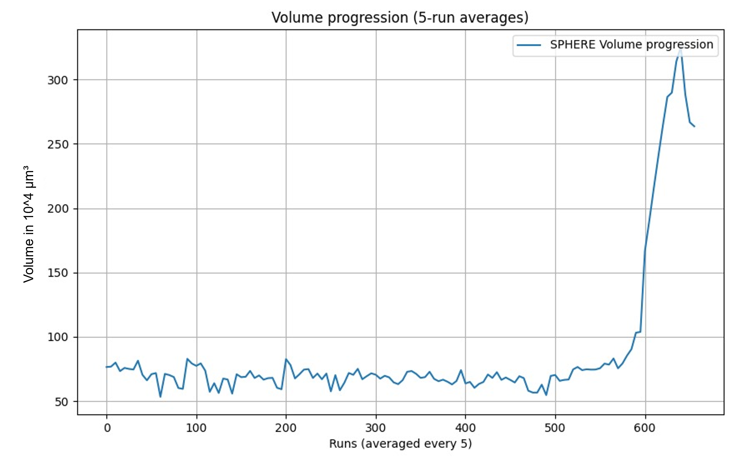

*Fig. 5 Volume progression of embryo 3D model (5 run averaged)*

**4. Discussion**

To summarize, it was possible to design an algorithm, which made a 3D model of the embryo in vitro. This was done by creating a mesh using the 11 different focal planes available. This is done by repeating the images for 15 microns until the next focal plane.

One idea about how this could be improved would be by writing an algorithm that interpolates the two images over the distances. This would mean creating additional in-between artificial slices, created by averaging data from the closest real slices to try to approximate the real volume between them. However, there is a lot of noise around the embryos, so the exact edges of the embryo are not very well defined. First and foremost, the presence of significant noise surrounding the embryos complicates the edge detection process. Accurate edge detection is crucial for effective interpolation, as it relies on well-defined boundaries to estimate intermediate values. In noisy environments, the edges can become blurred and indistinct, making it difficult for the algorithm to determine where the actual boundaries of the embryo lie. Without clear edges, the interpolated images may inaccurately represent the structure, leading to distorted or misleading 3D models. Additionally, interpolating between focal planes assumes a level of continuity in the data that may not exist in noisy images. If the noise significantly alters the image across different planes, the interpolated results may fail to maintain geometric fidelity and anatomical accuracy. Embryos can exhibit diverse shapes and structures due to natural variation, growth dynamics, or developmental stages. This biological variability can further complicate interpolation, as it may require the algorithm to account for unique geometrical features that are between the initial real slices that cannot be generalized across the sample.

Another option would be to increase the number of focal planes available in the machine, which would aid in solving the interpolation problem, as spatial loss, and therefore the need for spatial interpolation, will not be as significant.

Another limitation of the machine was the single angle at which the machine made 2D pictures. Having a second camera making pictures at a perpendicular angle to the first camera, would greatly improve the accuracy of the 3D model As there would be a whole new axis available to map with the camera. These images at a perpendicular angle would provide the information needed to make an accurate interpolation method for the images from the other angle, which in itself results in a more accurate 3D model. This method of capturing data from multiple angles to create a 3D model is already used in CT scanners [8].

The embryos are extremely sensitive to external factors, such as temperature change, growth environment, radiation or light exposure. And if the embryos are exposed too much to such factors there is a big chance of a stop in development. Hence, there are not a lot of options for other plausible 3D imaging methods(CT scans, Ultrasounds, MRIs) without disturbing the embryos, besides the current method of taking pictures at different focal planes. There are some research papers [9, 10], where alternative methods such as High-resolution transcriptomics [9] or high resolution Ultrasound [10] are used, but these are only used in later stages of the embryonic development stages.

In conclusion, while the current method lays a solid foundation for 3D modeling of embryos in vitro, significant improvements are necessary to overcome challenges like noise, unclear edges, and limited spatial data. Refining the algorithm with additional parameters and preprocessing could enhance the stability and reliability of the results, but the current version still faces limitations. Access to more comprehensive data, such as multi-angle images or a greater number of focal planes, would be crucial for improving model accuracy. Alternative methods, such as using convolutional neural networks, offer promising solutions but require substantial, high-quality datasets and extensive training. Continued research and development in these areas, along with exploring new imaging techniques, will be essential for creating more reliable and precise 3D models of embryos in vitro. Ultimately, addressing these challenges could be key to advancing the field and enabling more accurate embryo analysis.

**Acknowledgements**

We would like to thank Aimée Sakes, John van den Dobbelsteen, dr. Evert Santbrink and Masia Moschopoulou for the support and gathering of the embryo data.

**References**

1. Vitrolife, "EmbryoScope+ Time-Lapse System,". [Online]. Available:<https://www.vitrolife.com/products/time-lapse-systems/embryoscopeplus-time-lapse-system/>
2. Vitrolife, *EmbryoScope+ User Manual*, Section 10: Technical specifications, Subsection: Embryo images. [Online]. Available:<https://www.vitrolife.com/globalassets/support-documents/product-manuals/EmbryoScope_Plus_User_Manual_en-gb.pdf>

[3] Endowment for Human Development, "Carnegie stage 1-4," *The Endowment for Human Development*. [Online]. Available:<https://www.ehd.org/developmental-stages/stage1.php>. [Accessed: Jan. 21, 2025].

[4] M. Cruz, N. Garrido, J. Herrero, I. Pérez-Cano, M. Muñoz, and M. Meseguer, "Timing of cell division in human cleavage-stage embryos is linked with blastocyst formation and quality," *Reproductive BioMedicine Online*, vol. 25, no. 4, pp. 371–381, 2012. [Online]. Available: <https://doi.org/10.1016/j.rbmo.2012.06.017>

[5] Khan Academy & Association of American Medical Colleges (AAMC), 2014, *Overview of the IVF process*, YouTube video, accessed 22 January 2025,<https://www.youtube.com/watch?v=dAOWQC-OBv0>.

[6] Progyny, 2022, *IVF Procedure Step by Step - Part 3*, YouTube video, accessed 22 January 2025,<https://www.youtube.com/watch?v=xNmX3tBeC58>.

[7] Merrion Fertility Clinic, "Understanding Embryo Grading," [Online]. Available: https://merrionfertility.ie/understanding-embryo-grading/.

<https://docs.opencv.org/4.x/d9/d61/tutorial_py_morphological_ops.html>

<https://onlinelibrary.wiley.com/doi/full/10.1002/bdrc.20023> (cant open it with tu delft account but seems promising)

<https://link.springer.com/article/10.1186/s13326-015-0034-0>

[8] CT (Computed Tomography) Scanners

Rigaku Corporation, “How does CT reconstruction work?” *Rigaku.com*. [Online]. Available: <https://rigaku.com/products/imaging-ndt/x-ray-ct/learning/blog/how-does-ct-reconstruction-work> [Accessed: Jan. 23, 2025].

[9] Cell, “3D reconstruction of a gastrulating human embryo.” [Online]. Available: [3D reconstruction of a gastrulating human embryo - ScienceDirect](https://www.sciencedirect.com/science/article/pii/S009286742400357X) [Accessed: Jan. 22, 2025]

[10] Turkish-German Gynecological Association, “Three-dimensional ultrasonography by means of HDlive rendering in the first trimester of pregnancy: A pictorial review.” [Online]. Available: [Three-dimensional ultrasonography by means of HDlive rendering in the first trimester of pregnancy: A pictorial review - PMC](https://pmc.ncbi.nlm.nih.gov/articles/PMC4922723/) [Accessed: Jan. 22, 2025]