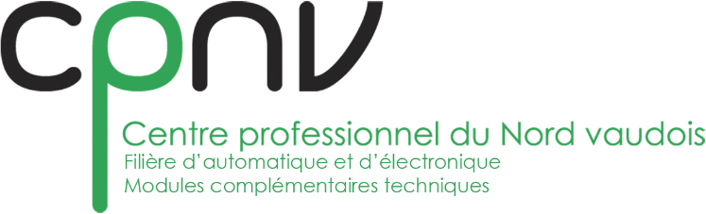

|  |
| --- |
| CPNV |
| Template |
| P1704_Manettes |

|  |
| --- |
| PICOTTE Alexandre  20/04/2018 |