# Skylight接口文档

注：以下请求例子都是模拟的数据，实际不存在，请勿以此为请求数据向后台发送，数据请以实际为准

## 博客相关

### 显示所有博客

<http://127.0.0.1:8861/blog/showAll>

response: {

"status": 200,

"msg": "success",

"data": [

{

"id": "5a56630c-1ba2-4d9f-a6d5-8d0293c20248",

"authorname": "Tom",

"authorid": "1",

"visablelevel": 1,

"coverid": "10010",

"title": "title",

"pageviews": 0,

"time": "2018-10-26T10:45:03.000+0000",

"praise": 0

}

]

}

### 上传博客

http://127.0.0.1:8861/blog/publish

request:{

“authorId”:1,

“authorName”:”Tom”,

“coverId”:”11111111”,

“title”:”title”,

“visualLevel”:0/1/2/3

“text”:”<p>aaaa</p>”

}

Response:{

“status”:”200”,

“message”:”success”

“data”:null

}

### 显示博客内容

<http://127.0.0.1:8861/blog/text/blogId>

Request: {

"id":"daa12f48-76b8-4f97-9e98-689f022aeedb" //此处为博客id

}

Response: {

"status": 200,

"msg": "success",

"data": {

"blogid": "daa12f48-76b8-4f97-9e98-689f022aeedb",

"text": "<p>的大幅度反对法<br/></p>"

}

}

### 显示博客信息

<http://127.0.0.1:8861/blog/find>

Request：

{

"blogId":"1"

}

Response：

{

"status": 200,

"msg": "success",

"data": {

"id": "1",

"authorName": "Tom",

"authorId": "1",

"visableLevel": 0,

"coverId": null,

"title": "",

"pageViews": 1,

"time": null,

"praise": 1,

"comments": 1,

"summary": null

}

}

### 封面上传接口

http://127.0.0.1:8861/file/coverUpload

//此接口采用表单方式上传

Request：

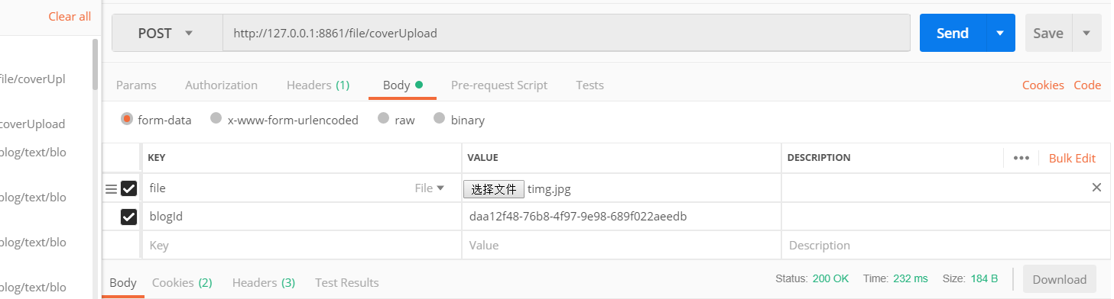

Response：{

"status": 200,

"msg": "upload successfully",

"data": null

}

### 博客点赞

http://127.0.0.1:8861/blog/praise

Request：

{

"user1Id":"2",

"user2Id":"1",

"blogId":"1"

}

Response：

{

"status": 200,

"msg": "success",

"data": null

}

### 取消点赞

<http://127.0.0.1:8861/blog/cancelPraise>

Request：

{

"user2Id":"be7338d04ba94b539f1f9523ee519d27",

"blogId":"1"

}

Response：

{

"status": 200,

"msg": "success",

"data": null

}

### 评论博客

http://127.0.0.1:8861/comment/addToBlog

Request：

{

"userId":"2",

"blogId":"1",

"content":"对博客1的评论"

}

Response：

{

"status": 200,

"msg": "success",

"data": null

}

### 增加浏览量

<http://127.0.0.1:8861/blog/view>

Request:

{

"blogId":"1"

}

Response：

{

"status": 200,

"msg": "success",

"data": null

}

### 根据作者的id获取所属博客

<http://127.0.0.1:8861/blog/author>

Request：

{

"authorId":"1"

}

Response：

{

"status": 200,

"msg": "success",

"data": [

{

"id": "1",

"authorName": "Tom",

"authorId": "1",

"visableLevel": 0,

"coverId": "palace.jpg",

"title": "文章1",

"pageViews": 1,

"time": "2018-11-05T16:12:28.000+0000",

"praise": 1,

"comments": 2,

"summary": "这是一个简介1",

"sessionId": "story"

}

]

}

### 获取用户收到的评论

<http://127.0.0.1:8861/comment/user>

Request：

{

"userId":"1"

}

Response：

{

"status": 200,

"msg": "success",

"data": [

{

"reviewerId": "be7338d04ba94b539f1f9523ee519d27",

"blogName": "搜索1",

"beCommentId": "f625f087-df02-4706-be87-a32343c96f11",

"userId": "1",

"content": "测试对用户评论",

"toBlogFlag": 0,

"reviewerName": "smh",

"reviewerCover": null,

"user2Id": "be7338d04ba94b539f1f9523ee519d27",

"id": "7f26ef15-ea44-4c85-bc29-f44f319df1da",

"time": "2018-11-20T04:50:03.000+0000",

"blogId": "1",

"beCommentContent": "测试对博客评论2"

},

{

"reviewerId": "be7338d04ba94b539f1f9523ee519d27",

"blogName": "搜索1",

"beCommentId": "35e80d6a-8123-415e-accc-a2a297ae44e0",

"userId": "1",

"content": "测试对用户评论",

"toBlogFlag": 0,

"reviewerName": "smh",

"reviewerCover": null,

"user2Id": "be7338d04ba94b539f1f9523ee519d27",

"id": "a16880cb-c7e3-4741-8c46-b039805e52ed",

"time": "2018-11-20T04:41:09.000+0000",

"blogId": "1",

"beCommentContent": "对博客1的评论"

} ]

}

### 更改投稿专栏信息

<http://127.0.0.1:8861/blog/contribute>

Request：

{

"id":"1",

"sessionId":"story",

"time":"2018-10-30"

}

Response：

{

"status": 200,

"msg": "success",

"data": null

}

### 返回点赞列表

<http://127.0.0.1:8861/praise/author>

Request：

{

"authorId":"76189973d5834a128a112631d4030f9f"

}

.

Response：

{

"status": 200,

"msg": "success",

"data": [

{

"user2Id": "be7338d04ba94b539f1f9523ee519d27",

"id": "0eea47f7-8e1c-4700-bdae-fbdc1397f132",

"time": "2018-11-23T03:37:02.000+0000",

"user1Id": "76189973d5834a128a112631d4030f9f",

"praiserName": "smh",

"blogId": "1",

"blogTitle": "搜索1"

}

]

}

## 作者相关

### 上传头像

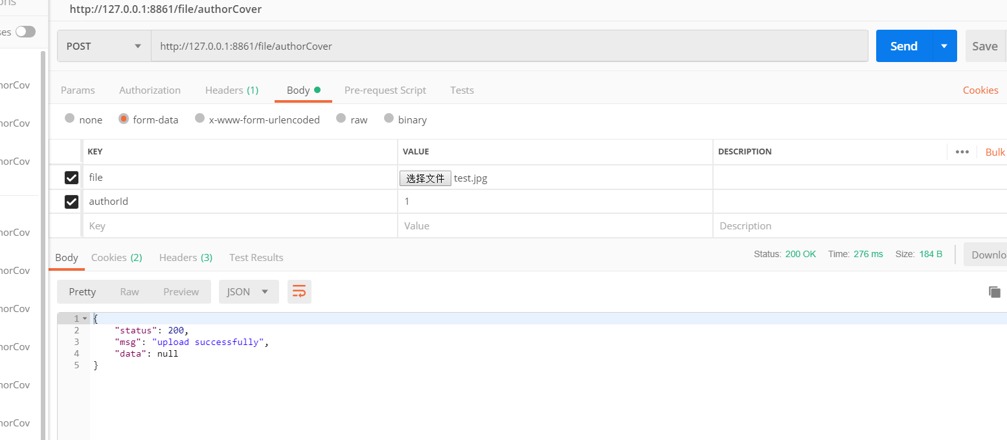

### 更新作者信息

<http://127.0.0.1:8861/author/setInfo>

Request：{

"id":"1",

"name":"Tom",

"sex":"1", //0代表女，1代表男，2代表保密

"intro":"I'm Tom"

}

Response：成功

{

"status": 200,

"msg": "success",

"data": null

}

失败

{

"status": 404,

"msg": "该作者不存在",

"data": null

}

备注：当前数据库中有Tom（id为1）

### 获取作者信息

http://127.0.0.1:8861/author/getInfo

Request：

{

"authorId":"1"

}

Response：

成功：

{

"status": 200,

"msg": "success",

"data": [{

"id": "1",

"name": "Tom",

"concernTotal": 0,

"praiseTotal": 0,

"articleTotal": 0,

"commentTotal": 0,

"sex": 1,

"intro": "I'm Tom",

"userId": "1",

"fans": 0

},{

]

}

失败：

{

"status": 404,

"msg": "该作者不存在",

"data": null

}

## 点赞相关

### 根据作者id获取点赞信息

<http://127.0.0.1:8861/praise/author>

Request：

{

"authorId":"1"

}

Response：

{

"status": 200,

"msg": "success",

"data": [

{

"user2Id": "1",

"id": "1",

"time": "2018-11-12T15:58:18.000+0000",

"user1Id": "2",

"blogId": "10",

"blogTitle": "文章10"

},

{

"user2Id": "1",

"id": "88a9a7e5-cd7f-4ed2-b157-4935f858fb46",

"time": "2018-11-17T05:24:51.000+0000",

"user1Id": "2",

"blogId": "1",

"blogTitle": "文章1"

}

]

}

### 判断当前用户是否对此博客点赞

<http://127.0.0.1:8861/praise/ifPraise>

Request：

{

"blogId":"1",

"user2Id":"1"

}

Response：

{

"status": 200,

"msg": "success",

"data": true

}

## 私信相关(message)

备注：toBlogFlag为1代表是对博客的评论

### 向用户发送私信

<http://127.0.0.1:8861/message/comment>

Request：

{

"user1Id":"1",

"user2Id":"be7338d04ba94b539f1f9523ee519d27",

"content":"测试发送私信"

}

### 获取收到的私信

<http://127.0.0.1:8861/message/receive>

Request:

{

"userId":"1"

}

Response:

{

"status": 200,

"msg": "success",

"data": [

{

"coverId": null,

"authorName": "Tom",

"user2Id": "be7338d04ba94b539f1f9523ee519d27",

"id": "1",

"time": "2018-11-06T03:26:04.000+0000",

"user1Id": "1",

"content": "smh给Tom的私信"

},

{

"coverId": null,

"authorName": "Tom",

"user2Id": "be7338d04ba94b539f1f9523ee519d27",

"id": "97d571aa-4331-4f94-af38-3b0baa985973",

"time": "2018-11-20T03:28:57.000+0000",

"user1Id": "1",

"content": "测试发送私信"

}

]

}

### 获取发出的私信

<http://127.0.0.1:8861/message/send>

Request：

{

"userId":"be7338d04ba94b539f1f9523ee519d27"

}

Response：

{

"status": 200,

"msg": "success",

"data": [

{

"coverId": null,

"receiverName": "smh",

"user2Id": "be7338d04ba94b539f1f9523ee519d27",

"id": "1",

"time": "2018-11-06T03:26:04.000+0000",

"user1Id": "1",

"content": ""

},

{

"coverId": null,

"receiverName": "smh",

"user2Id": "be7338d04ba94b539f1f9523ee519d27",

"id": "1b2bb180-0d1b-470a-81f1-42b82464526f",

"time": "2018-11-20T04:34:20.000+0000",

"user1Id": "1",

"content": "测试发送私信"

},

{

"coverId": null,

"receiverName": "smh",

"user2Id": "be7338d04ba94b539f1f9523ee519d27",

"id": "97d571aa-4331-4f94-af38-3b0baa985973",

"time": "2018-11-20T03:28:57.000+0000",

"user1Id": "1",

"content": "测试发送私信"

}

]

}

### 发送对博客的评论

http://127.0.0.1:8861/comment/addToBlog

Request：

{

"user2Id":"be7338d04ba94b539f1f9523ee519d27",

"content":"测试对博客评论",

"blogId":"1"

}

Response：

{

"status": 200,

"msg": "success",

"data": null

}

### 发送对用户的评论

<http://127.0.0.1:8861/comment/addToUser>

Request:

{

"userId":"1",

"user2Id":"be7338d04ba94b539f1f9523ee519d27",

"content":"测试对用户评论",

"blogId":"1",

"beCommentId":"f625f087-df02-4706-be87-a32343c96f11"//在哪条评论下面的评论

}

Response:

{

"status": 200,

"msg": "success",

"data": null

}

### 获取博客的评论（不包含用户对用户）

<http://127.0.0.1:8861/comment/getByBlog>

Request：

{

"blogId":"1"

}

Response：

{

"status": 200,

"msg": "success",

"data": [

{

"reviewerId": "1",

"beReviewerCover": null,

"userId": "2",

"content": "对博客1的评论",

"toBlogFlag": 1,

"reviewerName": "Tom",

"beReviewerId": "2",

"reviewerCover": null,

"beReviewerName": "Tony",

"user2Id": "1",

"id": "94e6ee58-f35d-4702-acd0-6ffba0caf2e3",

"time": "2018-11-17T05:31:20.000+0000",

"blogId": "1"

},

{

"reviewerId": "1",

"beReviewerCover": null,

"userId": "2",

"content": "对博客1的评论",

"toBlogFlag": 1,

"reviewerName": "Tom",

"beReviewerId": "2",

"reviewerCover": null,

"beReviewerName": "Tony",

"user2Id": "1",

"id": "f695cb90-61ea-4c7d-8321-88c0a9f6ef00",

"time": "2018-11-17T05:30:26.000+0000",

"blogId": "1"

}

]

}

### 获取博客下用户对用户的评论

<http://127.0.0.1:8861/comment//getUserCommentByBlog>

Request：

{

"blogId":"1"

}

Response：

{

"status": 200,

"msg": "success",

"data": [

{

"reviewerId": "be7338d04ba94b539f1f9523ee519d27",

"beReviewerCover": null,

"beCommentId": "f625f087-df02-4706-be87-a32343c96f11",

"userId": "1",

"content": "测试对用户评论",

"toBlogFlag": 0,

"reviewerName": "smh",

"beReviewerId": "1",

"reviewerCover": null,

"beReviewerName": "Tom",

"user2Id": "be7338d04ba94b539f1f9523ee519d27",

"id": "7f26ef15-ea44-4c85-bc29-f44f319df1da",

"time": "2018-11-20T04:50:03.000+0000",

"blogId": "1"

},

{

"reviewerId": "be7338d04ba94b539f1f9523ee519d27",

"beReviewerCover": null,

"beCommentId": "35e80d6a-8123-415e-accc-a2a297ae44e0",

"userId": "1",

"content": "测试对用户评论",

"toBlogFlag": 0,

"reviewerName": "smh",

"beReviewerId": "1",

"reviewerCover": null,

"beReviewerName": "Tom",

"user2Id": "be7338d04ba94b539f1f9523ee519d27",

"id": "a16880cb-c7e3-4741-8c46-b039805e52ed",

"time": "2018-11-20T04:41:09.000+0000",

"blogId": "1"

},

{

"reviewerId": "be7338d04ba94b539f1f9523ee519d27",

"beReviewerCover": null,

"beCommentId": "35e80d6a-8123-415e-accc-a2a297ae44e0",

"userId": "1",

"content": "测试对用户评论",

"toBlogFlag": 0,

"reviewerName": "smh",

"beReviewerId": "1",

"reviewerCover": null,

"beReviewerName": "Tom",

"user2Id": "be7338d04ba94b539f1f9523ee519d27",

"id": "824dacf3-1e99-473a-a3c2-a3a71826df0b",

"time": "2018-11-20T03:50:42.000+0000",

"blogId": "1"

}

]

}

## 专栏相关

### 获取所有专栏信息

<http://127.0.0.1:8861/concern/all>

Response：

{

"status": 200,

"msg": "success",

"data": [

{

"id": "draw",

"name": "手绘",

"sessionConcernId": null,

"sessionArticleId": null,

"sessionConcernTotal": 4,

"blogId": null

},

{

"id": "dress",

"name": "穿搭",

"sessionConcernId": null,

"sessionArticleId": null,

"sessionConcernTotal": 12,

"blogId": null

},

{

"id": "english",

"name": "英语",

"sessionConcernId": null,

"sessionArticleId": null,

"sessionConcernTotal": 3,

"blogId": ""

},

{

"id": "food",

"name": "美食",

"sessionConcernId": null,

"sessionArticleId": null,

"sessionConcernTotal": 28,

"blogId": null

},

{

"id": "internet",

"name": "IT互联网",

"sessionConcernId": null,

"sessionArticleId": null,

"sessionConcernTotal": 5,

"blogId": null

},

{

"id": "love",

"name": "爱情",

"sessionConcernId": null,

"sessionArticleId": null,

"sessionConcernTotal": 15,

"blogId": null

},

{

"id": "makeup",

"name": "美妆",

"sessionConcernId": null,

"sessionArticleId": null,

"sessionConcernTotal": 8,

"blogId": null

},

{

"id": "movie",

"name": "电影",

"sessionConcernId": null,

"sessionArticleId": null,

"sessionConcernTotal": 23,

"blogId": null

},

{

"id": "photo",

"name": "摄影",

"sessionConcernId": null,

"sessionArticleId": null,

"sessionConcernTotal": 6,

"blogId": null

},

{

"id": "story",

"name": "故事",

"sessionConcernId": null,

"sessionArticleId": null,

"sessionConcernTotal": 10,

"blogId": null

},

{

"id": "travel",

"name": "旅行",

"sessionConcernId": null,

"sessionArticleId": null,

"sessionConcernTotal": 6,

"blogId": null

}

]

}

### 根据作者或用户获取关注专栏

<http://127.0.0.1:8861/concern/user>

Requset:

{

"userId":"be7338d04ba94b539f1f9523ee519d27"

}

Response:

{

"status": 200,

"msg": "success",

"data": [

{

"sessionId": "story"

}

]

}

### 用户是否关注专栏

<http://127.0.0.1:8861/concern/ifConcerned>

Request：

{

"userId":"33333",

"sessionId":"story"

}

Response：

{

"status": 200,

"msg": "success",

"data": {

"exist": false

}

}

### 添加/取消关注

<http://127.0.0.1:8861/concern/action>

Request:

{

"userId":"be7338d04ba94b539f1f9523ee519d27",

"sessionId":"story",

"action":"add" //action可选项为(add,delete)

}

Response:

{

"status": 200,

"msg": "success",

"data": null

}

## 关注作者相关

### 关注/取消关注作者

<http://127.0.0.1:8861/concernAuthor/action>

Request：

{

"user1Id":"b3f00d8dfe31407c8239287d0ac423e1",

"user2Id":"b3f00d8dfe31407c8239287d0ac423e1",

"action":"add" //同上

}

Response：

{

"status": 200,

"msg": "success",

"data": null

}

### 根据作者获取关注用户

<http://127.0.0.1:8861/concernAuthor/author>

Request：

{

"authorId": "b3f00d8dfe31407c8239287d0ac423e1"

}

Response：

{

"status": 200,

"msg": "success",

"data": [

{

"followerName": "smh",

"followerCover": null,

"time": "2018-11-21T15:35:45.000+0000",

"followerId": "be7338d04ba94b539f1f9523ee519d27"

}

]

}

### 是否关注

<http://127.0.0.1:8861/concernAuthor/ifConcerned>

Request：

{

"user1Id":"b3f00d8dfe31407c8239287d0ac423e1",

"user2Id":"be7338d04ba94b539f1f9523ee519d27"

}

Response：

{

"status": 200,

"msg": "success",

"data": {

"concerned": true

}

}

### 根据用户获取关注的作者

<http://127.0.0.1:8861/concernAuthor/user>

Request:

{

"userId":"be7338d04ba94b539f1f9523ee519d27"

}

Response:

{

"status": 200,

"msg": "success",

"data": [

{

"authorName": "czz",

"authorCover": null,

"time": "2018-11-21T15:35:45.000+0000",

"authorId": "b3f00d8dfe31407c8239287d0ac423e1"

}

]

}