BIT4138: Advanced Cryptography

STUDENT DETAILS
Student Name: Joan Wairimu Muchiri
Admission Number: BSCCS/2024/53575
Course/Class: Bachelor of Computer Science
Unit Code: BIT4138
Unit Name: Advanced Cryptography
Lecturer Name:
Semester/Academic Year: 3.2
Contents
Week 6: Substitution-Permutation Networks (SPN), S-Boxes and Non-Linearity 2
Title 2
Required Evidence 2
Student Reflection 2
Week 7: Block Cipher Cryptanalysis 3
Title 3
Required Evidence 3
Student Reflection 3

Week 6: Substitution-Permutation Networks (SPN), S-Boxes and Non-Linearity

Title
Implementation of a Basic SPN Model and Avalanche Effect Demonstration

Required Evidence

Fig 1: Fig 1: SPN Basic Implementation – terminal output showing key mixing, S-Box substitution, and permutation applied across rounds to encrypt user-entered plaintext
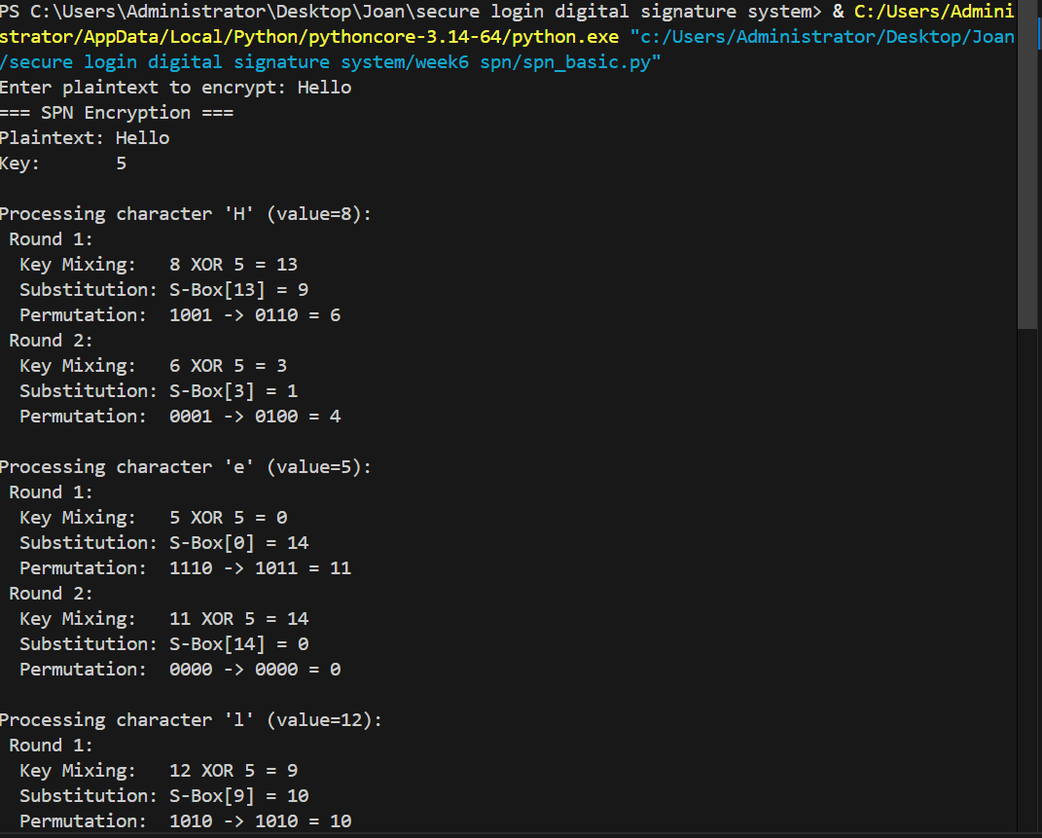

Fig 2: Fig 2: Avalanche Effect Demonstration – two inputs differing by a single bit processed through the SPN, showing a significantly different output and confirming the avalanche effect
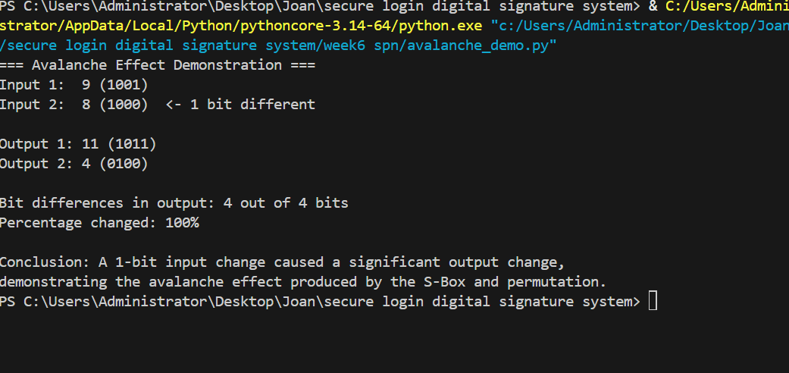

Student Reflection

This week I implemented a basic Substitution-Permutation Network in Python, applying key mixing, S-Box substitution, and permutation across multiple rounds. I learned that SPNs operate on the entire data block at once, unlike Feistel networks which split data into halves. A key challenge was understanding how the S-Box introduces non-linearity, making the cipher resistant to algebraic attacks. Fig 2 demonstrates the avalanche effect, where changing just one bit of input caused a significant change in the output, confirming the strength of the substitution and permutation operations combined. This forms the conceptual foundation for understanding how AES achieves its security.

Week 7: Block Cipher Cryptanalysis

Title
Differential Cryptanalysis Simulation and Mini Cryptanalysis Toolkit

Required Evidence

Fig 1: Fig 1: Differential Cryptanalysis Simulation – two similar plaintexts encrypted and compared, showing the input difference equals the output difference and confirming a weakness in a simple XOR cipher
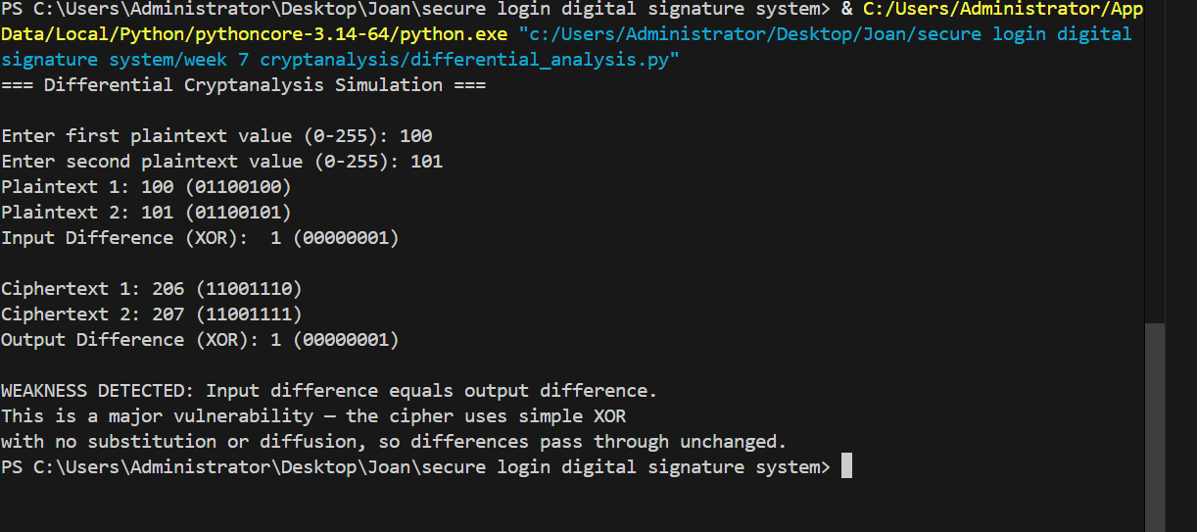

Fig 2: Fig 2: Mini Cryptanalysis Toolkit Output – combined results of frequency analysis, statistical bias calculation, and an algebraic attack that successfully recovers a secret key
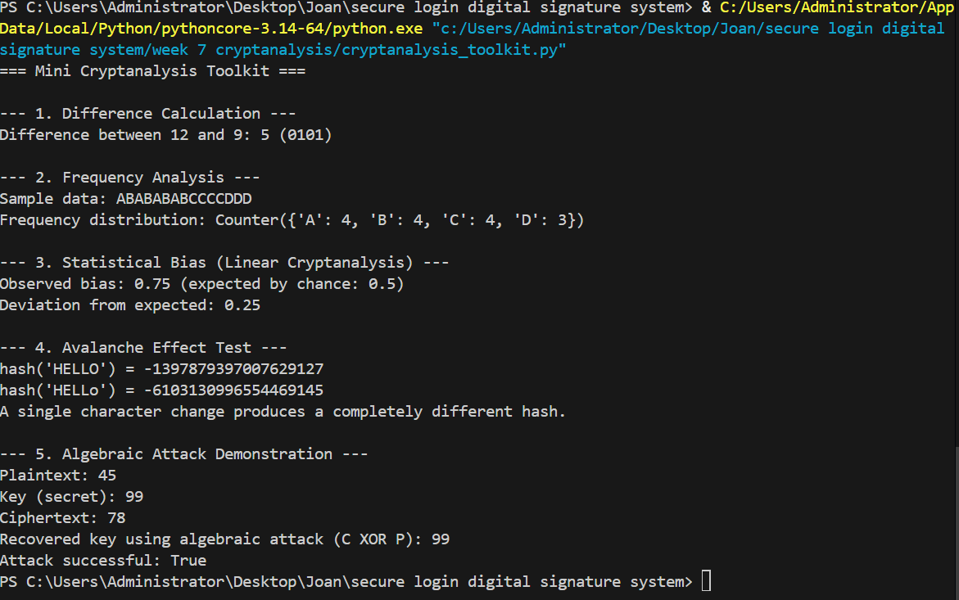

Student Reflection

This week I explored how attackers analyze block ciphers using algebraic attacks, differential cryptanalysis, and linear cryptanalysis. I implemented a differential cryptanalysis simulation that revealed a major weakness in a basic XOR cipher: the input difference between two plaintexts always equalled the output difference, meaning no diffusion was taking place. A challenge was understanding how linear cryptanalysis relies on statistical bias rather than exact equations. The cryptanalysis toolkit in Fig 2 was the most insightful part of the practical, as it showed that a poorly designed cipher allows an attacker to recover the secret key directly using simple algebra. This reinforced why AES uses strong S-Boxes and multiple rounds to resist these exact attack types.

