BIT4138: Advanced Cryptography
Week 8 Assignment 1
PKI Security Incident Report

Student Name: Joan Wairimu Muchiri
Admission Number: BSCCS/2024/53575
Unit Code: BIT4138
Unit Name: Advanced Cryptography
Lecturer:
Semester: 3.2

PKI Security Incident Report: The DigiNotar Breach (2011)

1. Organization Involved
DigiNotar was a Dutch Certificate Authority that issued digital certificates used by government websites and secure communications across the Netherlands. It was acquired by VASCO Data Security International in January 2011, just months before the breach was discovered.

2. Cause of the Incident
In June 2011, an unknown attacker compromised DigiNotar's entire network by exploiting a vulnerability in an outdated public-facing web server. The Fox-IT forensic investigation revealed that DigiNotar had no antivirus protection, used weak administrator passwords, had insufficient logging, and lacked proper network segmentation between public and internal systems. Once inside, the attacker gained full administrative control and issued over 500 fraudulent certificates for major domains including google.com, Mozilla, Microsoft, and various government agencies.

3. Impact on Users
The most serious impact was on Iranian internet users. Fox-IT's investigation identified approximately 300,000 OCSP requests from Iranian IP addresses, indicating the fraudulent certificates were being used to conduct Man-in-the-Middle attacks — intercepting and decrypting citizens' encrypted communications in real time. Dutch government services that relied on DigiNotar certificates were disrupted, and organizations worldwide were forced to replace their certificates urgently when DigiNotar was distrusted by all major browsers.

4. Corrective Actions Taken
- Mozilla, Microsoft, Google, and Apple removed DigiNotar from their trusted CA lists within days of public disclosure, invalidating all DigiNotar certificates globally.
- The Dutch government terminated its contract with DigiNotar and migrated its certificate infrastructure to another CA.
- VASCO Data Security declared DigiNotar bankrupt and shut it down.
- Fox-IT produced a detailed forensic report (Operation Black Tulip) documenting the full timeline and cause of the breach.

5. Lessons Learned for PKI Security
- CAs must implement strong security hygiene — antivirus, strong passwords, proper logging, and network segmentation are non-negotiable for systems that underpin internet trust.
- The CA trust model has a weakest-link problem. This drove the introduction of Certificate Transparency logs, which require all issued certificates to be publicly logged so unauthorized certificates can be detected quickly.
- Incident reporting must be faster. DigiNotar's breach ran for nearly two months before disclosure. Mandatory rapid reporting requirements for CAs would limit damage significantly.
- Critical infrastructure should not depend on a single CA. Diversification reduces the impact of any one CA failure.

Practical Task 1: Certificate Inspection
Using Python's SSL library, a live website certificate was inspected to identify key PKI fields including the issuing CA, subject name, expiry date, TLS version, and cipher suite. This demonstrates how digital certificates function in practice and how PKI information is embedded in real-world HTTPS connections.

Fig 1: Certificate inspection output; issuer CA, subject name, expiry date, TLS version, and cipher suite for google.com
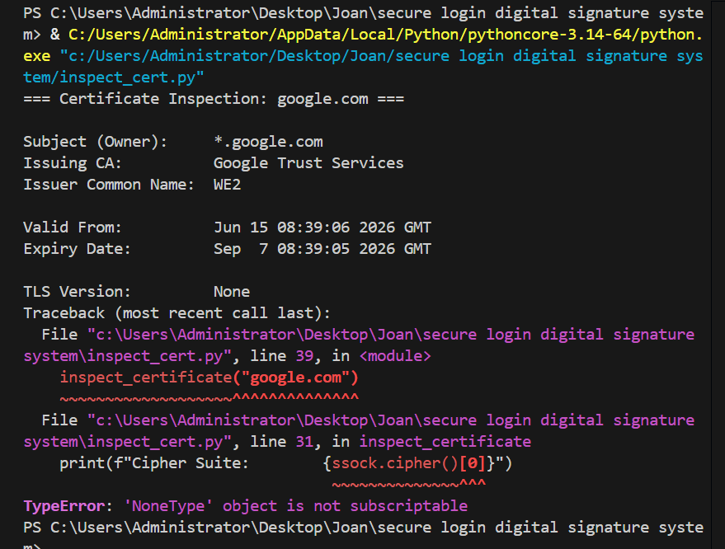

The Role of Diffie-Hellman Key Exchange in Modern Internet Security

1. Definition of Diffie-Hellman
Diffie-Hellman (DH) is a key agreement protocol invented by Whitfield Diffie and Martin Hellman in 1976. It allows two parties to establish a shared secret key over a completely public channel without ever sending the secret itself and without having communicated beforehand. It does not encrypt data directly but rather establishes the shared key that is then used for symmetric encryption such as AES.

2. How the Protocol Works
Both parties agree publicly on a large prime number p and a generator g. Each party independently chooses a private key which they never share. Alice computes her public key A = g^a mod p and Bob computes B = g^b mod p. They exchange these public keys openly. Alice then computes the shared secret S = B^a mod p and Bob computes S = A^b mod p. Due to the mathematical properties of modular arithmetic, both calculations produce the same result without either party ever sending the secret across the network.

Using the handbook example: p = 23, g = 5, Alice's private key = 6, Bob's private key = 15. Alice's public key = 8, Bob's public key = 19. Both independently compute the shared secret as 2.

3. The Discrete Logarithm Problem
The security of Diffie-Hellman relies on the Discrete Logarithm Problem: given g, p, and g^a mod p, finding the exponent a is computationally infeasible when p is a sufficiently large prime (typically 2048 bits or more). Computing g^a mod p in the forward direction is fast and easy. Reversing it has no known efficient algorithm for large enough parameters, making the shared secret unrecoverable for any attacker who observed only the public exchange.

4. Applications in TLS/SSL
Diffie-Hellman is embedded at the core of TLS, which powers HTTPS. During a TLS handshake, DH is used to derive session keys that encrypt all subsequent communication. The most widely used modern variant is Ephemeral Elliptic Curve Diffie-Hellman (ECDHE), which generates fresh DH parameters for every session, providing Perfect Forward Secrecy. This means that even if a server's private key is compromised later, past recorded sessions cannot be decrypted because the ephemeral keys no longer exist. ECDHE is the standard key exchange mechanism in TLS 1.3. DH is also used in SSH, IPsec VPNs, and end-to-end encrypted messaging protocols such as Signal.

5. Security Challenges and Solutions
Man-in-the-Middle Attacks: DH provides no authentication, so an attacker can intercept the exchange undetected. Solution: Combine DH with PKI certificates so each party can verify the other's identity before proceeding.

Weak Parameters: Small prime numbers weaken DH significantly. The Logjam attack (2015) exploited servers using 512-bit export-grade primes. Solution: Use primes of at least 2048 bits or switch to ECDH for equivalent security with smaller key sizes.

Quantum Computing Threat: Shor's Algorithm could theoretically solve the Discrete Logarithm Problem on a sufficiently powerful quantum computer. Solution: Post-quantum cryptographic algorithms are being standardized by NIST as quantum-resistant replacements for DH and RSA.

6. Conclusion
Diffie-Hellman solved one of the most fundamental problems in cryptography — allowing two parties to derive a shared secret without ever sending it. Every HTTPS connection depends either directly on Diffie-Hellman or on principles it introduced. While authentication weaknesses and future quantum threats require ongoing solutions, DH remains one of the most important contributions to modern cryptography and internet security.

Practical Task 2: Diffie-Hellman Key Exchange Implementation
A Python program was developed that accepts public values p and g, allows two users to choose private keys, generates public keys using modular exponentiation, computes the shared secret independently for both parties, and verifies that both arrive at the same value. This directly demonstrates the protocol described in the assignment.

Fig 2: Diffie-Hellman key exchange output; public parameters, private keys, public keys, shared secret computation and match confirmation
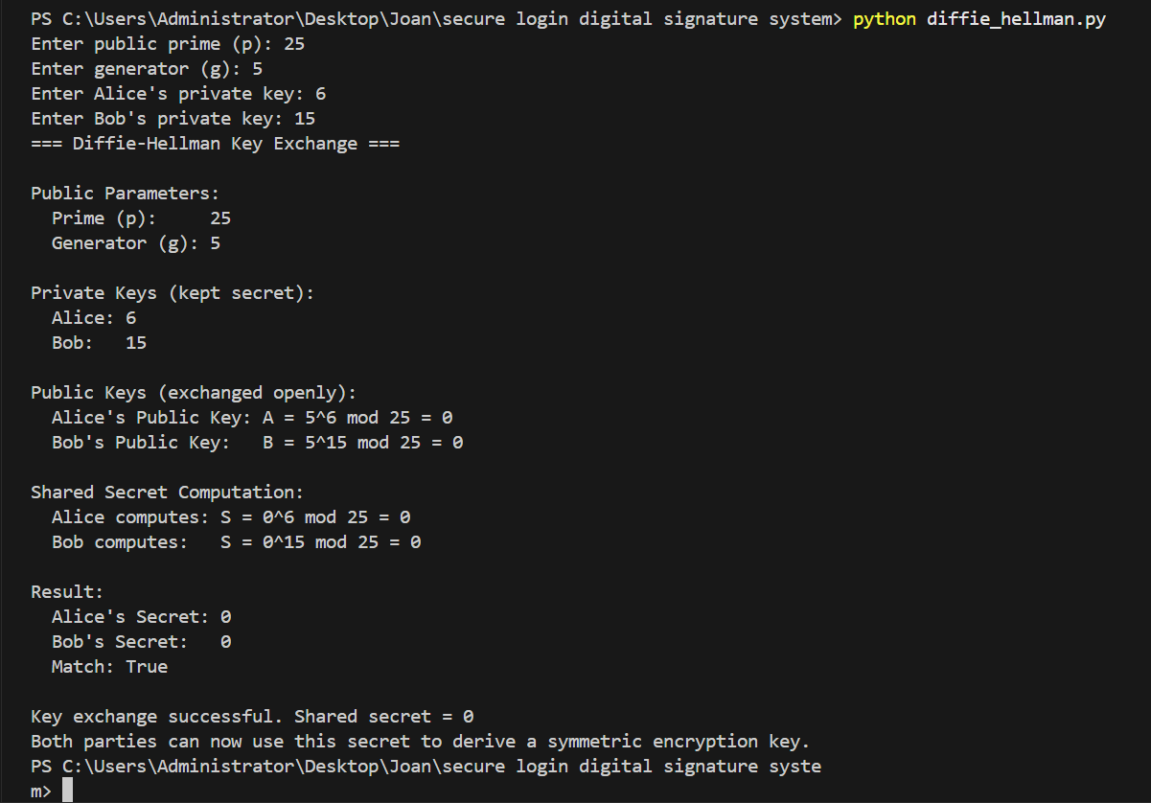

Creative Addition: Man-in-the-Middle Attack Simulation
To demonstrate the main security weakness of Diffie-Hellman, a MITM simulation was built showing an attacker (Eve) intercepting the DH exchange between Alice and Bob. Eve substitutes her own public values, establishing separate shared secrets with each party. Neither Alice nor Bob detects the intrusion, illustrating exactly why DH must be combined with certificate-based authentication in practice.

Fig 3: MITM attack simulation output; Eve intercepting the DH exchange and establishing separate shared secrets with Alice and Bob undetected
