Leader - Younga Jin #301055699

Ilah Song #301056569

Joanna Lu #300916162

Cai Zhang #301003518

COMP122 group Project

DBO (Database Organizer)

Contents

Group Introduction 2

Document Convention 2

Problem Description 2

Housekeepers 3

Clients 3

HR Department 3

CS Department 3

Fact Finding 4

Improvement of Accessibility to the Data 4

Analyzing data for marketing purpose 4

Involved Customer Service 4

Business Rules and Understanding 4

Registration 4

Resource Management 4

Invoice and Payment 5

Database Users 5

User’s Data Requirements 5

Table Relationships 7

ER Diagram 7

Metadata 8

Normalization 10

Scripts 11

# Group Introduction

**Group name**: DBO (Database Organization)

|  |  |  |
| --- | --- | --- |
| **Name** | **Student Number** | **Notes** |
| Younga Jin | 301055699 | Group leader |
| Ilah Song | 301056569 |  |
| Joanna Lu | 300916162 |  |
| Cai Zhang | 301003518 |  |

# Document Convention

|  |  |
| --- | --- |
| **Stakeholders** | |
| Housekeeper | Employees who afford a cleaning service to clients. |
| Client | Customers who pay for cleaning service. |
| HR Department | Human Resource Department. It deals with overall employee management such as housekeepers’ information, salary and so on. |
| CS Department | Customer Service Department. It deals with overall client management such as clients’ requests, payment and so on. |

# Problem Description

Cleaning house is a small housekeeping company. Initially, this small start-up company only uses paper to track the work activities, invoices and to record employees’ and clients’ information, employees’ salary. Now the business is getting popular and the company has more customers and more housekeepers need to manage. The owner of the company decides to digitize the paper works to help them reduce the time they spend on manual work.

Creating a database to track the work activities, managing human resources and invoicing can help the company focus on providing better services.

## Housekeepers

* Housekeepers have to know the cleaning service’s information as location, unit area, service type, schedule and so on. However, it is burdensome to make sure that information about the work is updated on the paper-based system before they start working.

## Clients

* Clients want to know the previous or past service information such as payments, remainders, total price, and so on and to change their service types, schedule and so on. But they may not get the current information since data sharing among the two departments and housekeepers takes time.

## HR Department

* Housekeepers’ personal information such as contact information (address, phone#) and salaries are recorded on paper, it is difficult to organize.
* The HR department should calculate housekeepers’ salaries depending on their work activities and other information. However, it takes a long time since information is recorded on paper. And it is hard to figure out mistakes.

## CS Department

* The CS department is responsible for the payment by clients. However, a paper-based system may cause a long stretch of time and miscalculation.
* When clients ask the CS department about service, the CS department wants to record it and share it with housekeepers simultaneously.

As the rapid growth of Clean House, the company perceives that the problems mentioned above will cause big problems. And they feel the necessity of an efficient data management method. The company expects that data processing efficiency and accuracy with a digitalized system because the HR department and CS department can access and manipulate data together and all of the stakeholders can approach updated data.

# Fact Finding

## Improvement of Accessibility to the Data

In the present system that updated information is not shared between the HR and CS department, therefore, the departments have to send requests to another department frequently when they need information. A digitized data system can support sharing updated and accurate data to every stakeholder.

## Analyzing data for marketing purpose

Helping find out what's the most popular services among the customers, and the company focuses on promoting such service. Understand customers' needs, with tracking records the CS Department, can study when a particular customer needs clean service and take a proactive step to offer such service before they request.

## Involved Customer Service

With the current system, client's payments are recorded by paper, it is easily lost, and it is difficult for the customer service apartment to manage, the new database system will eliminate the problems and helps to track invoicing status easily. The CS Department can write a simple query to find out which invoice hasn't been paid by customers and which housekeeper.

# Business Rules and Understanding

## Registration

The Cleaning House company collects the housekeepers' information into the database when they are hired. Clients' information is collected into the database when they request a cleaning service to the Clean House company. Personal information about housekeepers and clients can be modified. Each service and salary data are recorded and the status of them can be changed.

## Resource Management

The HR department can access and change the housekeepers' information and services’ information. Housekeepers can access themselves' information but cannot modify it directly. The CS department has the privilege to access and change the clients' information and services' data. The CS department can also access the housekeeper's information but they cannot modify it. Housekeepers can only read the clients' information who they work for, however, they are not able to access the clients' personal information such as payment details

## Invoice and Payment

The Clean House has three cleaning options. And the service charge is calculated depending on the type, time and unit area. The CS department calculates the service charge and sends the invoice to the clients. Clients can pay with two different pay options; card and check. The CS department records the option, price, pay date and remainders. The HR department calculates the housekeepers' salaries depending on their hourly wage and hours they worked.

## Database Users

* HR Department
* CS Department
* Housekeepers
* Clients

# User’s Data Requirements

|  |  |  |
| --- | --- | --- |
| **Users** | **Table** | **Fields** |
| CS Department, Clients | Clients | Client ID |
|  |  | First Name |
|  |  | Last Name |
|  |  | Street |
|  |  | City |
|  |  | State |
|  |  | Zip |
|  |  | Phone |
|  |  | Email |

|  |  |  |
| --- | --- | --- |
| **Users** | **Table** | **Fields** |
| HR Department, Housekeepers | Housekeepers | Housekeeper ID |
|  |  | First Name |
|  |  | Last Name |
|  |  | Street |
|  |  | City |
|  |  | State |
|  |  | Zip |
|  |  | Phone |
|  |  | Email |
|  |  | Date Of Entry |
|  |  | Hourly Wage |

|  |  |  |
| --- | --- | --- |
| **Users** | **Table** | **Fields** |
| CS Department, Clients, Housekeepers | Service Types | Service Type Number |
|  |  | Charge Per Unit Area |
|  |  | Service Type Description |

|  |  |  |
| --- | --- | --- |
| **Users** | **Table** | **Fields** |
| CS Department, Clients, Housekeepers | Services | Service Number |
|  |  | Service Type Number |
|  |  | Client ID |
|  |  | Housekeeper ID |
|  |  | Service Date |
|  |  | Service Hour |
|  |  | Unit Area |
|  |  | Pet (‘Y’ or ‘N’) |
|  |  | Status (F/U/C) |

|  |  |  |
| --- | --- | --- |
| **Users** | **Table** | **Fields** |
| CS Department, Clients | Service Payments | Service Payment Number |
|  |  | Service Number |
|  |  | Client ID |
|  |  | Total Price |
|  |  | Payment Option |
|  |  | Payment Status |
|  |  | Remainder |

|  |  |  |
| --- | --- | --- |
| **Users** | **Table** | **Fields** |
| HR Department, Housekeepers | Salary Payments | Salary Payment Number |
|  |  | Housekeeper ID |
|  |  | Payment Date |
|  |  | Total Salary |

# Table Relationships

|  |  |  |
| --- | --- | --- |
| **Table Name** | **Relationship** | **Table Name** |
| Housekeepers | 1:M | Salary Payments |
| 1:M | Services |
| Clients | 1:M | Services |
| Services | 1:1 | Service Payments |
| Service types | 1:M | Services |

# ER Diagram



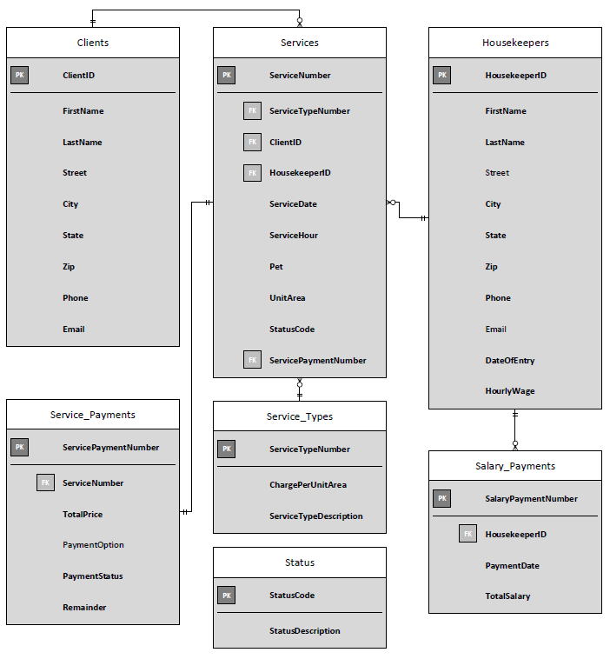

# Metadata

|  |  |  |  |  |
| --- | --- | --- | --- | --- |
| **Table** | **Attributes (Columns)** | **Data Type** | **Constraint Type** | **Required** |
| Clients | ClientID | Number(4,0) | Primary key | Yes |
| FirstName | Varchar2(30) |  | Yes |
| LastName | Varchar2(30) |  | Yes |
| Street | Varchar2(30) |  | Yes |
| City | Varchar2(30) |  | Yes |
| State | Varchar2(2) |  | Yes |
| Zip | Varchar2(6) |  | Yes |
| Phone | Varchar2(12) |  | Yes |
| Email | Varchar2(30) |  | Yes |
| Housekeepers | HousekeeperID | Number(4,0) | Primary key | Yes |
| FirstName | Varchar2(30) |  | Yes |
| LastName | Varchar2(30) |  | Yes |
| Street | Varchar2(30) |  | No |
| City | Varchar2(30) |  | Yes |
| State | Varchar2(2) |  | Yes |
| Zip | Varchar2(6) |  | Yes |
| Phone | Varchar2(12) |  | Yes |
| Email | Varchar2(30) |  | No |
| DateOfEntry | Date |  | Yes |
| HourlyWage | Number(5,2) |  | Yes |
| Service_Types | ServiceTypeNumber | Number(4,0) | Primary key | Yes |
| ChargePerUnitArea | Number(5,2) |  | Yes |
| ServiceTypeDescription | Varchar2(30) |  | Yes |
| Services | ServiceNumber | Number(4,0) | Primary key | Yes |
| ServiceTypeNumber | Number(4,0) | Foreign key | Yes |
| ClientID | Number(4,0) | Foreign key | Yes |
| HousekeeperID | Number(4,0) | Foreign key | Yes |
| ServiceDate | Date |  | Yes |
| ServiceHour | Number(5) |  | Yes |
| UnitArea | Varchar2(12) |  | Yes |
| Pet | Varchar2(1) | Check(Y/N) | Yes |
| StatusCode | Varchar2(1) | Check(F/U/C) | Yes |
| ServicePaymentNumber | Number(4,0) | Foreign key | Yes |
| Service_Payments | ServicePaymentNumber | Number(4,0) | Primary key | Yes |
| ServiceNumber | Number(4,0) | Foreign key | Yes |
| TotalPrice | Number(5,2) |  | Yes |
| PaymentOption | Varchar2(10) |  | No |
| PaymentStatus | Varchar2(1) | Check(Y/N) | Yes |
| Remainder | Number(5,2) |  | Yes |
| Salary_Payments | SalaryPaymentNumber | Number(4,0) | Primary key | Yes |
| HousekeeperID | Number(4,0) | Foreign key | Yes |
| PaymentDate | Date |  | Yes |
| TotalSalary | Number(5,2) |  | Yes |

# Normalization

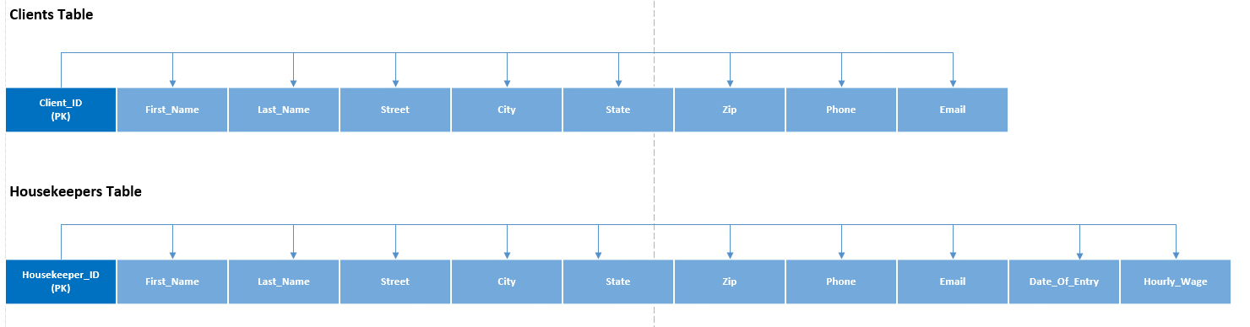

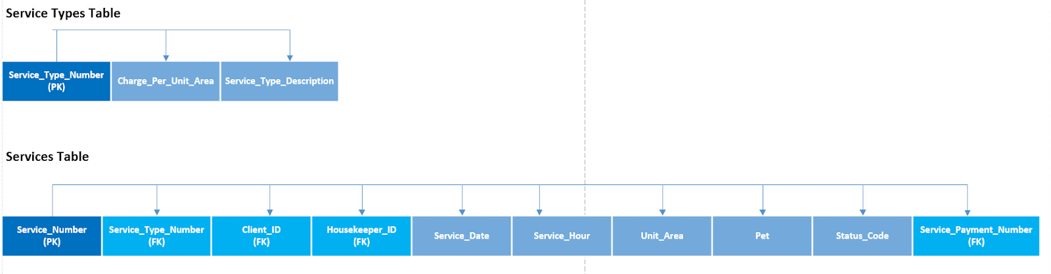

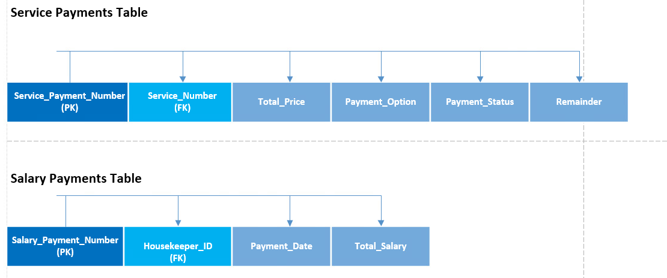

# DDL Scripts



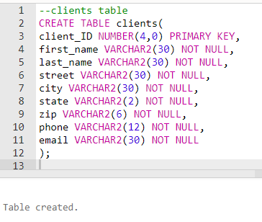

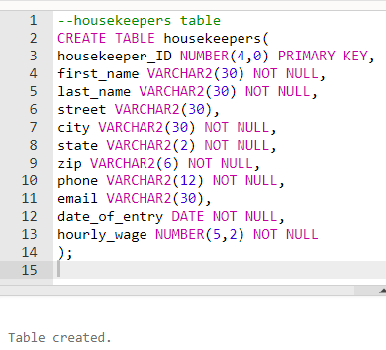

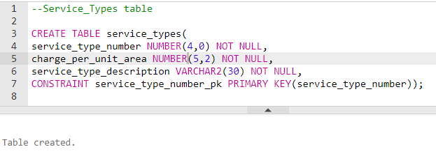

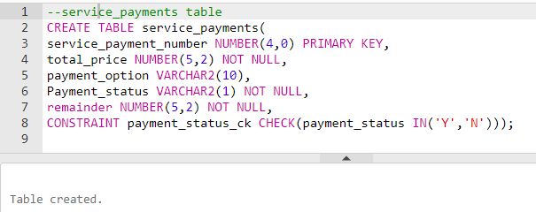

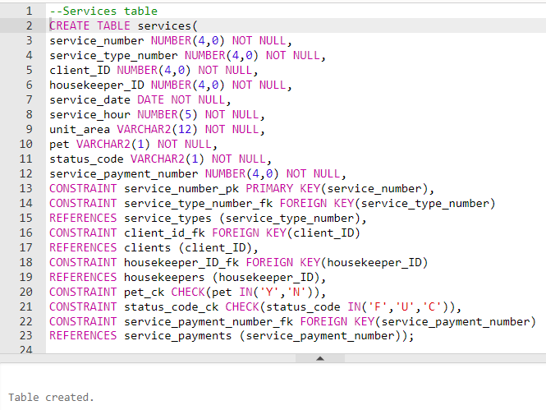

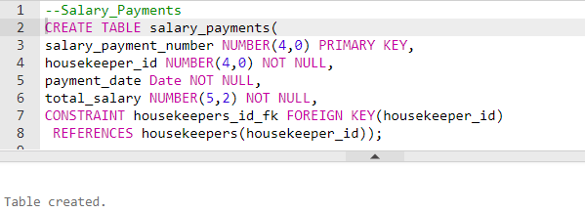

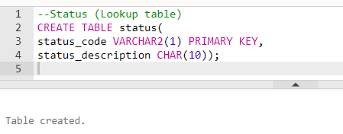

# DML Script



**status table**

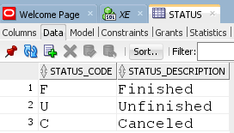

**housekeepers table**

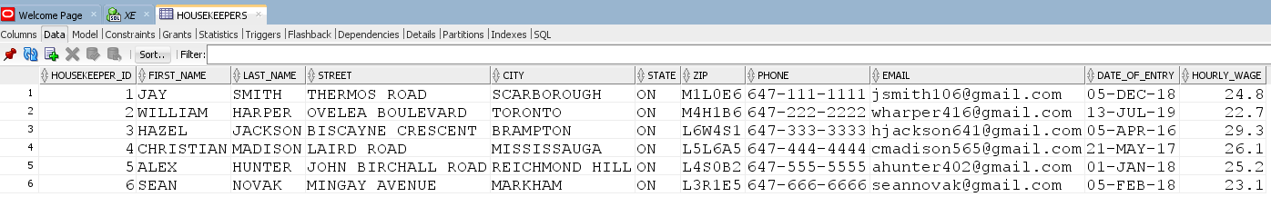

**clients table**

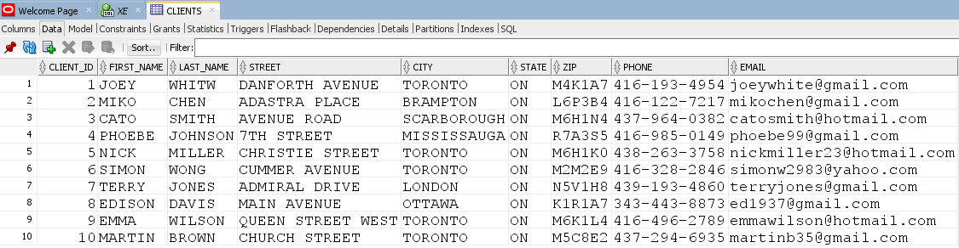

**service_types table**

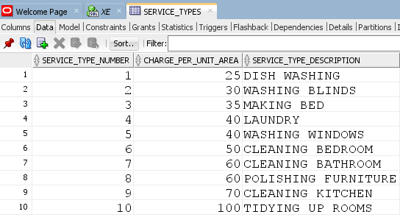

**service_payments table**

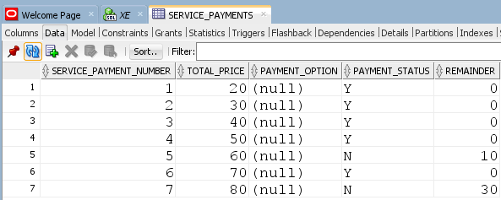

**services table**

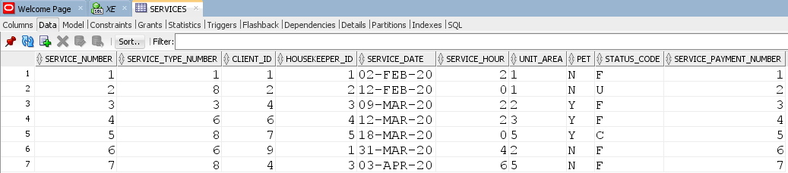

**salary_payments table**

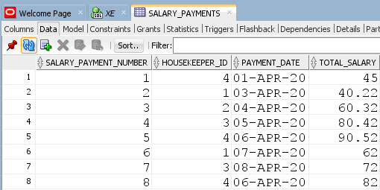

# SQL statements



1. **What is the most popular service?**

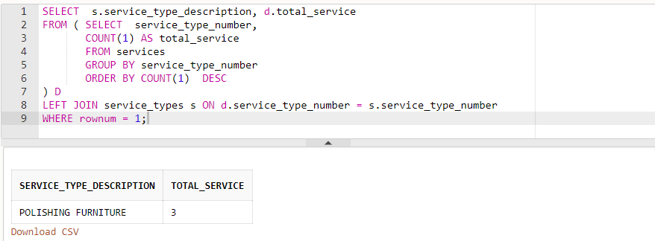

1. **What is the total revenue in 2020 so far?**

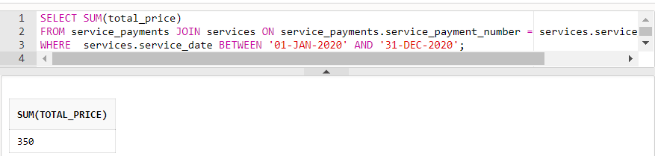

1. **What is the average case income for each employee?**

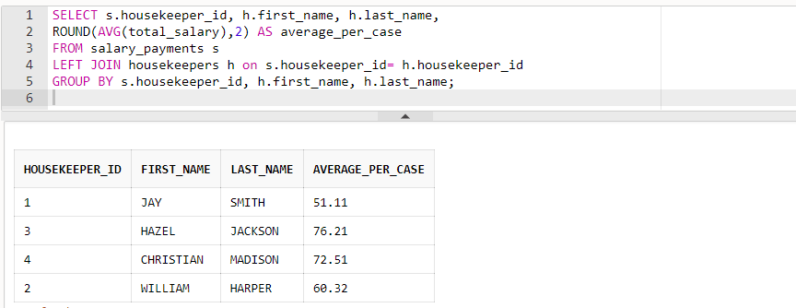

1. **Display clients who live in ‘TORONTO’ have requested service ‘CLEANING BEDROOM’.**

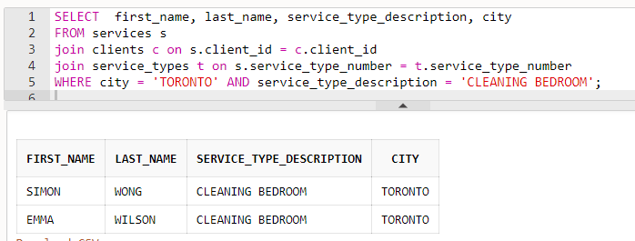

1. **Display employee’s income in March 2020.**

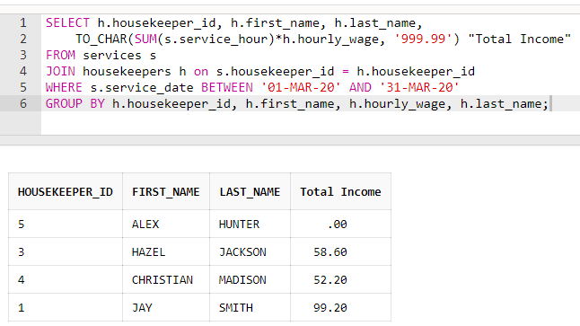

1. **Display how much the customer paid for our company.**

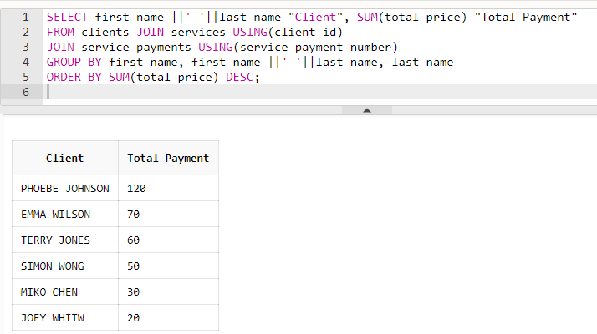

1. **How much money is paid for each service type? order by the sum of money.**

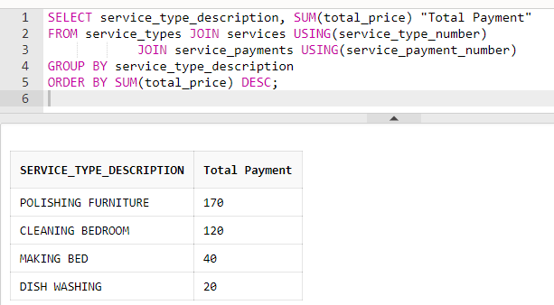

1. **Display clients who live in SCARBOROUGH.**

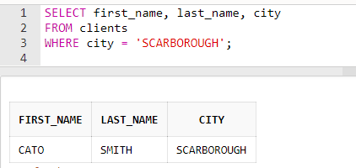

# Final version File including DDL, DML, and SQL

