Supplementary Information for

Auditory, but not audiovisual cues lead to a better learning of an unfamiliar musical style

Ioanna Zioga, Peter M. C. Harrison, Marcus T. Pearce, Joydeep Bhattacharya, Caroline Di Bernardi Luft

Corresponding authors:

Ioanna Zioga, [i.zioga@qmul.ac.uk](mailto:i.zioga@qmul.ac.uk)

Caroline Di Bernardi Luft, [c.luft@qmul.ac.uk](mailto:c.luft@qmul.ac.uk)

**Artificial music grammar**

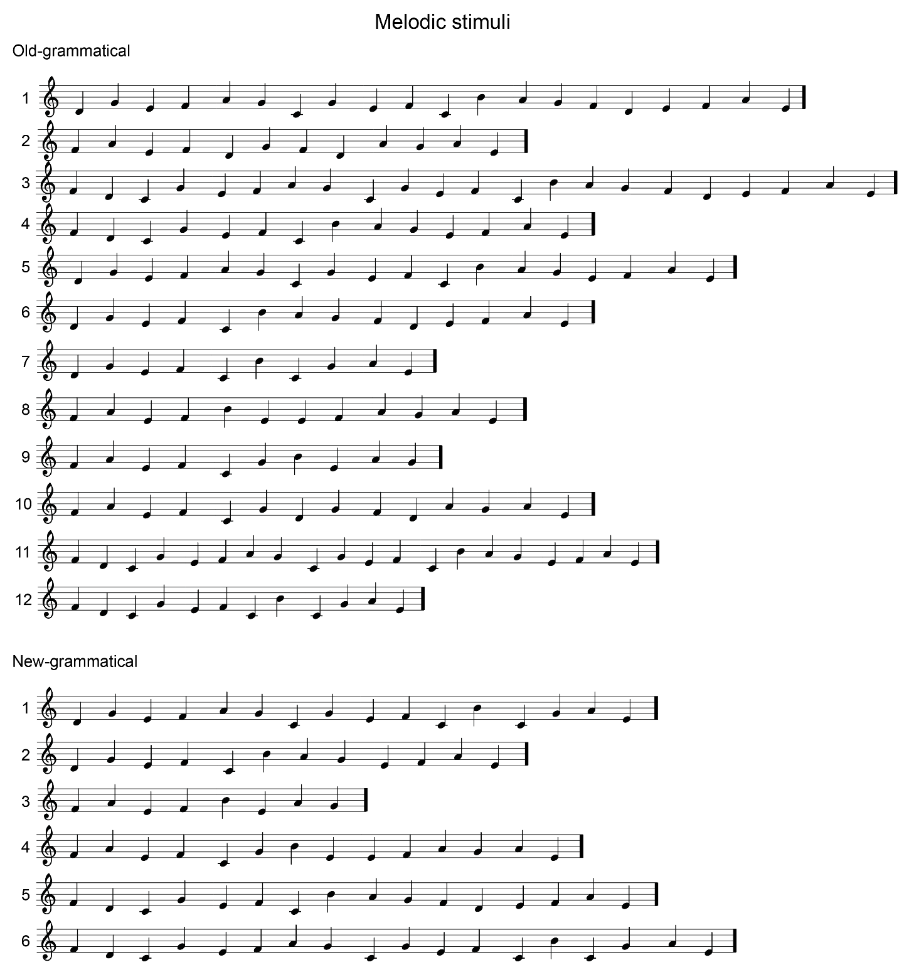

**Figure S1 –** Musical notation of the melodic stimuli, generated by the artificial music grammar by Rohrmeier, Rebuschat, and Cross (2011). The 6 new-grammatical melodies were used in the generalisation session, while the 12 old-grammatical were used in all the other sessions.

**Audio examples of the melodic stimuli**

1. Old_grammatical_HP: melodic segment used in the pre, post, and intermediate sessions ending on a high-probability note
2. Old_grammatical_LP: melodic segment used in the pre, post, and intermediate sessions ending on a low-probability note
3. Old_grammatical_INC: melodic segment used in the pre, post, and intermediate sessions ending on an incorrect note
4. New_grammatical_HP: melodic segment used in the generalisation session ending on a high-probability note
5. New_grammatical_LP: melodic segment used in the generalisation session ending on a low-probability note
6. New_grammatical_INC: melodic segment used in the generalisation session ending on an incorrect note

**ERAN (140 – 220 ms)**

We analysed the ERAN in response to violations of expectancy (low-probability, LP) notes and violations of grammaticality (incorrect notes, INC) (Figure S2B). To identify the topography of the ERAN in our data, we plot a topoplot of the average difference between LP and INC notes vs. high-probability notes (HP) (Figure S2A). By visually inspecting the topography, the peak electrode was identified at the front midline (Fpz; E6 in the EGI system). Despite the absence of right lateralization, we use the original ERAN terminology throughout. Please refer to the paper for the results (p.26).

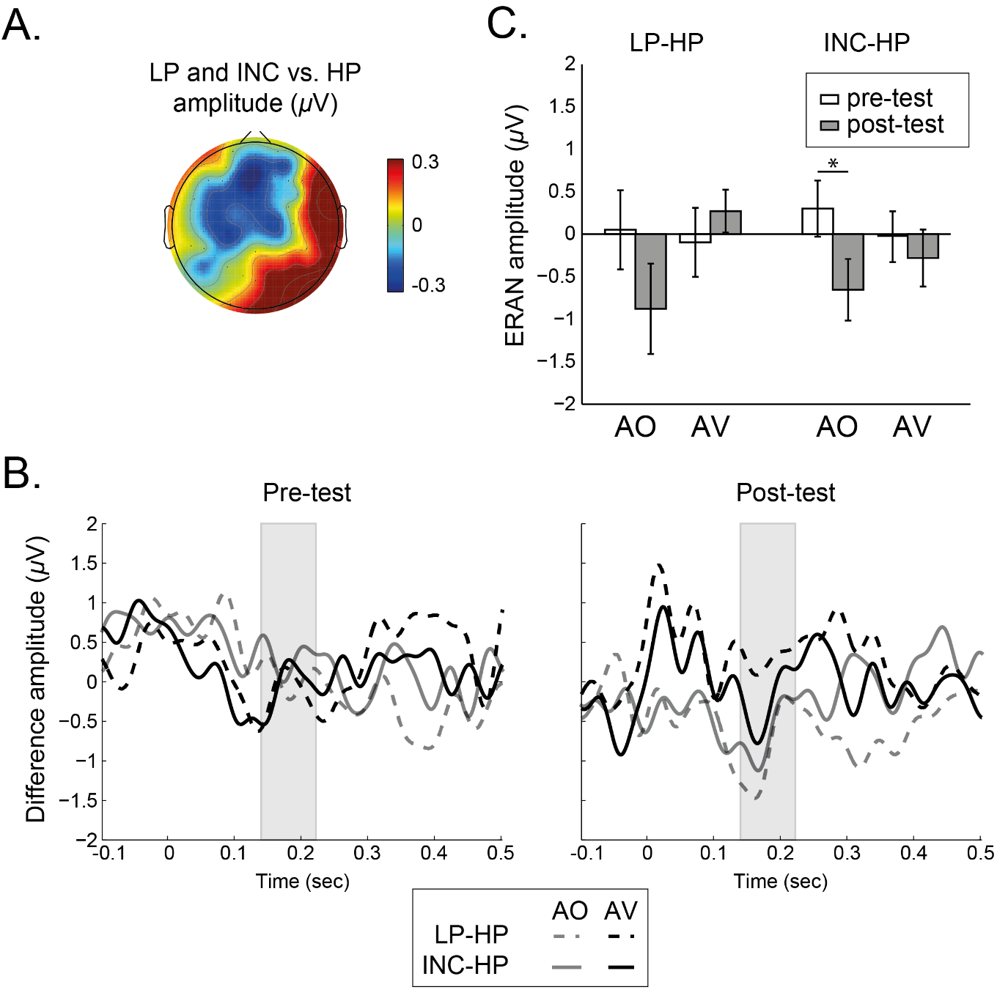

**Figure S2 – A.** Difference topoplot between LP and INC vs. HP notes for the ERAN across all participants; **B.** Grand average, difference ERPs in response to low-probability (LP) minus high-probability (HP) notes (dashed line), and to incorrect (INC) minus HP notes (solid line), separately for the auditory-only (AO, gray) and for the audio-visual (AV, black) group, for pre- (left) and post-test (right) sessions. The designated area represents the ERAN time window; **C.** Mean amplitudes for LP-HP and INC-HP differences in the pre- (white) and post-test (gray), separately for each group. Error bars represent ± 1 standard error mean (*SEM*). * *p* < .050.

**Non-parametric cluster permutation analysis**

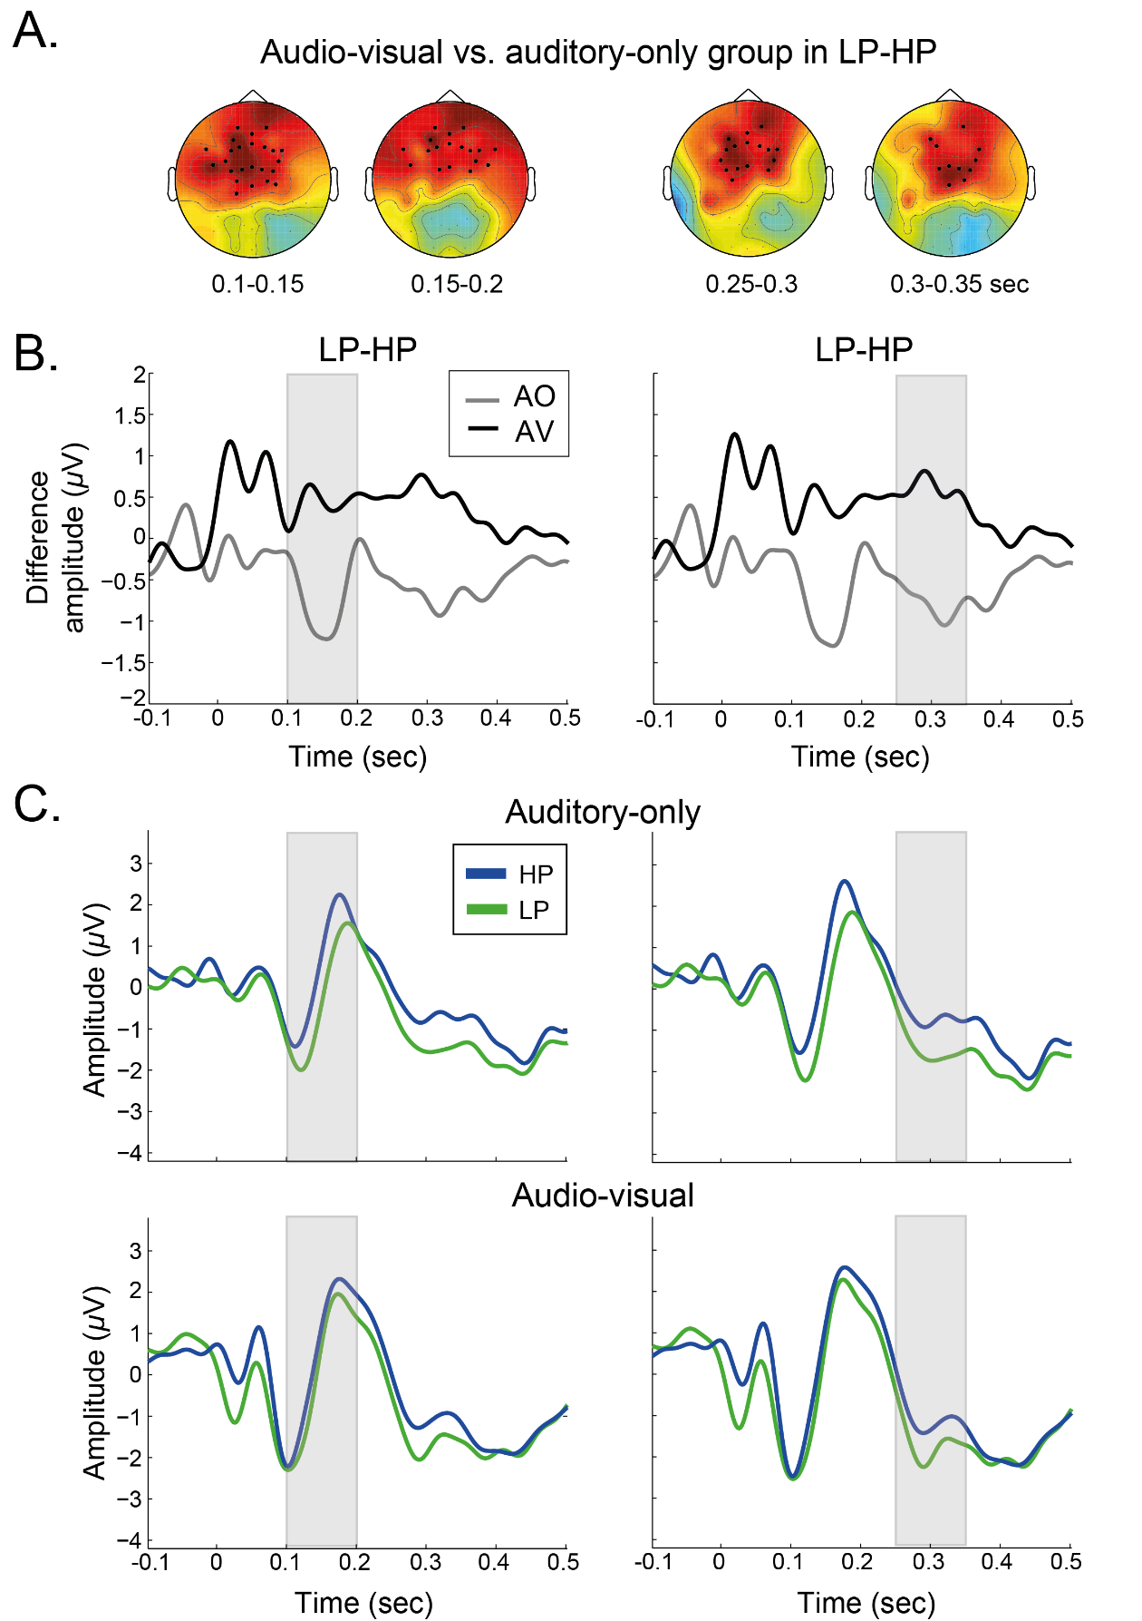

**Figure S3 –** Cluster permutation results comparing the audio-visual (AV) vs. the auditory-only (AO) groups on their responses to low-probability (LP) minus high-probability (HP) notes. **A.** Topoplots representing the *t*-values of the comparison. Significant electrodes within each cluster are highlighted as black dots; **B.** LP-HP difference ERPs for AV (black) and AO (gray) in for the cluster from 100-200 ms after note onset (left), and for the cluster from 250-350 ms (right); **C.** Grand average ERPs in response to HP (blue) and LP notes (green) for AO (top) and AV (bottom), and for the first (left) and the second cluster (right).