Evenwel v. Abbot Case Analysis

Voting Age Population

* Voting Age Population

1. Basic Characters of Voting Age Population under Plan S172

Table 1: Summary of Voting Age Population

|  |  |
| --- | --- |
| Total State Population(of 31 districts) | 18279737 |
| Ideal District Population | 589669 |
| Plan Overall Range | 117249 |
| Smallest District Population(27) | 524120 |
| Largest District Population(3) | 641369 |

Source: Texas Legislation Council Table PlanS172_Red202–derived from the 2010 US Census

136 S. Ct. 381; 193 L. Ed. 2d 288

Table 2: Deviation of Voting Age Population.

|  |  |  |
| --- | --- | --- |
|  | Total Absolute Deviation | Percent Deviation |
| Plan Overall Range | 117249 | 19.88% |
| Smallest District | 65549 | 11.12% |
| Largest District | 51700 | 8.77% |

Table 3: Measure of Relative Inequality for Voting Age Population.

|  |  |
| --- | --- |
| Maximum Deviation | 19.88% |
| Gini Index | 0.023 |
| L(1/2) | 0.484 |

1Gastwirth, Joseph L. Statistical reasoning in law and public policy: volume 1: Statistical Con-cepts & Issues of Fairness.1988

Figure 1: Lorenz Curve for Voting Age Population

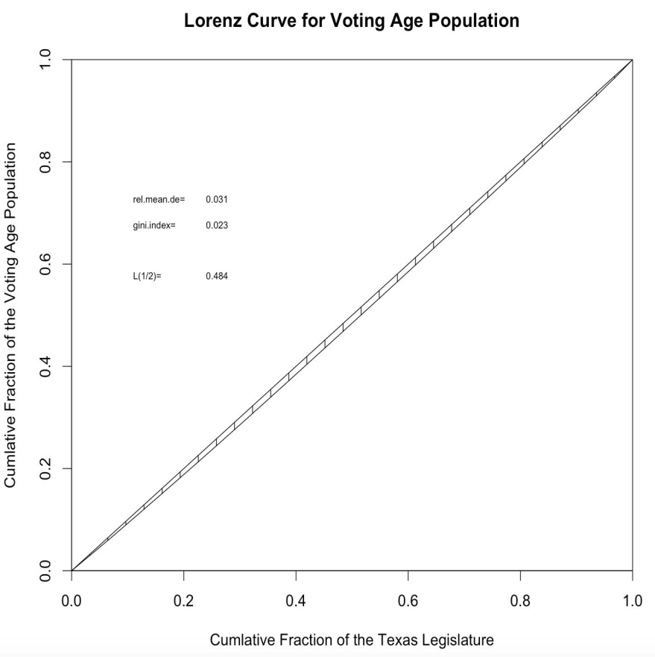

1. Analysis by District

Voting power share percentage(Voting Power Share), voting power(VP)2 of each district divided by total voting power.

V P = pops

where s is number of senate seat for each district and pop is population of each district.

2voting power. (n.d.) Burton’s Legal Thesaurus, 4E. (2007)

|  |  |  |  |  |  |  |  |
| --- | --- | --- | --- | --- | --- | --- | --- |
|  | | Table 4: Detailed Analysis of Voting Age Population. | | | | |  |
|  |  | |  |  |  |  | |  | |
|  | District | | Voting Age Population | Diﬀerence | Deviation | Voting Power Share | |
|  | 1 | | 616458 | 26789 | 4.54 % | 3.08 % | |  |  |
| 2 | | | 582997 | -6672 | 1.13 % | 3.26 % | |  |  |
| 3 | | | 641369 | 51700 | 8.77 % | 2.96 % | |  |  |
| 4 | | | 597765 | 8096 | 1.37 % | 3.18 % | |  |  |
| 5 | | | 620718 | 31049 | 5.27 % | 3.06 % | |  |  |
| 6 | | | 551137 | -38532 | 6.53 % | 3.45 % | |  |  |
| 7 | | | 572446 | -17223 | 2.92 % | 3.32 % | |  |  |
| 8 | | | 572635 | -17034 | 2.89 % | 3.32 % | |  |  |
| 9 | | | 580100 | -9569 | 1.62 % | 3.27 % | |  |  |
| 10 | | | 1602461 | 12792 | 2.17 % | 3.15 % | |  |  |
| 11 | | | 582677 | -6992 | 1.19 % | 3.26 % | |  |  |
| 12 | | | 588816 | -853 | 0.14 % | 3.22 % | |  |  |
| 13 | | | 590736 | 1067 | 0.18 % | 3.21 % | |  |  |
| 14 | | | 640349 | 50680 | 8.59 % | 2.97% | |  |  |
| 15 | | | 574255 | -15414 | 2.61 % | 3.31 % | |  |  |
| 16 | | | 614614 | 24945 | 4.23 % | 3.09 % | |  |  |
| 17 | | | 605764 | 16095 | 2.73 % | 3.13 % | |  |  |
| 18 | | | 587890 | -1779 | 0.3 % | 3.23 % | |  |  |
| 19 | | | 566604 | -23065 | 3.91 % | 3.35 % | |  |  |
| 20 | | | 577960 | -11709 | 1.99 % | 3.29 % | |  |  |
| 21 | | | 567099 | -22570 | 3.83 % | 3.35 % | |  |  |
| 22 | | | 592255 | 2586 | 0.44 % | 3.21% | |  |  |
| 23 | | | 576192 | -13477 | 2.29 % | 3.3% | |  |  |
| 24 | | | 596939 | 7270 | 1.23 % | 3.18 % | |  |  |
| 25 | | | 610120 | 20451 | 3.47 % | 3.11% | |  |  |
| 26 | | | 589522 | -147 | 0.02 % | 3.22% | |  |  |
| 27 | | | 524120 | -65549 | 11.12 % | 3.62 % | |  |  |
| 28 | | | 586992 | -2677 | 0.45 % | 3.23% | |  |  |
| 29 | | | 571426 | -18243 | 3.09 % | 3.32 % | |  |  |
| 30 | | | 623474 | 33805 | 5.73 % | 3.05% | |  |  |
| 31 | | | 1573847 | -15822 | 2.68 % | 3.31 % | |  |  |

Source: Plan S172 2010 Census data

1. Gerrymandering Analysis

Figure 2: Voting Age Population Distribution

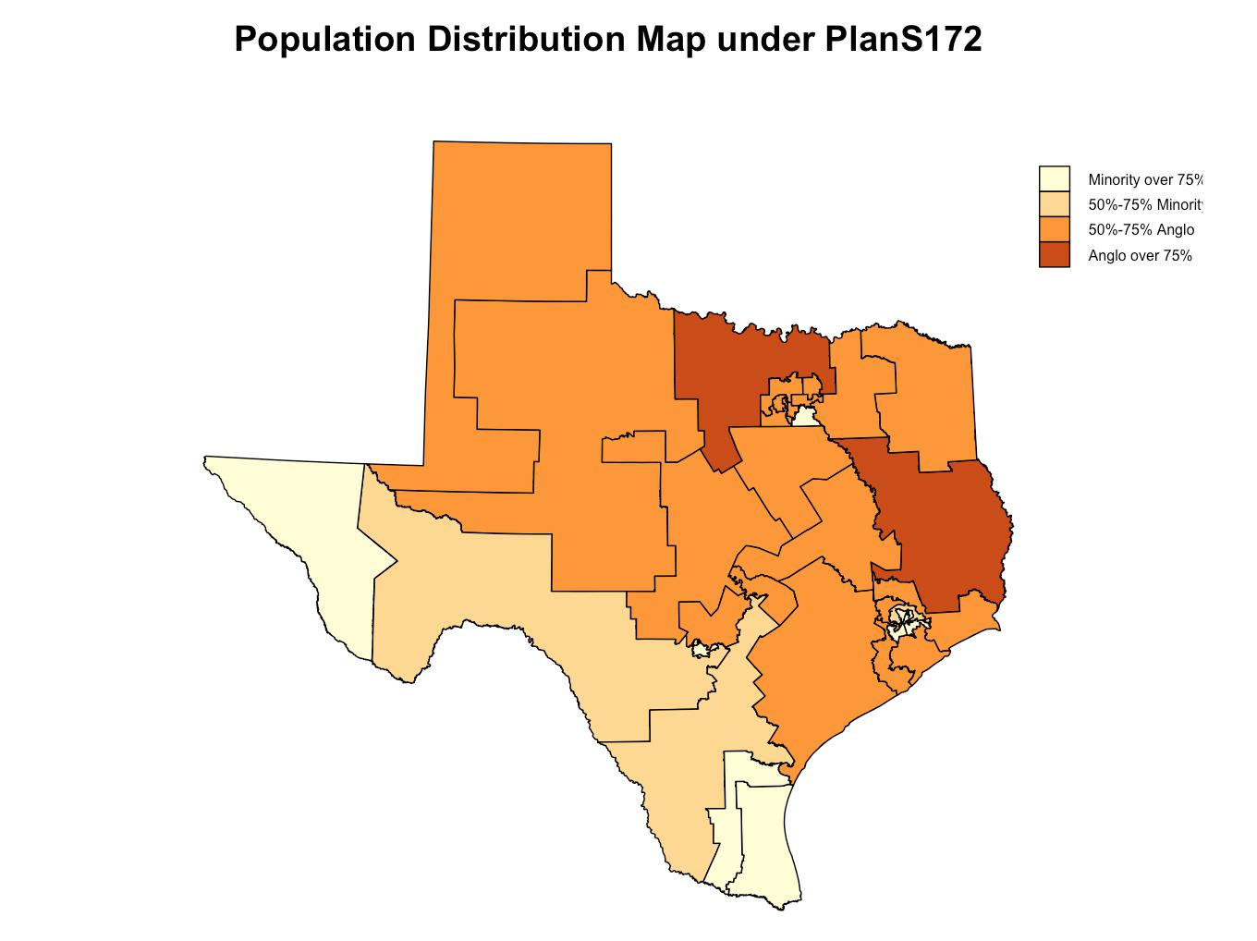

Figure 3: Box-Plot of Minority and Majority Population in Texas

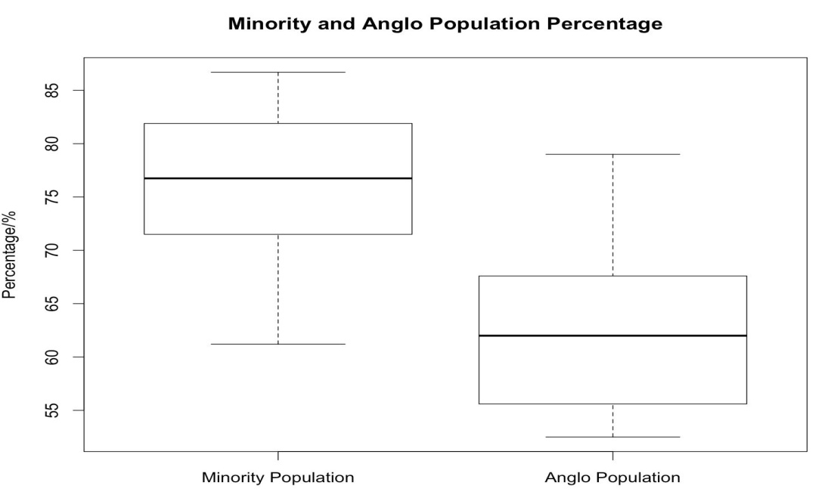

|  |  |  |  |
| --- | --- | --- | --- |
| A | Appendix |  |  |
| A.1 | R code |  |  |
| library ( l a w s t a t ) | |  |  |

#Read CSV F i l e

vap=read . csv ( ’~/Dropbox/ f i l e s /Legal Stat / case a n a l y s i s /Evenwel case /data/VAPd

#Convert d a t a i n t o numeric d a t a

for ( i in 2:7){

vap [ , i ]=as . numeric( gsub( " , " , "" , vap [ , i ] ) )

}

for ( i in 8:12){

vap [ , i ]=as . numeric( gsub( "%" , "" , vap [ , i ] ) )

}

attach ( vap )

#Function f o r T o t a l pop , i d e a l pop and d i s t r i c t number

basic_stat=function ( data ){

n=nrow( data )

totalsum=sum( data )

idealpop=totalsum /n

out1=rbind ( TotalStatePopulation=totalsum , TotalDistrictsRequired=n , I d e a l D i s t r

return ( round( out1 , d i g i t s = 0 ) )

}

#Ba s i c C h a r a c t e r s

b a s i c_stat ( Voting . Age . P o p u l a t i o n )

#Function f o r Plan o v e r a l l range , s m a l l e s t , l a r g e s t pop b a s i c_range=function ( data ) {

s m a l l=min( data ) smallnum=which . min( data ) l a r g e=max( data ) largenum=which .max( data ) r a n g e o v e r=l a r g e s m a l l

ave=mean( data )

out2=rbind ( PlanOverallRange=r a n g e o v e r , S m a l l e s t D i s t r i c t N u m=smallnum ,

S m a l l e s t D i s t r i c t=s m a l l , L a r g e s t D i s t r i c t N u m=largenum , L a r g e s t D i s t r i c Average=ave )

return ( round( out2 , d i g i t s = 0 ) )

}

#Ba s i c Range

b a s i c_range ( Voting . Age . P o p u l a t i o n )

#Function f o r p e r c e n t a g e d e v i a t i o n o f p l a n o v e r a l l range , s m a l l e s t , l a r g e s t pop d e v i a t i o n=function ( data ) {

|  |
| --- |
|  |
|  | s m a l l=length ( data ) |  |  |
|  | l a r g e=max( data ) |  |  |
|  | ave=mean( data ) |  |  |
|  | por=l a r g e s m a l l |  |  |
|  | ppor=por/ave |  |  |
|  | sdd=abs ( s m a l l ave ) |  |  |
|  | psdd=sdd/ave |  |  |
|  | l d d=l a r g e ave |  |  |
|  | pldd=l d d /ave |  |  |
|  | z1=rbind ( por , sdd , l d d ) |  |  |
|  | z2=rbind ( ppor , psdd , pldd ) | | |
|  | out3=cbind ( round( z1 , d i g i t s = 0 ) , z2 ) | | |
|  | colnames ( out3 )=c ( ’ Total | Absolute Deviation ’ , ’ Percent Deviation ’ ) | |
|  | rownames( out3)=c ( ’ Plan | Overall Rnage ’ , ’ Smallest D i s t r i c t ’ , ’ Largest D i s t r i c ’ ) | |
|  | return ( out3 ) |  |  |
| } | |  |  |
| #D e v i a t i o n | |  |  |
|  | deviation ( Voting . Age . Population ) | | |

|  |  |  |  |  |  |  |  |
| --- | --- | --- | --- | --- | --- | --- | --- |
| #Lorenz | | Curve |  |  |  |  |  |
| l o r e n z . curve ( Voting . Age . Population , seq ( from=1, to =1) , | | | | | | | |
| main = | | " Lorenz Curve f o r Voting Age Population " , | | | | | |
| xlab | = | "Cumlative | Fraction | of | the | Texas | L e g i s l a t u r e " , |
| ylab | = | "Cumlative | Fraction | of | the | Voting | Age Population " ) |

#Gini I n d e x

g i n i . index ( Voting . Age . P o p u l a t i o n )

#Function f o r c a l c u l a t i n g d i f f e r e n c e , d e v i a t i o n #and v o t i n g power s h a r e f o r each d i s t r i c t

* i s t r i c t_stat=function ( data ) { n=length ( data )

t o t a l s u m=sum( data )

i d e a l p o p=round( t o t a l s u m /n , d i g i t s = 0 ) l o w d i s t r i c t=rep (min( data ) , n ) ad=data i d e a l p o p

* + f i=abs ( data i d e a l p o p ) / i d e a l p o p vtp=sum( 1 /data )

v t p s =(1/data ) /vtp

* + i s t=t ( t ( 1 : 3 1 ) )

out4=as . data . frame( cbind ( d i s t , Voting . Age . P op ul a ti on , ad , d f i , v t p s ) ) colnames ( out4 )=c ( ’ D i s t r i c t ’ , ’VAP ’ , ’ D i f f e r e n c e ’ , ’ D e v i a t i o n ’ , ’ VotingPower ’ ) return ( out4 )

}

# S t a t i s t i c s f o r Each D i s t r i c t

d i s t r i c t_stat ( Voting . Age . P o p u l a t i o n )

#Wilcoxon Test

anglopop=X. Anglo [X. Anglo > X. B l a c k H i s p a n i c ] anglopop

minpop=X. B l a c k H i s p a n i c [X. BlackHispanicH > X. Anglo ] minpop

summary( anglopop ) summary( minpop )

#For d a t a w i t h o u t t i e s

w i l c o x . text ( minpop , anglopop )

#For d a t a w i t h t i e s library ( exactRankTests )

w i l c o x . e x a c t ( minpop , anglopop )

#B o x p l o t

boxplot ( minpop , anglopop , names=c ( ’ Minority Population ’ , ’ Anglo Population ’ ) , main = " Minority and Anglo Population Percentage " , ylab=’ Percentage%’ )

A.2 Data Set

A.2.1 Raw Data Set

Data Source: PlanS172_Red202(ftp://ftpgis1.tlc.state.tx.us/PlanS172/Reports/PDF/)

Variable Discription:

District: District Number

Voting Age Population: Voting Age Population(18+) in each district

Anglo: Anglo voting age population

Black: Black voting age population

Hispanic: Hispanic voting age population

BlackHispanic: sum of Black and Hispanic voting age population

Other: Other racial/ethnic population

%(Anglo,Black,Hispanic,BlackHispanic,Other) : Percentage of total voting age population

|  |  |  |  |  |  |  |  |  |  |  |  |
| --- | --- | --- | --- | --- | --- | --- | --- | --- | --- | --- | --- |
| Red-202 |  |  |  |  |  |  |  |  |  |  | Texas Legislative |
| Data: 2010 Census |  |  |  |  |  |  |  |  |  |  | Council |
| PLANS172 02/21/2012 5:18:04 PM |  |  |  |  |  |  |  |  |  |  | 02/22/12 8:19 AM |
|  |  |  |  |  |  |  |  |  |  |  | Page 1 of 1 |
|  |  |  | **Voter Population Data Senate Districts-PLANS172** | | | |  |  |  |  |  |
| **District** | **Voting Age Population** | **Anglo** | **Black** | **Hispanic** | **BlackHispanic** | **Other** | **%Anglo** | **%Black** | **%Hispanic** | **%BlackHispanic** | **%Other** |
| 1 | 616,458 | 434,458 | 106,304 | 64,594 | 169,835 | 12,165 | 70.5% | 17.2% | 10.5% | 27.6% | 2.0% |
| 2 | 582,997 | 363,859 | 70,456 | 129,886 | 198,762 | 20,376 | 62.4% | 12.1% | 22.3% | 34.1% | 3.5% |
| 3 | 641,369 | 483,044 | 79,984 | 68,049 | 147,209 | 11,116 | 75.3% | 12.5% | 10.6% | 23.0% | 1.7% |
| 4 | 597,765 | 394,677 | 83,500 | 98,852 | 180,843 | 22,245 | 66.0% | 14.0% | 16.5% | 30.3% | 3.7% |
| 5 | 620,718 | 410,159 | 63,748 | 117,177 | 179,185 | 31,374 | 66.1% | 10.3% | 18.9% | 28.9% | 5.1% |
| 6 | 551,137 | 85,444 | 68,911 | 386,042 | 451,455 | 14,238 | 15.5% | 12.5% | 70.0% | 81.9% | 2.6% |
| 7 | 572,446 | 318,440 | 69,156 | 133,835 | 200,516 | 53,490 | 55.6% | 12.1% | 23.4% | 35.0% | 9.3% |
| 8 | 572,635 | 354,862 | 57,950 | 81,549 | 137,992 | 79,781 | 62.0% | 10.1% | 14.2% | 24.1% | 13.9% |
| 9 | 580,100 | 307,700 | 67,435 | 164,504 | 229,522 | 42,878 | 53.0% | 11.6% | 28.4% | 39.6% | 7.4% |
| 10 | 602,461 | 317,342 | 107,962 | 149,687 | 255,430 | 29,689 | 52.7% | 17.9% | 24.8% | 42.4% | 4.9% |
| 11 | 582,677 | 347,306 | 63,761 | 133,293 | 195,405 | 39,966 | 59.6% | 10.9% | 22.9% | 33.5% | 6.9% |
| 12 | 588,816 | 400,322 | 46,961 | 100,252 | 145,843 | 42,651 | 68.0% | 8.0% | 17.0% | 24.8% | 7.2% |
| 13 | 590,736 | 75,463 | 261,494 | 202,979 | 459,173 | 56,100 | 12.8% | 44.3% | 34.4% | 77.7% | 9.5% |
| 14 | 640,349 | 367,163 | 59,995 | 166,803 | 224,029 | 49,157 | 57.3% | 9.4% | 26.0% | 35.0% | 7.7% |
| 15 | 574,255 | 188,372 | 135,283 | 219,706 | 351,501 | 34,382 | 32.8% | 23.6% | 38.3% | 61.2% | 6.0% |
| 16 | 614,614 | 325,919 | 68,249 | 158,661 | 224,889 | 63,806 | 53.0% | 11.1% | 25.8% | 36.6% | 10.4% |
| 17 | 605,764 | 318,189 | 77,261 | 122,375 | 197,188 | 90,387 | 52.5% | 12.8% | 20.2% | 32.6% | 14.9% |
| 18 | 587,890 | 323,352 | 70,666 | 155,873 | 224,601 | 39,937 | 55.0% | 12.0% | 26.5% | 38.2% | 6.8% |
| 19 | 566,604 | 157,621 | 41,226 | 356,850 | 395,224 | 13,759 | 27.8% | 7.3% | 63.0% | 69.8% | 2.4% |
| 20 | 577,960 | 127,923 | 13,150 | 426,384 | 437,952 | 12,085 | 22.1% | 2.3% | 73.8% | 75.8% | 2.1% |
| 21 | 567,099 | 152,439 | 22,756 | 384,834 | 405,385 | 9,275 | 26.9% | 4.0% | 67.9% | 71.5% | 1.6% |
| 22 | 592,255 | 400,413 | 66,928 | 106,482 | 172,010 | 19,832 | 67.6% | 11.3% | 18.0% | 29.0% | 3.3% |
| 23 | 576,192 | 107,949 | 235,637 | 222,922 | 455,565 | 12,678 | 18.7% | 40.9% | 38.7% | 79.1% | 2.2% |
| 24 | 596,939 | 416,507 | 65,301 | 95,501 | 157,507 | 22,925 | 69.8% | 10.9% | 16.0% | 26.4% | 3.8% |
| 25 | 610,120 | 397,666 | 27,734 | 161,746 | 187,523 | 24,931 | 65.2% | 4.5% | 26.5% | 30.7% | 4.1% |
| 26 | 589,522 | 145,948 | 44,904 | 381,781 | 422,770 | 20,804 | 24.8% | 7.6% | 64.8% | 71.7% | 3.5% |
| 27 | 524,120 | 64,820 | 3,970 | 451,599 | 454,233 | 5,067 | 12.4% | 0.8% | 86.2% | 86.7% | 1.0% |
| 28 | 586,992 | 361,873 | 34,696 | 179,057 | 212,205 | 12,914 | 61.6% | 5.9% | 30.5% | 36.2% | 2.2% |
| 29 | 571,426 | 89,258 | 19,255 | 454,873 | 471,188 | 10,980 | 15.6% | 3.4% | 79.6% | 82.5% | 1.9% |
| 30 | 623,474 | 492,684 | 33,240 | 78,941 | 111,172 | 19,618 | 79.0% | 5.3% | 12.7% | 17.8% | 3.1% |
| 31 | 573,847 | 343,512 | 28,386 | 188,057 | 215,080 | 15,255 | 59.9% | 4.9% | 32.8% | 37.5% | 2.7% |

A.2.2 Data for Wilcoxon Test

Table 5: Detailed Analysis of Voting Age Population.

|  |  |  |  |
| --- | --- | --- | --- |
| District | % Anglo District %Black+Hispanic | | |
| 1 | 70.5 | 6 | 81.9 |
| 2 | 62.4 | 13 | 77.7 |
| 3 | 75.3 | 15 | 61.2 |
| 4 | 66.0 | 19 | 69.8 |
| 5 | 66.1 | 20 | 75.8 |
| 7 | 55.6 | 21 | 71.5 |
| 8 | 62.0 | 23 | 79.1 |
| 9 | 53.0 | 26 | 71.1 |
| 10 | 52.7 | 27 | 86.7 |
| 11 | 59.6 | 29 | 82.5 |
| 12 | 68.0 |  |  |
| 14 | 57.3 |  |  |

1. 53.0
2. 52.5
3. 55.0

22 67.6

1. 69.8
2. 65.2

28 61.6

1. 79.0
2. 59.9

|  |  |  |  |  |  |  |  |  |  |  |  |
| --- | --- | --- | --- | --- | --- | --- | --- | --- | --- | --- | --- |
| R code: |  |  |  |  |  |  |  |  |  |  |  |
| anglopop=c ( 7 0 . 5 , 6 2 . 4 | , 7 5 . 3 | , 6 6 . 0 | , 6 6 . | 1 , 5 | 5 . | 6 , | 6 2 . 0 | , 5 3 . 0 | , 5 2 . 7 | , 5 9 . 6 | , |
| 6 8 . 0 , 5 7 . 3 , 5 3 . 0 , 5 2 . 5 , 5 5 . 0 , 6 7 . 6 , 6 9 . 8 , 6 5 . 2 , 6 1 . 6 , 7 9 . 0 , 5 9 . 9 ) | | | | | | | | | | |  |
| minpop=c ( 8 1 . 9 , 7 7 . 7 , | 6 1 . 2 , | 6 9 . 8 , | 7 5 . 8 | , 7 1 | . 5 | , | 7 9 . 1 , | 7 1 . 7 , | 8 6 . 7 , | 8 2 . 5 ) |  |