Interim Report
Team Project Module · National College of Ireland · Individual Project
Project Name: _____Smart Parking System____________________
Student Name: ____Joanne Brennan Elliott_________________
Student Number: __X23410001_________________
Module / Cohort: __HDSDEV_SEP25_______________________
Date: ____________25/06/2026 Rev3________________________

1. Project Overview
I am building a Smart Parking Booking System that allows users to register, log in securely, and book standard or disabled parking spaces with the option to locate their parked vehicle using the ‘Find My Car’ and ‘Navigate To My Car’ functionality included in this will be a parking timer count-down.

2. Deliverables & Progress
Deliverable | Status | Notes (what remains; will you reach it?)
Project proposal | Done | Submitted, Week 3
SRS written and submitted | Done | Submitted, Week 4
Core matching feature (Must) | In progress | Basic version working
Interim documentation | In progress | Interim report underway
Sprint Documentation in Jira | In progress | Sprints are constantly being updated as I proceed and complete tasks
GUI front-end (Must) and gRPC back-end calls | In progress | Functional HTML & CSS with server.js, client_browser.js and .proto files; styling improvements ongoing
System architecture & DB schema | Done | SQLite schema implemented; user and bookings tables created
User login (Must) – FR-001& NFR-004 | Done | Login validation working and users added to user.db and store password using hashing added
User registration & login (Must) - FR-002 | Done | New users not in the users.db are asked to register and then are permitted to login
Booking a parking space (Must) - FR-003 | Done | Standard booking implemented.
User receive an email confirmation (Should) - FR-004 | Not started | Not started with the email functionality
Receive alerts when reserved time is ending- FR-005 | In progress | Count down - start/stop timer added, with highlighting the remaining 5 mins in red font as warning.
Booking a disabled parking space (Must) -FR-006 | In progress | Disabled booking option implemented; needs refinement for validation rules
Proof of disability check prior to allowing to reserve a disabled parking space. (Should) - FR-007 | Not started | This is a should have so not essential, more work needed to update user table with boolean for disable status to allow booking to proceed.
Parking spaces viewable in real time. (Should) - FR-009 | In progress | Changed the functionality - user gets given a designated space, function to pick a location not started
Admin features (Should) - FR-011 | Not started | Planned for after MVP
Admin daily/ weekly report of booking- FR-014 | In progress | Started but not fully functional – new database table log_audit to be created
Flex grid GUI for iPhone and other devices | Not started | This is a nice to have and will depend on time pressures

3. Progress Against the MVP
I am on track for the Week 7 MVP. The core MUST requirements — registration, secure login, and basic parking booking — are already functional. The remaining work involves refining booking validation with disability check prior to reserving, improving the GUI layout, and completing the admin view.

4. Evidence / Current State
Figure1: login screen Figure 2: after login and parking space booked
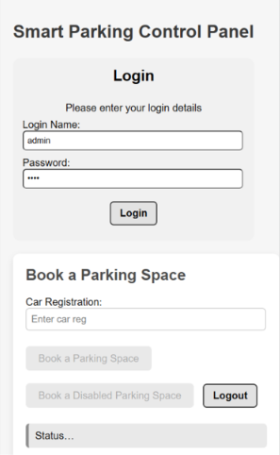
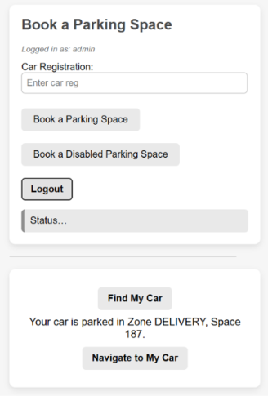

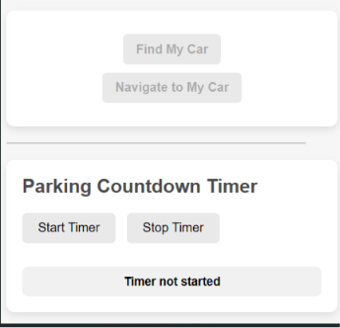

Figure 3: My Jira Project SDLC – screenshot progress
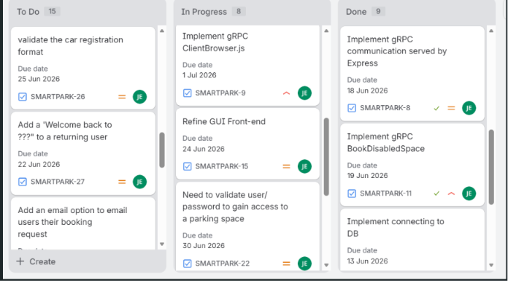

Repository link: JoanneBrennanElliott/project_smart_parking: My Smart Parking System built for NCI project semester, implementing gRPC microservices, a Node.js bridge, and a simple GUI for user interaction.

5. Challenges & Risks

Password security upgrade: Moving from plain-text passwords to bcrypt hashing required rewriting both registration and login logic. Fixed successfully, but highlighted the risk of inconsistent DB state.
Nice to have security and validation of the parking disabled permits, development is ongoing.
Front-end spacing/layout issues: As development was progressing, the new functional deliverables needed user interface changes which caused alignment problems slowed progress; resolving with CSS adjustments.
Database resets: Needed to clear and rebuild the user table multiple times to allow more fields to be added during the ongoing development of the system e.g. last_time_logged_on, disabledAccess and permitNumber. Risk mitigated by writing a reset script.
Time pressure: A welcome back greeting for returning users, and the ability to validate a users car registration along with an email confirmation are on the ‘nice to have’ list but will not impact the functionality of the system if not complete. One challenge for me is to code for the user/driver, to have the ability to pick their own parking space (FR-009) - algorithm needed here for priority queue, currently limited functionality as user will be given a designated space with a unique booking reference, without with ability to pick their own location. Will need to be revisited in verison2 if not completed to a usable standard within 10 weeks.
Remaining features (admin view, additional validation rules and flex-grid GUI) must be tightly scheduled to avoid slipping past Week 10.
Potential scope creep: Additional features for Admin may need to be dropped or paired back to ensure a stable final build.

6. Plan to Completion
Week(s) | Planned Work
Week 8 | Finalise booking logic, add validation, improve GUI layout with flex-grid, complete user feedback messages with email
Week 9 | Implement admin dashboard (view bookings, manage spaces), refine error handling,
Week 10 | Final build, full user and system testing, documentation and video demo

