
Higher Diploma in Science in Computing – Software Development (HDSDEV_SEP25)
Module: Project
2025/2026
Joanne Brennan Elliott
X23410001
x23410001@student.ncirl.ie
Smart Parking System
Technical Report


Project Submission Sheet – 2025/2026
Student Name: Joanne Brennan Elliott
Student ID: X2341001
Programme: Higher Diploma in Science in Computing – Software Development (HDSDEV_SEP25)
Year: 2025/2026
Module: Project
Lecturer:Arjun Chikkankod
Submission Due Date: 2nd August 2026
Project Title: Smart Parking System
Word Count (excluding bibliography and appendices): _______________________________________
I hereby certify that the information contained in this (my submission) is information pertaining to research I conducted for this project. All information other than my own contribution will be fully referenced and listed in the relevant bibliography section at the rear of the project.
ALL internet material must be referenced in the references section. Students are encouraged to use the Harvard Referencing Standard supplied by the Library. To use other author's written or electronic work is illegal (plagiarism) and may result in disciplinary action. Students may be required to undergo a viva (oral examination) if there is suspicion about the validity of their submitted work.
Signature:
Date:

Table of Contents
TOC \h \o "1-3"

Right-click this table in Word and choose “Update Field” to populate the contents and page numbers.

Table of Figures
List each figure and table with its number, description and page. In Word, this can be generated automatically with Insert → Table of Figures.

Glossary, Acronyms, Abbreviations and Definitions
Define every term and acronym used in the document.
Term / Acronym | Definition
API | Application Programming Interface — a defined way for software components to communicate

Executive Summary
Maximum 300 words. State the problem being addressed, describe the technical solution, and briefly report the findings of the evaluation.

1 Introduction
This template is a guide rather than a fixed form; your report may need changes to headings, format or content. Suggested word count: 6,000–8,000 words, from the Introduction up to (not including) the References.

1.1 Background
Why? Why does this project matter, and what problem does it solve? This expands on the problem statement from your proposal.

1.2 Aims
What? What does the project set out to achieve?

1.3 Technologies
How? Briefly describe the technologies used and how each contributes to your project. Do not copy and paste descriptions from websites — explain them in your own words.

1.4 Structure
A brief overview of each chapter that follows.

2 System

2.1 Requirements
Present your final requirements. They have probably evolved since your requirements specification — explain what changed and why, referring to the scope decisions recorded in your interim report (for example, a COULD dropped to WON’T). State clearly which requirements were delivered.

2.1.1 Functional Requirements
Reproduce your functional requirements as user stories with their MoSCoW priority, as in your requirements specification, and add the delivery status of each. All MUST requirements should be delivered for a complete project.
ID | User Story | Priority | Status (Delivered / Partial / Not delivered)
FR-001 | As a [user], I want [goal], so that [benefit] | MUST | Delivered

2.1.2 Non-Functional Requirements
Reproduce your non-functional requirements (Performance, Security, Usability, Compatibility) with their measurable targets, and report whether each target was met.
ID | Requirement (with measurable target) | Priority | Target met?
NFR-001 | Page load under 3 seconds on 4G | SHOULD | Met (2.1s measured)

2.1.3 Data Requirements (AI / ML and data-driven projects)
If your project uses data or machine learning, describe the dataset(s): source, licence, size, and how the data were split into training, validation and test sets. Omit this subsection if it does not apply.

2.2 Design and Architecture
Describe the design, system architecture and components, and the main algorithms used (with standard mathematical notation where appropriate). An architecture diagram is usually helpful. For an ML project, describe the model architecture, the preprocessing pipeline, and the training procedure.

2.3 Implementation
Describe the main classes and functions in your code, and explain the key concepts and decisions behind them.

2.4 Testing
Describe the testing tools, test plans and test specifications used — for example unit, integration and system tests.

2.5 Graphical User Interface (GUI) Layout
Provide screenshots of the key screens and explain each.

2.6 User Testing
Provide evidence from a small usability test with real users — typically 3–5 classmates or target users. State the tasks you set, any ratings (e.g. 1–5), and one or two short quotes. Describe the users you actually had. If your project has no direct end user (for example a model or data pipeline), state this and rely on your Evaluation section instead.

2.7 Evaluation
How was the system evaluated, and what were the results? This usually includes usage data, user feedback and performance measures. For an ML project, report your evaluation metric(s) on the held-out test set, the baseline you compared against, and present the results in a table. Relate the results back to the success criteria and MUST requirements you set.
Quantitative results may be reported in tables or figures. A table caption goes above the table and is cross-referenced in the text (see Table 1). Tables often read better without vertical lines.
Table 1: Classification performance against the baseline on the held-out test set.
Model | Accuracy | Precision | Recall | F1-score
Majority-class baseline | 0.62 | 0.31 | 0.50 | 0.38
Logistic regression | 0.79 | 0.78 | 0.77 | 0.77
Proposed model (CNN) | 0.86 | 0.85 | 0.86 | 0.85
A figure caption goes below the figure (see Figure 1). If you use colour, make sure the figure is still readable in black and white — for example by using different line styles, markers or patterns.
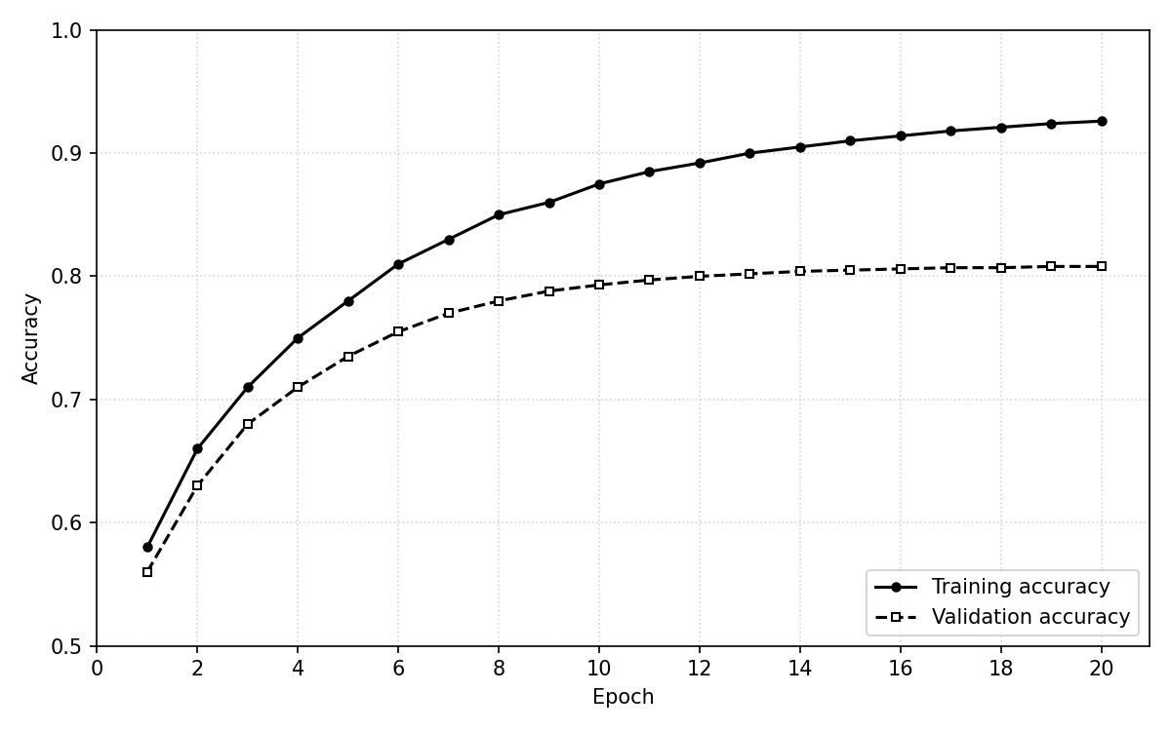
Figure 1: Training and validation accuracy across epochs. The two curves use different line styles and markers so the figure remains readable in black and white.

3 Conclusions
Describe the advantages, disadvantages, opportunities and limitations of the project. Reflect honestly on what you set out to deliver in your proposal against what you actually delivered, and what you would do differently.

4 Further Development or Research
With more time or resources, where could the results of this project lead?

5 References
Use APA, Harvard or another internationally recognised style consistently. References to websites must include the access date. The NCI library referencing guide is at https://libguides.ncirl.ie/referencingandavoidingplagiarism.

6 Appendix

6.1 Project Proposal

6.2 Requirements Specification

6.3 Interim Report

6.4 Video Demonstration
A link to a screen-recorded video walkthrough of the working application (maximum 5 minutes), hosted on YouTube (unlisted is fine). Show the key features in use and briefly narrate what is happening.
Video link: [paste your YouTube URL here]

6.5 Other Material Used
Any other reference material used in the project — for example evaluation surveys or test data.

