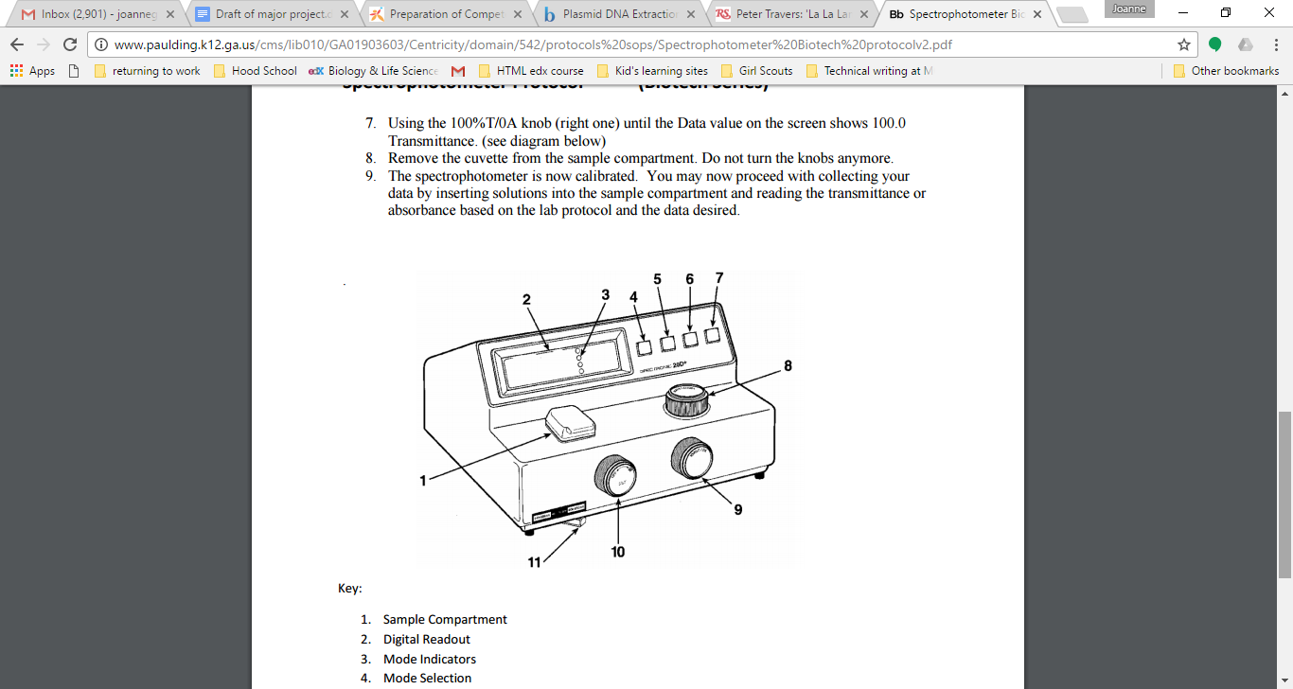

1. Sample compartment

2. Digital read out

3. Mode indicators

4. Mode selection

5. Decrease

6. Increase

7. Print

8. Wavelength control

9. Transmittance/ Absorbance control (100% T/OA)

10. Power switch/ zero control

11. Filter lever