**Deep Learning based Diabetic Retinopathy Detection**

Implementation Supporting HopeScope Smartphone Fundus Camera & Application by Helios Opthalmics

DEEP LEARNING MODULE DOCUMENTATION

# Data Analysis and Data Preprocessing

Dataset downloaded from Kaggle: <https://www.kaggle.com/c/diabetic-retinopathy-detection/data>

35126 training images, ranging from 433 x 289 px to 5184 x 3456 px classified into five DR stages   
https://lh3.googleusercontent.com/TwknJyCZgJ5KJigWyYVcSCQ-v0zMCVKVhaiHHhc-o_MWO4GNZRvGXmTw9_HOJVWtkdL_YtUFxeQWjIh44ljtIWIc0LC_722Igupd53Ra7z5ocuerbw-wkWXBCLE3NXEvpqQyIwIbuHo  
 0 1 2 3 4

## Data Analysis

Frequency distribution and Pie Chart

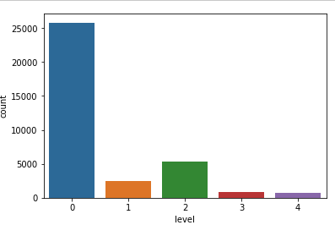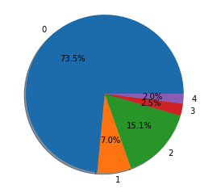

There is data imbalance for classes 1, 2, 3 and 4

Frequency distribution and Pie Chart after clubbing classes 1, 2, 3, 4 into 1

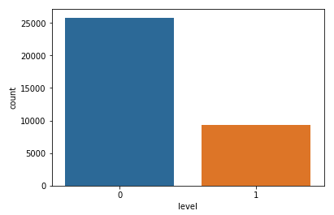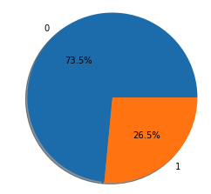

## Data Preprocessing

**Image cropping and resize**  
 Images were cropped and padded (whenever needed) and resized into 512 x 512 pixels.  
Time taken - 5 hours

**Colour Equalization** Images had different lighting and colour spectrum. They were equalized using a representative average of the dataset. [1]  
For each pixel

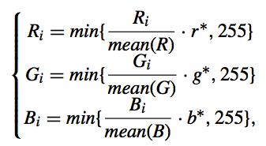

where r*, g* and b* are the average red, blue and green channel pixel values of 1000 images from dataset.

r* = 99.15564215469361

g* = 68.90390924453736

b* = 49.521488990783695

Time taken - 30 minutes

## Data Preprocessing Pipeline

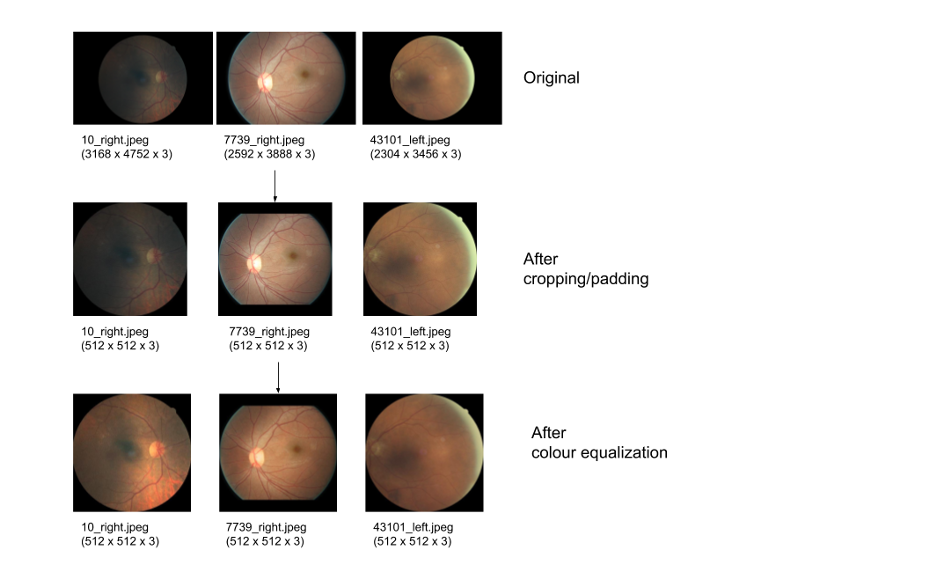

# References

[[1] Diagnosis of Diabetic Retinopathy Using Deep Neural Networks - Zhentao Gao, Jie Li, Jixiang Guo, Yuanyuan Chen, Zhang Yi, Jie Zhong](https://ieeexplore.ieee.org/document/8581492)