Links and dataset descriptions are inserted below…  
  
Customer Transaction Insights

* Amazon US Customer Reviews (Kaggle): <https://www.kaggle.com/datasets/cynthiarempel/amazon-us-customer-reviews-dataset>

This dataset contains over 130 million customer reviews from Amazon.com, covering various product categories and marketplaces.

* E-Commerce Transaction Data (Kaggle): <https://www.kaggle.com/datasets/carrie1/ecommerce-data>

This dataset includes order details such as product ID, quantity, transaction date, and customer details. This is valuable for analyzing purchase behavior and transaction trends.

Inventory and Stock Management

* Amazon Products Dataset 2023 (1.4M Products) (Kaggle):

<https://www.kaggle.com/datasets/asaniczka/amazon-products-dataset-2023-1-4m-products>

This dataset includes detailed information on over 1.4 million Amazon products, encompassing pricing and sales data. While it doesn't provide explicit inventory levels, the sales data can be instrumental in analyzing stock trends and demand forecasting

* Amazon Sales Dataset  
  <https://www.kaggle.com/datasets/karkavelrajaj/amazon-sales-dataset>

This dataset contains data on over 1,000 Amazon products, including ratings and reviews. Although it doesn't directly address inventory levels, the sales information can offer insights into product performance and potential stock management strategies.

Product and Vendor Analysis

* Amazon Products Dataset 2023 (1.4M Products) (Kaggle):

<https://www.kaggle.com/datasets/asaniczka/amazon-products-dataset-2023-1-4m-products>

This dataset includes detailed information on over 1.4 million Amazon products, encompassing pricing and sales data. While it doesn't provide explicit inventory levels, the sales data can be instrumental in analyzing stock trends and demand forecasting

Payment and Financial Transaction Analysis

* Online Payment Fraud Detection Dataset (Kaggle): <https://www.kaggle.com/datasets/ealaxi/paysim1>

This dataset covers specifics to fraud detection, it includes transaction details that can be useful for tracking payment methods, analyzing customer payment behavior, and implementing fraud detection methods.

Shipping and Return Data

* **Logistics and Shipping Time Data (Kaggle)**: <https://www.kaggle.com/datasets/prachi13/customer-analytics>

This dataset covers shipping times, carrier information, and delivery times, which are crucial for shipment tracking and logistics efficiency analysis.

Shopping Behavior and Wishlist Data

* Online Retail Dataset (UCI):

<https://archive.ics.uci.edu/ml/datasets/Online+Retail>

This dataset includes shopping cart and wishlist activity, useful for analyzing shopping behavior, abandoned carts, and customer purchase intent.

Promotion Effectiveness Data

* Promotion Campaign Data (Kaggle): <https://www.kaggle.com/datasets/rodsaldanha/arketing-campaign>

This dataset contains promotion details, customer response, and sales impact data. This can help analyze the effectiveness of promotions and refine future campaign strategies.

Logical schema image and reasoning is inserted below…

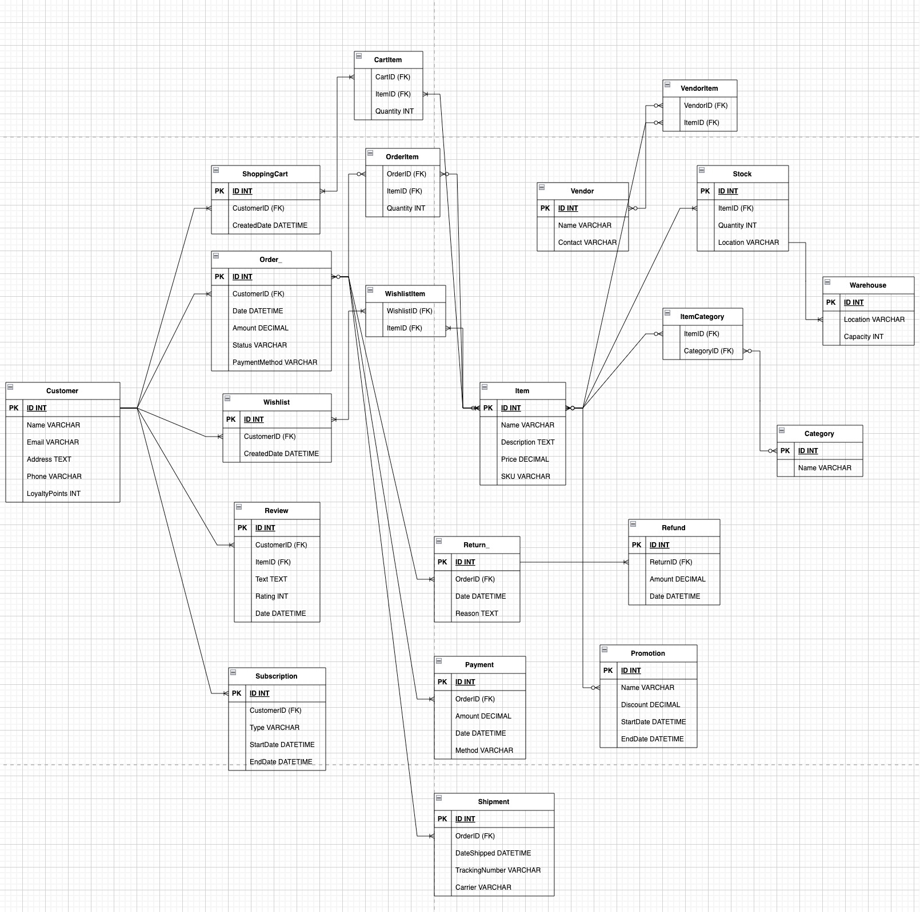

These optimizations aim to improve data retrieval efficiency, support for real-time and batch processing, and data integration across structured and unstructured sources.

1. Normalization Adjustments
   1. Customer, Wishlist, and Subscription
      1. These entities are well-structured in terms of normalization. The Customer entity’s direct attributes (ID, Name, Email, Address, Phone, LoyaltyPoints) are sufficiently normalized, as are related entities like Wishlist and Subscription.
   2. Order and OrderItem
      1. The separation of Order and OrderItem tables is appropriate for normalization, avoiding repeated order details for each item in an order.
      2. We might consider moving PaymentMethod to the Payment table, as this would reduce redundancy in the Order table and ensure that all payment information is stored in one place.
   3. Promotion
      1. Since Promotion is linked with Order, we could consider creating an OrderPromotion associative table to capture orders with multiple promotions. This avoids storing a single promotion ID in Order and allows more flexible promotion applications.
2. Handling Unstructured Data
   1. Review Entity
      1. Since Review.Text could contain unstructured data (free text), it would be beneficial to optimize for text search. We could consider adding a SentimentScore or TopicTag attribute, which could store data derived from natural language processing (NLP) on Text. These attributes would make querying for sentiment or topic-specific reviews faster.
   2. Item and Reviews Relationship
      1. We might want to add an ItemReview table if reviews are shared between items, or store a reference to Item in Review to keep reviews directly related to the products they pertain to. This supports easier association of unstructured review data with structured item data.
3. Optimizing Stock and Warehouse
   1. Stock and Warehouse Relationship
      1. Instead of storing Location within Stock, we can consider associating Stock directly with Warehouse to clarify the physical locations of items. This would also support scalable inventory management by location.
   2. Warehouse Capacity Tracking
      1. To handle complex inventory needs, we could add an InventoryLog table that tracks changes in Stock.Quantity over time, which would support trend analysis for stock levels.
4. Extending ShoppingCart
   1. ShoppingCart and CartItem
      1. The ShoppingCart entity could include an additional attribute, like TotalAmount, to store the total price of all items in the cart. This helps in analyzing abandoned cart values and can support business insights into cart activity.
   2. Cart Item Interaction Tracking
      1. We could add a CartEvent table that logs when items are added or removed, capturing user behavior.
5. Optimizing Refund and Return
   1. Return and Refund Relationship
      1. Since returns often lead to refunds, a ReturnRefund associative table or a reference between Return and Refund entities could simplify tracking whether each return resulted in a refund.
   2. Return Reasons
      1. Adding predefined reason codes to Return can help with structured analysis of return reasons, supporting both operational improvements and customer service insights.
6. Structuring Vendor and Item
   1. Vendor and Item Relationship
      1. We could add an attribute like VendorRating in Vendor to store aggregated ratings or feedback, providing insights into vendor performance.
   2. Item Data Structuring
      1. Consider adding ImageURL or Specifications (for structured product details) to Item if these are relevant. This would improve structured data integration with unstructured data sources, such as product descriptions or user-uploaded images.